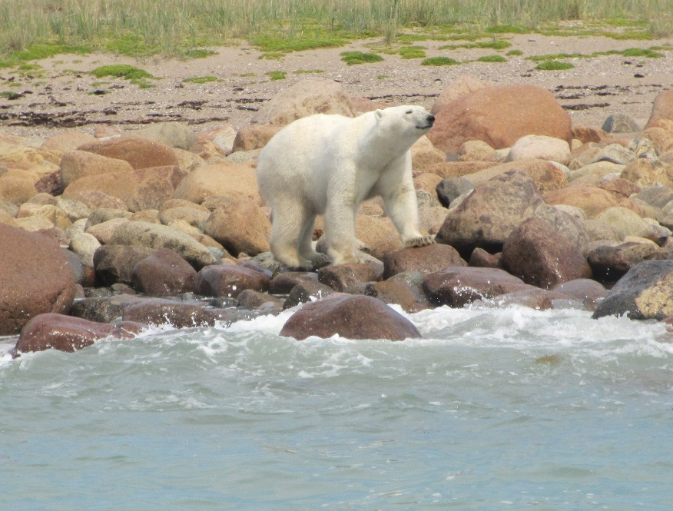

We Are Off to See
The Polar Bears!

Churchill, Manitoba

We live in San Antonio, Texas. In 2014, my wife announced that she would not make any more trips. Not airplanes. Not cruise ships. Not even any long car rides. She had had both hips replaced and was on a walker, so this was no surprise.
OK. It was a surprise however, that in November 2018, she decided to make one more BIG trip. She had spent the previous year on a diet and exercise program and wanted to celebrate.
She suggested Newfoundland. I had spent 18 months there in 1960/61 and made a three-week return trip there in 2003 (see my book, “Where Have All the Pretty Colored Houses Gone”). I suggested we rent a car and tour the island. This was vetoed (too much riding and walking). She looked at the tours to the Greek Islands. Too much walking. No trip.
I suggested a trip with little walking and with something different to see – the polar bears at Churchill, Manitoba. She looked at the tours and decided this was it. We made reservations at Lazy Bear Lodge in Churchill, beginning 19 July. This would catch wildflowers, birds and all the animals. Included were local tours and round-trip air to/from Winnipeg for $11,355 Canadian ($8578.68 US), air fare to/from Winnipeg ($897.08) and trip insurance ($848.00) plus additional expenses for a total of about $11,000 for the two of us. Now for the fun part – planning.
Planning had already begun. Internet surveys found information on paleoeskimo, predorset, Dorset, Inuit, and woodland Indian (Swamp Cree) cultures. Checklists of plants, birds and animals of the Churchill area were found and copied off the Internet. Mosquito netting and repellant were purchased. Got my cameras ready.
BACKGROUND
Churchill, Manitoba, is located on the Western Hudson Bay at the mouth of the Churchill River at 58°46’09” N and 094°10’09” W. It’s a long way from other towns or cities being 1000km (620 miles) northeast of Winnipeg. This is just north of Wapusk National Park and 600 miles south of the Arctic Circle.
Churchill is in the polar vortex with winter temperatures hitting 55° below zero. This -55°F vortex, driven by global warming, breaks out every few years into really cold weather for the north central and New England states with Minneapolis and Chicago dropping to as much as -20°F.
About 7800 Before Present (B.P.) the central glacial shield (about 8,000 feet of ice) melted into Lake Tyrell and flooded Hudson Bay with 180m of glacial meltwater. This pushed the shoreline about 100km west allowing the ground rebound about 100 feet. It is still rebounding about 15 feet per hundred years.
Beginning about 4000 B.P., the area became a migratory hunting grounds for the Paleoeskimo hunter/gathers known as the Pre-Dorset. They were in the area until about 2700 B.P. Several Pre-Dorset sites have been found near Churchill. (An archeoastromomer might say the Pre-Dorset sites were cited in the form of one of the constellations like Sirus. Additional sites might be found by plotting ground locations of other stars in the constellation.)
About 500 AD the Chipewyan Dene people arrived from the wooded south. Around 1000 AD, the Thule people arrived from the west and the Pre-Dorset people were eliminated. The Dene settled throughout the North.
The Danes arrived in 1619 and wintered over near the site of Churchill. Hudson’s Bay Company built the first permanent settlement in 1717. They named the trading post after John Churchill, 1st Duke of Marlborough, who was governor of the Company.
Since then there have been various military adventures in the Churchill area by the Canadian and US governments. There was a listening post during WWII and the Cold War for German and Russian intelligence. A Strategic Air Command (SAC) base (Ft. Churchill Rocket Range?) was erected for cold weather and atmospheric research. It was even picked as the British nuclear test site. A second rocket range for atmospheric research was established in 1956 and deactivated in 1984.
The railroad reached Churchill in 1929. It was a difficult build on permafrost and muskeg. This was the primary source of supply to the community until a deep-water port was established. The railroad transported wheat and other products from Winnipeg for shipment to Europe. The US built Fort Churchill in 1942 in cooperation with the Canadian government as part of the Crimson Route to ship goods to Europe during WWII.
The railroad became uneconomical and the port closed. The railroad was sold to a US company which refused to maintain the tracks. The railroad company was reorganized and began service in December 2018. (The first trainload of grain for the year arrived while we were there.)
Without the military, shipping, and the railroad, the community turned to ecotourism with tours to see the polar bears and whales. There are several internet articles on Churchill’s history and current activities.
In 1957 Ft Churchill became a SAC rocket test base firing 3500 Nike-Apache, Nike Orion and the Canadian Black Brant sounding rockets doing atmospheric research. These were sub-orbital launches. Data-filled nosecones had to be retrieved. The SAC facility was closed in 1965 when it became the Canadian Rocket Research Range. This closed in 1984. It is currently known as Churchill Northern Studies Centre (CNSC). Ft. Churchill base was demolished in 1981 with only the roads, runways and maintenance hangar still in operation.
There are several other objects of interest to be seen including a grounded freighter and a crashed C-46 aircraft.
The former HMCS Churchill/Naval Base signals intelligence station building is located near downtown. It was established in the late 1950’s and fully closed in 1968. It did atmospheric studies and intercepted Cold War Russian radio signals. A new university site and other local uses have been proposed but has never implemented.

Time to go.
We were up 0300 on Friday, July 19, 2019. Packing was completed. Set the bags out for the taxi at 0400. I took two small digital cameras, two mini digital recorders for notes, and two binoculars. I also had a digital thermometer and two compasses. Temperature was forecast to be mid-forties to mid-sixties, so minimal cold weather clothing was packed. The only reference I took for this trip was “Sub-Arctic Wildflowers & Plants” by the Churchill Northern Studies Centre. No pictures but a good checklist.
We were booked on Westjet (Delta) at 0610 to Minneapolis and on to Winnipeg for overnight. A charter would take the entire tour group to Churchill Saturday afternoon.
I had not been to Winnipeg for several years. There were many new buildings. Computer stores and malls were prominent. There were several Mexican food restaurants. Housing was spreading out onto the surrounding prairie with several large subdivisions. Crime seemed to be up.
The hotel was the Inn at the Forks. First class hotel. We went to the hotel dining room for supper. I ordered a Molson beer and was told they had only local beers, so I got a Corona(?). Since Canada has gone wild on Mexican food, I tried the hotel version. I should listen to myself and not eat Mexican food away from San Antonio. Another time I ordered a guacamole BLT. The BLT part was ok but there was only about half a teaspoon of guacamole.
Our charter aircraft was parked near some antique airplanes from the closed air museum and National Guard. One was a Bristol air freighter and German bomber with a single nose-mounted propeller.
The shuttle was a CRJ9000. It carried cargo in the front half of the cabin. Interesting to see safety instructions in English, French and Inuit.
We crossed Lake Winnipeg and flew over hundreds of potholes. It was interesting to see the abundance of these small lakes and the gradual disappearance eof the southern woodlands.
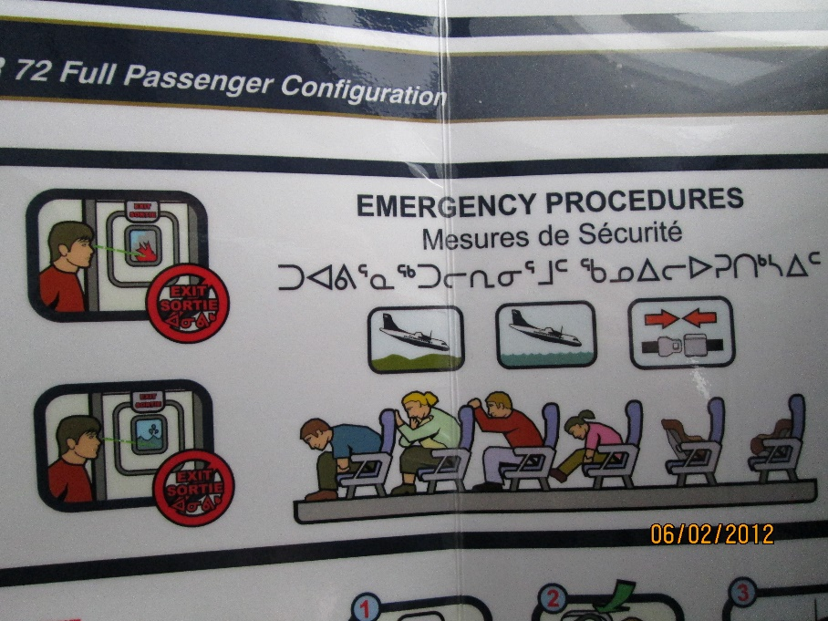
Emergency Procedures Card
We arrived in Churchill after a relatively smooth two hour and thirty-minute flight. After checking in at the Lazy Bear we loaded back on the busses for a cultural tour. Churchill has 600 to 800 relatively permanent residents. Along the main street there are 1.5 grocery stores, one hardware, half a dozen restaurants, several gift shops, and one main paved street about a mile long. There are a bunch of dirt roads and trails left from the Air Force.

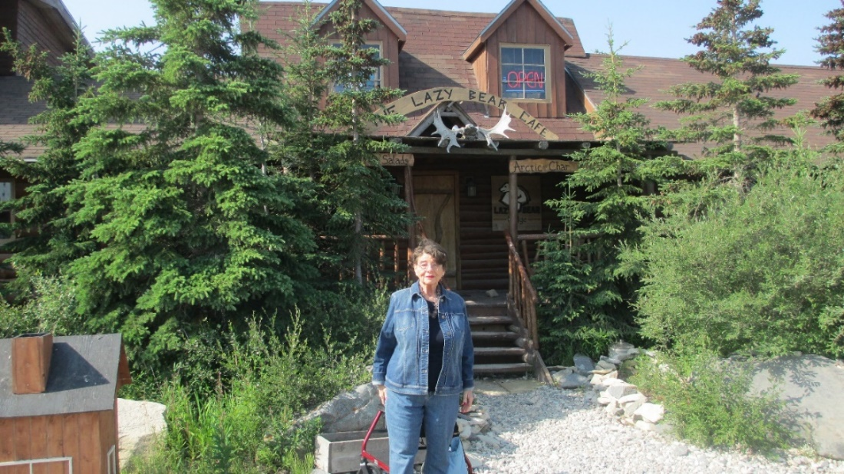
Carol in front of the Lazy Bear.
We went to see the Battery at Cape Merry. This was built as a complement to Fort Prince of Wales on the other side of the river. We passed the port and visited the polar bear jail and “Miss Piggy” – a crashed C-46. Other features were pointed out like the Eskimo Museum and the old train station that is now the Cultural Center and Museum.
After we returned there was short trip to the Cultural Center for a talk on the Dene culture. She said the Dene were common in the north, but I was unfamiliar with the name. I have since found more about the Dene. This is a group of First Nation tribes that speak Athabascan and live across artic Canada. They possibly migrated across the Bering Strait as much as 30,000 years ago between ice ages. Look on Wikipedia for more information.
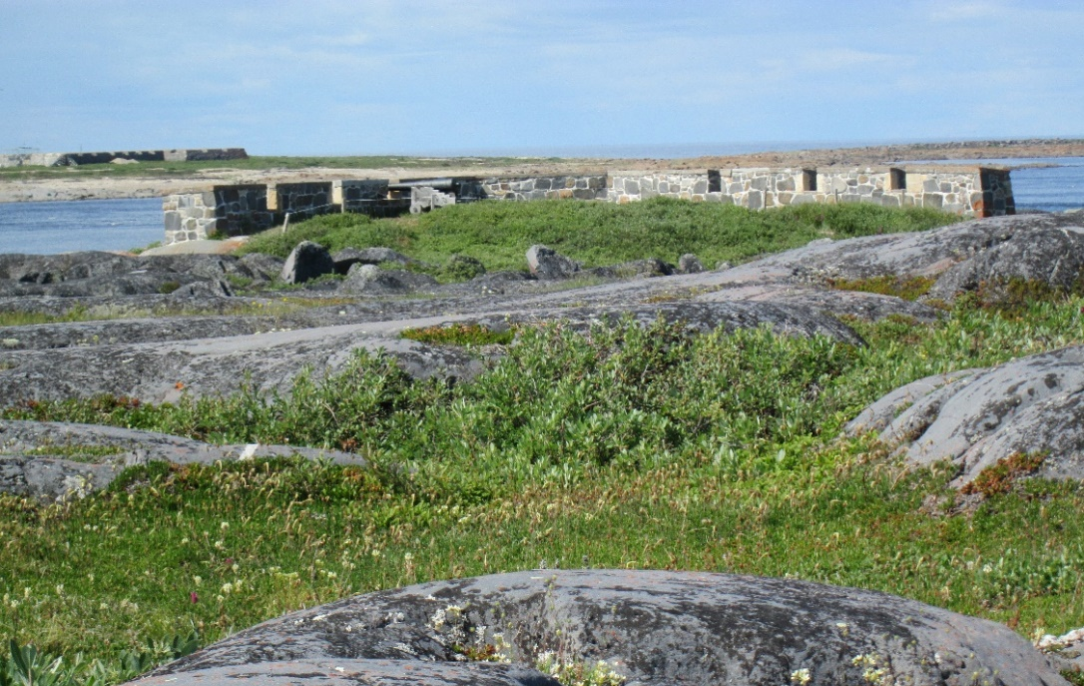
The Battery at Cape Merry
Carol did not attend so after the talk I walked back to the lodge along the main drag, Kelsey St. I stopped in at the Artic Trading Company to see local art and crafts and bought a pair of fur-lined moccasins. Their art included paintings in various media, carvings, and applique art where figures are cut out and stitched to a background material and any details are embroidered onto the figure.
Next stop was the grocery store to see how the prices ran. Canadian money ran $1.25 to a dollar. Produce was available but about twice our local prices. Cokes were $2.30 each. Batteries were twice our price. T-shirts ran about $23 bucks.
I continued along the street. It was two lanes asphalt edged by six feet of stone on each side and about 50 feet of clear space to the buildings. There were a few individual houses, but most people lived in apartments. There were a few pickup and motorcycles but not many cars since everything had to come by air or train or ship.
Sunday morning, we visited the stone gun battery on Cape Merry and went to see “Miss Piggy”. This was a C46 cargo plane owned by Lamb Air that lost an engine and crashed 13 Nov 79. Disney painted some murals on it and used it in a movie.
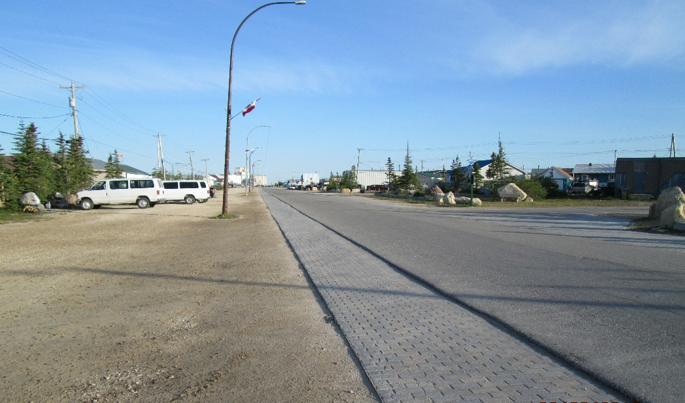
Kelsey Street looking Downtown
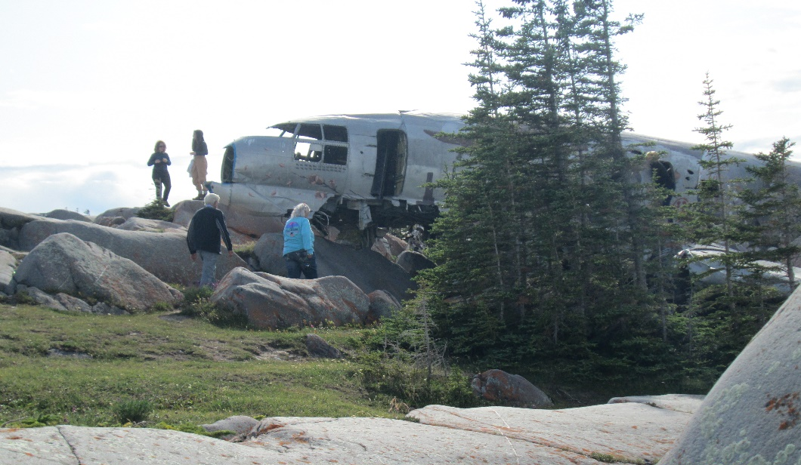
Miss Piggy
We noticed the one-sided trees caused by the winter wind. There was also a “skirt” around the bottom of the trees where the snow covers the bottom branches.
The polar bear jail was where nuisance bears were held after trapping. Bears were held a couple weeks in hopes they would not come back to town after they were released. The traps are large culvert with welded bars and a spring-loaded door. There is a polar bear patrol that keep the bears out of downtown using cracker shells and these traps.
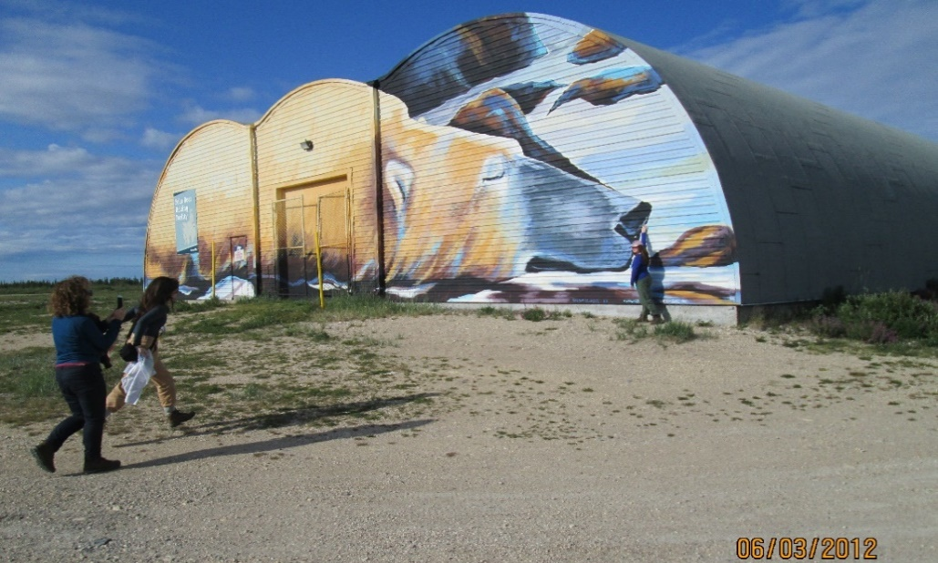
Polar Bear Jail
We returned in time for supper and the arrival of the first grain train of the year. It was twilight until after 2300 and light about 0430 overcast with no aurora.
Monday morning after breakfast we went down to the dock and loaded into zodiac boats for a three-hour whale watching excursion. We passed the grain loading facility and out into the river. The whales were in the mouth of the Churchill River where the freshwater mixed with the Bay’s saltwater.
The beluga whale belongs to the toothed whales and were feeding on caplin, an anchovy-like small fish. The whales were broaching in singles and small groups. The water was relatively clear, and you could see whales as they passed under the boat. Some followed the motor. Mothers with young came to check us out. They were friendly and not at all aggressive. A hydrophone was put out to listen to the whales. There was not much singing by the whales although a couple made calls that we could hear.
I looked up to see several contrails. These were European flights headed for the US. Planes going the other way are on the other side of the bay.
The tide was changing as we headed back to the dock. Lines of foam formed where the fresh water of the river met the denser water saltwater of Hudson Bay. Air temperatures ranged from the upper 40’s to low 60’s. Bay temp was 44°F.
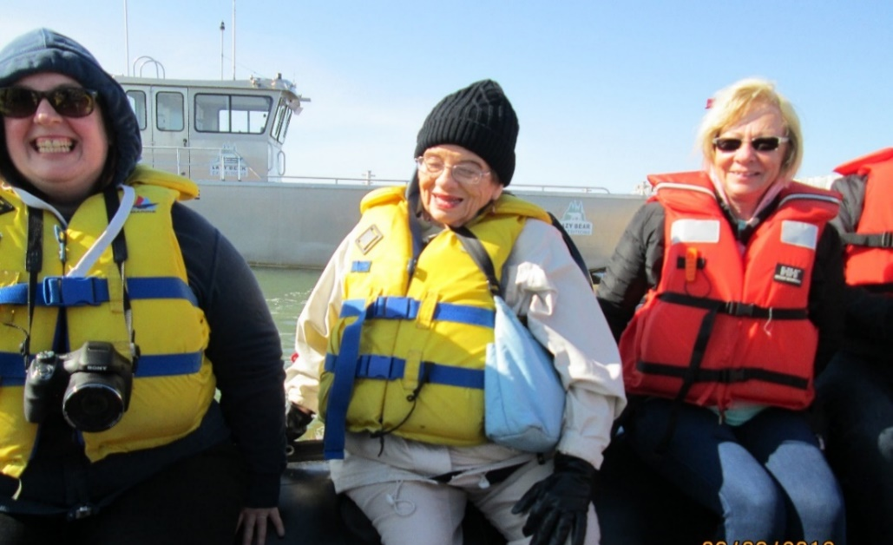
Carol Ready for Whale Watching
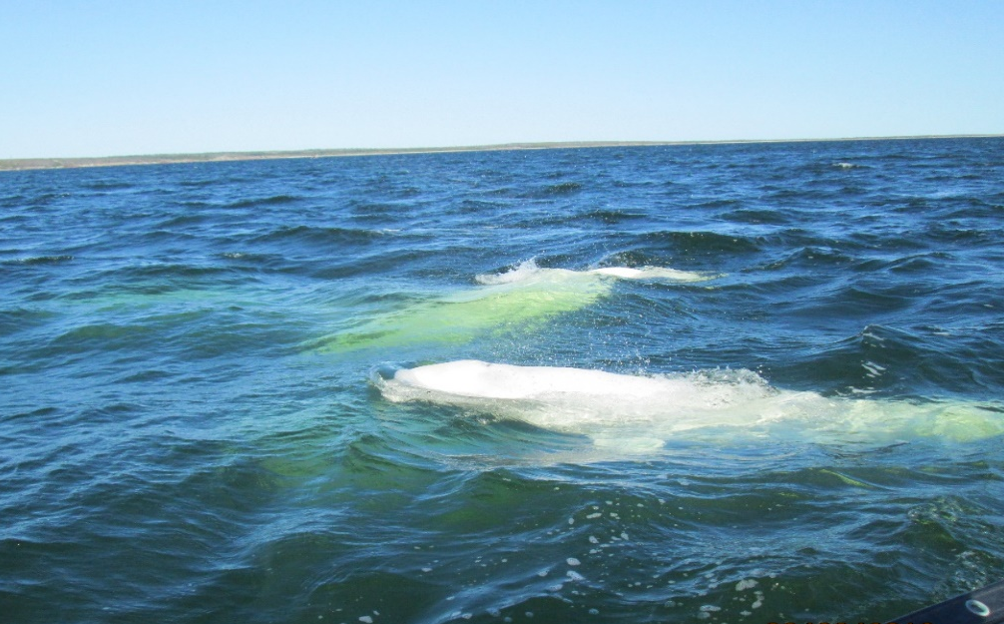
Beluga Whales
Our next stop was at Fort Prince of Wales. It was built in 1731, captured by the French and retaken by the British. Restoration of the stone fort was begun in 1930s and is still underway. There was a nice walk to the fort through the boulders and flowers.
Our guide always carried a shotgun and checked the area for bears. She knew her flowers and wildlife.
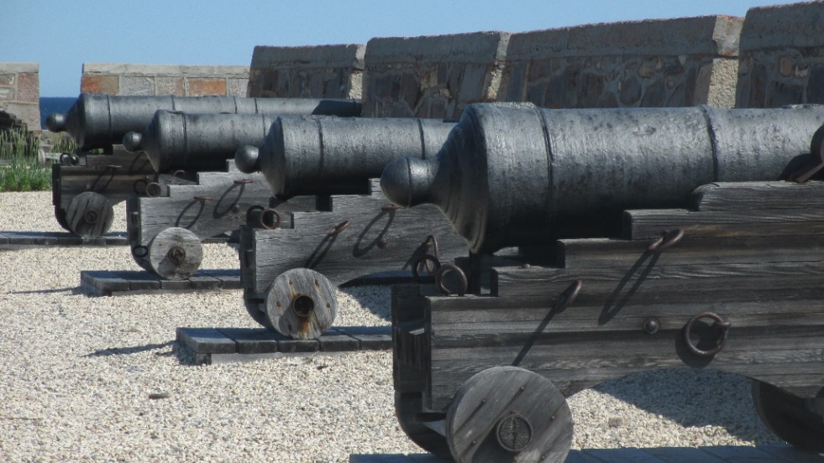
Guns of Fort Prince of Wales
Many of the boulders were home for one or two lichens. There was also reindeer moss- another lichen.
We climbed to the top of the fort to look at the canons and layout of the fort. Thick stone walls. Numerous canons of three sizes. Must have been miserable in the winter.
Tuesday’s excursion was about 50 miles north to near the Copper River. We gathered at the dock and put on red exposure suits before getting into the boat for about a two-hour ride. The boat was aluminum with a drop gate bow. We bounced across about four-foot swells.
When we arrived, the guide jumped ashore with a shotgun to scout for bears. She returned to the boat as a bear came over the berm and headed down to the beach. The boat backed off and we watched this bear parade along the water’s edge. After about half an hour we went to a small island that had three bears that we watched until they disappeared into the brush.
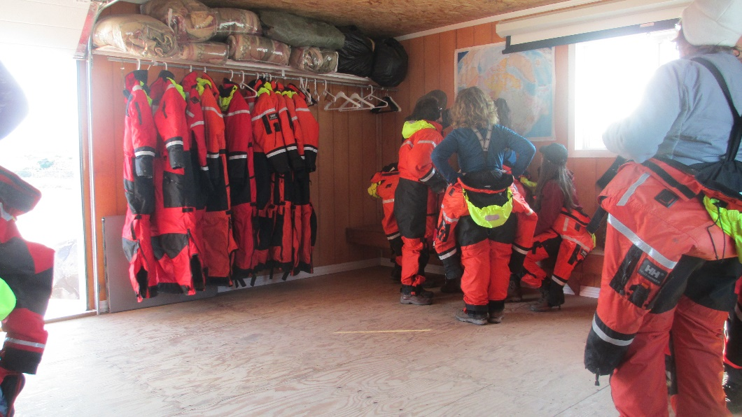
Suiting up

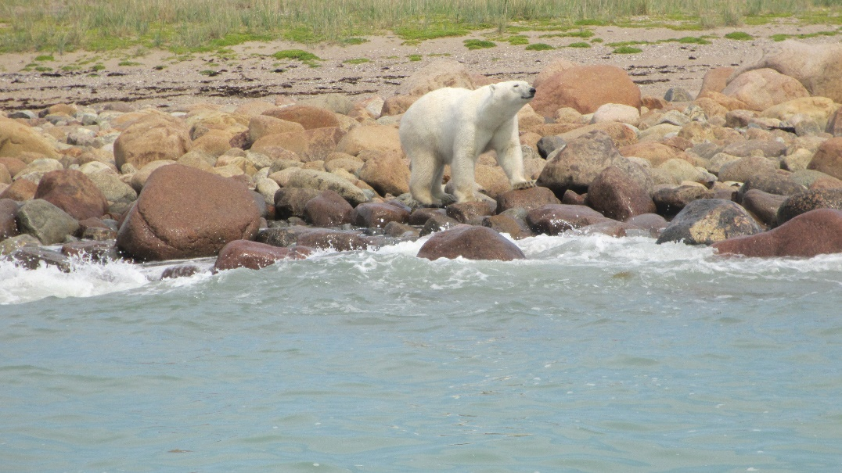
Polar Bear
Wednesday was a free day and the day of optional tours. Since we were not taking any extra tours Carol and I went to see the Eskimo Museum/Itsanitag Museum and some of the gift shops.
A taxi took us through the residential area on the way to the museum. These were mostly apartments and dormitories.
We spent a couple hours looking at displays of Inuit, Dene and Dorset tools and art. Some local wildlife and fossils were also on display. Very interesting. There was a good selection of books on the area along with some locally made jewelry.
There was a mounted bear, a musk ox, an elk, and a seal, and displays of kayaks, sleds and snowshoes. The carvings were representative of local life or religious items. Most of the carvings I had seen before were for the tourist trade like seals and whales and Bilikins on the west coast.
There was one display of seashells of Hudson Bay. I found four species mixed with the seaweed (mostly Bladder Wrack) on the beach.

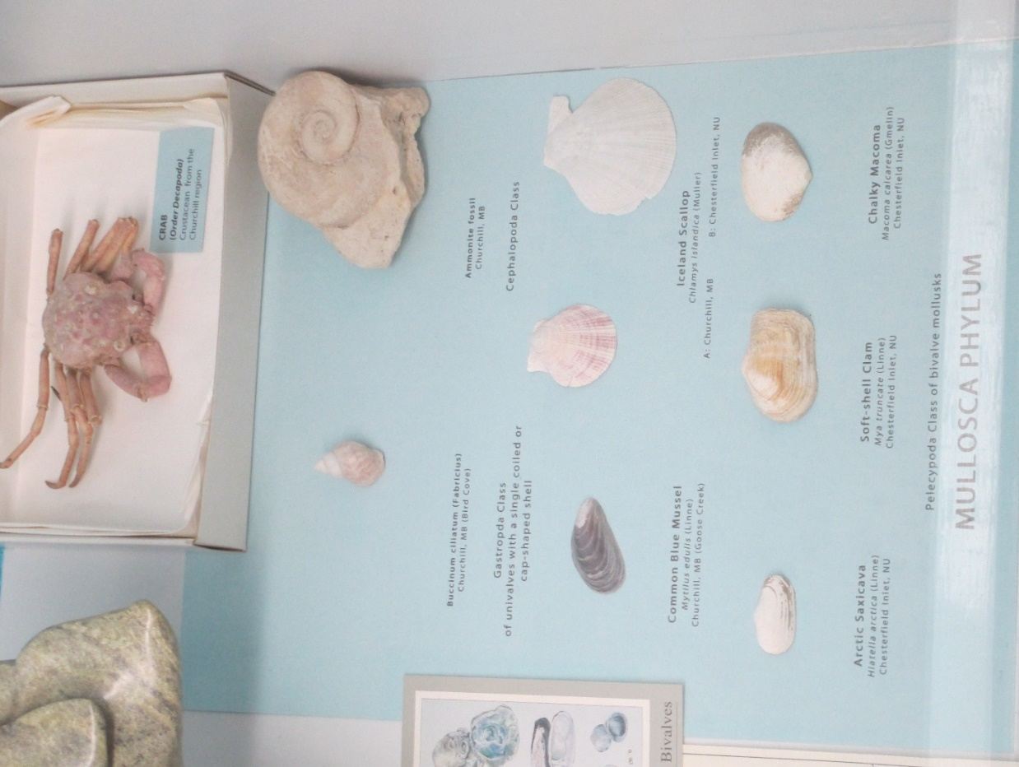
Eskimo museum

They were juveniles except for the Blue Mussel. A couple Buccinum, one Soft-shell Clam, and two Chalky Macoma about fingernail size.
We went on down the street to the Artic Trading Company and two other shops before heading back to the hotel for supper. I had an elk steak followed by a milkshake. Carol had a steak.
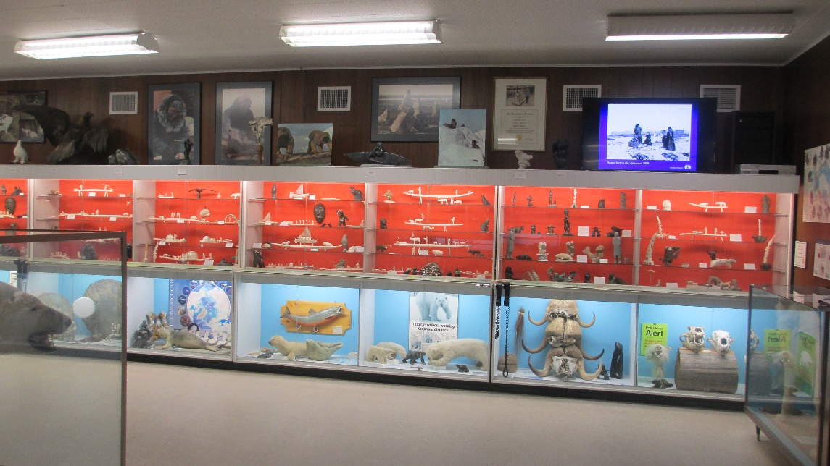

Some shots were heard that night near the hotel. The bear brigade had chased off a bear from behind the hotel.
The last day we were packed and set the bags out and headed for breakfast. We were soon on the bus for a final tour and transport to the airport. The old Air Force roads lead us to the bear jail and the old rocket launch facility and the Churchill Northern Studies Centre. We boarded the huge crawler vehicle for potential bear watching and drove to the beach. There were no bears. The tide was out, and the beach was littered with drift lines of Bladder Wrack and immature seashells.

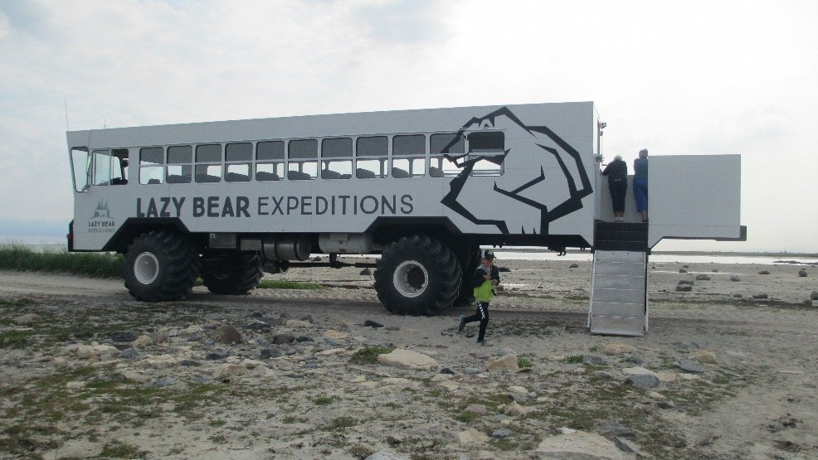
Tundra Vehicle
Offshore was a rusting stranded ship, the MV Ithaca. She had been an eighty-meter ore carrier. She had sailed out of Churchill to Rankin Inlet on 10 September 1960 and lost her rudder in an 80mph storm. She had dropped sea anchors that failed and came aground on 14 September with 37 men on board. The shallow reef allowed the crew and cargo to be rescued. At low tide visitors can walk out to the ship.
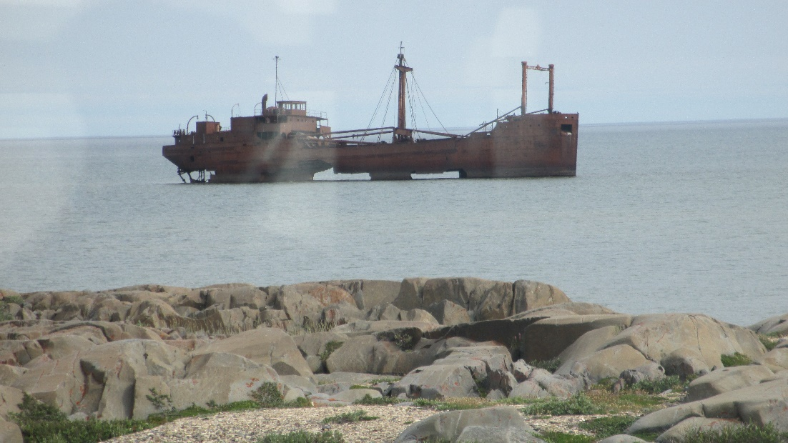
MV Ithaca Wreck

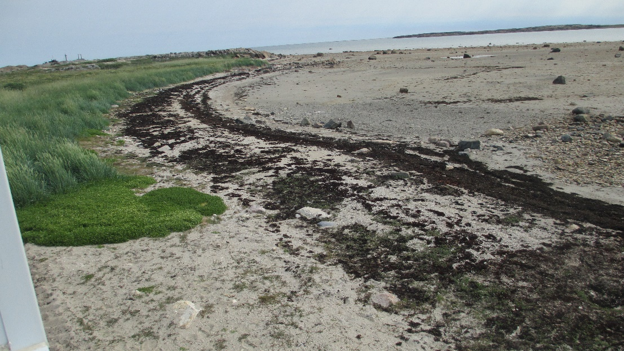
The Beach at low tide
Back at the airport we boarded our charter flight and were in Winnipeg after a 2.5-hour flight.
After a night in Winnipeg we went to the airport and were on our way to Minneapolis. Leaving Minneapolis, I noticed several buildings had flat pink structures on the roofs – solar panels. One little town was peppered with little pink dots. I guess these were solar panels powering streetlights, etc.
We arrived in San Antonio and were home about 2200.
Now for the fun part. I spotted two butterflies. One was yellow (one of the sulfurs) and the other white (Cabbage White).
Mosquitoes and midges were not as bad as I had seen them in other parts of the north. Maybe it was the time of year. The most common mosquito was a large brownish one that was slow and silent. You could swat it easily. The bites did cause an itchy red welt.

Mosquitoes in My Motel Room
When I opened the door and turned on the light
mosquitoes were lurking just waiting to bite.
I swatted and squashed for a minute or two
and they disappeared right into the blue.
I turned on the sink and flushed out a couple
and one from the overflow compounded my trouble.
I turned on the tub and three more were washed out
then two more flew out of the drain with a pout.
They hid in the drapes and under the chairs
and hummed about blood that soon would be theirs.
Stop! I can't take any more.
I threw on some clothes and ran out the door
to find a bug bomb
to kill these blood sucking ladies and even their mom.
I sprayed half a can. There. That should be enough
that is, if these swamp ladies were not super tough.
I backed out the door to wait 'til they died
but out in the courtyard was one I could ride
so I left the very same night
straight back to West Texas where tall tales don't bite.
+++++
Another old friend was the biting fly. We called them flying teeth. The locals called them bulldogs. They land and bite out a chunk that hurts and bleeds. They drove the caribou and moose crazy.
Deer Flies - Daughters of Mars
Like small vicious hawks
deer flies attacked anything that moved
like moose and man and bear.
Females of the genus Chry'sops
bit out chunks of flesh and drank blood
like a party animal drinks beer.

These pretty colored biting flies
ran caribou crazy on warm windless afternoons.
Moose cows submerged to escape the bites.
The moose bulls, fed up, crashed through
arctic willow and beaked hazel brush
with all their frantic might.

We cast our favorite wet flies
dressed in a head net, long sleeves and gloves.
Lunch of beans and trout remained untouched
but we crudely ate lunch with our gloves on
because exposed skin received vicious bites.
Deer flies were almost too much.

A vector for rabbit fever
and a bane of the arctic realm
these flies disappeared with the setting sun.
Supper should have been no problem
except that at twilight
mosquitoes began having their fun.

The arctic adventure was over
but my wrists had a number of scars.
I miss the trout and the caribou
but not those colorful Daughters of Mars.
+++++
There were not many birds were seen in number or variety. I only saw Canada Geese, Common Eider, Arctic Tern, Golden Eagle, Common Raven, White-Crowned Sparrow and House Sparrow.
The mammals seen were the Polar Bear, and Beluga Whales.
Much of the vegetation was mostly familiar from Newfoundland and other trips north. Lichens. Flowers. Shrubs and trees. A couple new grasses. “Sub-Arctic Wildflowers & Plants” by the Churchill Northern Studies Centre was extremely helpful and the only reference I carried. I shot pictures of many plants for reference and identification with other references including Wildflowers of Churchill and the Hudson Bay Region by Karen L. Johnston and Plants of the Western Boreal Forest and Aspen Parkland by Johnson, Kershaw, MacKinnon and Pojar.
The geology is interesting. There is permafrost that keeps pothole ponds from draining. The surface material in Churchill is part of the Precambrian Shield with relic beach lines. The rock is a dark gray quartzite called Churchill quartzite. Evidence of glaciation is apparent in scars and glacial shaping and polishing of the bed rock. Sedimentary material around town was imported from deposits upriver and contains many of fossils from the Pleistocene and Silurian.
This area was under up to a couple miles of ice 15,000 years ago which depressed the land about 1000 feet. The ice melted to form the Tyrell Sea up to 159 feet deep and expanded the shoreline many miles. Since the melting time the surface has been rebounding about 15 feet per hundred years and still rising.
On the other side of Hudson Bay in the SE corner is the Nastaporia Arc, a suspected 2-billion-year-old meteor crater 300 miles in diameter mostly under water.

All together It was a well planned and executed trip which both of us enjoyed. For further adventures look at “Do Bears do it in the Woods?” This was a visit to Winnipeg and Riding Mountain National Park on our website www.pretensepress.com.

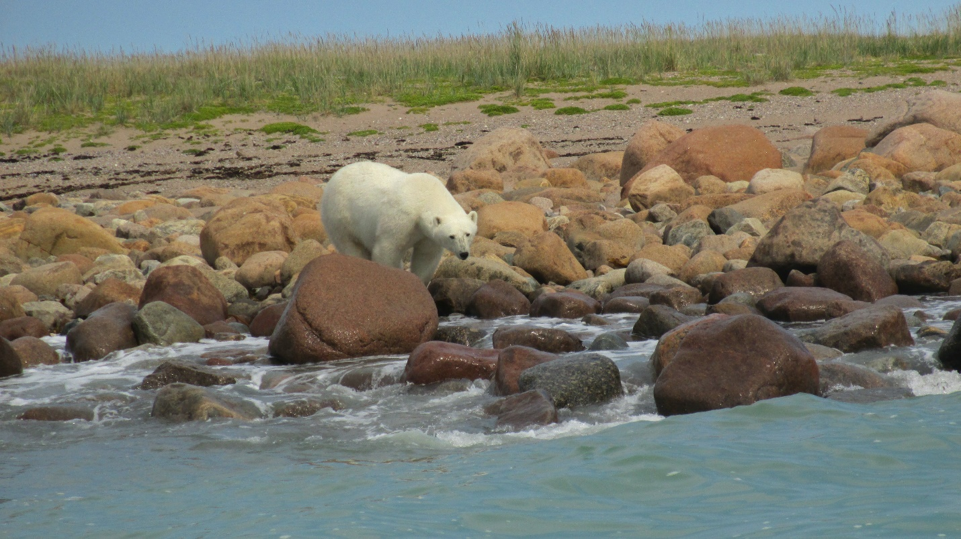
Bye Bye Bear

