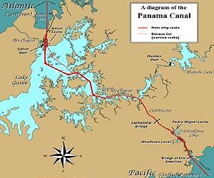

Cruise through the Panama Canal

April 2003

By

Carl Lahser
Copyright © 2010 by Carl Lahser. All rights reserved. If you must copy any part of this work please give the author appropriate credit.

Published by: Pretense Press (pretensepress.com)
6102 Royal Breeze
San Antonio, TX 78239
(210) 657-5139
clahser@satx.rr.com
Publications by the author:

USA Bigfooting Around – Washington state
Blue Ridge, GA
City of Angels
Galveston
New York Christmas – Hudosn Valley and NYC
Niagra Falls and Toronto
October was a Busy Month Minneapolis and the Shennadoah Valley
Portland in the Summer
San Francisco Home Exchange
Santa Fe Getaway
Shelling Trip
Summers End

Canada Backdoor to the Yukon
Do Bears do it in the Woods - Winnipeg
Enterprise II – Calgary, Edmonton, Athabasca Enterprise North
Vancouver – Vancouver, Victoria, Inland Passage
Where Have All the Pretty Colored Houses Gone - Newfoundland

Mexico Cabo San Lucas
Copper Canyon
Flowers of the Air
Hey Momma, When we Goin Again
Mata Ortiz
Mr. Cuul in Yucatan
San Miguel
Searching for the Phantom Crown
Todo Santos Ecoadventure

Europe A Quick Little Christmas Trip Christmas on the Rhine
Dickens Christmas - Three Weeks in London
Cross-section through a Rainbow – Corfu, Athens, and Rhodes
Greek Poems
Return to Assinara Bay – Italy
Three Weeks in Berlin

China China Tour China Sings
Hong Kong 1979

Other Travel Panama Cruise
Under the Southern Cross (Under Clouds) – Machu Pichu and the Amazon

Poems Cryptic Romance
Ecoview 1 - Not Your Usual Neighborhood
Ecoview 2 - Texas
Ecoview 3 - D.C.
Ecoview 4 - St Louis to Minneapolis
Ecoview 5 – Southwest
Ecoview 6 - Green Things
Rincon de Carl
Snapshots of the North
Snapshots of Mexico
Summers End
Texas to Alaska Traffic Games
Tyndall Beach
Walk on a Different Beach
Weather watching

Other Alamo Road – Mom’s Story
BASH – Bird/Aircraft Strike Hazard
Bessies Pictures 1930
Butterflies and Birdwatching - PIF Bird Meeting
Forty Years of Fishing – Professional History
Green Stuff Articles from the SCION
San Antonio Wildflowers by the Month
Teacher, Leafs Don’t Change Color – Growing up in the Valley Thinking of Flying – Military history

Plays Cryptic Romance
A Body in the Trunk
A Blow for JFK
A Beard like Mine
The Black Birds – A BASH Play

Essays Broken Shoulder
Dinosaur Diving
Haiti
Hip 3 – Hip Replacement
Impossibility of Time Travel Knee Repair

Fiction HiJaak
Stories Grampus Told
All titles are available from Pretense Press. Booksellers
are encouraged to write for seller’s information.
Printed in USA.

Cruise through the Panama Canal April 2003

Introduction. Carol came home from bridge one night after discussing vacations with other players and decided she wanted to take a cruise through the Panama Canal. Shortly thereafter an offer of a cruise through the Panama Canal arrived on the computer. It looked like fun so we booked on 8 July 02.
I had been to Panama 35 years before. This was long before Noriega when we still had several Army and Air Force bases and the Panama Canal Company ran the canal. I had visited the Miraflores lock and taken the train along the Canal. Shopping had been good on both ends of the Canal. I liked the bird watching and seeing the jungle of Central America.
Price was $1399 each plus $279 port charges and tax of $279 each plus cruise insurance of $128 each totaling $3612. This was for one of their 624 ocean view cabins with extended balcony on the Carnival Spirit for a 16-night cruise leaving Miami terminal 3 on Tuesday, 1 April 03.
The ship was gross 86,000 tons and 893 feet long with 106 feet beam designed for Panama Canal passage. The maximum size ship allowed is 965 feet by 106 feet beam. The lock chambers are 110 feet by 990 feet. Not much wiggle room.
Itinerary was proposed as: 0800-1400 Friday in Cartagena, Columbia; Panama Canal transit 0800-1600 Saturday; 0800-1800 Monday in Punt Arena, Costa Rica; Acapulco 0700 Thursday to 0400 Friday; 0800-1700 in Puerto Vallarta on Saturday; 0800-1700 Sunday in Mazatlan; 0700-1400 in Cabo San Lucas on Tuesday; and dock in San Diego at 0700 Thursday. We used frequent flyer miles for American Airline electronic tickets from San Antonio to Miami and San Diego to San Antonio. This schedule turned out to be 80-90% correct.
I did my homework on birds and local histories in books and on the Internet. I took A Guide to the Birds of Venezuela by de Schauensee and Phelps and A Field Guide to the Birds of Mexico and Central America by Irby Davis.
The itinerary looked interesting except I found nothing on Punta Arena specifically. I found the port had closed about ten years previous and had recently reopened along with a new commercial port that was still under construction.
I found a good list of the area birds from one of the resorts. Websites like http://www.lonelyplanet.com, http://www.blackworld.com,
http://www.mytravelguide.com, http://www.ddg.com, and http://www.about.com
had a lot of maps and information. There were several websites with pictures and narrative of similar cruises and a lot of information on the resorts on the Mexican Rivera.

Day 0. We flew to Miami on 31 Mar from San Antonio at 0840 to DFW and arriving in Miami at 1430. We crossed East Texas and Louisiana hitting the Gulf over the very mouth of the Mississippi River. We were feet dry near Ft Meyers then across the Everglades to Miami. There were more gravel pits than I remembered from the late 70’s and Florida International University had grown from two buildings to a large campus. We flew half way to the Bahamas and turned to land from the east.
The weather was cool as we waited for the hotel shuttle to take us to the Wyndham Airport, which was a designated transfer point.
We checked in for the night and then checked in with the cruise people and were given a schedule for transportation to the port.

Day 1. Next morning we tagged the bags and got them down for transportation by 1000. We checked out of the hotel ($148.48) and sat around for two hours waiting for transportation.
Tipping had begun with the taxi driver from the house, the hotel shuttle driver, the porter, the maid, the porter, the bus baggage handler, the bus driver, the port baggage handlers. And we had not even got to the ship yet.
The TV was following a Cuban who had hijacked a plane and wanted to come to Miami. He eventually gave up.
Time passed. I walked along the canal that separated the hotel from a golf course in the airport clear zone that I first saw almost 50 years ago. Landscaping was with primarily coconut and Christmas palms, Sea Grape, Ficus trees, and crotons. Land crabs had dug burrows in the sandy canal bank.
We finally had to identify our bags for loading on the bus. The trip to the port was $10 each and took about twenty minutes.

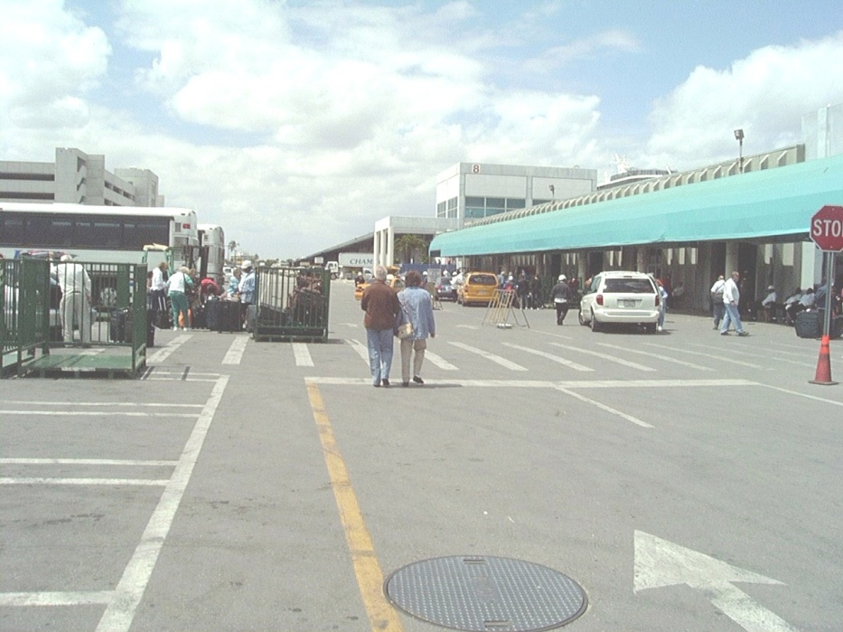
Next came the embarkation check-in. ID the bags. Walk through the maze and up stairs and through the metal detectors and x-ray then more maze to the assignment of a room, dinner seating assignment (first seating was at 1745 at table 204), a notice that we would not get shore leave in Cartegena, and establish credit for use on the ship (They circumvented tipping the ship personnel by a 15% surcharge).
We came on board and finally found our cabin. We were in 7148 on deck 7, port, forward with our own balcony. It was now after 1300 so we went to lunch at the La Playa Grille on the Lido deck while they delivered our bags.
We unpacked and moved in for the duration. There was adequate drawer and closet space, a compact bath with a shower, air conditioning and adequate lighting.
I crashed for a few minutes. It was suddenly 1730 and time to head for the Empire dining room on decks 2 and 3 aft. We were shown to our table and introduced to our two servers. We were not assigned tablemates for some reason. The menu offered a selection of several hors d’ oeuvres, soups, salads, entrees, deserts, drinks, wines and liquors. Overall the selections were varied and well prepared, the service was very good, and the food was good but not the quality I had expected.
Sailing time was 1700 but it was delayed to top off the fuel. It was 1830 by the time we started down the channel. We finished supper watching coconut palms drift past.
We walked around the ship for an hour or so as the ship turned southeast at 22 knots. It was dark and the wake fluoresced a green and white trail a mile behind the ship.
That evening there were 8 -10 foot seas. Overnight the NE wind freshened to 40-50 K. Carol put her seasick patch on. So much for Day 1.

Day 2 began off SW of Cayu Lobo with its huge flag whipping in the breeze. There was no sunrise with clouds and a 20-30K wind out of the north. We loafed along the northern coast of Cuba all day and moved into the Windward Passage (Passo de los Vientos) about 1800. We passed between Jamaica and Haiti during the night and into the Caribbean. New course was a little west of south straight to Cartegena. It was too deep to swim – 2500 fathoms.
The last time I was in the area was 1962 when we went to Guantanamo and chased Cuban mobile missile sites. On the way back to Norfolk we were in the recovery group for John Glenn’s flight. The aircraft carrier I was on, the USS Forrestal, spent a couple days off the Outer Banks in March in 70K winds out of the NE gusting to 120K with 70-foot waves. That 1100-foot, 80,000-ton ship really rocked and rolled.
We checked the activities and Carol found a bridge group. I walked several miles around the weather deck and watched Cuba slide by. Wind across the deck was pretty fierce for walking. I was surprised they did not close the exposed deck 10. Walkers really got a workout with a 50K headwind. All the deck chairs were lashed down.
The wind had been 30-40K all day but stiffened in the evening with gusts to 82K that blew the tops off the waves. Seas were up to 15 feet.
The cruise was relatively smooth thanks to the stabilizer fins. Propulsion was by two 17.6 MW 360° electric Aziopods and three 1910 KW bow thrusters. This is powered by six 9-cylinder Wartsila diesel engines running the electrical power plant. Power transfer and maneuvering was smooth and quiet.
I requested an engineering tour to see the water, wastewater and solid waste and was told the EPA and Coast Guard did not allow this. Later I asked for an interview with the engineering staff and was told this was not permissible. I did get a good tour of the galley looking at sanitation, solid waste handling, recycling, and hazardous materials. I will discuss this later.
We had lobster for the first formal meal of the cruise. The Captain was supposed to be there but I did not see him the whole trip.

Day 3 got light but the sun forgot to come out for a couple hours. There was high cirrus clouds with a NE wind of 45K. Clouds and sun angle change the sea color shades of light and dark green. We went to breakfast about 7 almost every morning on the Lido deck - cereal, eggs, etc. Twice during the cruise we went to the Empire dining room for the more formal breakfast.
About 0900 the wind dropped and some cumulus clouds were forming. I was surprised to see virga at sea with the rain evaporating before it hit the surface. Maybe the surface winds were blowing the rain away. Waves dropped to about 5 feet. Occasional small silver two-winged flyingfish took off and skipped off the swells.

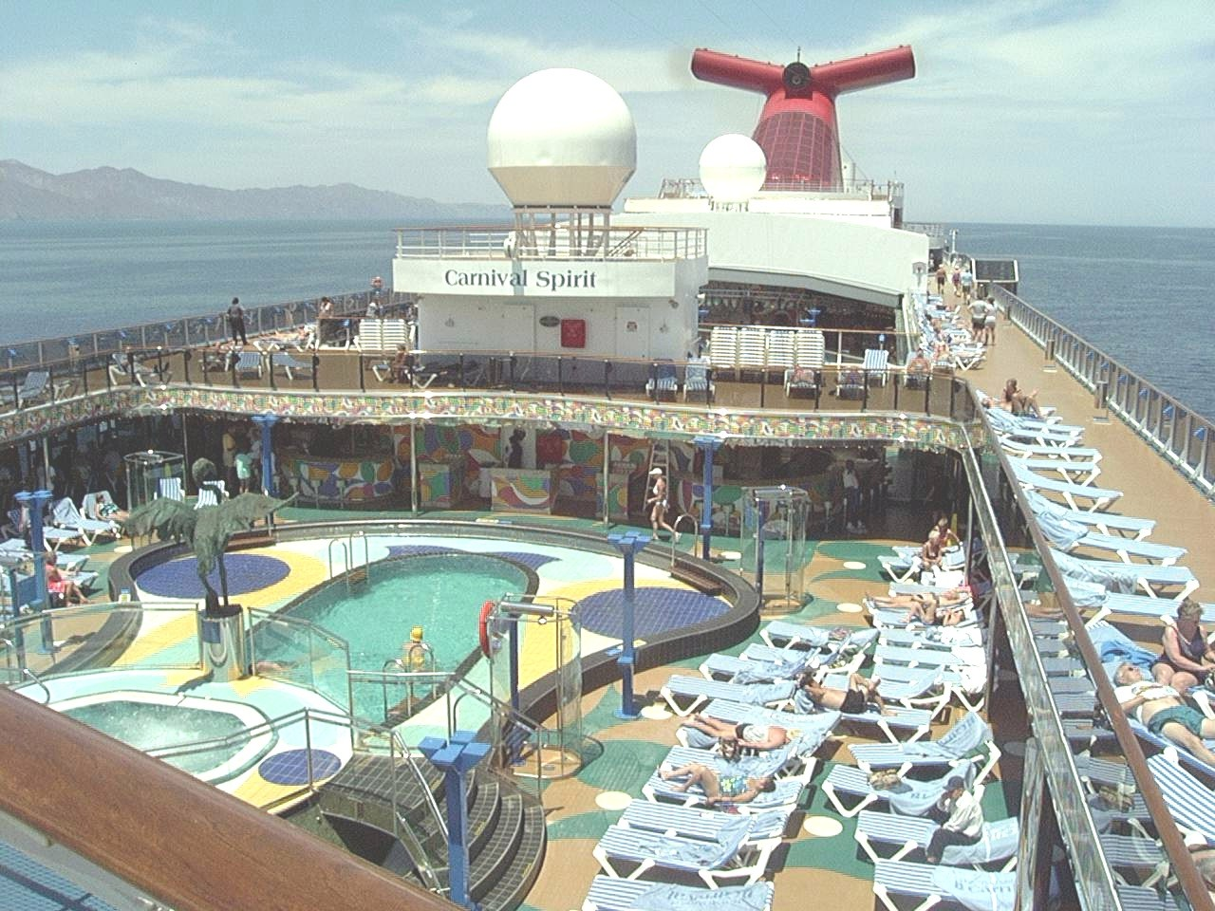

Here is a list of a typical days activities: A golf putting competition, ping pong and shuffleboard, arts and crafts, bridge, a hair seminar, trivia, dance class, chess and checkers, an art auction, sports trivia, an afternoon concert, cooking class, bingo, hairy chest contest, newly wed game, etc. The library was mostly a collection of novels locked in cabinets that had computer terminals in front of them. No movies. No interest groups like poetry or natural science. Shows in the evening, including amateur nights, had mediocre entertainment at best. Could hardly stand the excitement.

The morning of Day 4 we arrived off of Columbia about 0700 and entered the channel near Isla de Terra Bolea. A White Egret flew across the bow. Several Common Terns, Black Skimmers and Laughing Gulls flew by. I noticed the channel markers were all solar powered.
We passed several mangrove-covered islands. Three men were pulling a beach seine on one. A Columbian Coast Guard helo flew over and a flight of Brown Pelicans crossed our stern.
We arrived in the outer harbor near the lighthouse and dropped anchor kicking up a lot of mud in the doing. We were at N10°23’00.3” W075°32’49.7” about a mile off the beach.

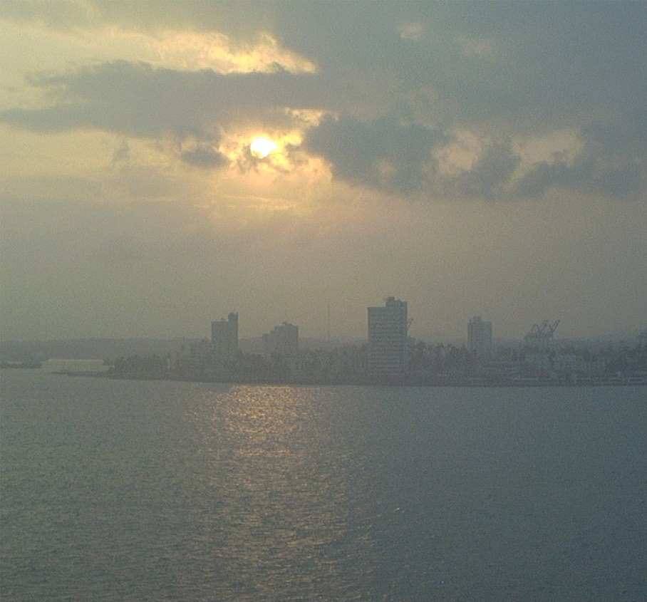

There was a petroleum smell in the harbor. A number of fishing boats maybe 20 feet long were pulled up on shore. A flock of Widgeons floated off the beach with Pelicans and an Anhinga sat on one of the fishing boats.
There was another cruise ship at a dock with several container ships. A passenger ferry crossed the mouth of the harbor. Behind the lighthouse was anchored a Columbian destroyer escort.
Stacks of three power plants and a big smoke cloud were to the south of downtown. The Fort San Felipe de Barajas built between 1657 and 1769 sat in the city center along with the Cathedrals of Plaza Bolivar. I was hoping to get to see the city but the docking was cancelled and we got a $25.00 rebate.
The anchor was raised at 0940. We pivoted around using the bow thrusters and the Aziopods and left passing a fort on a channel island at the harbor entrance. The Island was home to a flock of Caribbean Grackles.
The pilot left at 1020. We began another afternoon and night of quality sea time on our way SW to Colón, Panama.
The weather warmed up and the sky was clear. Occasional flyingfish launched themselves from the briny deep to escape some predator or maybe just for the fun of it. It was a nice afternoon with a showy sunset.
There was shipboard TV. One channel showed ship position. One had a forward view. One had a view aft. One was a CBS channel from New York City. Another was an ABC channel from Nashville. A movie channel that showed the same three flicks 24 hours a day for the entire trip. Four channels showing the official trip videos and periodically announcing that these were on sale in the camera store.

Day 5 was another day where it just got light. We had passed the San Blas Islands in the dark. Lines of seaweed drifted past as we slowly approached the breakwater at the entrance to Port of Cristobal from the north. The Ports of Manzanillo and Coco Solo and the city of Colón were out of sight to the east. We entered into Bahia Limón and sailed to the entrance to the first compartment of the three Gatun Locks. There are several websites with good pictures like the following http://www.plrphoto.com/Columbia,%20Panama%20Canal,%20Costa%20Rica%20Pictures%20For%20Sale.htm, http://pages.prodigy.net/rmfz/cartagena.htm

Several White Egrets and Black Vultures were in the rocks and on the mud banks along the channel. Several Chapman’s Swifts flew around the ship as we waited for a big container ship to get through the adjacent lock. A cloud of smoke rose from a burning sugar cane field. I noticed the Canal Zone gate guard had a line of cars and trucks backed up. Several Black vultures cruised the sky and several had been working the mud banks along the entrance channel. I noted a Tropical Kingbird sitting in the spiral of razor wire along the canal and a Costa Rican Tanager zipped past.
Most of the passengers were outside on the various decks watching the operation of the locks. The balconies sound nice but you can’t see much to the front or rear and deck 5 had lifeboats obstructing the view.
Small boats picked up lines from our ship and attached them to diesel-powered locomotives called mules. Each 55-ton mule could exert 70,000 pounds of force. Six mules are used to tow the ships through the locks.

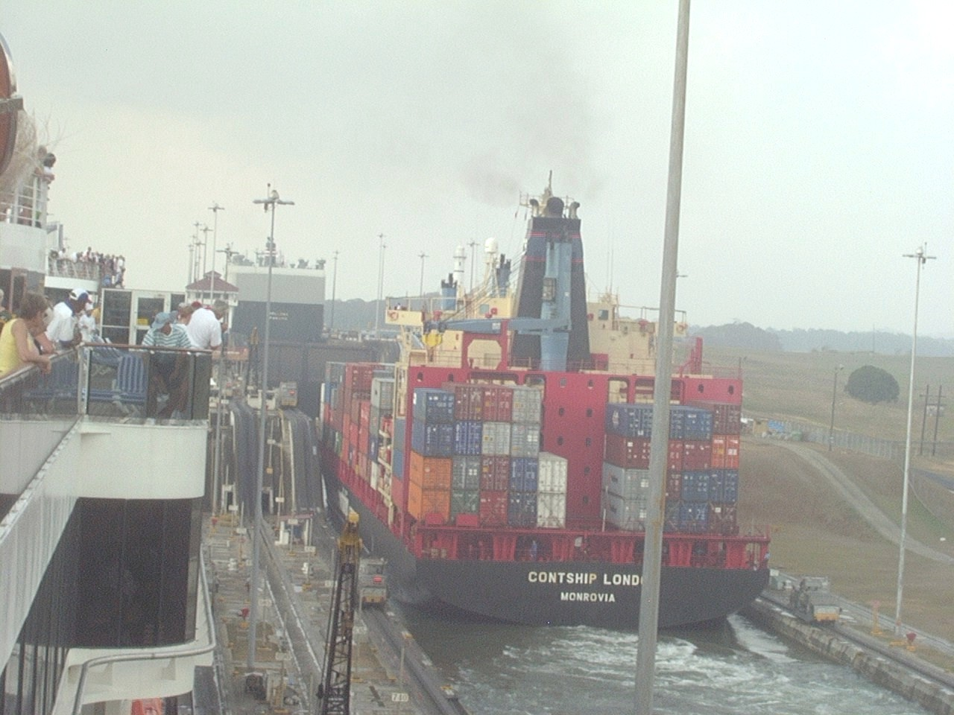

The container ship pulled out of the first lock and the gates closed behind it. We were pulled into our lock and the gate closed behind us. The adjacent lock drained into our compartment until they equalized. Valves were set and our compartment filled and the gate opened into the next lock. The adjacent compartment emptied, the gate opened and another ship was ready to enter. Each passage through the locks uses 52,000,000 gallons of fresh water all gravity fed to raise the ship 80 feet to Gatun Lake. We entered Gatun Lake at 0950.
Midway through the lock was the first of a series of range stations. Coded lights allowed ships under radio control to determine their exact location. This system was being upgraded.
One of the first structures visible on Gatun Lake was the dam on the Chigras River that controlled the lake level. There was a second dam on this river at Gamboa controlling the flow into the lake from the 100 inches plus rainfall in the mountains.
The channel lead past Isla Tigre on the starboard (right) and the Isla Juan Galegas on the port (left). There islands and spoil banks and inundated forest are vegetated and habitat for birds and animals. We passed Isla Barro Colorado with the National Geographic research lab. Several small boats of young people paddled along the edge of the fairway. Gatun Lake ended and we followed the old Chigras River riverbed to Gamboa.
At Gamboa began the roughly ten-mile Gaillard or Culebra Cut over the Continental Divide to the Pedro Miguel Locks. The Cut required constant maintenance due to the unstable soil. It was recently widened from 152m (486 ft) to 192m (614 ft) to allow for two-way traffic.

The Cut ended at the Pedro Miguel Locks. About 1430 the ship dropped into Miraflores Lake. Another mile or so was the Miraflores Locks the second step into the Pacific. We entered the Pacific at 1600. The former Army Central Command Headquarters building on the south bank had been converted into university. The old visitor center at the locks was being replaced. I was first there in 1969.

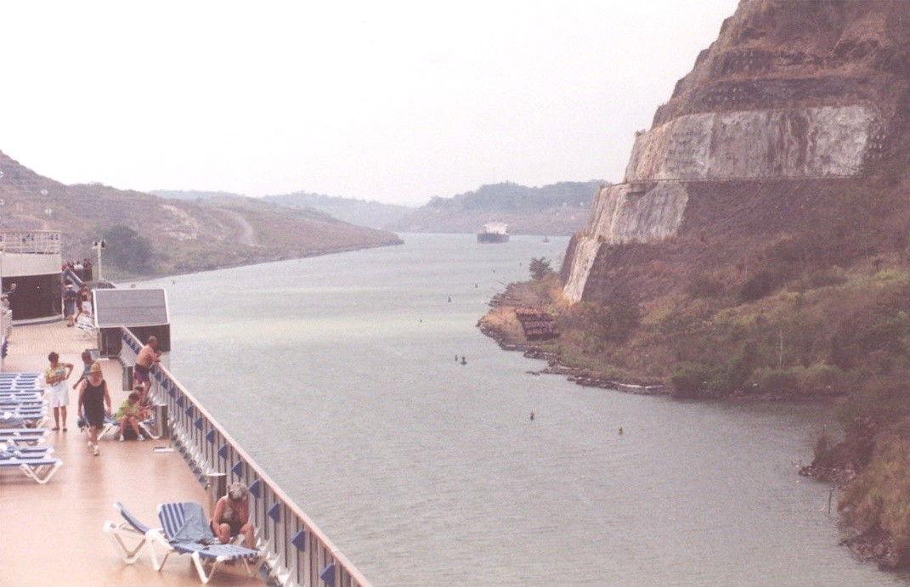

The channel widened and the Bridge of the Americas and the Ports Rodman and Balboa appeared in the distance.

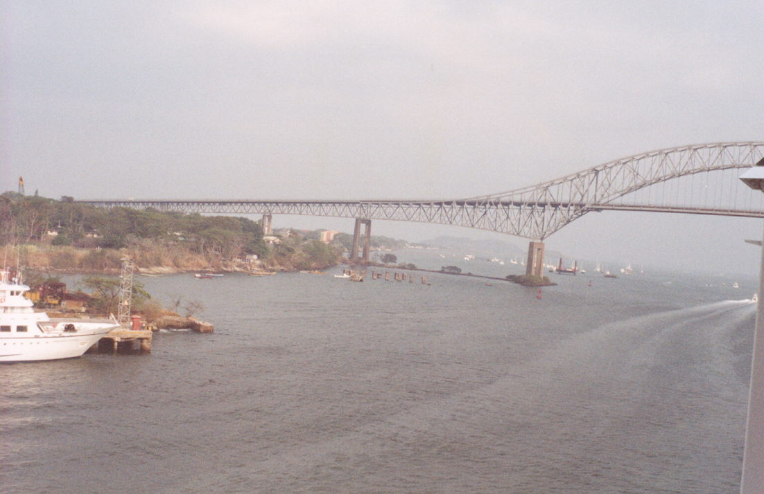

Frigatebirds and Laughing Gulls cruised the skies while several groups of Anhinga flew up stream. Several White Egrets looked like they were headed to a rookery. An Osprey sat on a power pole. About a hundred Brown Pelicans were floating or gliding in small groups.

We passed out into the Pacific Ocean passing the Amador Causeway to Naos Island. The lighthouse at the Port of Fort Amador disappeared in the evening haze. We were off to Coast Rica.

On April 6 we were off of Isla de Coba at N05º06’07” W82º26’13”. Three Brown Boobies played in the air currents around the ship and even landing on the bow gear. Before long there were ten Boobies. When they went after fish they flew straight into the water. There were occasional small two-winged flyingfish. Several large black dragonflies around the water slide on deck 10 aft. (They were probably hitchhikers from Panama. I found several dead in the trash next day.)

Near the Costa Rican border off Punta Libre in the Gulfo Dulce we passed a large pod of dolphins. Maybe fifty animals were chasing flyingfish that took off in all directions. Soon after we passed the dolphins we passed a large sea turtle.

The April 7 predawn sky turned pink then washed out to white. The sun did not appear for another two hours. Frigatebirds and Brown Pelicans cruised the skies announcing land nearby. Two white-rumped feral pigeons raced past the ship heading out to sea then turned back and beat us into port.

As we worked into the harbor and the dock there were more pigeons flying out over the water and Tropical Grackles flew along the beach. The port of Puntarenas was in the mouth of Golfo de Nicoya in Puntarena province and had been closed for about ten years.

The dock was a concrete structure probably 2500 feet long and 30 feet wide extending from the beach. It was the only thing on Doña beach until the Punta Caldera commercial port that was under construction several miles to the south. The dock could accommodate two ships and was wide enough for two lanes of bus traffic.

We had breakfast early and were in the Pharos Palace to meet our tour at 0730. I was taking one called “Skywalk in the Forest”. Carol signed up for the tour to Poas Volcano National Park with a lunch stop at Sarchi. We took water and cameras, our passports and the ship ID card.

Several websites describe this area of Costa Rica, http://tourism.co.cr, http://www.costaricamap.com, http://www.hotelpuntaleona.com. This last has a checklist of 330 birds on the resort grounds.

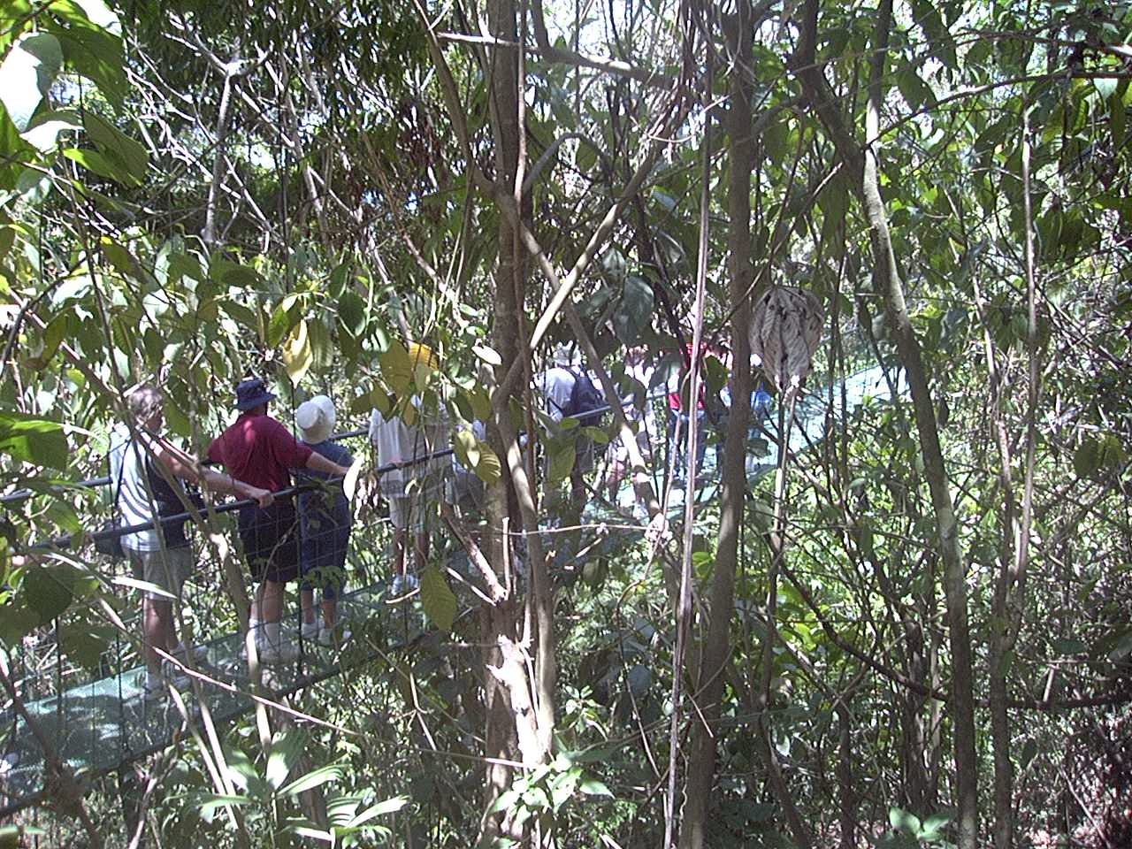

My tour went from Puntarena to along highway 17 to highway 23 along Playa Doña and the commercial port at the town of Caldera. There were several narrow railroad cars left from the time Costa Rica had a railroad.

Along the road were coconut trees, Tropical Almond, mango, citrus, papaya, tamarind, cashew, and banana. Flowering plants included yellow Esperanza, several colors of bougainvillea and hibiscus, red flamboyant and African tulip tree, and golden rain. There were several species of cactus, castor bean plants, kapok trees, huisache, and Honduran mahogany. Along the beach were coconut and almond trees and beach morning glory.

A couple miles further we crossed the bridge over the Tárcoles River. We stopped to look at the colony of American Crocodiles in the river above the bridge. One of the crocs looked maybe 15 feet long. The guide mentioned pollution as a problem with crocodile distribution and survival. There is an effort to reintroduce them to some rivers and a homing study to see if they are fixed on the hatching site and if they can find it after being moved.

Below the bridge a herd of Zebu cattle grazed and drank. Vegetated sandbars in the river supported white herons. Vaux Swifts flitted about and a kettle of Black Vultures was riding on a thermal.

Several vendors near the bridge had all manner of souvenirs from butterfly pictures to carved figures and T-shirts. The butterflies were caught wild instead of farmed.

Along this section of road were cecropia, wild banana and papaya, and a pink tree called locally Indian crown. Mistletoe, bromeliads, and ferns grew on branches of some of the larger trees. We passed a field of melons, some good pasture and several herds of cattle.

A few minutes further we turned on to a dirt road for a couple miles to the Villa Lapis resort. We stopped for a stretch, water and a pit stop then drove another mile to the Carara biological preserve.

This trip consisted of about an hour and a half easy hike through jungle and across 5 suspended bridges across ravines. This same trip on the ground could take a couple days depending on the weather. Our guide for about 30 hikers was a reformed stockbroker. He had a good general knowledge but was not a biologist. One problem was the group was strung out over maybe 50 meters of trail and since I brought up the rear I could not usually hear our leader. It was interesting but being near the end of the dry season and at mid day there was not bird or animal activity. I was fairly familiar with the vegetation but still saw some new plants such as Vanilla orchids and philodendrons, Balsa trees, and Elephant ear trees whose seedpods were shaped like a large brown ear.
We returned to the Villa Lapis for a vegetarian lunch and rehydration. There was tea and lemonade, two kinds of pineapple, two kinds of bananas, and papaya and mango slices. I tried one of their local beers – terrible.
While eating near the stream a couple iguanas were spotted in the trees. A gray basilisk or Jesus Christ lizard (Basiliscus sp.) with a big neck ruffle and walks on water went crashing through the vegetation.
After about 45 minutes we headed back to the ship. Costa Rica history and culture was discussed and the cost of real estate and living on the economy.
Three rivers empty into the bay near the port and a large fresh water marsh. There were White Egrets, Blue Heron, and a Rosette Spoonbill in the marsh edges and Vaux Swifts filled the air.
We were delivered back to the ship. I dropped binoculars and cameras and got a bite to eat then walked back to the beach. I walked about half a mile on the beach in both directions and found no shells. The beach was muddy sand with little drift marking the high tide lines. Leaving the beach to enter the stalls along the malecón I found a sand dollar and a half of a Reticulated Venus (Periglypta edmondsoni).
Carol’s trip to the Poas Volcano National Park with a lunch stop at Sarchi was programmed for eight hours. After riding for a couple hours the area was in fog and the caldron was not visible. There was a stop at the village of Sarchi where oxcarts and other items were carved and painted. There was a delay and her bus was the last to return to the ship.
Dinner in the Empire room was frog legs of prime rib. We sailed for Acapulco about sundown.

On 8 Apr the sun chose not to have a sunrise again. We were heading Northwest about 20K with a 20 K wind from the NE. We had passed Nicaragua and were off the Gulfo de Fonseca where Honduras and El Salvador come together. I saw some Pacific Shearwaters feeding and some green flashes in the dark swells, possibly tuna probably feeding on the same baitfish.
The sky was overcast and cool. We were out past the continental shelf but mountain peaks of El Salvador and Guatemala occasionally showed to the starboard. Two more sea turtles drifted by.
A dark cloudbank sat on the northern horizon like a Blue Norther was coming. During the night the wind picked up to 35-40K with 10-12 foot waves.

On the morning of 9 April winds were up to 65 and the weather decks were closed. We were in the Gulf of Tehuantepec back over the continental shelf. Around noon we the wind hit 82K blowing the top off 15 foot waves. About 1600 we were heading west off of Puerto Ángel out of the Gulf of Tehuantepec about 200 miles south of Acapulco.

About 0600 on 10 April we entered Acapulco Bay. No wind. Clear skies. Pelicans and Frigatebirds wheeling around. Buildings climbing the hills in all directions. The dock was across the street from the old fort that changed to a maritime academy and museum.

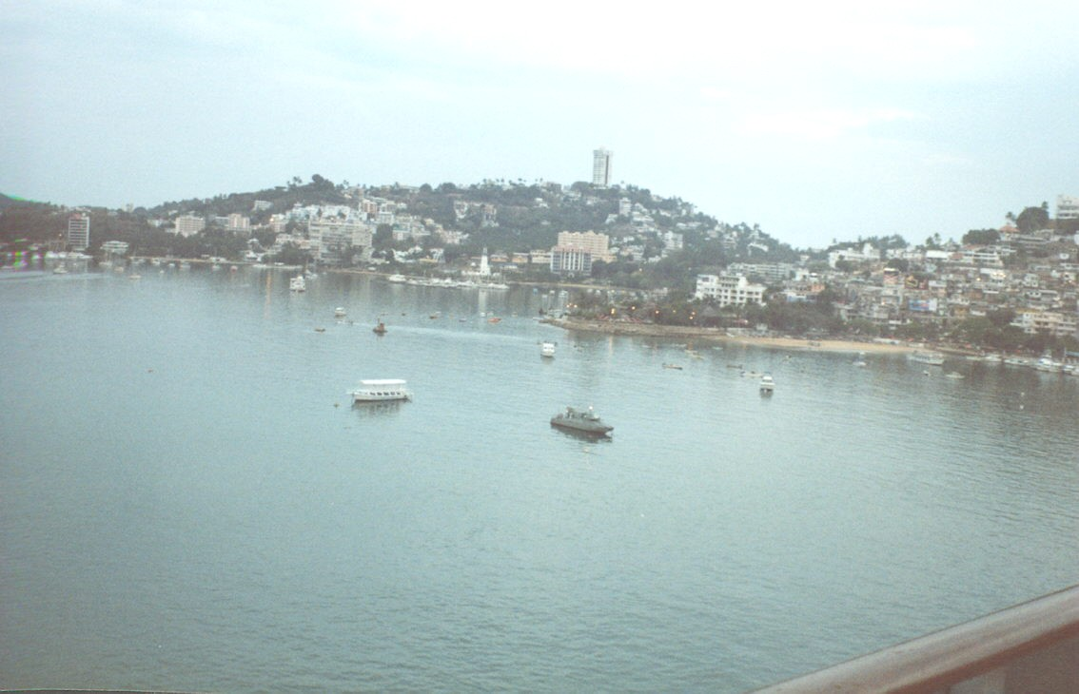

We signed up for a city tour that included the cliff divers and a side trip to Coyuca lagoon, a beach and resort maybe ten miles to the north. We met in the Pharos lounge and followed our leader off the ship and through the Mexican customs and visitor center.
We loaded up thirty to a bus and went to see the cliff divers. Cliff diving began about 50 years ago as some young fishermen trying to impress the girls. There is a relatively sheer cliff about 130 feet above the water into a narrow (20 foot) channel 12 feet deep with a sea cave at the end. Look at the Website http://community.webshots.com/album/1854551ZvJhESBAyk for pictures. The divers (las Clavidistas) wait until the waves are just right then they have to get out about 20 feet to miss the wall. My first impression was that this sure is dumb but like hotdoggers anywhere they make money doing something different and they do it safely. There is a shrine to the Virgin of Guadalupe at the top and divers go off several ledges as singles or groups depending on skill and seniority. An entrance fee is charged to maintain the diver’s retirement and medical insurance. The individual divers expect tips and sell autographed photographs. Only the senior diver draws a salary.
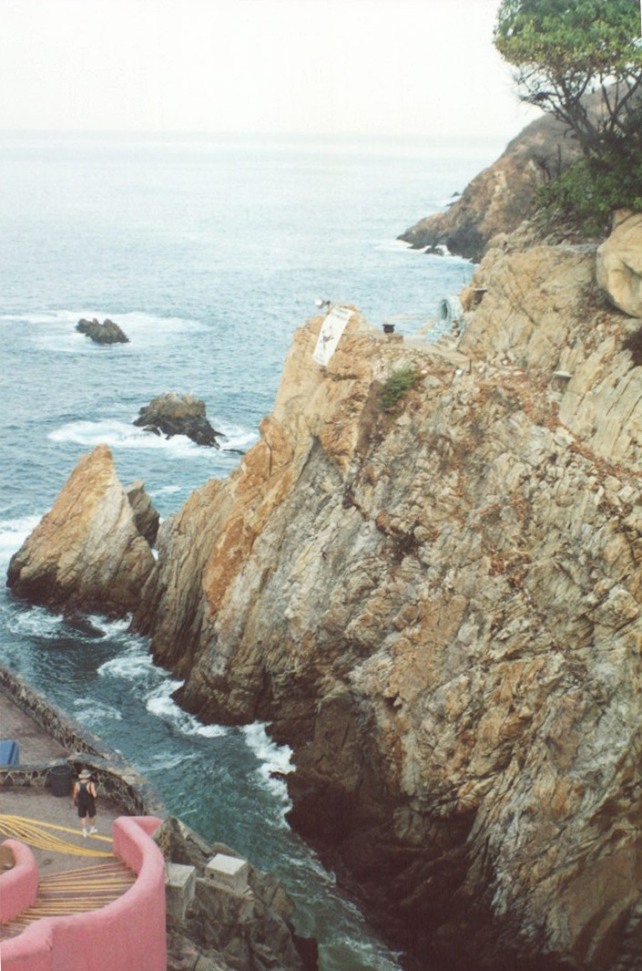
.
We loaded up and drove north along the Pie de la Cuesta, a sandy beach about 20 miles long out to the tip of a peninsula with the 28 square mile fresh water Coyuca lagoon inside.
Along the road was a Mexican Air Force Base. This was the set used for several Rambo and other similar movies.
Also along this road was a new squatter village on a barren section of public land. These are called parachutitas because the people seem to fall from the sky and develop a homestead. If they live on the land for five years it’s theirs.
A mile further north was a resort that went for $300 a night. Strange neighbors.
On the way back to town we stopped at a place for a coke and pit stop. It was on the lagoon side with rental boats and jet skis. I walked across the road through another restaurant to the beach. Nice tan sand along the Pie de la Cuesta. There was a steep forebeach with pounding surf. Nothing on the beach but the palapas. No flotsam. I looked along the seawall and found a limpet and half a Donax shell.
On the ride back there was discussion about the economy, real estate and construction cost, wages, etc. Our guide pointed out the homes or former homes of some of the movie stars.
Our next stop was the city market with several jewelry stores. I got the impression they should be paying us to take the tour.
We were back at the ship in time for lunch. We still had the afternoon and half the night so we went back ashore and took a taxi to the old market. We looked at several shops. The Mexican souvenirs change every year. We hit a shop with jewelry and found some opals with good prices. Since we can resist most everything but temptation we bought some. I also found several antiques from Colima and Jalisco about 1000 years old.
Dinner included Alaskan deer (Caribou) steak.
Every evening when we got back the beds were turned down with chocolates and a towel animal of some kind like dogs, swans, crabs. One afternoon there was a class showing how to make 16 different animals. This, like the napkin folding, was interesting but of marginal utility and promptly forgotten.

On 11 April we were supposed to sail about 0400. For whatever reason we left at 0700 for an over night run to Puerto Vallarta. A little after 0800 we passed a small pod of dolphin. About 1100 we were off San Francisco Bay and a flock of 30-40 brown boobies began to work around the ship and stayed until sunset.

It was 0700 on 12 April when we began working our way into the port area at Puerto Vallarta or PV. Frigate birds and pelicans were out in Bandaras Bay. Pacific grackles and Laughing gulls met us on the shore.
I signed up for the expert walking tour up into the foothills of the Sierra Madres Mountains. The scenery was good but none of the trail was above a class three. There were areas with loose pebbles. No one mentioned we might have to ford the Mascota River several times. The river rocks were smooth but I found I was tender footed barefooted.
We rode out six miles to the village of La Desembocada with the bikers and horseback riders passing the bullring and the airport on the way. Our hiking party was two guides, a Japanese couple and I. We were driven about a mile to the end of the road and began an up hill climb for about 30 minutes to the high point on the trail, about 2000 feet.
On the way up we saw a Tufted Flycatcher and Beecheys Jay. Some of the vegetation was familiar but I found some new ones - the ear tree, a viney Bougainvillea, organ pipe cactus probably a species of Pachycereus or Lemaireocereus, large bracket fungi, termite nests located in the tree tops to escape the ants, and a new mistletoe. There were Pacific madrone, gumbo-limbo or sunburned Indian trees, mahogany and some prickly pear cactus.
Both guides spoke fair English and had an interest in the environment. I asked the leader if he had had college. He said one year then he got married.
There were several overlooks where the valley showed between the trees. We could see much of the Mascota River including the horseback group.
We worked our way down to the valley floor and stopped at a hot spring that had been improved and converted into a spa. Banana trees and bougainvillea surrounded the spring. Rancho Sierra Madre had a grove of citrus trees and a number of banana and papaya trees. One large ear tree had a nest of the Altamira Oriole. A flock of Pacific parakeets flew in by twos twittering. A pileated flycatcher flew through.
We walked along the river until we came to a ford. This old tenderfoot need a little assistance to ford the stream bare footed but I did not look forward to sloshing along in wet shoes. About a mile along a road beside the stream we met a pickup, two guys on horseback, and a couple dozen head of cattle. The cattle made a run for the water and they and two cowboys walked up stream.
A Guatemala Ivorybill Woodpecker flew across the road into the woods. Several Mexican Caciques chased a Black-throated Magpie-Jay across the river. Several whiptail lizards darted along the road. A fence lizard sat blending into a tree trunk.
We reached a second ford. Down stream in a shallow area with willows stood several White Ibis and Great Egrets. Just about the time I got my shoes off again the truck came along, drove across the river and picked us up for the ride back to the starting place.
Back at the cantina I ordered two tacos and a Carta Blanca beer. I thought the Carta Blanca brewery had closed down years ago. Maybe just in Monterrey.
We were back to the ship just in time to catch my wife and take a “Gallery tour” but no one said anything about most of the galleries and museums being closed for siesta on Saturday afternoon.
We stopped at the north end of the Malecón and walked north and east to a small unimpressive gallery on Hidalgo then to the Galleria Indigena on Hidalgo and Corona with all of this year’s chic pottery, then west on Corona to a gallery on Morelas with a lot of good modern art, then to a restaurant overlooking the Malecón and the bay. We got a quick (Mexican quick) coke and I dashed over to the Huicotyl Indian shop and museum then back to the bus. We all decided to stop on the island in the Cuale River that is several blocks of shops and the closed natural history museum.

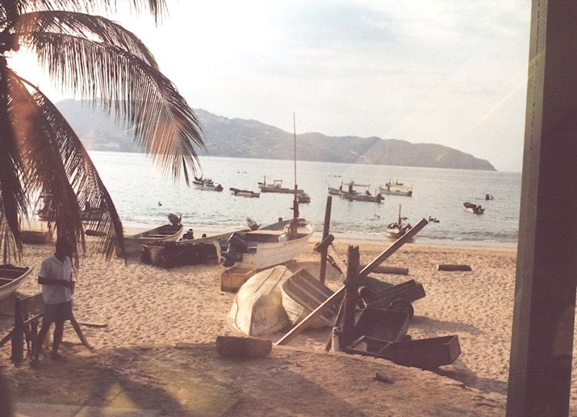

Lovers Arch is in the hillside north of the island. This was the bridge between the houses of Liz Taylor and Richard Burton during the shooting of Night of the Iguana.
After twenty minutes there we rounded up most of the group and headed to another gallery that was closed that just happened to be across the street from a high-end jewelry store. The store had some excellent amber. Then we stopped at Plaza Genovesa near the dock. This has a lot of shops and two big jewelry stores. We were back on board the ship in time for supper. This was another excursion they should have paid us to take.
We looked at the Sheraton Bougainvillea where we stayed before. The wing we were in was severely damaged. A hurricane in November 02 had roared in from the west with a high tide and 30-foot waves and had destroyed most of downtown and beachfront property including a public school.
I watched the undocking. The trees at the Maritime Terminal were filled with Pacific Grackles that sound different from our Texas grackles. A large concrete block where the bow lines were tied appeared to be the roost for several species of birds. They had settled in and were disturbed by the line handlers. A Socorro Storm Petrel, several Red-Footed Boobies and Pacific Shearwaters, a bunch of Brown Pelicans and some Black-legged Kittiwakes. The birds left as three men came out to cast off the bow line. The line was taken in as the men went to cast off the breast line. This line was taken in and between two tugs and the bow thrusters we moved away from the dock into the night. Some of the pelicans and Shearwaters returned to their roost.

About 0700 on Sunday, 13 April, we were approaching Mazatlan in Sinaloa state about 200 miles north of PV. We passed the lighthouse and old Mazatlan on the starboard. On the port we passed Isla de los Chivos, Isla de los Venados, and Isla de los Pajaros and into the channel passing Isla de la Piedra and docking at the cruise ship docks. An interactive map of Mazatlan is at http://www.maps-of-mexico.com/. We docked at N23º11’49.4” W165º24’38.7”.
A pair of pigeons flew out past the ship, turned around, and beat us to shore. Frigatebirds floated on thermals over the water and several Shearwaters played around the ship.

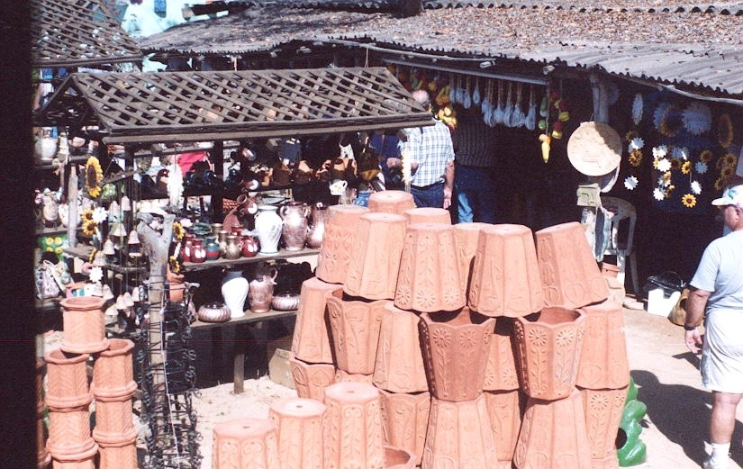

We booked a tour up Highway 40 (the Highway of Death) to the foothills of the Sierra Madres. First stop was an adobe brickyard. They produced both sun-dried adobe and kiln-fired bricks. They both begin the same with a mixture of clay, sand and organic such as rice hulls, hay, and manure. It is mixed by hand until just right then turned into molds set on a sanded surface to prevent sticking. The forms are removed and the bricks are dried over night. They are then moved to dry for another week. The bricks can then be used or stacked to form a kiln and baked. The clay quarries provide clay and hold water for making the bricks. When the clay quarries are worked out it is used as rice paddies. A worker can produce 1000 bricks a day earning about $10. These workers are part time alternating with farming work.
There are a number of adobe brickworks and several sand and gravel works in the riverbed and several cement block works to provide the material to keep Mazatlan growing.
We passed through groves of citrus and mangoes and truck gardens of tomatoes and peppers. These are harvested and shipped fresh by truck all over Mexico and the US.
Our next stop was a furniture factory and pottery. A machine shop cut the rough furniture pieces and these were then hand finished. Some of the chisels looked hand made. They used local mahogany, ear tree and raintree (amapa) wood. They sold the furniture by the truckload and also sold pottery made on site. A potter was demonstrating making pottery by the slab technique. Further down the road were several other similar shops.
I finally identified a dooryard tree that was bare with small green fruit. This was the local plum called ceredo.
We drove several more miles out into the foothills. The highway was narrow two-lane with no shoulders most of the way, no guardrails with a 35mph speed limit and lots of truck traffic. There are 20-30 fatalities and numerous accidents and there were about 150 crosses marking death sites. This was the only road connecting north central Mexico to the coast. They were building the start of a new toll road near Mazatlan but it will probably take years.
We passed through the village of Concordia strung along the road and spread over the hills. The school used satellite TV instead of full-time teachers and was apparently having success. We passed a church and other buildings mostly painted in bright colors.
A little further on the van turned off the highway to the old mining town of Copala. It began as a Spanish gold mining town in 1565. It was taken over by an American mining consortium but was literally destroyed by Pancho Villa as part of his cultural reform. The weather and picturesque cobblestone streets and old buildings have attracted Americans to settle here. There was a central square and church, a restaurant and hotel, several gift shops and the normal bakery, general store, etc. We had lunch of what I considered rather bland Mexican food with no tortillas until I asked for them. There salsa was mild and the chips were tough. I had a Carta Blanca beer.
Along the route I saw vultures, a Black-throat Magpie-Jay, a Tufted Flycatcher, and a Northern Mockingbird. The principle cactus was an organpipe cactus locally called cardone probably a species of either Pachycereus or Lemaireocereus. There were a few large prickly pears in tree form possibly Opuntia megacantha.
We stopped for a 25-minute shopping opportunity at Mazatlan’s Golden Zone. I skipped the jewelry stores in favor of seashell world. Shelling laws had changed and prices had really increased in the past few years. They had no large shells and no coral.
Back at the ship we had supper and I came up to deck ten to watch the ship leaving port. Several Vaux Swifts played around the ship. A Sinaloa Crow flew over also watching the operation. Several Black-legged Kittiwakes and pelicans were working the harbor.

The 14th of April was another quality sea day. It’s only about a hundred miles to Cabo San Lucas so we turned north up the Sea of Cortez or Gulf of California for about a hundred miles to near Isla San José then circled back almost to Mazatlan before heading directly west. They may have been hoping to see whales but it was a little late in the season. About 0800 I saw an American Egret headed north but several miles off shore. There are no islands in the area and no freshwater for many miles. Later in the day two Frigatebirds were cruising to the west. About 1600 we passed a large sea turtle.
I stopped at the pizza bar for lunch and asked for jalapeno and anchovies and was told they only had cheese or pepperoni or calzone.
This was formal night but again I did not see the captain. I guess the captains of smaller ships eat with the passengers.

On the 15th of April we dropped anchor in the harbor of Cabo San Lucas N22º53’03.3” W109º59’58.8”. The trip to shore was by lighter or water taxi that carried about 40 people a trip. Frigatebirds rode the thermals. Laughing Gulls and pelicans accompanied the fishing boats and lounged on the dock.
Our tour was the coastal highlight tour. Our guide pointed out the major hotels and eateries including a bagel shop. The first 20-minute stop was at one of two glassblowers in town. It was interesting to watch them work and surprising how little time it took to make a piece. They had a large variety of products for sale. House Sparrows and pigeons were at home in the courtyard.
The next stop after passing a couple golf courses was at a condo resort on Playa Médano with a nice vista of the harbor and Barco Verado. We drove another 15 miles past more golf courses and resort complexes and a botanical display with Elephant trees and organ pipe cactus and an herbal shrub called Damiana (Turnera aphrodisiaca) that is a cure-all tonic like Ginseng. There were a couple iguana lizards on one of the big cactus. There was also a Gila Woodpecker.
We passed more resorts along Bahia Santa Maria and Bahia Chiléna and Punta Palmillas on to San Jose del Cabo and the Playa Costa Azul on Bahia San Jose del Cabo. We passed another golf course in town on the way to the mission and town square. Another 20 minutes to shop and back to Cabo San Lucas for more shopping. You can find interesting maps like the interactive http://www.cabobob.com/00BajaHwy/mapframes.htm, and http://www.loscabosguide.com/maps/maps.htm
Meanwhile back at the ship another liner had dropped anchor and another was holding offshore. We took the lighter back in time for lunch while they pulled the hook in mid afternoon. Another 40 hours at sea and we would be in San Diego.

I saw a dark cloud on the north horizon that looked like an old Blue Norther. A couple hours later the wind came up and we spent 16 April rocking and rolling.

We packed up and had the bags ready for pickup by midnight. We arrived on 17 April about 0700 to sunny skies that disappeared by 1000 with showers. After breakfast we checked the room once more, got our carry on bags, got in line for customs and began waiting for our color section to debark. We were next to last to go about 1100.
The last steps were to go into the terminal, find our bags and head for home.

Comments.
I was highly aggravated in not getting to see engineering or at least talk to some of the engineering staff.
I was disappointed that we did not get ashore in Cartegena as advertised. We were not advised of the change until we were on board. A $25 per person rebate does not make up for the loss. This was probably the port tax and not compensation for our lost port call.
Anyone taking a cruise should be aware of the total cost. The advertised price was $1399 each. Then there were $279 port charges each and a tax of $279 each plus cruise insurance of $128 each totaling $2085 each or $4170 per couple plus expenses.
Then there is transportation to and from home to the ports. San Antonio to Miami was $356 each and San Diego to San Antonio was $146 each totaling about $1004 but I had enough frequent flyer miles to cover the tickets.
An extra day on each end contingency time had a cost for hotel, local transportation and meals of $150 each day or another $300.
There was a $10 charge each in Miami for the bus to the port. Add a %15 tip for the crew, the tours and miscellaneous expenses like $1.50 for a coke plus tip, etc that totaled about $1800.
This totaled about at almost $3600 per person for a $1399 cruise special. The planning cost appears to be the cruise price multiplied by 2.6.
I forgot to mention a travel glitch. The package was purchased from American Express who listed it as a 16-night cruise leaving on 1 April. Carnival listed it as a 17-day cruise. This led to confusion in scheduling the airline reservation and resulted in a ten-minute call from the ship at $7.00 a minute to the airline to change the flight time. The change could have resulted in a fee of $35 each for changing reservations but did not. Since the next available flight was on the 18th we had to spend a night in San Diego.
The term 17-day cruise itself was misleading. We spent most of day 1 getting on the ship and situated and not sailing until sundown. Day 17 ended at sunup and took until noon to get off. The 16-night terminology is more accurate.
I reached the conclusion that I am not a cruise person. Cruise activities were mostly gambling, drinking, eating, art auctions, and a hairy leg contest in the pool. The ship did not announce weather, flocks of birds, sea mammals, or other things of interest to me. I don’t mind sea time if the goal is worth it but not days at sea for a few hours shore time. Having been temporarily assigned to two aircraft carriers and a destroyer escort I have had plenty of “quality sea time.” If it had not been for bird watching and reading the trip could have been a real drag.

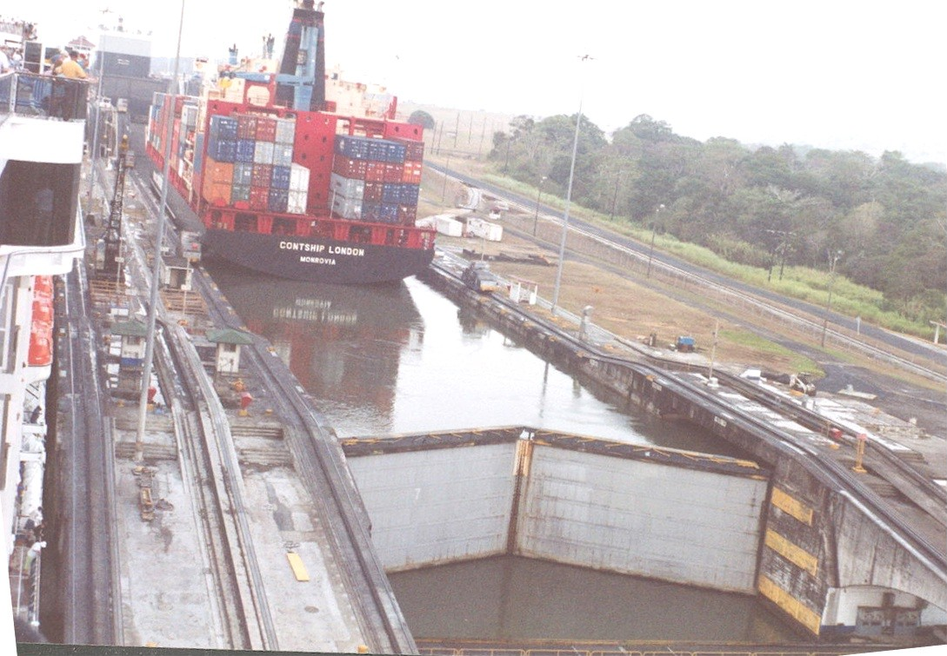

The trip was interesting but
I have had enough “quality sea time” for a while.

