First Orbital Flight
Feb 20, 1962
More than just zipping around the world
View from a Recovery Ship

Carl Lahser

First Orbital Flight
Feb 20, 1962
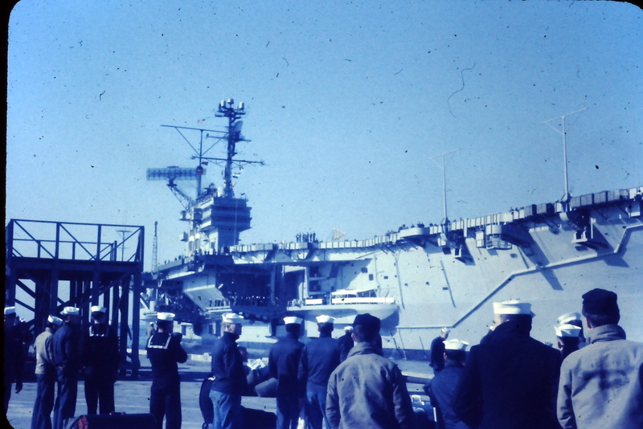
Boarding the USS Forestall
There are not many days fifty years ago of which I specifically remember details but waiting for John Glenn’s first orbital flight on 20 February, 1962, was one. Fifty year old slides help. The flight was more than just zipping around the world. Here is my view from a recovery ship.

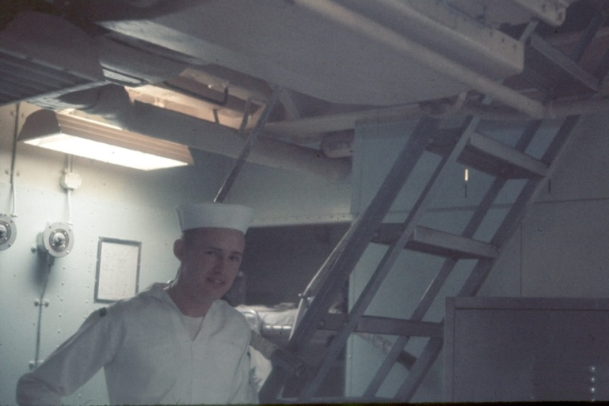
We were deployed on board the aircraft carrier USS Forestall (CVA) in early January 1962 for a six-week cruise. I was in an aviation electronics recon squadron (VAW33) stationed at Quonset Point Naval Air Station as an aviation electronics technician second class and electronic countermeasures (ECM) aircrewman and general
Home for six weeks flunky. Our primary job was to
locate and track Cuban mobile sites missile. We had three AD5-Q (ECM version of the AD5 Spad) commonly called Queer Spads for the “Q” and the ECM capability. These were the passenger hauling version of the AD or Sky Raider. A plane would leave Guantanamo and fly south towards Jamaica then turn around and head for the Cuban coast. A few miles off the coast the Cuban controlled Russian fire control radar would lock on and we would plot their location and return to Guantanamo.

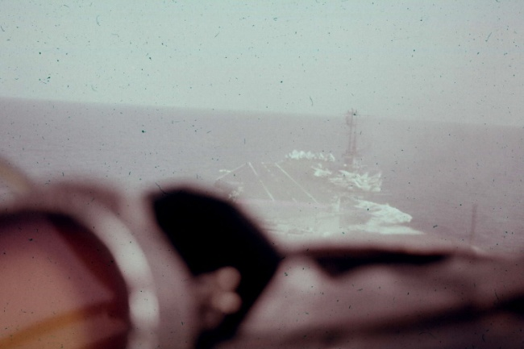
We had finished our six week deployment and had stopped in Port Au Prince, Haiti, on the way back to Norfolk, Virginia. The carrier group (Forestall and several destroyers) diverted north into the Bahamas Islands to serve as the recovery team for initial launch and first orbit recovery sites for the Mercury space, Ready for landing capsule, Friendship 7, piloted
by Col John Glenn on the first US orbital flight. There were two other carrier groups further down range covering the second and third orbit recovery areas. Each group was responsible for over a thousand square miles.
On the 18th of February a Marine helicopter arrived from the aircraft carrier, USS Constellation. carrying a frogman team (they were called frogmen or underwater demolition teams (UDT) long before they became SEALS) and a dummy space capsule they had carried from Cape Canaveral.
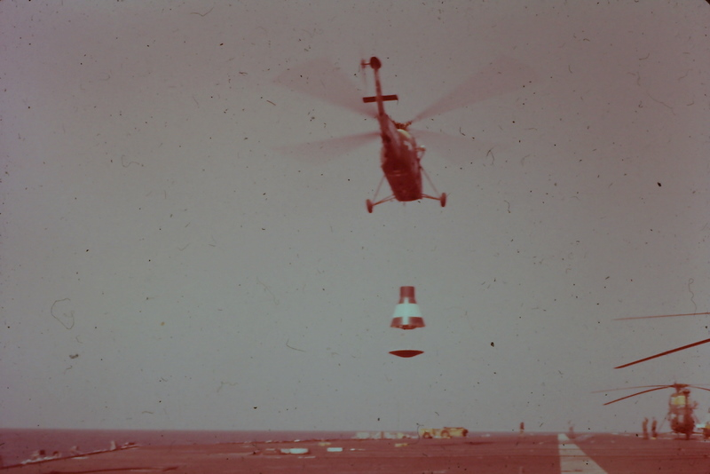
Delivering the dummy space capsule and frogmen
Next morning the capsule was flown out and dropped off so we could practice location and recovery. Several things were learned. First, the was that the helicopter that tried to pick the capsule out of the water could not break the suction of the flat heat shield bottom of the capsule in the water.

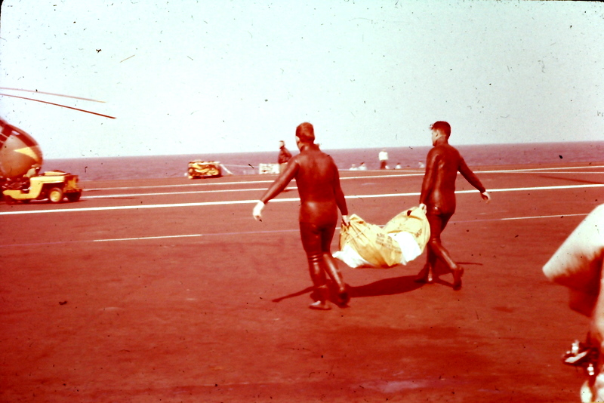
Another option, Operation Catcher’s Mitt, was also a failure. This was hanging a cargo net from the starboard airplane elevator with the free end attached to a crane. The idea was to come along side the capsule, scoop it up in the net, and lift it onto the deck. It did not work for several reasons. We picked up the capsule and waited
Loading the flotation collar for the real thing.
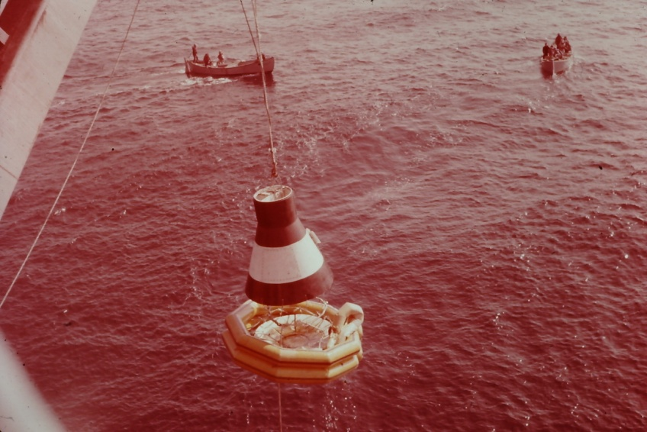
Early on February 20 most of the ship’s crew was on the flight deck waiting for the launch back at Cape Canaveral. We were disappointed since it was overcast and the launch was not visible.
Since the initial launch was successful the ship hit
full speed heading for the first orbit splash down site. We had about 90 minutes to race about 30 miles and get set up.
Colonel Glenn and his Picking up the dummy capsule capsule completed the full
three orbits. He and the capsule were recovered a couple hours later by the Navy Destroyer, Noa, 21 minutes after splashdown.
Just another boring day at sea. We set course to Norfolk and home.

Carl 20 Feb 2012

