Shore Leave
Haiti, 1962

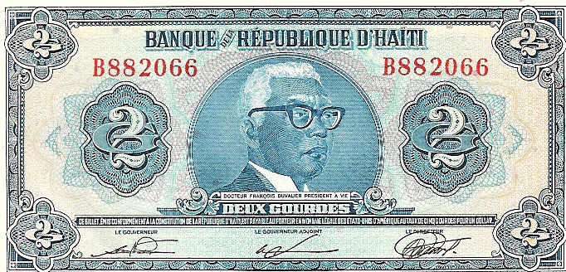

By

Carl Lahser

Shore Leave in Haiti, 1962

Carl Lahser

We were heading for R&R in Port au Prince, Haiti. The word came over the 1MC public address system. We would have port and starboard liberty in four hour shifts beginning at 0900. Class A uniforms for enlisted and civilian clothing for the officers.
This was February, 1962. We had finished a six-week tour at Guantanamo Bay, Cuba, flying everyday to track Castro's mobile missile launchers. We would fly down to Jamaica, get down on the deck and make a run at Santiago de Cuba or some other town or military installation so that they would turn on any radar they had. We would ID it and mark its location. It was not hard for find the fire control radars because they locked on to almost anything that flew by. Whup. Whup. BZZZZZZ. That high pitch scream got annoying after a while.
Anyway, I was in the first landing party and our CO had given permission to stay the whole eight hours. We were anchored off Isla de la Gonaves about ten miles from Port au Prince so the liberty boat took a good twenty minutes to reach fleet landing. It was an invigorating ride across a flat sea through the clear, sunny morning air.

Fleet landing was the commercial dock where cruise ships usually docked. A number of cabs with drivers that spoke English to some degree vied with each other to take us on a tour. Several of us settled on a driver that had lived in New York who promised a "liberal" tour.
We got the ride down Harry S. Truman Blvd past Papa Doc's Pink House modeled on our White House. Truman was Papa Doc's hero for some reason. The street, paid for by US taxpayers, was eight lanes wide with almost no traffic. The Pink House was showing signs of mildew and neglect common in the tropics.

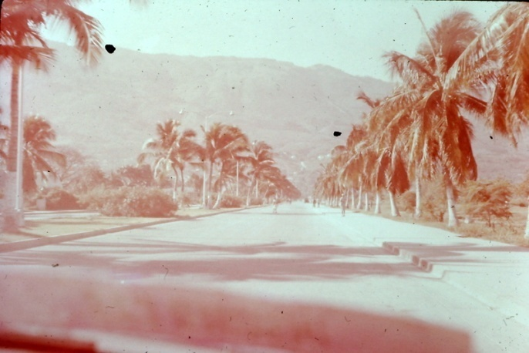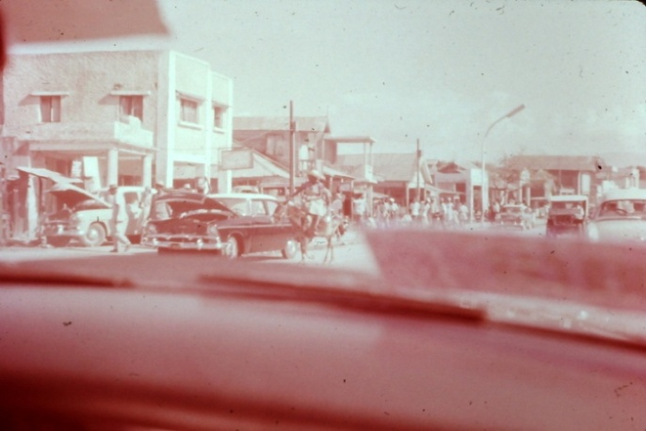
South Harry S. Truman Blvd Central Harry S. Truman Blvd

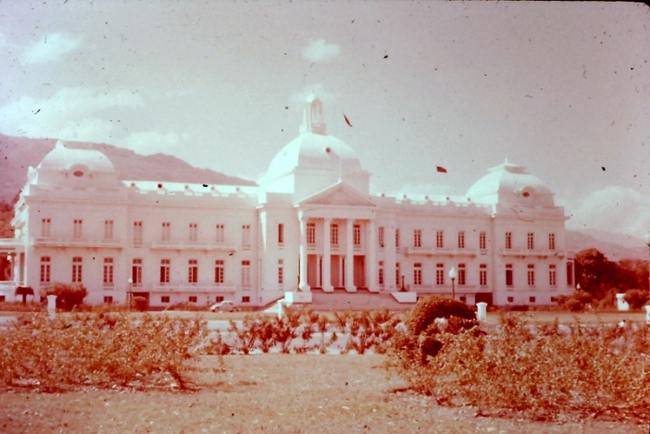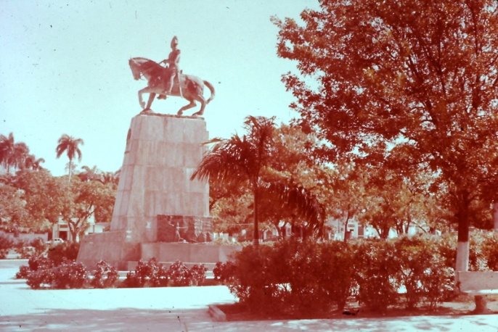
Pink House (Capitol) King Christophe Statue

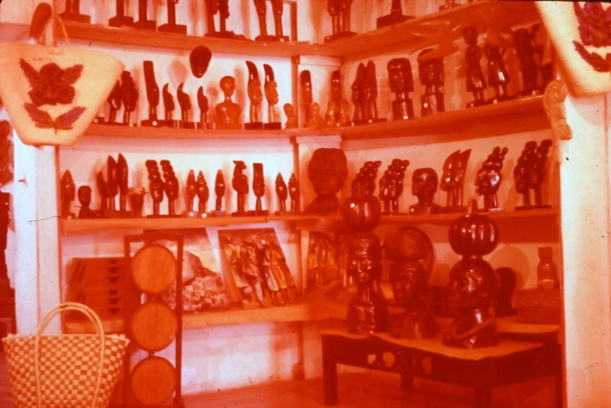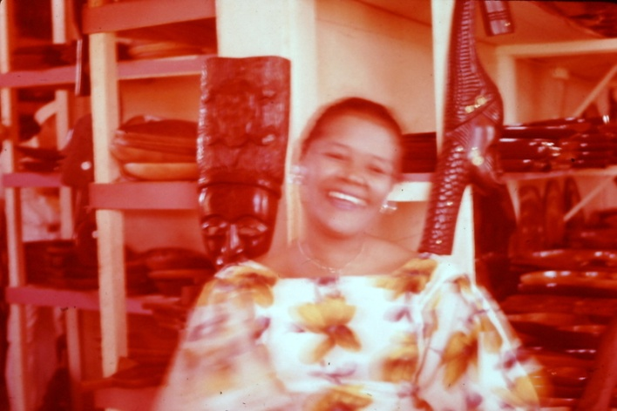

Souvenir Shop Shop Girl

We got the scenic tour up the hills and down embassy row. A twenty-acre estate complete with staff rented for $200 a month US. Booze was cheap, gas was high and milk unavailable. We stopped at a brandy distillery where I tried several thimbles full and got a buzz. Hibiscus brandy was the best.

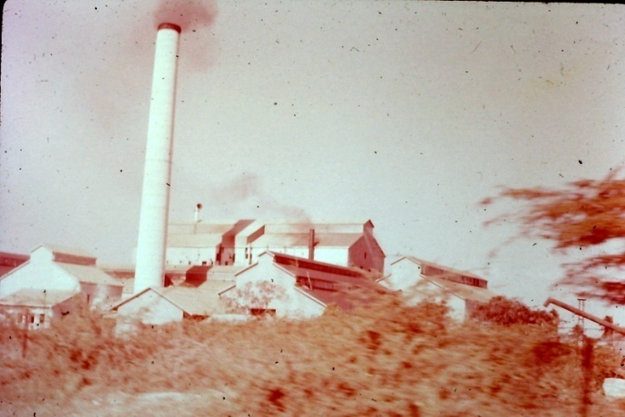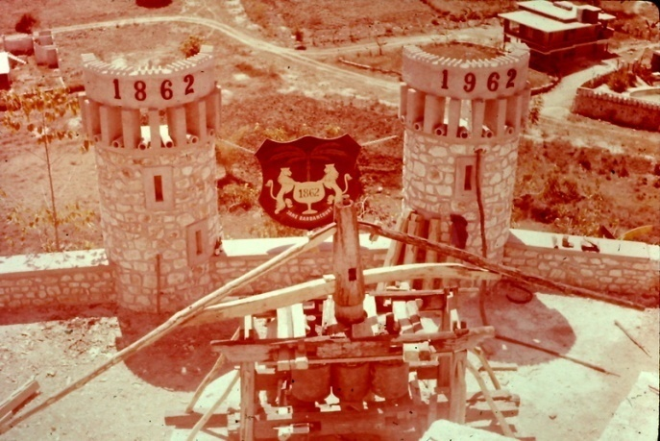
Sugar Refinery Brandy Distillery

Two men had a pair of fighting cocks and for a dollar you could shoot pictures of the cocks getting it on.

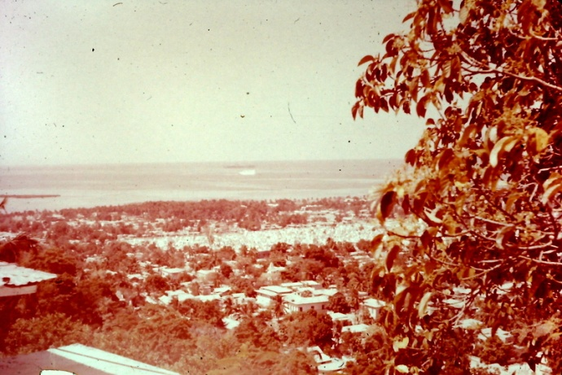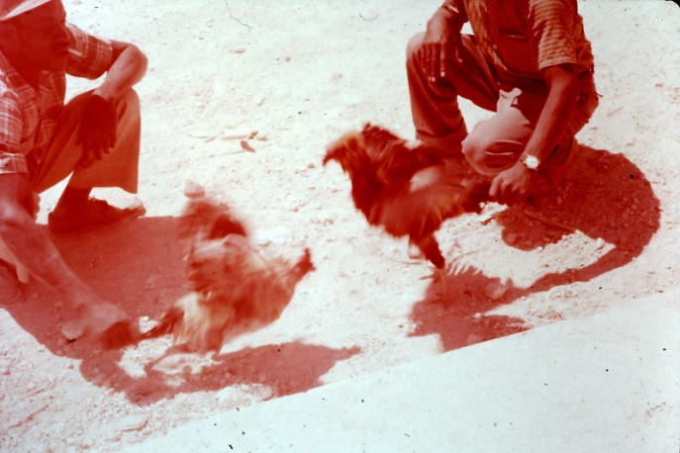
Port au Prince Fighting Cocks

We went to the Hotel Cap Haitian for lunch and a voodoo show. The hotel was high above the city and offered a fantastic view of the harbor. The lunch cost about two dollars and the hokey voodoo show cost eight.
It was getting late in the afternoon and, as we headed back towards the harbor, our liberal driver said he was going to show us something we were not supposed to see. He had no use for Papa Doc and his secret police. We took off our hats and hunched down as we took a tour of the barrio. People living in filth with no sanitation or protection from the sun or rain. Kids that did not cry from hunger and depression. No fuel or clean water. Our driver said he could get in trouble for taking us through there but he thought we should know all was not as we were shown in the morning's trip.
We left quickly and said nothing the rest of the way to the fleet landing. The trip cost ten dollars split three ways but we each gave him five.
I guess the last part of the trip was a shock to the senses because I did not remember it for several years. Papa Doc and Baby Doc are gone and we just invaded Haiti again. Pictures on the news show that things have not improved in the last thirty years. The light colored upper class and foreigners still own 97 percent of everything. The poor are even poorer if that is possible.
Carl Lahser
09 Sep 94

