Iceland Deployment 1960

I was manning the ECM in a radar Constellation (Navy WV-2 or Air Force RC-121 Warningstar) out over the North Atlantic. We were monitoring the fishing fleet and commercial sea traffic while looking for the stray Russian radar signatures. Everything was normal until the entire North Atlantic UHF radar crazy. Jammed.

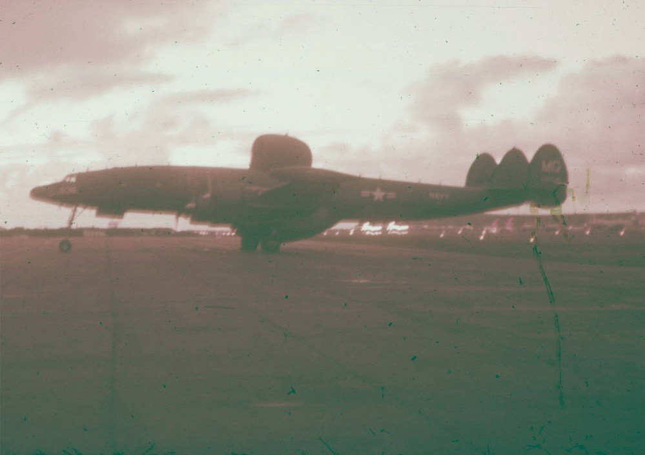
WV2 Warningstar/ RC-121

On this very day in September 1960 the BMEWS (Ballistic Missile Early Warning System) at Site 1 at Thule, Greenland, became operational.
With BMEWS operational our patrols were no longer needed. We flew standby for a couple of weeks. Then the powers that be decided we should deploy to Iceland. Apparently they had discovered some holes in the BMEWS coverage north of Iceland and we were to fly a couple racetrack configurations to plug these holes.
Newfoundland was hot and dry with scattered brush fires in September so a change of scenery sounded like fun. Aircrewmen went with the aircraft. As liberty went at night one club looked pretty much like another and if we got off in the daylight hours there was a whole new country to see. Being just south of the Arctic Circle Iceland was never completely dark.
Half the squadron’s planes and crews flew to Keflavik Air Station and moved into the boxy new barracks the Air Force had recently vacated. The personnel were to be rotated every two weeks.
Keflavik Air Base is located on the Keflavik International Airport. This is on the Reykjanes peninsula on the extreme south-west corner of Iceland. It is about 60 miles west of Reykjavik, the capitol of Iceland and about 15 miles from Grindavík where the Blue Lagoon (Bláa Lónið) spa is located.
By the way, they drive on the wrong side of the road!
There was no Status of Forces agreement with any outsiders so Icelanders had access to most of the base including prominent Icelandic police presence on the base. The local police had authority to come into the barracks and the military clubs. They kept watch on the cars and anyone coming from the club and approaching a vehicle was assumed to be driving drunk.
There were also tales of the 18-50 Club where any pregnant Icelandic female could name any male who had been on the island for paternity – 50 bucks a month until the kid reached 18. Iceland had a reputation of having an extremely high rate of Chlamydia and other sexually transmitted diseases.

There were also rumors that no blacks were allowed on the island and one of our crew who was Cherokee was sent back to Newfoundland. There was a rumor that the Admiral had brought his black steward and had caused a minor international incident.
The base has been operated over the years by US, British, Danes and a threat from Germany in 1942 and was finally closed on 8 Sept 2008. Planes stationed there included P-38 Lightning, P-51Mustang, British Lancasters, our radar Constellations, P2V Neptunes, F-89 Scorpions, and F-4 Phantoms.
This part of Iceland was relatively flat with rocky volcanic soil. Vegetation included about 400 species of mostly Holarctic plants such as reed grasses, cotton grass, dandelion, and invasives like bluegrass. There were numerous lichens (Reindeer Moss) and other primitive plants. The winters are mild for the latitude because of the proximity of the Gulf Stream.
The general climate is called maritime temperate. While we were there the in early fall days were clear and warm and long. I even got a touch of sunburn. The heat was on in the barracks all the time since the heating system was circulating water and the water source was a thermal well.
There was a fishing village near the base with a small fishing fleet and processing facility. When the wind came from the southeast the smell of drying fish commanded your attention. The catch was principally cod for drying with an occasional whale for meat and oil.

Near the end of our deployment my crew took a field trip to Reykjavik. This was different in that the enlisted were required to were civvies but the officers had to wear their uniform. A Navy bus took us the sixty miles through the volcanic plains and low hills covered with dry grass. We saw a herd of small shaggy horses grazing amongst the grey volcanic boulders. There were a couple small flocks of sheep with long wool ready for the coming winter. The weather was overcast in the 50’s, cool enough for light jackets.
The population of Reykjavik was less than 100,000 but this amounted to 60% of the island population.
Reykjavik the capitol and a seaport located on the south side of Faxaflói Bay in SW Iceland. Mount Esja was visible in the distance.
We visited the Althingishủs or parliament. This is the home of the oldest democracy in the world. Founded in 930 it was moved to Reykjavik in 1881.
We drove around the marsh fed Tjőrnin or town lake. This is home for about 50 species of birds.
The city was not particularly impressive with a lot of apartment buildings but the infrastructure was with almost every building having its own hot spring for heat and hot water. This has changed with new centralized cogeneration heating plants.
There were greenhouses heated by hot springs growing fruits and vegetables. A lot of the soil was naturally warmed enough to grow potatoes and, in 1925, the first green houses were built. There was about 100,000 sq m under glass which has now increased to almost 200<000 sq m. Crops included vegetables and ornamental plants like roses and even bananas
We also passed the Culture House (now called the Museum House). At the time this was the city museum but has since expanded to include many exhibits and references.

We stopped for lunch in mid afternoon prior to returning home. I din’t remember the menu except for the dessert. This was the national dish called skyr. It is similar to strained yogurt. It is made from raw milk fermented with Staph. salivarious. It is strained and served with sugar. Good stuff.
Back at Keflavik we packed up and returned to Newfoundland. Iceland looked like an interesting place to vacation but looking at today’s prices it would be expensive.

