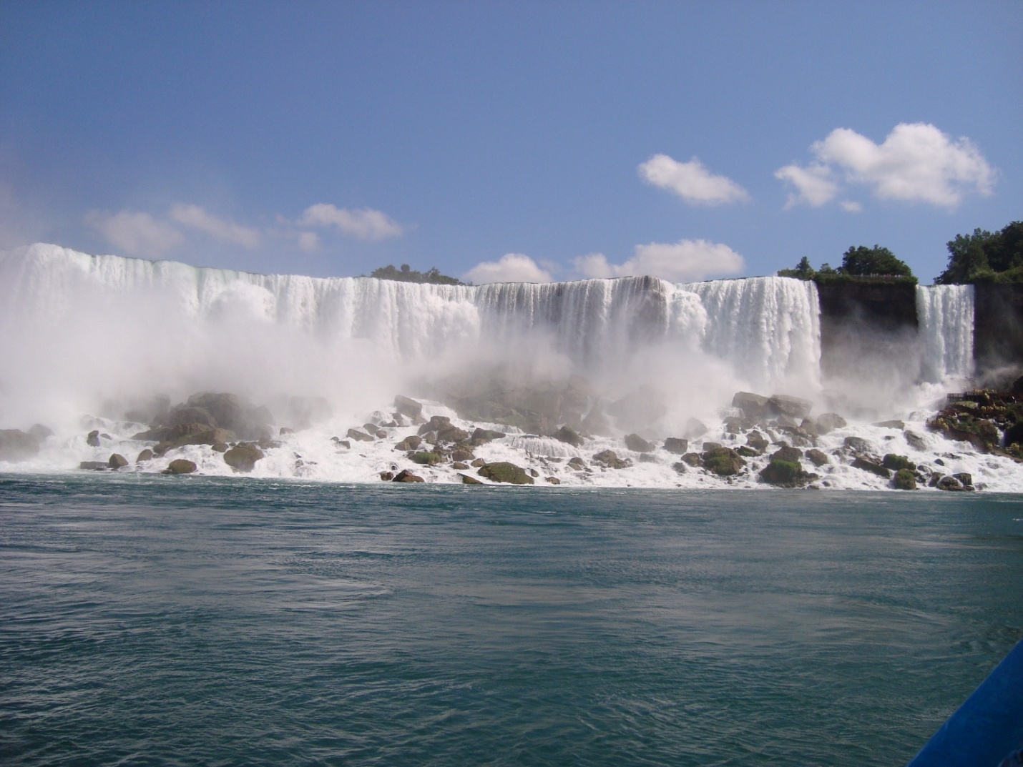
Niagara Falls and Toronto
24 Aug – 3 Sep 2009

Niagara Falls and Toronto
24 Aug – 3 Sep 2009
My wife was looking for a short vacation. One of her friends suggested Niagara Falls staying at Niagara-on-the-Lake and then a few days in Toronto. I had driven through Buffalo NY in 1962 but had not seen Niagara Falls and had been to Montreal but not Toronto so why not.

For a bit of background. The Great Lakes and Niagara Falls began with glacial activity several million years back as a tropical sea with coral probably when the tectonic plate was south of the equator. Successive cycles of wet and dry deposited thick layers of salt beneath Lakes Huron and Michigan and parts of Lake Superior. This area became an inland lake archeologist call Lake Iroquois. Over several million years in this big depression a thick layer of limestone was deposited on top of the salt which was then covered with a highly resistant layer of dolomitic limestone. A 100,000 years ago a mile-thick ice sheet gouged out the individual lakes. About 12,500 years back the ice began to retreat and the melt water filled the lakes. The water level increased as the ice sheet melted and soon the lakes were connected drowning out some of the lowlands between the individual lakes. Lake Eire finally filled and began discharging water through the Niagara River over an escarpment that has become Niagara Falls. The Great Lakes water level has dropped and recovered several times during the past 8,000 years. Niagara Falls flow has been reduced to a trickle. An erosion process called heading had moved Niagara Falls about six miles upstream. Current erosion rates range from less than an inch to as much as three feet a year so that in maybe 20,000 years Niagara Falls will disappear, Lake Eire will drain and become a river, and the Great Lakes will become a sea level water course.
Currently the Great Lakes contain about 20% of the world’s fresh water. Niagara Falls consists of three falls: American Falls between Prospect Point and Luna Island; Bridal Veil Falls (the smallest) between Luna Island and Goat Island; and Canadian/Horseshoe Falls between Goat Island and Table Rock.
In 2009, 28 million visitors were expected. Peak visitors has been 72,000 per day generating approaching $3 billion spent per year.

Monday. Delta Airlines took off at 0710 for Atlanta. The flight was smooth over scattered clouds.
One of the passengers was a little unusual. He had a cat on a leash. He put on his back pack and put the cat on top of it. He rode without a pet carrier but the cat was very well behaved.
We arrived in Atlanta and took off a little late for Buffalo. The weather was clear.
The Appalachian Mountains run NE/SW and there were linier clouds that looked like con trails over the valleys. North of these mountains were a zillion small cotton ball clouds all the way to Buffalo.
We landed a little after lunch and picked up our rental car at Enterprise. Carol had made the reservation with Enterprise and I suggested she look at Expedia. She got the car for 30% less. Enterprise up graded us to a Tiburon. This was a nice two door without much trunk space. However, the back seat folded down. It ran well but I had a gripe about bumping my head getting into the car and difficulty finding the seat belt over my shoulder.
We had instructions on getting to Niagara Fall but we got lost several times and drove 140 miles to cover the 20 to the bridge. We set the GPS for our destination in Canada but it refused to find anything north of the border so we had turned it off. Once across the border we saw signs for our destination – Niagara-on-the-Lake. Coming back to the US we cheated the system and turned the GPS on as we crossed the bridge. We had no trouble finding the Buffalo airport.
We drove through Niagara Fall, Ontario, and had our first view of the falls. Impressive. Road signs lead us towards Niagara-on-the-Lake and I stopped at the first fruit stand to ask directions to the particular address. An old French lady said she did not know and waved us on along the road.
After wandering around town and crossing the same streets several times I finally found a man with a map who pointed out the location. Our bed and breakfast was in the NW corner of town near the entrance to the Welland Canal. Lots of history in this area.
The B&B was an old house with three bedrooms for rent. It would become an inn if there were more than three. The gardens needed tending but our room was comfortable and the food was good. The B&B was run by a couple from Ireland. The breakfasts were large and good.
Our bed and breakfast was in the NW corner of town near the entrance to the Welland Canal. Lots of history in this area. The first canal was opened in 1829 partially to divert water to a grist mill near Port Colborne on Lake Erie. Later modifications straightened and deepened the canal and moved the first lock to St. Catharine on Lake Ontario. There are eight locks that change water level 326.5 ft. The canal is 26 miles and takes an average of 11 hours for passage. Shortly after the canal was opened lampreys enter Lake Erie. Numerous other exotic organisms have passed through the locks invading the Great Lakes.

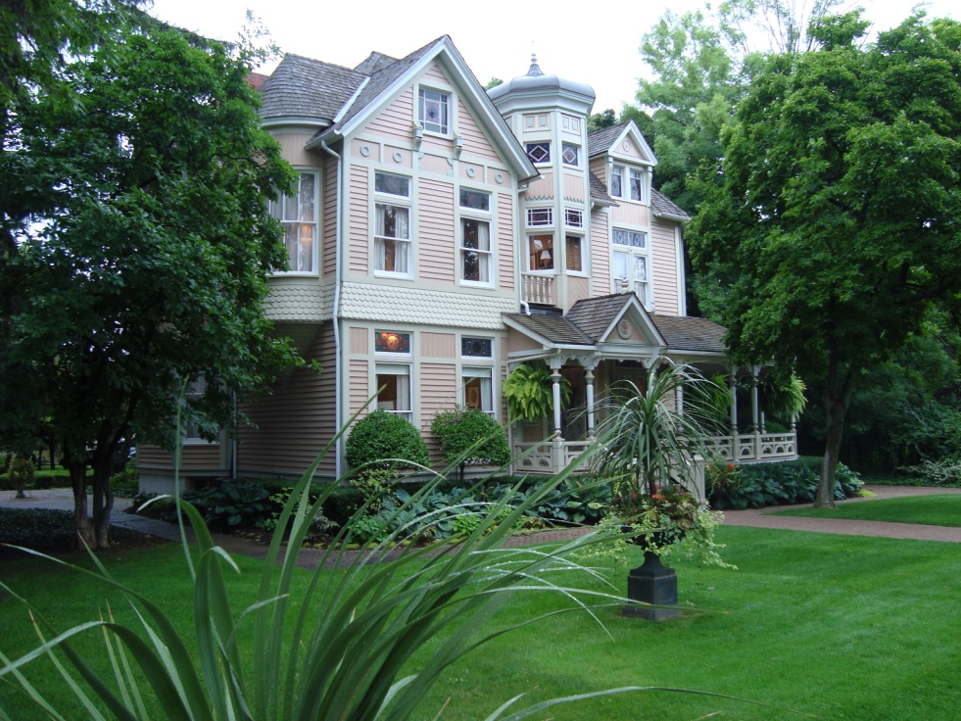
B&B

Tuesday. Carol had made reservation for a tour on the computer. The tour included double-decker bus transportation, the Journey Behind the Falls at Table Rock Visitors Center, a tram ride over Whirlpool Rapids, and the Maid of the Mist boat ride. We parked in a municipal lot a mile from the tour for $15 for the day. The Niagara Falls area has been the most tourist developed of any of the major parks.
The bus was an old English double-decked bus. The tour company had bought 20 of them for local tours. The bus made a run up river a couple of miles explaining the sights such as the Old Scow sunk above the Falls and tales about going over the Falls.
First time I rode a double-decker bus was in England. We had landed at Mildenhall RAFB and were riding into London. I had a seat topside in the front row. It was a strange sensation to go into a roundabout backwards since they drove on the left side of the road.
The bus turned around and stopped at Table Rock Center for the Journey Behind the Falls. Table Rock visitor center has had a $32 million renovation with parking, food and souvenirs with a 360° theatre called Niagara’s Fury and Journey Behind the Falls. An elevator dropped 151 ft to 600 feet of tunnels and an outside balcony and two short tunnels that had viewing areas. The trip comes with a plastic poncho.

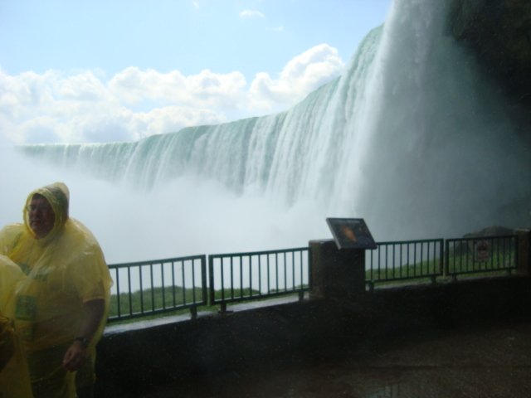

Behind the Falls

While waiting for the bus I watched people. I don’t think I had ever seen such a crowd as the people walking along the river.
Table Rock Center was well landscaped considering the cool moist conditions. I saw a couple Herring Gulls (Larus argentalus) cruising over the parking lots, some Bronzed Grackles (Quiscalus versicolor) running under parked cars, and House Sparrows (Passer domesticus) in the shrubbery.
The next stop was at the Whirlpool Aero Car. The Niagara River canyon makes a near right angle turn resulting in a turbulent situation that produces large short-term whirlpools. There is no such thing as a permanent whirlpool.

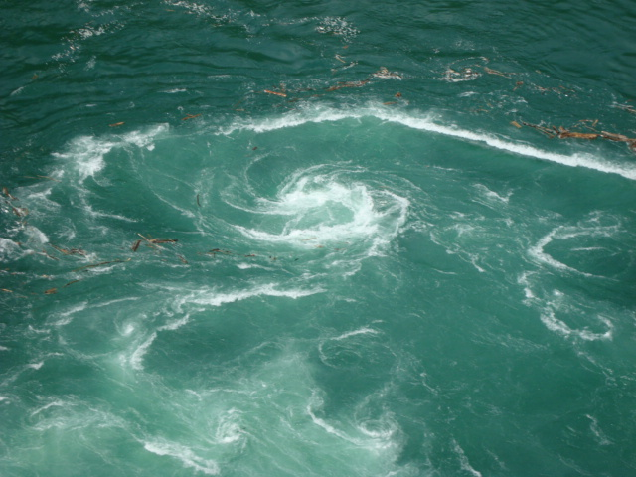
Whirlpool

A 3600-foot cable car ride, built in 1916, crosses the corner over the whirlpools and back. Very large and deep whirlpools occur that are spectacular. There was also a jet boat ride that came up river and into some of the whirlpools.
The bus proceeded down river passing the Niagara Parks Botanical Gardens, the longest golf course in Canada, the School of Horticulture with the Butterfly Conservatory, and a brief stop at the 40 foot floral clock. The clock’s 2000+ plants are replanted twice a year.
The tour concluded at the foot of Clifton Hill. We walked to the place where the Maid of the Mists was loading. We walked down the switchbacks in the cliff side about 150 feet to the dock. The two ferry boats take about 200 people each for a fifteen minute ride past American Falls, Bridal Veil Falls, and near Horseshoe Falls. The ride was cold and wet so everyone was issued a plastic poncho. The ride provides some remarkable close up views of the three Falls. The ride has operated since 1846.

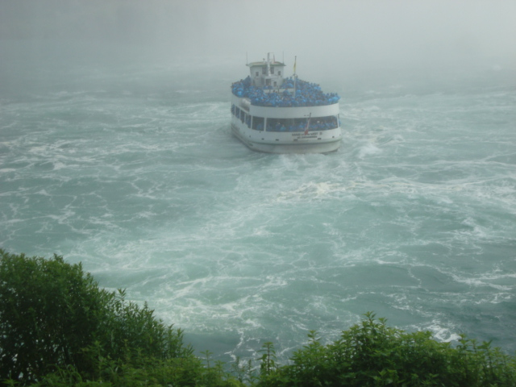
Maid of the Mist

Back in downtown Niagara-on-the-Lake we stopped for supper and found our way home in the misty dusk.
Pickup trucks stripped of their doors and beds used to harvest fruit were heading home. Prime picking season had passed but there was still plenty of fruit to harvest.
There was no sunset as such. It just got darker.

Wednesday. It was misting so we went down town to see the six art galleries. One was a photo gallery. One was crafts. The other four were interesting local artists. Carol bought a giclée (computer print on canvas) and a fancy jacket in one of the boutiques. I bought an ice cream cone for $3.50.
After it stopped drizzling we went out to Fort George. This Revolutionary Era fort had been built in 1796 across the river from Fort Niagara. During the War of 1812 the fort was destroyed in May of 1813 and finally abandoned in 1820. The Fort has been restored to pre-1813 appearance and opened as the Fort George National Historic Site in 1950. The officer quarters were nice but the enlisted lived in much more Spartan conditions. Enlisted families lived in a corner of the barracks separated by sheet walls.

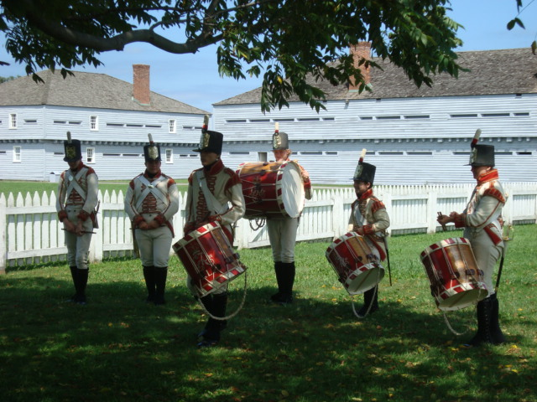
Ft. George

We left in late afternoon to find our way to the 525 foot tall Skylon Tower for supper in their revolving restaurant. The view of the Falls from the tower was excellent. They had a special dinner menu for $30 that included the elevator ride. Their prime rib was pretty good.

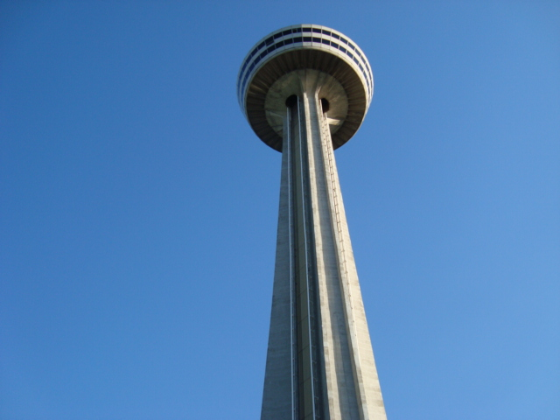
525 foot tall Skylon Tower
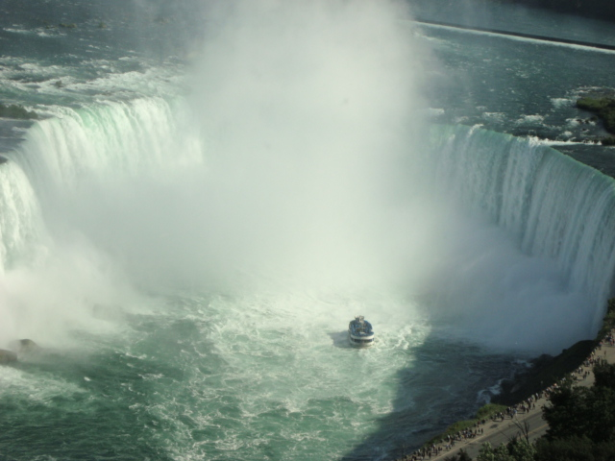
Falls from above

After supper, we looked at the two First Nation Seneca casinos. A white multistory modern sugary-style facility, the Casino Niagara, was situated alongside many of the area's hotels. The other, Niagara Fallsview Casino Resort, was a multistory building that was part of big entertainment complex, the Fallsview Tourist Area, that had been one of the biggest commercial construction projects in the Province.

Thursday. I was out in the backyard before breakfast. A female Ruby-throated Hummingbird (Archilochus colubris) was feeding and a pair of black poll warblers (Dendroica striata) was in the trees. A small flock of Canadian Geese (Branta Canadensis) was flying north towards the lake.
After breakfast we started out to see the botanical center. We stopped at an art museum along the way. It was the retirement home built by a famous local lawyer who had himself buried in the front yard. The museum had a big collection of early pioneer and Indian art, paintings of Niagara Falls, and early Canadian bronzes.
The Niagara Parks Botanical Gardens and School of Horticulture was about 30 acres including the gardens, landscaping school, student dormitories and the Butterfly Conservatory. There was no entry fee to the garden but the butterfly conservancy was $15 each. We toured the butterfly house. As we were leaving there was an announcement that a butterfly had escaped through the airlock into the gift shop. That is one of the dangers of displaying exotics – thy might get out and get established possibly messing up the local ecology.
We started on the garden walk when Carol spotted a horse drawn carriage ride that cruised through the park. The carriage driver gave us a guided tour of most of the park without the walking.
The horticulture school was a highly regarded training center for landscapers. They take 20 students a year for a three year course. Cost is about $5,000 for Canadians and $15,000 for foreigners including room. The students do the work in the gardens and each has a multiyear research project.
We left about 2PM to go to a winery for a tour. The winery was one of about 70 in the area. It had been in business for about 30 years. The winery covered over 200 acres. This winery grafted all its own vines on native root stock and was unusual since it did not buy or sell grape juice from anyone else. The vines were raised on wires rather than V posts or T posts. There were several windmills at $10,000 each to protect the vines against early cold snaps and a series of gas canons were used to keep the birds away. The rows were mulched with leas and plastic mulch and pesticides were not used. Rose bushes were used at the ends of the rows as an indicator of pests, nutrition and soil condition.
Next we went underground 30 feet to the pressing room. The grapes were crushed and trash was removed. Depending on the type of wine to be made the skins were removed immediately for white wine, left for a few days for blushes, or left in the juice for about three weeks for red wines to add appropriate color. The juice is then pressed and the juice held for several months for fermentation.
The wine is then bottled. The guide did not mention killing the yeast and sterilizing the wine to stop fermentation in the bottle.
I asked about sparkling wines. (Sparkling wines are not killed and have a little sugar added to continue a little fermentation for bubbles. Too much sugar makes too much gas that can break the bottles or cause most of the wine to escape on opening.) The guide was not clear on this.
We tasted several wines. Nothing great. The guide told about making ice wine where the grapes are allowed to freeze, picked at night in freezing weather and are crushed frozen before fermenting. The process is much more expensive in labor, equipment, and processing and makes an expensive sweet desert wine that was selling for $70 a quarter liter (about 8 oz). No sampling.
The guide said their Pinot Noir was excellent. I asked she had heard of the geriatric wine called Peenomore. Yankee humor.
The winery was setting up for a wedding. I noticed one lady with and electric iron pressing the table cloths after they had been put on the tables.
We had supper at the Charles Inn. Food and service was good but the price was high.

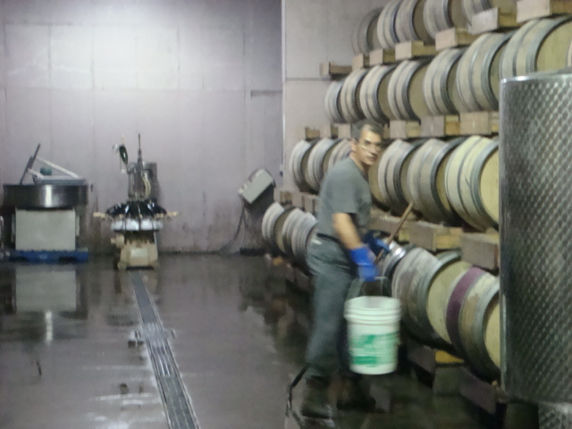
Winery Barrel Room

Friday. We packed up and loaded the car to return to Buffalo airport to catch the bus to Toronto. Breakfast was full of discussion of Toronto and what to see. We were served potato scones and sausages and scrambled eggs with a spicy sauce that tasted much like A-1.
We got the driving instructions and entered the US across the Rainbow Bridge to avoid the heavy morning traffic. Once across the bridge and out of Indian Territory we set up the GPS that worked fine in the US. We were to the airport in less than an hour.
We turned in the car and caught the bus. We had to go into Buffalo to buy tickets. We left for the two-hour ride to Toronto about 1330.
It took almost an hour to go through customs in a really ratty immigration and customs office.
The roadside was green with grapes on the fences and stands of Queen Anne’s Lace and Goldenrod. Wet spots were filled with Arundo and invasive Phragmites. Biodiversity at this time of the year was limited.
We passed one area along the lake where several kite surfers were doing their best to ride minimal waves. The sky was cloudy with a temperature of 18°C (65°F).
About an hour later we hit rush-hour traffic entering first Hamilton and then Toronto. We got off at Union Station about ten blocks from our hotel. A ten dollar cab ride took us the rest of the way.
After we unpacked we had supper in the hotel restaurant – their pre-theatre special.
The room was a suite with living room, bedroom, dressing room and a separate tub and shower. There were two large flat screen TVs and a small refrigerator.

Saturday. We left the hotel about ten and went to a big mall, the Eaton Center, for a little shopping and breakfast.
About noon we took the subway to visit Casa Loma. This was the home built by Sir Henry Mill Pellatt a prominent banker and military man. He hired architect E. J. Lennox to help him built his dream of a medieval castle overlooking Toronto. Construction began in 1911 and took three years costing $3,500,000. The Pellatts lived there about ten years before they went bankrupt. The city took over the castle and rented it to the Kiwanis Club who restored and operated the facility since 1937. The castle is furnished and has beautifully landscaped grounds.

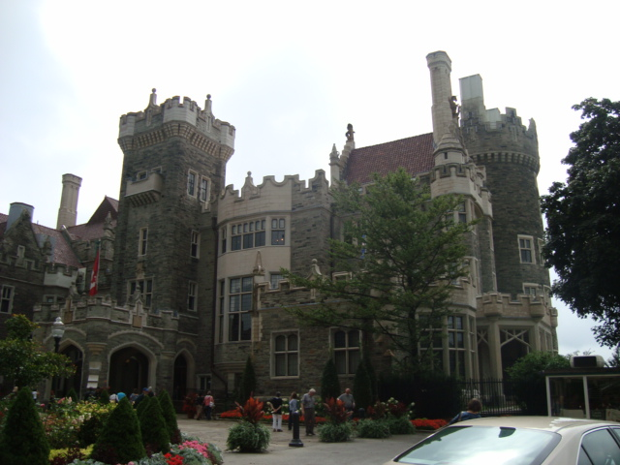
Casa Loma

Back at the Eaton Center we had supper at the Baton Rouge which was not a Cajun restaurant. I had lobster ravioli which was very good and a Guinness. Carol had a steak.

Sunday. We decided to get a ticket for the double-decker bus. The ticket was $30 each and good for a week. It was a sightseeing bus that you get on or off at their stops. It had two routes so we took one route complete and then took the other route to the Scotiabank Busker Fest for Epilepsy. This was about four blocks of vendors selling everything and singers, jugglers, and other entertainers. Interesting afternoon.
A bagpiper was playing on the corner where we waited for the bus. Interesting to watch but it sounded so good when he quit.
We stopped in an English pub for supper. I had Sheppard’s Pie and an IPA. Carol had fish and chips. This was a town of pubs with one on practically every corner.

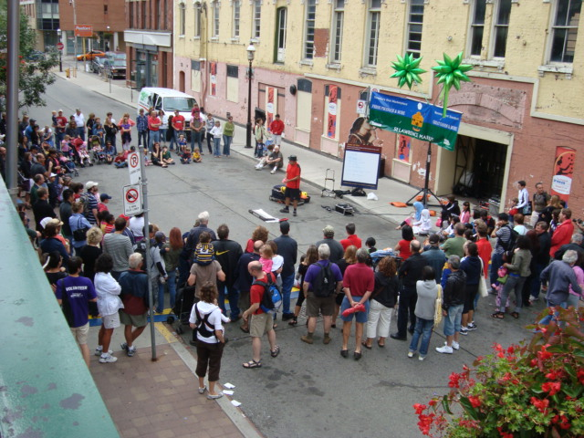
Street Fair

Monday. After breakfast we took the double-decker bus to the waterfront. The waterfront from Front St south was built over the old waterfront and railroad yards from fill dredged from the harbor. This area is covered with office buildings and condos.
According to advertising the harbor area was full of craft shops and art galleries. Truth is there were one gallery and an Inuit museum and a group of crafters making glass and metal works and a lot of million dollar condos overlooking the harbor. The galleries and the Inuit museum were closed since Monday is an international down day for galleries. The craft area consisted of several shops separated from visitors who were restricted to a glass-lined hallway where visitors could see crafts people at work.
We went on a harbor boat ride. The ride cruised the waterfront before crossing to the islands to the three islands – Ward’s, Algonquin, and Centre. There are permanent residents but no cars on the islands. The local ferry from Toronto brings over a few commercial vehicles for their deliveries. We passed Hanley Point the first full-time family lived and made a stop on Centre Island that was developed as a park. We returned along the eastern waterfront to the dock.
Water fowl of the islands included, Canadian Geese (Branta Canadensis), Mute Swans (Cygnus olor), Anhinga (Anhinga anhinga), and the Eastern Belted Kingfisher (Megaceryle alcyon alcyon).
There was fountain with bronze salmon leaping up stream.
We headed back to the hotel. I noted large metal recycling containers near the corners that had separate slots for recyclable, paper and trash. In the airport in Buffalo there were compactor recycling containers for plastics and newspapers. Toronto also charges a nickel fee for plastic bags.

Tuesday. Today was museum day. We caught the subway to the Royal Ontario Museum near Queens’s Park. The north side of the building along Bloor St was a modern façade the Michael Lee-Chin’s Crystal building.
The first level was the museum store, learning center, lecture rooms and lunch room.
On lever 2 the natural history displays. The mineral collection was outstanding. There were birds, dinosaurs, mammals, a bat cave, marine life, and several discovery collections.
Level 3 was cultural collections with a good mix of areas and displays.
Level 4 contained costumes and textile exhibits and the Institute of Contemporary Culture.
Level 5 was a restaurant that was also open evenings.
We took the subway to the Art Gallery of Ontario. This is a modern museum of mostly Ontario art collection such as Thompson collections of ship models, Canadian art and photography and the Henry Moor sculpture collection. Carol decided not to see this.
We did go to the museum store. They had books, prints, statuary, and masks. The Indian artifacts were Inuit, Seneca, Algonquin but no western tribes. I checked their prices.
We headed for the CN tower for supper. The ride up the 1500 foot tower took about two minutes. The revolving restaurant took 72 minutes per revolution. The CN stands for the Canadian National Railroad that built the tower. The view was nice but not as interesting as from the tower in Niagara. To the southwest were the cities of Mississauga, Burlington, and Hamilton. To the east was Oshawa. The southern lake shore was visible on the horizon.
Supper was good and the service was as good as you could want. Taxi, supper and tip came to $140.

Wednesday. We took the bus to the CN tower to finish up our tour ticket. We did not get to the zoo or the Children’s Museum since they were both outside of town to the east. We also did not get into the 70 miles of tunnels connecting the downtown area. Like many northern cities the tunnels and sky walks allow a near normal life year around.
The tower elevator had a glass window so you can see the ground as the elevator does its thing. There was also a large glass plate in the floor so you could walk out over space. Many people refused to go near it.

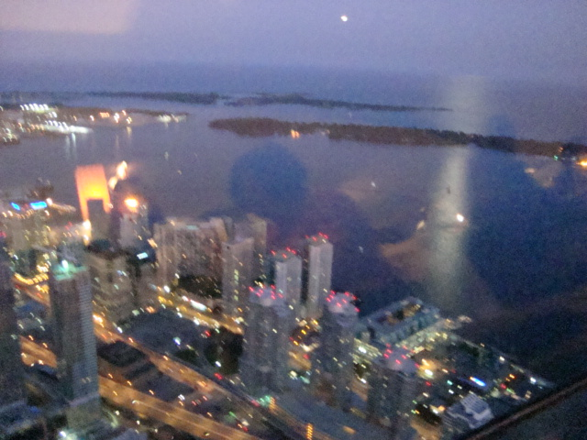

We went to the Bata Shoe Museum housed in a museum shaped like a shoebox. I was surprised at the extent of the historical displays of shoes from around the world. The collection of North American Indian footwear was particularly interesting.

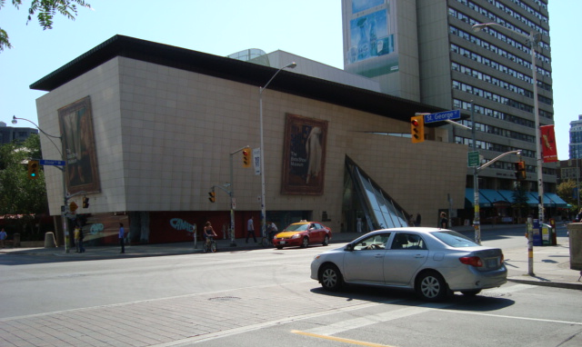
Bata Shoe Museum

Back at the hotel we decided to go out for Thai for supper. Very good. I had a cup of lychee liquor for desert.

Thursday. We packed up and left for the bus station and were on our way to the airport about 1100. Customs took about an hour again through a ratty facility with major construction underway.
We were on our way and were home in San Antonio by10 PM.

After thoughts. The weather for this trip was enjoyable. 70’s in the day time and 50’s at night. Could hardly be better.
The city of Niagara was crowded and rather impersonal dealing with strangers. The falls were impressive.
Niagara-on-the-Lake was pretty and clean and felt more like visiting in-laws. Wine, apples, cherries, and history a plenty.
Toronto was a vanilla city. There were a lot of people working hard but the city struck me as not very exciting.

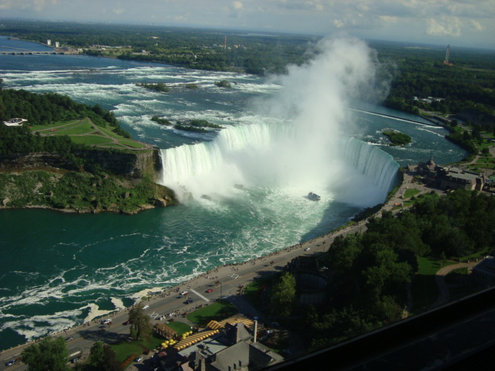
Niagra Falls

