HEY MOMMA,
WHEN WE GOIN’ AGAIN?

by

Carl Lahser

Mexico City and Puerto Vallarta
in December 1995

Copyright © 2004 by Carl Lahser. All rights reserved. If you must copy any part of this work please give the author appropriate credit.

Published by: Pretense Press
6102 Royal Breeze
San Antonio, TX 78239
(210) 657-5139
clahser@satx.rr.com
Other books by the author:

Europe Return to Assinara Bay – Italy
Cross-section through a Rainbow – Corfu, Athens, and Rhodes
Greek Poems
Three Weeks in Berlin
Dickens Christmas - Three Weeks in London
Canada Backdoor to the Yukon
Do Bears do it in the Woods - Winnipeg
Enterprise II – Calgary, Edmonton, Athabasca Enterprise North
Vancouver – Vancouver, Victoria, Inland Passage
Where Have All the Pretty Colored Houses Gone - Newfoundland
China China Tour China Sings
Hong Kong 1979
Mexico Cabo San Lucas
Cabo San Lucas 2
Flowers of the Air
Hey Momma, When we Goin Again
Mata Ortiz
Mr. Cuul in Yucatan
San Miguel
Searching for the Phantom Crown
USA Bigfooting Around – Washington state
Galveston
New York Christmas – Hudson Valley and NYC
October was a Busy MonthMinneapolis and the Shennadoah Valley
Santa Fe Getaway
Shelling Trip
Poems Cryptic Romance
Ecoview 1 - Not Your Usual Neighborhood
Ecoview 2 - Texas
Ecoview 3 - D.C.
Ecoview 4 - St Louis to Minneapolis
Ecoview 5 – Southwest
Ecoview 6 - Green Things
Snapshots of the North
Summers End
Texas to Alaska Traffic Games
Tyndall Beach
Walk on a Different Beach
Weather watching

Other Travel Panama Cruise
Under the Southern Cross (Under Clouds) – Machu Pichu and the Amazon
Other Alamo Road – Mom’s Story
BASH – Bird/Aircraft Strike Hazard
Butterflies and Birdwatching - PIF Bird Meeting
Forty Years of Fishing – Professional History
Green Stuff Articles from the SCION
Hip 3 – Hip Replacement
San Antonio Wildflowers by the Month
Teacher, Leaves Don’t Change Color – Growing up in the Valley
Thinking of Flying – Military history
Printed in USA.

HEY MOMMA,
WHEN WE GOIN’ AGAIN?

Fore play.
We had been putting off visiting Mexico City for several years. The opportunity finally came for a couple days in Mexico City on the way to Puerto Vallarta.
“Getting there is half the fun” is usually true for me. Planning and research time was set aside to find what can be seen prior to the visit to Mexico City and Puerto Vallarta in December 1995. After visit research both identifies and explains more about what was seen and often uncovers things missed on site. I never seem to have enough time to get ready, but it usually falls together at the proper time.
I reviewed guidebooks for Mexico including Fodor’s Mexico, Frommer’s Puerto Vallarta, Manzanillo and Guadalajara, and an old copy of Frommer’s Mexico and Guatemala on $15 and $20 a Day formed a basis for the trip. Berler’s The Conquest of Mexico which is a modern review of Prescott’s History of the Conquest of Mexico and The Political Economy of Mexico by Glade and Anderson gave some insight into the history and development of that country.
For natural history, I looked at Bailey’s Manual of Cultivated Plants and Hortus Second and Flowering Plants and Ferns of Arizona by Kearny and Peebles, A Field Guide to Pacific Coast Shells, A Field Guide to Western Birds, and Butterflies of the Western US by Oppler.
For health and safety, I checked the US State Department Traveler’s Advisory for Mexico and the Armed Forces Medical Information Center’s Monthly Disease Occurrence (Worldwide) .
I made airline reservations on Aeromexicana in August to Puerto Vallarta (PV in California slang) planned to leave San Antonio on Saturday (2 Dec) returning on Saturday (9 Dec). In November Aeromexico cancelled our return flight because of overbooking for holiday traffic for the Festival of the Virgin of Guadalupe (the patron saint of Mexico) on 9 - 12 December. This was, in a way, opportune since the weekday flights were about ten per cent cheaper. I rescheduled the flight to leave Thursday (29 Nov.) with two days in Mexico City before continuing on to PV and returning on the following Friday.
Hotel reservations in Mexico City were made at the Calinda Geneve Quality Inn using their 800 number. The difference in the air fare paid for one night’s room.
We reserved a timeshare condo for Puerto Vallarta at the Sheraton Buganvilla through Resort Condominiums International.

Mexico City.
Thursday. Aeromexico’s Airbus A320 aircraft left San Antonio on time. We flew south and crossed the Rio Grande River east of Laredo, passed over Monterrey and, near Ciudad Victoria, saw the lake backed up by the Vicente Guerrero Dam on the Rio Soto.
The A320 was the best riding airliner I had flown on to date; very smooth and quiet. The meal and beverage service was outstanding. I was impressed with the professional appearance and demeanor of Aeromexicana’s cabin crew and the ground crew.
About thirty minutes north of Mexico City, we crossed a range of mountains, and the clouds took on a gray-brown color. We had been in and out of the clouds several times when the snow covered peaks of Popocatapetl and Ixtaccihuatl came into view.
These mountains are both over 17,000 feet above sea level and have a permanent mantle of snow. In Aztec mythology, Popocatapetl was a warrior in love with Ixtaccihuatl (the sleeping lady) before they were changed into mountains.
We began our letdown through a white haze into the Valley of Anahuac (the Mexico City basin) passing over numerous suburbs for almost ten minutes. Visibility varied from two to ten miles. We finally flew over the downtown with almost 2000 churches, historic and modern buildings, buildings of pink and blue and orange and lavender, and numerous parks and boulevards just before landing at the Bénito Juarez International Airport on the eastern edge of the Federal District (D.F.).
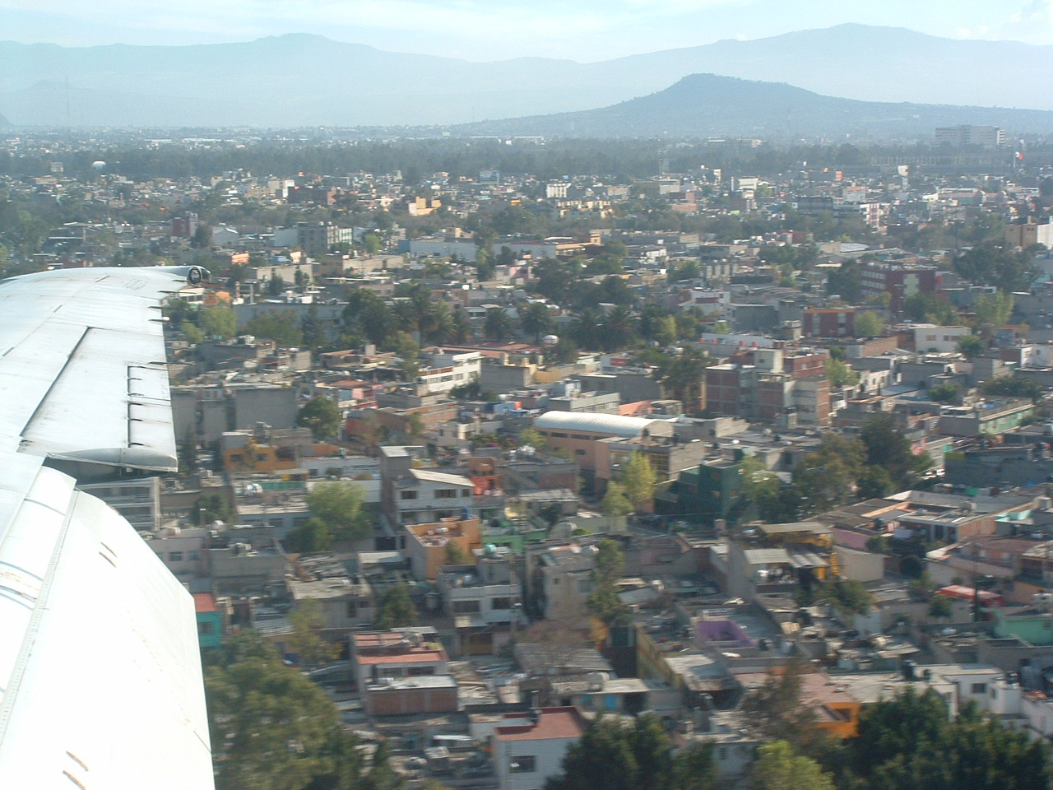
A sparrow hawk (Falco sparverius) sat on one of the taxiway signs, and a Blue Heron (Ardea herodias) checked standing water between the runways for food. Both the runway and taxiway were rough.
The plane parked. We were transported to the terminal on a mobile lounge.
Mexico City and volcanos to the south

Baggage and customs were painless, and we were in a cab to the hotel thirty minutes after landing.
The ride to the hotel provided an insight into the crowding in Mexico City. We passed “Sabor Bergerking” and several Dansea snack bar chain outlets on the way. Only one Pemex gas station was passed. Gas stations were not on every corner like in the US.
One of the largest cities in the world it is home to an estimated twenty-two million (22,000,000) residents. Most of the dirty industries, such as a PEMEX refinery, were closed or moved out of town. The intent was to clean up the environment of the Valley of Mexico and to attract skilled workers out of the city. The strategy helped somewhat, but people move in from rural areas faster than the far fewer skilled workers move out with industry. The sky was blue overhead but brown-gray with air pollutants up to about forty-five degrees above the horizon .
Another strategy to move traffic has been to make many of the streets one way and reducing the lane width to 8 -10 feet. Most of the lane marks were obliterated so they drive if there’s room. The main streets have four or six sections of two or three lanes divided by tree planted dividers.
Mexico City drivers were patient and remarkably courteous considering their historic reputation of driving with the horn. They would be in deep trouble in any US city where every driver thinks he owns his lane.
The average speed around town appeared to be about 25-30 KPH, but with three or four lanes weaving about it looks like chaos. We, personally, saw no accidents and noted few dented fenders. Although none of the vehicles looked like a real air polluter, smog accumulates. It’s probably for the best that forty percent of the cars are inoperable at any one time. There was also a couple thousand pounds of untreated sewage volatized in Mexico City’s air.
We checked in about 1430. The Hotel Geneve was built in 1912 and had a reputation for patronizing service. It was bought by Quality Inns, remodeled and given an attitude change under the name of Calinda Geneve. An old slow elevator, skeleton key locks and a full service staff gave a turn-of-the-century atmosphere.
We arranged tours for the afternoon and the next day as an orientation to Mexico City and to see the maximum in the time available. The first tour was to begin at 1500 with a ride thirty miles north of town to the pyramids at Teotihuacan. A city tour of the Zocalo, national palace and cathedral and the “floating gardens” at Xochimilco were reserved for Friday.

Teotihuacan.The driver and guide picked us up in a VW van then picked up four other people at other hotels - a man from India, a woman from Columbia and a couple from Arizona who were Mexican citizens.
The route was roughly north along the Metro line on Avenida Insurgentes to Highway 85.
Most of the hills were covered with housing. Several quarries were evident where limestone and red lava were being removed in vertical lifts.
Dry fields of corn and okra were waiting to be burned. Burning crop waste seemed strange in an area where air pollution was so bad. Smoke from burning fields gags San Antonio at times.
Plantations of prickly pear cactus sold prickly pears or “tunas” as an agricultural crop. Blue agave (Agave atrovirens) was grown to produce pulque, fermented agave nectar.
The first stop was at a handicraft center with silver, onyx and obsidian art. Tablecloths made of “henequen”, fibers from Agave fourcroydes, were also sold.
The management demonstrated the making of pulque. The flowering stem was removed from the center of a large Agave plant and a hollow scooped out where a lightly sweet nectar was collected.
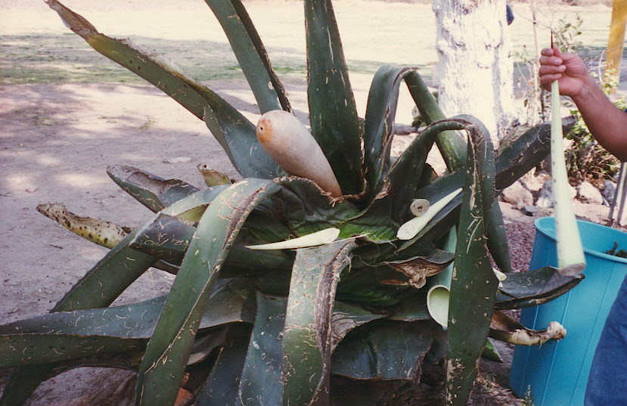
In about 24 hours the nectar ferments into agave wine or pulque or distilled into a brandy.
A natural paper was collected from the skin of the agave leaf and agave fibers are extracted to make rope and the coarse fabric called henequen.
Making Pulque
We arrived at the north entrance of the historical site about 1600, two hours before closing time. The site was begun about 300 B.C. by a relatively unknown culture that claimed the site was the center of the universe. The area had prospered, and the population peaked about 500 A.D. at about 300,000 inhabitants. Its importance declined and the site was abandoned about 750-800 A.D. The eight square mile site contained two large pyramids, numerous platforms for palaces and temples, and a Temple to Quetzalcoatl.
The tour began with a walk through a partially reconstructed palace. Only the foundations and lower sections of the walls remained but some murals and carvings survived.
This exited down a flight of steps to the Avenue of the Dead. Over a mile long and about a hundred yards wide, the Aztecs called it the Avenue of the Dead because they thought the mounds along the street were tombs.
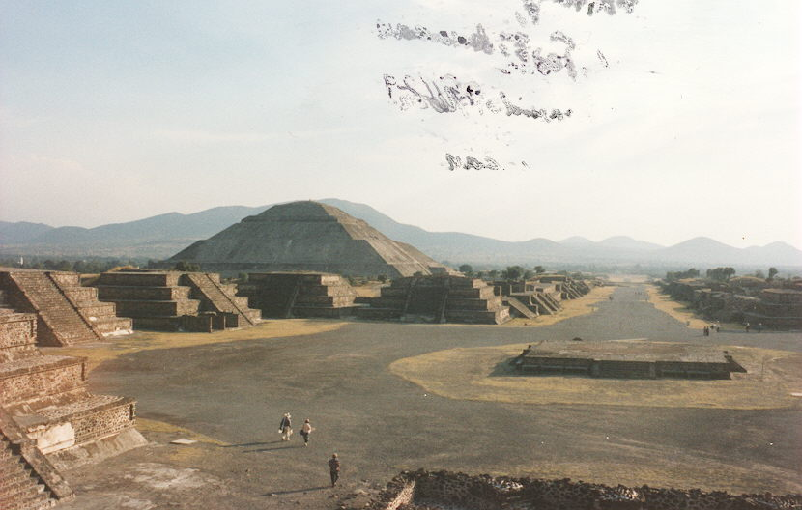
The Spanish left the site intact since it was abandoned and no structures were visible. Villages, like Cholula and Pachuca, in the area promised more loot and slaves. The massacre at Cholula is story for another time.
Avenue of the Dead

OTHER PEOPLE’S PYRAMIDS
(Tiotihuacan)
Aztecs slaughtered and sacrificed
friend and foe alike
but they respected the gods
and the dead.
The Spaniards killed in the name
of the Church
and destroyed whole cultures
as a million heathens bled.
*****
The smaller Pyramid of the Moon dominated the scene being at the north end of the Avenue of the Dead. The pyramid was only about 180 feet tall, but the climb was difficult because the steps were of irregular height and only about eight inches wide.

Climbing the Pyramids
at Tiotihuacan

Sailboats are not the only thing to tack
Its also for adventurous people that
common sense may lack
and want to climb the pyramids.

The steps are about eight inches wide
so the easiest route is serpentine
or diagonally from side to side
to climb the pyramids.

The easy part is going up.
You look around and then start down
then Whoops!
Its a long way down the pyramids
*****
The number of steps and terraces were based on a calendar of ten thirty day months per year and a fifty-two year cycle.
I had a hip replaced ten months before and was determined to climb the pyramids to prove that I was in good shape. The altitude added to the challenge since the site is about 7,000 feet above sea level. Many people huffed and puffed just walking around. I turned back at the top terrace. The top was covered with boulders in no particular order and was poor walking. I shot several pictures of the site and tacked back down across the steps to the Avenue of the Dead.
Live men and children stalked the Avenue selling silver bracelets, carvings of obsidian and other souvenir items. I avoided all of them and found the guide at the base of the Pyramid of the Sun.
I climbed on top of the foundations of the temples that lined the Avenue and was going to take a picture and leave. The guide and a fellow passenger were going to the top, and I couldn’t resist a challenge to do something extra dumb. The guide bounded up the steps carrying my camera bag, and I hobbled along behind, sometimes on all fours, puffing all the way.
The steps to the top terrace were the most difficult with a hump in the middle so you began climbing almost straight up and finished almost horizontal. From there it was not far to the top.
The temperature was about 70F, the sky was cloudless and the view from the top was outstanding. The Pyramid of the Moon to the north, the Temple of Quetzalcoatl to the south, cactus and desert to the east and west, were framed by the setting sun and by a half-moon about an hour before the zenith.
Pyramid of the Moon
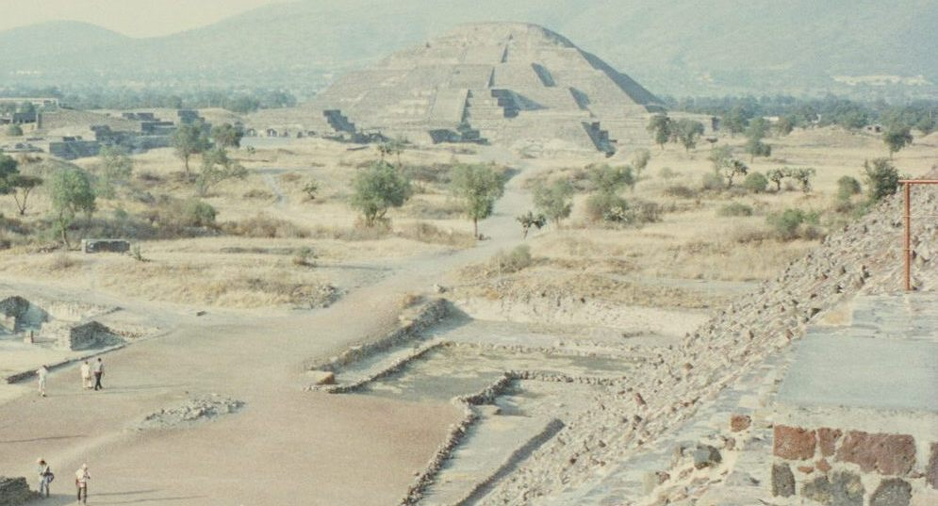
When we got back down, my fellow passenger wanted to see the rest of the site and said he would meet the van at the south gate. I was pooped and two Cokes dehydrated. I had had enough for one day.
The trip back to the hotel was through the dark. We passed an island of floodlights, the prison where a former president and his brother were being held on drug charges.
We found our way to our last stop on the tour, the new Basilica of Guadalupe at the north end of Avenida Insurgentes. The Basilica was designed by Pedro Rameriz Vasquez. Construction began in 1964. The Basilica was completed and dedicated in 1976. Located on the site of the Aztec Temple of Tonantzin (the mother of the gods), the Temple was replaced by a small Catholic chapel which was replaced in 1531 by a larger chapel to commemorate the appearances of the Virgin Mary to a recently converted Indian on 9 and 12 December, 1531.

TEMPLE PLACES

It seems strange that the Basilica
was built on the site of a church
built on top of a chapel
built on top of an Aztec temple
that had been modified over time.

Anthropologists say that a site
suited as a city or temple
is reused for that purpose
like a crook returns to the scene of the crime.
A hill is a hill that fact persists
regardless of culture or clime.
*****
The original chapel was over utilized and had been damaged by earthquakes. The second chapel was replaced by a larger, more ornate basilica in the 18th century. The basilica was damaged by several earthquakes and fire and had become structurally dangerous.
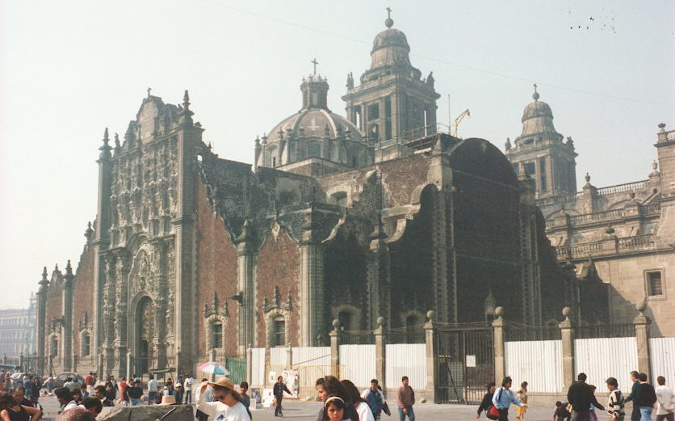
The new Basilica seemed to have a life of its own. Two processions, including people who had walked on their knees from their villages arrived while we were there. We had seen one pilgrimage along the road near the pyramids. Services appeared to be around the clock.
Basilica 2 and zocalo
A collection of stores surrounded the entrance to the site and carried numerous religious artifacts. Beggars occupied locations on the steps leading to the square in front of the Basilica and the steps leading to the Shrine. Vendors of all kinds had stalls around the square
The architecture was complex and the size was heroic, but I was really too tired to enjoy it. Because of the time of day the tour did not include the nearby colonial cemetery.
We returned to the hotel about 2000 and went out for supper. Streets and restaurants were full but not crowded. It was late November and cool but flower beds along the streets contained blooming pink and lavender azaleas, blue irises and red roses.

Dia de Guadalupe

The Virgin Mary produced
a red rose to prove her visitation.
Red roses bloom on December 12
to mark this celebration.
*****
The red rose is the flower of the Virgin of Guadalupe.
Supper was at a nearby nightclub - tough steak and cold beer.

Friday. We were up early. We would have been up shortly anyway because construction work began down the hall about 0700 and continued until about 2100. We had a continental breakfast and started a city tour at 0800.
This time it was just us and the guide and a driver. We went through the hotel dining room and out the back door across the street from the central police headquarters. About a dozen police were dressed in green uniforms with riding boots and spurs armed with flak jackets and automatic weapons. No parking was permitted and the police even looked carefully at vehicles that stopped to pickup or drop passengers.
As we drove north along the Avenida Insurgentes, the guide pointed out hotels and monuments. We turned on to the Paseo de la Reforma at the Glorieta Cuauhtemoc with its 31 gilded angels, passed the Glorieta Colo’n, then turned east on Juarez at the old art deco National Lottery. A block to the west was the Monument to the Revolution. Several hotels and other buildings damaged in the earthquake of 1985 were still standing awaiting demolition. They were filled with squatters from the countryside.

To the east on Juarez was the new glass and steel National Lottery building. We passed Alameda Park, the Belle Artes (Palace of Fine Arts) with murals by Rivera, Orozco and Siqueiros, the Bank

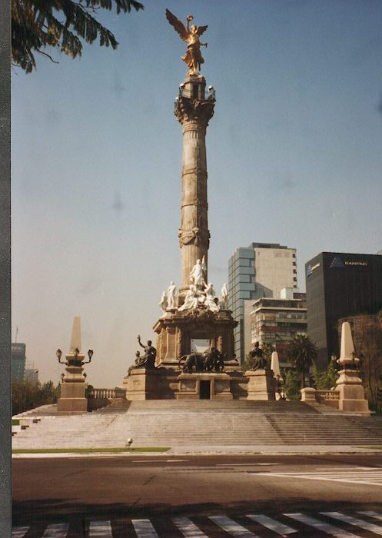
of Mexico and La Torre Latinoamericana (the Latin American Tower).
Avenida Juarez became Avenida Madero. At the intersection with Avenida Lazaro Cardenas was the Casas de Azuleos or House of Tiles. This colonial building covered in blue and white tiles was built in the late 1500s for the Counts of the Valley of Orizaba near Veracruz.
Further down on Madero was the Iturbide Palace. It was built for Don Augustin de Iturbide who proclaimed himself Agustin I, Emperor of Mexico in 1822. He reigned less than two months.
The Glorieta

At the Zócalo, we walked across a plaza that must occupy ten acres. The area got its name, Zócalo, from the Mexican word for pedestal. In 1843, a pedestal was constructed for a monument that was never built. As a result, the main plaza in many Mexican towns is called the zócalo.
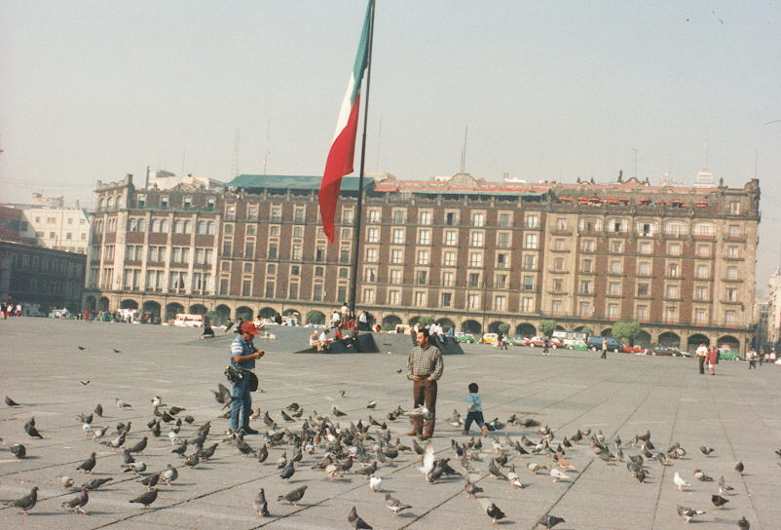
Street photographers were taking pictures of people and their kids in the plaza chasing and feeding a flock of pigeons.
The zocalo and capitol building

The National Palace, on the east side of the Zócalo, was begun by Hernán Cortés after he defeated the Aztecs. It was built on the site of the main Aztec pyramid using stones from the pyramids. Spanish viceroys and Mexican presidents lived in this structure until the Emperor Maximilian. He and modern presidents used it as an office building. Maximilian designed the Avenida de la Reforma leading from his castle in Chapultepec Park to the Zocalo after the Champs d’Élyées in Paris.
Inside the stairwell of the National Palace was a mural by Diego Rivera illustrating the history of Mexico completed in the 1950’s. A number of smaller murals were painted between the doors on the second floor porch around the central patio but Rivera died before completing all of the murals.
To the north of the Palace, the base of Templo Major, the Great Temple of the Aztecs, was recently discovered during some demolition. More excavation and some restoration will continue long into the future.
The Metropolitan Cathedral was also constructed from the stones of the Aztec temples. It had a number of chapels and outstanding carvings around the main altar. There were crypts below the Cathedral floor. Part of the problem with tours is they have their schedule to keep and ten minutes to walk through the Cathedral was much too short.
Beggars sat outside the door of the Cathedral. Around the corner, on Avenida de Cinco de Febrero, day workers patiently waited with signs advertising their specialty - painter, electrician, etc. Unemployment all over Mexico was high as was the rate of inflation. These combined to bring about a large underground business community that worked for cash or barter and rampant tax avoidance.
The van took us back to Reforma. We passed the Plaza de Garabaldi, known as the plaza of the mariachi. Groups and single singers and musicians waited for work. This was recommended for an evening visit for the music.
The next stop was at the Central Crafts Market. It was interesting but looked like the semi-permanent San Antonio flea markets. The prices and variety were little different from the Mercado in San Antonio where there was no duty and no shipping problems.
It was noon, and I told the driver we would like to find a place for lunch. Their reply was, “in a minute”. This must have been a Mexican minute because we went to the Museum of Anthropology for an hour. An hour allowed us to see the Aztec room only. The museum was a massive structure with separate halls for many of the cultures that originated in Mexico.
This was but one of a number of museums in Chapultepec Park. Others included the Museums of Modern Art, Natural History, Technology, National History and an 18th century Castle. There was also a lake, an amusement park and a zoo.
We managed to get a Coke before continuing our Mexican minute to Xochimilco. While we drank the Cokes we sat and watched a performance of the Totonac Indian voladores. It is originally from El Tajín between Tampico and Veracruz. Five men climb a 20-meter pole. Four of them sat on the edge of a platform while the fifth danced and played drum and whistle. The music stops and the four launch themselves backward into space and swing around thirteen times as ropes attached to their ankles unwound and the four approached the ground. Voladores was a fertility rite where four macaw-men make invocations to the four corners of the universe and bring the sun and rain with them. Back on the ground they hit the crowd for donations.
Our tour passed the Castle. The Castle was an Aztec fortress and built into its present form in the 1780s. It was used as a military college during the time of the Mexican War when the US Marines captured Mexico in 1847. At the base of Chapultepec hill, along the Reforma was the Niños Heroes, a monument to six cadets who jumped to their death rather than surrender to the US Marines. In the the 1860s, the Empress Carlotta would watch her husband, Maximilian, parade down the Reforma to the Zócalo. She also designed the grounds and gardens that surround the Castle. The Castle was still used as the official home of the president.
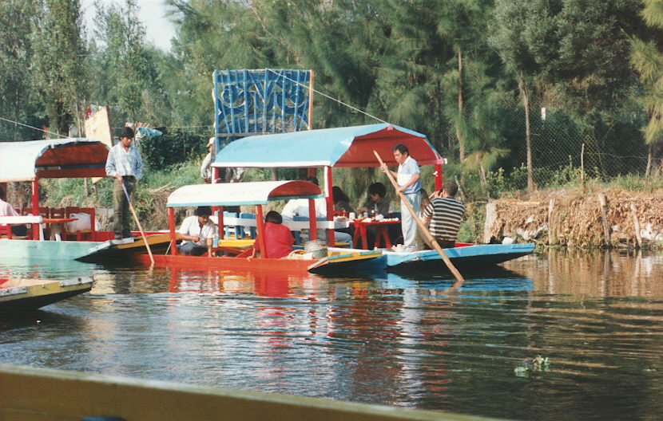
Our route passed University City, the former Olympic Village, and led down Friendship Boulevard lined with the statues donated by various countries after the Olympics. We flew past the exclusive Jardines del Pedregal (Lava Garden) protected ecological zone and residential area where the Xitle volcano erupted 2,000 years ago, the round Cuicuilco Pyramid near Tlalpan, the colonial community of San Angel and finally arrived at Xochimilco. The tour schedule did not allow time to visit these areas, but they were supposed to contain interesting features to be investigated during future trips.
Barges in Xochimilco

Xochimilco or “field of flowers”, was fifteen miles south of the Zócalo. It is one of the few areas of the Valley of Mexico to survive from Aztec times.
A shallow silty lake was modified into floating gardens(las chinampas) began by 1300 B.C. and expanded by the Aztecs between 1300 and 1500 A.D.
There were five lakes in the Basin: Xaltocan, Zumpango, Texcoco, Xochimilco and Chalco. The swampy southern areas were changed into productive farmland producing up to 7300 kilograms per hectare of corn. The term chinampas came from the Náhuatl chinamitl or fence of cane and from chinampan, within the fence. Channels were dug by the young chinamperos, and the spoil transported on flat bottom boats to become piles used as garden plots. A chinampa was outlined with poles and reinforced with willow stakes and matting to retain the soil. This farming method has been studied by many countries.
The Aztecs were not pleasant landlords so the natives of Xochimilco supported the Spaniards in the final invasion that defeated the Aztecs.
The signs leading to the gardens read, “Los Embarcaderos”, the boats. We boarded one of maybe a hundred “Trajineras”, the hand poled tour boats. Tourist do not actually get to see the farming areas.
It was Friday and few of the boats in the passenger fleet were occupied. However, the canals seemed crowded with boats - boats with troubadours; boats that sold food and jewelry; water-borne photographers with old, hand made cameras that waited along the water’s edge; boats with old women who sold flowers. A few boats were hauling laborers as well as cement and other construction materials.
The banks extended three to ten feet above the water level and were interlaced with tree roots and other vegetation. These gardens are not floating by any means.
A pleasant hour on the canals returned us to the docks.
Another thirty minute ride took us back to the hotel by 1530. The Mexican minute was over, and I was starving.
Lunch was of regional Mexican food at one of the hotel restaurants. We intended to go out for supper later, but a couple hours later I had a bout with enteritis which lasted most of the next week.

Saturday. We packed up and checked out of the hotel by noon. The Tagamet I was taking did nothing for the heartburn and neither did a bottle of Maalox.
A cab to the airport started us on the next leg of our trip.
The plane took off towards the south and circled over the remainder of the lakes and water supply for the city. We passed across the southern part of the city and turned northwest. There were a number of large quarries and reservoirs covered with water meal (Lemna sp.) We passed over Toluca, then over dry farmed lands, then over a series of east-west oriented ridges and deep canyons. Just north of Cuidad Hidalgo was Lago de Cuitzeo on the Rio Lerma. We continued WNW across the Parque National Lago de Camecurao.
We passed to the south of Lago de Chapala 35 miles south of Guadalajara. The water level in the lake had dropped 20-30 feet. It served as the water supply for Guadalajara and a source for local irrigation. One of the major causes of the low water level was the illegal pumping up stream on the Rio Lerma. Lake Chapala was still one of the sacred lakes of the Huichol Indians.
South and west of Guadalajara, big green valleys extended northwest into the Sierra la Primavera mountains. Lago Atotonilco reservoir was southward down the Coahuayana River between the Sierra Manzanillo to the east and the Sierra de Tepala to the west.
The plane turned almost straight west across the rough Sierra de Tepala just south of the Rio Ameca. The Ameca looped north and then swung southwest entering Bahia de Banderas north of PV.
Several valleys were spotted with what appeared to be oil well sites. Further west, logging roads led to large clear-cut forest harvests. The clearings supported cattle. The narrow roads were marked with light colored landslides and mines.
The Pacific, actually Bahia de Banderas, came into view as we let down along the Rio Ameca into Puerto Vallarta. The bay is one of the largest in the world measuring 19 by 25 miles. It was a stopping place for food, water and firewood for the 16th century Spaniards on their way to the Intendancy de Vieja California (Baja California) or the Isla de Perlas (Island of Pearls near La Paz) in the Sea of Cortez (Gulf of California). We followed the Rio Ameca to a beautiful landing on the one runway. The approach was from the north towards the center of downtown.
Vegetation visible from the airport left little doubt we were in the tropics. Tall Coconut palms (Cócos nucífera), toxic red castor beans (Rícinus commúnis), local mahogany trees (Cercocárpus betuloídes), cecropia (Cecrópia palmáta), Huisache (Acacia smallii ), Hibiscus (H. chinensis and H. rosea), Bougainvilla of several colors and other tropical plants grew in disturbed areas or as ornamentals around the airport.
Baggage handling was efficient, and we were out of the terminal in about 15 minutes.

Puerto Vallarta.
As we walked out the door, we were approached by a representative of the “Puerto Vallarta Condominium Assn.”. He was really a shill for one of the time-share condominiums offering taxi and breakfast but wanting a $20 deposit to make sure we would show up. The deposit was a new twist.
A twenty peso ($2) cab ride took us to the Sheraton. We checked in, and our luggage was taken to the condo management office where they wanted to set an appointment to sell their condo timeshare program.
Eventually we got to the room - a bedroom, bath, kitchenette and a living room with two day beds. Cable TV carried mostly stateside TV programs. One channel was a Denver station that was reporting on their recent snow storm.
I was not hungry so I drank a coke and crashed. The beach and unpacking could wait for a while.

Sunday morning I was up about six. The hotel was less than a mile from the center of town and la Inglesia de Nuestra Señora de Guadalupe (the Church of our Lady of Guadalupe). The church clanged its bells in the call to early mass at 0600. This happened every morning and served as the alarm clock for the central PV area.
I did my morning exercises, had a cup of tea and went out to look at the beach. A quiet walk along the beach just after low tide looking for shells did me a world of good.
The beach of Bahia de Banderas was composed of cobbles and well worn rocks. Some appeared to be petrified wood. Most were of volcanic origin including lava, breccia and granite. There were also wafers of red sandstone and small chunks of gray and white marble.
The only birds that were up with the sun were the numerous Great-tailed or Mexican Grackles (Cassidix mexicanus) around the hotels, a lone Anhinga (Anhinga anhinga) flying across the bay and a flight of six White-tailed Tropicbirds (Phaenthon aerthereus) looking for a thermal along the beach front to boost them to their soaring altitude.
The base halves of California oysters (Ostrea lurida expansa Carp.) remained on the seawall or “malecon”.
On an abandoned concrete pier four species of shells were found at or near the high water mark:
Acamea fenestrata Reeve (the fenestrate limpet);
Acamea testudinalis Esch. (plate limpet);
Littorina aspera Phil. (Periwinkle)
L. scabra (angulifera) (Linne) (variegated periwinkle).
An upper valve of an immature Ostrea fisheri Dall (Fisher’s oyster) was found on the beach.
A number of shells were offered for sale as local shells including a large Little Deer Cowry for 200 NS (the new or devaluated pesos, about $30 US), Hexaplex erythrostomus, and several Olives, but the vendors did not know anything about the shells.
Seeds or “sea beans” on the beach included young coconut (Cocos nucifera), tropical almond (Terminalia catappa L.), mango (Manganifera indica) and black mangrove (Avicennia nitida). Jungles to the north and south provided a ready source for these beach artifacts. Some, like the mango, was probably local refuse that found its way into the bay. Thanks to a lack of gulls and shore birds a shrimp was found on the beach. It looked like a Peneid about two inches long colored tan with olive drab spots.
I returned in time to sit through a presentation on the Sheraton time share concept. The primary difference was that the week in the condo could be traded in for two weeks in the hotel. In return for our time we were given breakfast and cut-rate tour prices.
BANDARAS BAY

Bandaras Bay is second in size
on the whole Pacific coast
The bottom is rocks and boulders
with few shell of which to boast
+++++

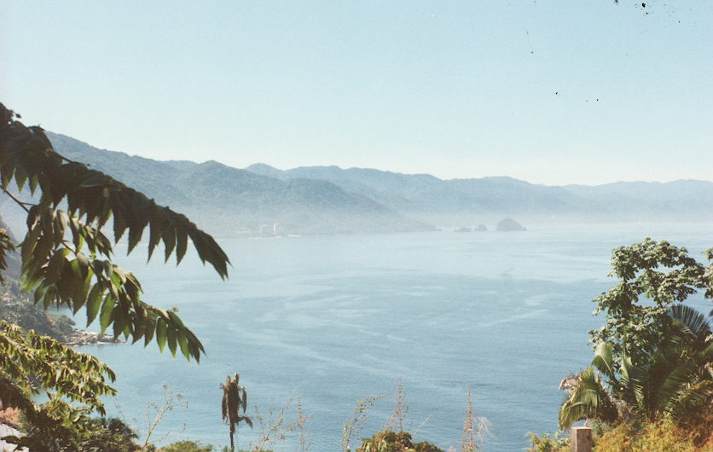
We took a cab to the market beside the Cuale River at the end of Av de Rodriquez and spent a couple hours shopping.
Bandaras Bay
Back at the hotel I was still not feeling well.
About eight on Sunday evening my wife was concerned with my lack of appetite and dehydration and called the hotel medical emergency number. The doctor said he would see me at 2200. He diagnosed bacterial enteritis, gave me an IV for dehydration, a course of medication (buscapina, percodan and chloramphenicol) and told me to avoid spicy, greasy food and alcohol for a week. This regimen did the job and cost $90 which was nonrefundable by our HMO, Humana, because I did not call them ahead of time after midnight on Sunday.

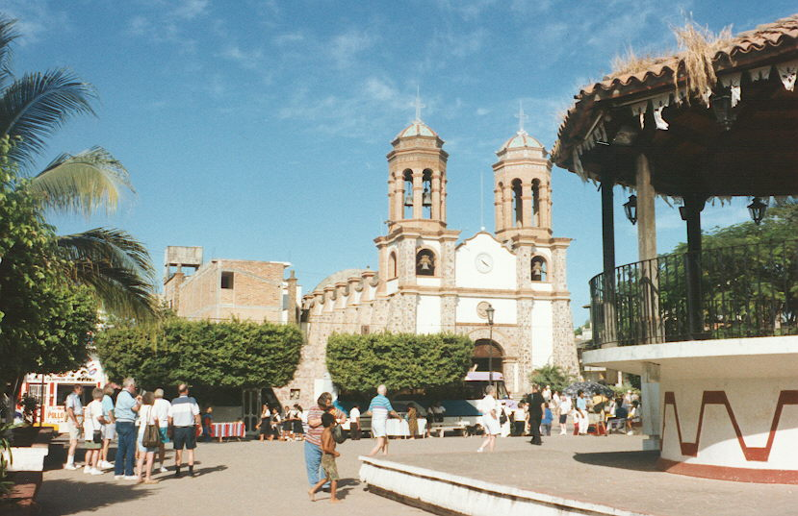
Monday morning I was almost back amongst the living, and we scheduled a tour of the city and the local jungle.
Zocalo
While we waited for the tour I noted that the hotel landscaping was over-planted with its theme of coconut, philodendron, ficus and
hibiscus. It also lacked some of the other common tropical plants such as Geiger trees, Flame trees, Ixoria and Frangipani. These trees and shrubs were found in the landscapes of other hotels and public areas.
Our tour bus picked up clients at other hotels, then proceeded along hotel row describing them as we drove. We passed by the 555 boat slips Marina Vallarta and airport. After crossing the Rio Mascota we turned inland to the village of Ixtapa.
Ixtapa was a farming and bedroom community about ten miles north of downtown PV. Minimum wage for workers was supported at 15 NS (about $2 US) a day. Tenants could become owners of condos and apartments in public housing by living in the unit for thirty years.
Public schools were free and mandatory through grade 10. School hours were 0700-1300 and 1400-2000 to allow children to work to help support the family. The state and national universities were free on completion of grade ten. English was a mandatory course. There were also many private and church sponsored schools. Several of the private schools were bilingual, dividing instruction between Spanish and English. Most of the schools required uniforms.
The stop in Ixtapa was near the old Catholic church on the zócalo (Remember that word?) Most of the town businesses were around the square. There were also small businesses such as raspa and lemonade vendors, a photographer and jewelry displays.
The plaza, like the streets, was constructed of paving brick. A bandshell dominated half the plaza and basketball court occupied the other half. A variety of tropical vegetation including coconut trees, Flame trees, Ficus trees and red and yellow Hibiscus, decorated and separated the areas and provided shade for benches around the plaza. I rested for a few minutes on a bench on the rincõn de viejo, a corner where old men while away their days watching the girls.
On the west side of the plaza sat a church covered in a tile mosaic. There were twin bell towers but the upper bells were present in only one. (Catholic churches usually have different styles for their bell towers so that the church will not be perfect.) Different from many, this church had a clock and a flag pole between the towers. It was furnished with wooden pews and bare walls.
About twenty minor archeological sits are registered around Ixtapa but these are not on the tourist routes.

THINGS THAT ARE AND AREN’T

Jerusalem Palms and Travelers Palms
are not what their names imply
Jerusalem Palms are cycads
and older than palms, by the way
Travelers Palms are banana trees
whose leaves have a special splay
+++++

The next stop on the tour was Viejo Vallarta, “Old Town”. A port on Banderas Bay was established in 1587 under the leadership of Captain Pedro de Unamuno. No proper community existed before 1851. Sr Guadalupe Sanchez Torres, who lived in Cihuatlan, Jalisco, made a living by shipping salt to the local mining operations. He decided to move his family and arrived on the bay on 12 Dec, 1851. He named the spot Las Peñas de Santa Maria de Guadalupe after the big rocks in the bay now called Los Arcos and the feast day of the patron saint of Mexico. The village of Las Peñas grew to about 1500 people by 1880 and became a municipality in 1918. Its name was changed to Puerto Vallarta for Sr. Ignacio L. Vallarta. Vallarta was the governor of state of Jalisco and had materially aided the defeat of General Zapata. Population in 1990 was about 250,000.
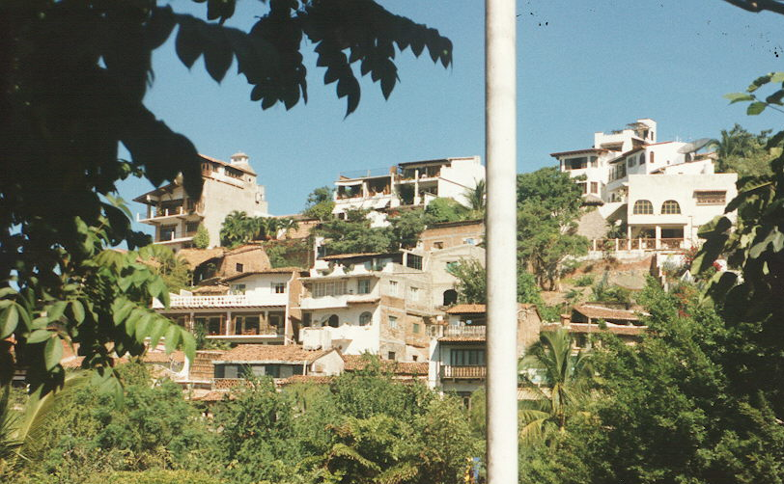
Streets were made of paving tile with ten foot lanes and narrow or no sidewalks. Most of the commercial buildings were multi-story with residences on the top floors. Most of the buildings had ends of reinforcing rods extending out of the roof to show that the structure was not yet completed and deserving of a tax break.
Gringo Gulch

A flying drive along the Malecon pointed out statues of the boy on a seahorse and two dolphins There was one of Sr Vallarta in the main plaza near the bandstand.
We made two stops for shopping and a two-minute stop to see “Gringo Gulch”. Here many Americans had high-priced homes such as Elizabeth Taylor. Her “Casa Kimberly” with its foot bridge to Richard Burton’s house was featured. (Tours of the house were available.)
We made quick photo stops at Conchas Chinas, Camino Real, the Inter-continental Presidente hotel.
There was no good spot to stop an see Los Arcos. These huge stones fell off the mountain into the bay and gave Las Peñas its name.
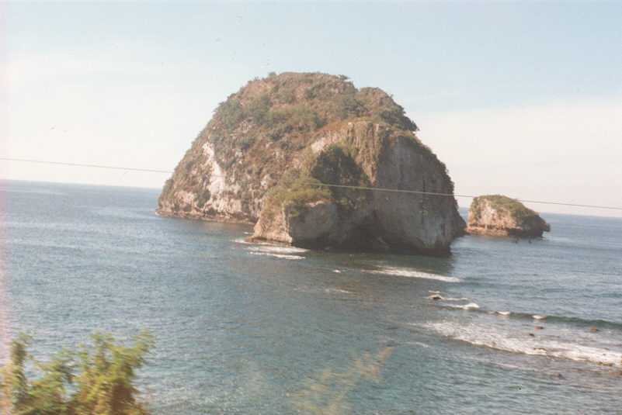
A short stop was made at Mismaloya. Here a shipyard had operated in 16th and 17th centuries. Two ships had been built that were used in settling California. Mismaloya was also the site of the filming of Night of the Iguana with Elizabeth Taylor and Richard Burton.
Los Archos

The tour stopped for lunch at El Edén. Located about three miles up the Mismaloya River, the site was built for some scenes in the first Predator movie with Arnold Swarzenegger. It had no phone or electricity but outstanding atmosphere and food.
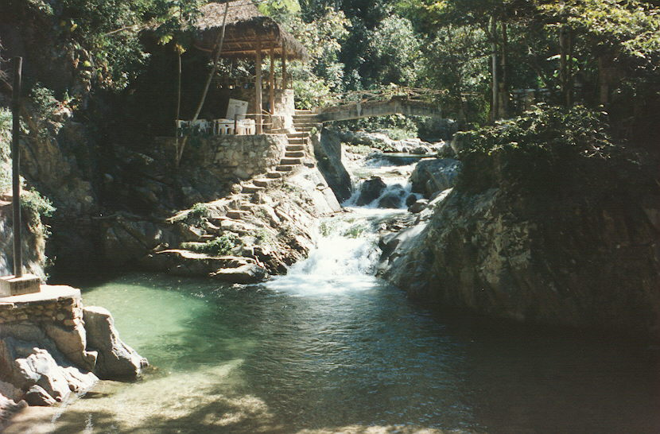
We sat overlooking the river and watched butterflies cruise the gorge. I saw a Pale Swallowtail, Papilio eurymedon, along the road. Several large blue-white Morpho butterflies, both black-and-white and black-and-yellow Zebras, several species of sulfurs and an Orange Tip cruised the walls and puddled. The rock walls near the water line were covered with ferns. Trees included gumbo-limbo, cecropia, mahogany. Soil along the road was a tan loess. A termite
El Eden

nest in a tree 30 feet above the water marked the high water line for the rainy season. A large, bright red dragonfly chased mosquitoes and other small prey. No birds were heard or seen.
We returned to the hotel late. Deciding to eat out, we took a cab to Archie’s Wok. The cab took the long way towards the mountains to Aveneda Libramiento, the bypass route for Highway 200. The road dove into and through a tunnel a couple hundred yards long. This was one of the most air polluted tunnels I ever experienced. We finally arrived at Archie’s. The Thai food including my fruit curry was very well prepared. Music was provided by a flutist and a couple kids passed by the open window offering gum for sale.

Tuesday’s trip was to San Blas for birds and a swamp trip. San Blas was about 90 miles (150KM) north of PV and about 25 miles (40 KM) west of Tepic, the capital of the state of Nayarit. Our bus followed the relatively new Highway 200 and crossed the Rio Ameca just below its junction with the Rio Mascota at Las Juntas. Near Mezcales we turned into Neuvo Vallarta, an exclusive group of condos and homes. The area was impressive but the passengers did not show up. Ponds in the delta of the Ameca River were covered with ducks and shore birds and surrounded with patches of moonflower.
We passed through Bucerias and began to climb over a band of hills, the Sierra de Vallejo, and then up the valley. Ranges of fog-shrouded hills were covered by a variety of tall trees and several species of palms. Scattered farms raised tobacco and pineapples. In the jungle near Las Piedras was a site where some of the scenes from Predator were filmed. The new resort of Rincón de Guayavitos catered primarily to the Mexican nationals.
Most of the 47,000 acres of farm land was irrigated from wells using center pivot systems. Some citrus, mangos and papaya were produced and new specialty crops such as oriental vegetables were being raised for the California market. New cash crops were needed because the decline in smoking in the US had decreased the tobacco crop by 60 percent. There was one large cattle ranch where corn was raised for cattle feed.
At Las Varas, a road lead westward towards Jacocotan, Santa Cruz and San Blas. Several small towns existed along the way, each with its public school and public building. Many large farms had disappeared and had been replaced by smaller family farms and cottage industries such as adobe brick making. Adobe brick sold for about 200 NS per thousand and producing a thousand bricks was a good day’s work for the family.
Arriving at the embarcadero (dock) we split into two groups of ten and climbed into two “pangas”, shallow draft aluminum boats with 40 horse outboard engines. The first hour and a half we would cruise through a mangrove forest looking for birds, turtles, crocodiles, and alligators. There would be a visit to an alligator farm and then a short ride to Tovara Springs for lunch before the return to the bus.
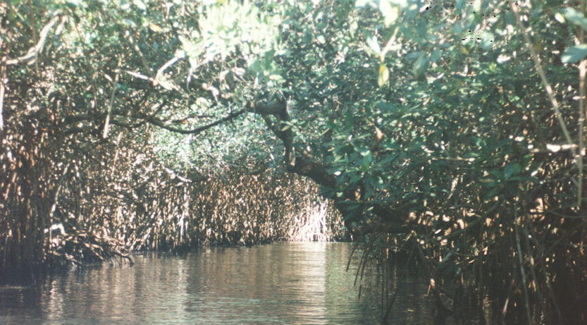
The trip began down a channel under a canopy black mangrove trees with interlacing branches that blocked out the sun. Ferns and bromeliads grew on the branches.
Mangrove Tunnel

Salinity changed the dominant tree to red mangrove and the overhead cover thinned and a blue sky appeared.
This quiet waterway wound through tall grasses and large mounds of spider lilies. Occasional trees sported hanging vines and colonies of bromeliads with red bloom stalks and dainty blue flowers.
Turtles sunned themselves on logs or the banks with most of them hitting the water as we approached. The water was clear but dark colored with organic material.
A Northern Boat-Billed Heron (Cochlearius selection) sat in a mangrove tree just out of reach. Birds roosted on the limbs of several dead snags along the channel. Anginas and American and Snowy Egrets (Egret egret and E. hula) were not overly disturbed at our approach. A tropical kingfisher flew out of sight. Several kingbirds had their kingdoms staked out. A green heron (Butorides virescens) took wing from the cane while a Great Blue Heron (Ardea herodias) ignored us. A Gila Woodpecker (Centurus uropygualis) beat upon a dead tree.
We passed an opening where grazing cattle and cattle egrets (Bubulcus ibis) were visible. Alligators occasionally took a calf but usually fed on fish and turtles.
Several alligators were seen hiding under the undercut bank and a couple small crocodiles were seen sunning in the shore. Hydrocottyl or pennywort, H. rotundifolia, the size of silver dollars, grew on a floating log.
A flock of Sinaloa Crows (Corvus sinaloae) greeted us at the government alligator farm. Several pens of alligators and crocodiles were being reared for release. Imported broodstock provided a broader gene pool and a number of young are released each year but poaching had kept the population low. Chickens were served as alligator food.
A short ride from the alligator farm brought us to Tovarus Spring for lunch.
Several of our companions went swimming in the cool, clear water of the spring. The pool also supported a number of large (ten pound) blue catfish and pan fish that looked like the Rio Grande Perch.
The water was clear and percolated through the bottom at the base of a hill. The area around the spring margin was rocked in and a restaurant was constructed along one side. About a dozen tables were located under a portál. Lunch was either steak or fish. This facility also lacked utilities except running water pumped by a gasoline generator.
Light blue Morpho butterflies cruised the spring. Bright gold and pale yellow sulfurs and several beautiful Orange Julias (Dryas julia) puddled in the water left on the headwall by the swimmers.
About 1400 we reboarded the pangas and returned to the bus. We entered the town of San Blas and turned south and up hill at the main intersection. Houses along the road had cactus and weeds on the roof and laundry hanging on the front porch.
Near the top of the hill was the remains of an old stone church. Further up on top of the hill sat the walls of the fortress, La Contadura. Its canons had commanded several miles of coastline and surrounding sea. It now provides a view of the town, acres of coconut trees and the coastal wetlands. The lighthouse at Playa Del Rey could also be seen .
San Blas had been a port for Spanish galleons trading with the Philippines. The fort was built to protect San Blas from pirates. It was destroyed during the war for independence in 1811.
Kids were all over racing the bus up the hill. They would take
candy but not money. Their parents looked on money as charity. However, the kids would sell local wild flowers for hard money.
Back down the hill the road went along the beach past Matanchen Bay and Las Islitas Beach and Playa Los Cocos. These beaches had a reputation of being some of the best surfing beaches in the world. The best waves were expected in September and October. The roadside was lined with beach barbecue shacks, now uninhabited.
The trip back snaked through the gathering dusk. There was no sunset to talk about. It just got dark.

Wednesday morning I was still not feeling top shape. I was up early so I went out on the beach to hear the church bells and watch the near-full moon set. The moon settled into a cloud bank on the horizon around the bay beyond Los Arcos near Yelapa. It was light by the time the moon disappeared but the sun would not appear over the hills to the east for another hour.
We went across the street from the hotel to a restaurant called the “100%” for one of their fruit and yogurt specials. My wife took a taxi to one of the shopping malls.
I gathered up my cameras and notebook and took a bus to El Centro for one and a half pesos. The bus had about a dozen plastic seats sized to hold two very small people. This was similar to seating five adults in the backseat of your car. The busses ran frequently and stopped wherever someone wanted on or off. The ride was less than a mile and took about five minutes.
I got off on near the center of the malecón and watched several pelicans flying in formation. They came in close to the surface of the bay in a perfect section landing formation then individually crashed.
Several groups of tourists were being guided along with their guide explaining the significance of the boy on the seahorse and the frolicking dolphins. Several tourists asked me to shoot a picture of them with their camera against these landmarks.
I crossed the street to the Palacio Principal (city hall) and stopped in at the tourism office. Between my broken Spanish and their elementary English we found what I was looking for. I picked up several brochures.
The zocalo was on the south end of city hall and a nativity scene was set up on the porch. I arrived in time to see a procession

The Malecon (Seawall)

Along the malecon
Flew squadrons of Pelicans
In tight formation
Past the seahorse statue.
Kids sat dangling their feet over the seawall
eating green mangoes

Across the street stood a Huicol Indian shop
Selling bead-covered animals
An icecream vendor leaned on his cart
Peering in the window.

Beyond the church was the zocalo
The rincon de viejo the old men’s corner
Was marked by a shoeshine throne
With raised metal footrests
A shoeshine while watching the girls.

Tourists in shorts and big hats
walked the malacon
watching the pelicans
eating icecream.
*****
of elementary school children dressed in a white peasent costumes arrive, complete with donkey, and go through the nativity ritual. Each child was given a basket of candy and escorted off by their parents.
Christmas decorations were being installed on the power poles and strung across the streets.
On the south west corner of the zocalo near the statue of Sr. Vallarta were several shoe shine stands and an old man selling raspa with bees buzzing around the colored syrups. I ambled past and turned down Ave. Morales towards the Cuale River. At least four people wanted to give me a meal and cut rate tour tickets for looking at one of the condominium timeshare deals.
Cuale Island was choice real estate with exclusive restaurants, boutiques and the Cuale Museum.
The museum had a good facility and well arranged displays. I bought a copy of their booklet Mesoamerican History by Ana Mendizabal published by the PV City Council.
Eastward the walk led through a block of boutiques and shops. Copper pictures, silver jewelry, wooden masks and water color paintings were offered for sale.
Exit from the island was across the river on a rope-and-plank suspension foot bridge to Avenida Constitucion. The bridge rippled and swung as a woman with a reluctant child by the hand came across. I crossed over and back just for the experience.
I wandered around the old part of town. Many of the homes had been converted into clubs or restaurants. None of the small hotels had a vacancy sign. Basilio Badillo led me west to Olas Altas and more shops. The Olas Altas Acuario or Aquarium was primarily a shop that sold aquarium fish and supplies.
Recrossing the river I went back north along the seawall and found a shop operated by the Huicol Indians. The shop contained displays of Huicol clothing and a medicine hut. Hand crafts included bead-studded sculptures where the beads were pressed into bees wax, T-shirts with Huicol designs, yarn paintings, baskets and pottery and books on the Huicol culture. The Indians live in the Sierra Madre Occidental at altitudes of 3,000 to 10,000 feet. A strong religion based on peyote prevailed.
A short two block walk brought me to Ave Juarez where the buses ran north. I caught a bus back to the hotel.
We watched the sunset over the southwestern tip of the bay and the Tropicbirds returning to roost on top of the hotel. A string of pelicans were heading south across the bay looking for their friends the dolphins that kept track of the shoals of fish. After sunset we had dinner at the hotel.

AN AERIAL ARMADA

A flight of ten pelicans
ride the thermals down the surf
Fifteen tropicbirds circle downwards
towards their night roosting turf
+++++

LONG NIGHT MOON

The full moon made its appearance
an hour after the sun had set.
It took that long to climb the eastern hills
and caused the tropicbirds to fret.
+++++

Thursday I stayed around the pool and beach while my wife went shopping. The temperature was in the 70’s and cool if the breeze blew or the sun slipped off leaving me in the shade.
We had reservations for the hotel fiesta for the evening. Since I was not supposed to drink or eat spicy foods, the evening was spent watching the other revelers. Marichi bands were good. They were followed by a comedian that conducted a series of drinking games. A bandit with tequila bottles made the rounds with a photographer passing out tequila slammers. The buffet was served about 2100 and I had fruit and several deserts. We left about 2200 as the party was getting in high gear. About midnight I was awakened by a fireworks display whose explosions reverberated off the hotel walls.
Friday morning we packed and checked out leaving the bags in check. The plane did not leave until 1400 so we went to downtown for a lobster dinner and some last minute looking.
A taxi took us to the airport a little past noon as we began the trip back to Texas. The plane took off on time. Twenty minutes later we were over Lake Chapala with Paracutin, the infamous volcano, visible above the clouds to the south.
We were in the Mexico City airport about two hours waiting for the plane to San Antonio. The boarding gate changed twice in that time.
The sun was setting as we finally left. The mountains of Mexico were dark until we passed over Monterrey and Saltillio. The land was black again until we neared the US border southeast of Laredo. Numerous small South Texas towns glowed like jewels and a lightning display enlivened the sky to the northeast.
We landed a little after 1900 and were through customs and home in another hour.
Hey, Mamma, when we goin’ again?
Bird List

Great-tailed or Mexican Grackle Cassidix mexicanus
Anhinga Anhinga anhinga
White-tailed Tropicbird Phaenthon aerthereus
Northern Boat-Billed Heron Cochlearius selection
American Egret Egret egret
Snowy Egret E. hula
tropical kingfisher
kingbird
green heron Butorides virescens
Great Blue Heron Ardea herodias
Gila Woodpecker Centurus uropygualis
Cattle egret Bubulcus ibis)

Shells

Acamea fenestrata Reeve (the fenestrate limpet);
Acamea testudinalis Esch. (plate limpet);
Littorina aspera Phil. (Periwinkle)
L. scabra (angulifera) (Linne) (variegated periwinkle).
Ostrea fisheri Dall (Fisher’s oyster)
Little Deer Cowry
Hexaplex erythrostomus
Olives
Plants

Tall Coconut palms (Cócos nucífera)
red castor beans (Rícinus commúnis)
mahogany trees (Cercocárpus betuloídes)
cecropia (Cecrópia palmáta)
Huisache (Acacia smallii ),
Hibiscus (H. chinensis
H. rosea)
Bougainvilla

