Return to Sardinia

A little romanticism is in order. Once upon a time, a magical floating island found refuge in the Mar di Sardegna on the timeless Island of Sardinia in the Mediterranean Sea. Five thousand men gazed out on the placid water, the rugged coastline, and the ancient castles shrouded in mist. Other men had lived on this coast for ten thousand years mining copper and silver and trading in saffron and lace. Then, out of the morning sun, came a flight of dragons.
This was in May of 1962, on board the USS Independence, CVA 62. We were there to take command of the US Naval Fleet in the Mediterranean. We had passed the Straits of Gibraltar the night before and had run 24 hours to make anchorage.
We had glided in quietly until vibrations and a muffled roar of reversing props followed by a clunking rattle of anchor chains marked anchors being set in the Sea of Sardinia. The anchorage was off the town of Bosa, founded by the Phoenicians over 3000 years ago. Capo Cacia lay to the north with the 12th century town of Alghero
I was on the starboard catwalk watching the anchor detail going about their various duties. A Navy cruiser and a couple destroyers or destroyer escorts were already at anchor. The Admiral’s gig was slowly circling, waiting for the anchor detail to be finished. Another couple destroyers and a submarine or two in our battle group were still at sea, making sure nothing slipped up on us.
Out of a hazy washed-out blue sky, just over the sun, came a welcoming fly-over from the carrier we were replacing. They came in on the deck and made mock attacks. ADs. A6s. The carrier would retrieve its aircraft and anchor in the Golfo del Asinara north beyond Capo Cacia.
That was my welcome to the Mediterranean and Europe, in 1962. In May 2005, my wife and I were going to spend three weeks in Italy. We planned a week in Rome, a week on Sardinia, and a week to visit Pisa, Florence, and Venice. A time-share exchange was reserved on Sardinia. We decided to take a week on each end and airline reservations were made a year in advance. Hotel and ferry reservations were made on the internet.
I rounded up my slides of the Med and several reference books. Travel books included Fodor’s 1996 Exploring Italy, and the 2003 Italy 2003, Fromer’s Italy 2003, the 1991 Colored Guide-Book Tuscany, the 1990 Cadogan Guides Tuscany and Umbria, the 1990/91 New Practical Guide Florence, Karen Brown’s 1993 Italian Country Inns & Itineraries, and the 1998 Eyewitness Travel Guides Sardinia.
I looked at the medical area intelligence reports concerning Italy in the Monthly Disease Occurrence (Worldwide) and looked at the Disease Vector Ecology Profile (DVEP) prepared by the Defense Pest Management Information Center. I also looked at websites for the Communicable Disease Center (http://www.topix.net/us/cdc) and the World Health Organization (http://www.who.int/en/) for health hazards.
There were also numerous websites about weather, antiques, birds, etc. I checked with the State Department for terrorist threats and any political hazards (http://travel.state.gov/) and Internet weather sites: http://www.discover-sardinia.com/weather/forecast_for_Olbia.cfm and http://www.wunderground.com/global/IY.html. I packed minimal medical supplies including Neosporin, Pepto tablets, Imodium, aspirin, Tylenol, sunscreen, a flashlight, tweezers and a needle, alcohol wipes, all our daily medications, and spare sets of glasses and sunglasses.
Since I keep a journal of sorts, I now take a microtape recorder, a digital and a film camera, a laptop PC, two pair binoculars, a few reference books, including Collins Pocket Guide - Birds of Britain and Europe, and Mediterranean Wild Flowers by Blamey and Grey-Wilson. I thought I managed to keep this to a minimum but forgot an electrical adaptor kit that would accept polarized plugs. I did not take watercolors or acrylic paints and did not have time to do much painting anyway. I did shoot about a thousand digital and film shots.
As it got closer to leaving, I went over Italian lessons and bought a digital translator, hoping these won’t be a waste of time and money. The rudimentary Italian worked fine, but I may return the translator since it did not have many useful phrases.
The week before leaving was spent in deciding what and what not to take in order to reduce the weight and number of bags. The goal was one checked bag each plus a carry-on each. We wound up with an extra bag, which was a pain to transport and would not fit into an economy rental car in Italy.
We were ready before the taxi arrived and at the check-in counter almost two hours early, as recommended. Although we had first class tickets, we could not use the first class check-in counter because of our international tickets.
Our Delta tickets were called enhanced business class instead of first class. We had business class to Atlanta with an upgrade to Rome. Seats on the flight to Rome were larger and further apart. They laid back for sleeping but were not all that comfortable. Food selection was from a menu with two choices and a choice of wines. Service was with cloth napkins, silver (the knife was plastic) and china. There were several audio channels and several movies plus the channel which showed where you were, speed, altitude, etc.
Tuesday. Weather was overcast. There was a thick cloud deck beneath us with several contrails in the distance. We were feet dry over Portugal but could not see Portugal or most of Spain. The route over the Med crossed Sardinia near Alghera and hit Italy north of the airport. We landed from the north about 0800 on Tuesday morning. The airfield was alive with wildflowers. Several Hooded Crows (Corvus commix sardonius) and a flock of small finches were feeding on the infield.

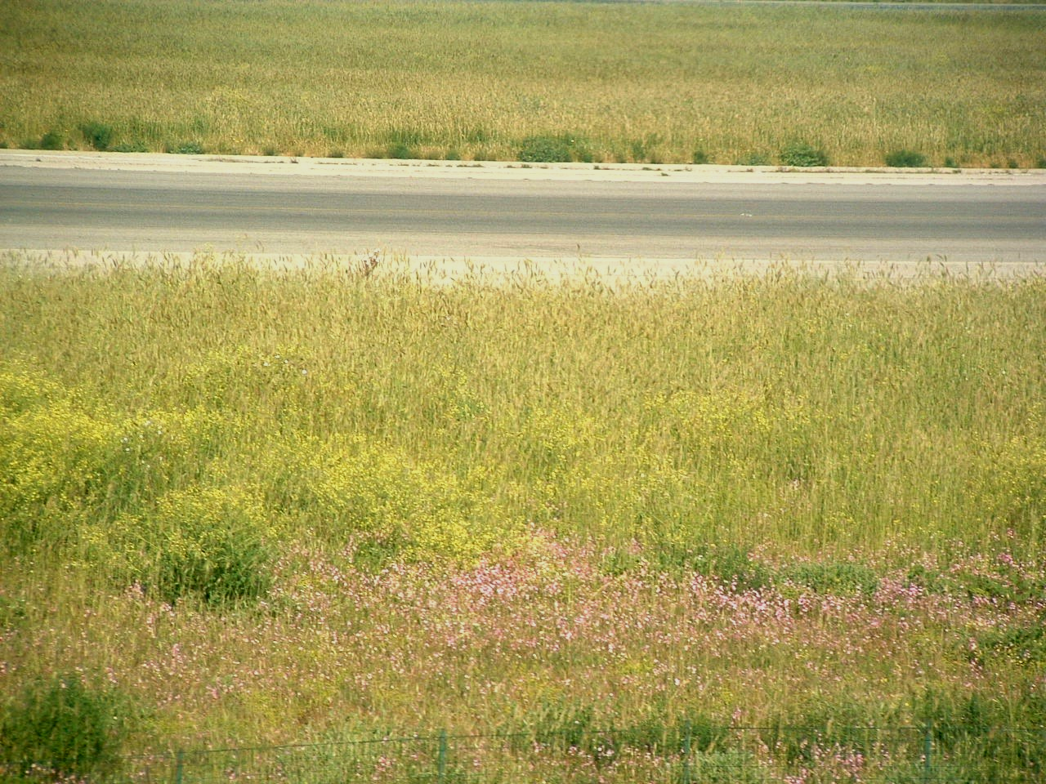

We left the plane and passed through immigration and customs easily. We had the choice of a 30 Euro (€) train ride with the bags plus a 10 € taxi to the hotel, a taxi for about 100 € or a shuttle bus for 65 €. We took the shuttle and were checking in by 10 AM. The official € was $1.45 but charges were from $1.60-1.80/€. During our three week stay the rate was as low as $1.17. The hotels were paid in advance in dollars.
Major roadside vegetation on the way to Rome consisted of yellow gorse (Ulex europaeus) and white myrtle shrubs (Myrtis communis) and false acacia (Robinia pseudacacia) trees that I, at first, thought were locusts. The route was mostly pasture and hay with trees along the ridges and bottoms. Numerous bright red Common Poppies (Papaver rhoeas) lined the right-of-way.
We got sort of a tour of the city since we were the third and last to be delivered to our hotel. The old city wall of Rome. The Coliseum. The Roman forum. The Circus Maximus.
This log contains observations and generalities. I’m not going to go into detail of the things seen if details are already readily available elsewhere.
Our hotel, the Grand Hotel Fleming, was relatively new. The room was on the fourth floor and had a bath and a balcony. The bath was crowded with a bidet, toilet, large pedestal sink, and a tub that was about two feet wide and 30 inches deep. The shower was on a hose. I forgot the electrical adaptors kit and could not plug in the razor or computer, and the hotel did not have one to loan. There was a fire suppression sprinkler head, but I saw no smoke detector. A continental or American breakfast was included.
Lunch on this day was at a restorante recommended by the hotel. It was a couple blocks away and served mostly pasta. Carol had spaghetti and Coke light, and I had dime-size ravioli with an Italian beer.
Back at the hotel, we arranged for three tours through Vastours. One covered the Trevi fountain, Pantheon, Piazza Navona, St. Peter’s basilica, lunch, the Roman forum, the Coliseum, the Capitol and St. Paul’s cathedral. Another tour covered the Vatican museums and Sistine Chapel, lunch, St. Mary Major, St. John’s in Lateran, the Holy Stairs, the old Apian Way, and the Catacombs. A third tour was to Naples and Pompeii.
For the afternoon and evening, we took a taxi to Piazza Navona. The plaza was two blocks long and one block wide with three fountains. I was surrounded by a church and several office buildings, antique shops, and a lot of sidewalk restaurants. The plaza was scattered with artists, vendors of purses, sunglasses, etc, and an assortment of mimes and musicians. Artists ranged from oils and watercolors to ink sketches. Subjects ranged from collages to copies of classics to landscapes and street scenes. Several were very good. We bought an unframed oil painting that we neatly rolled for transit. Many of the vendors selling purses and sunglasses were Africans from various countries. Pakistanis walked around with bubble guns and other small items.

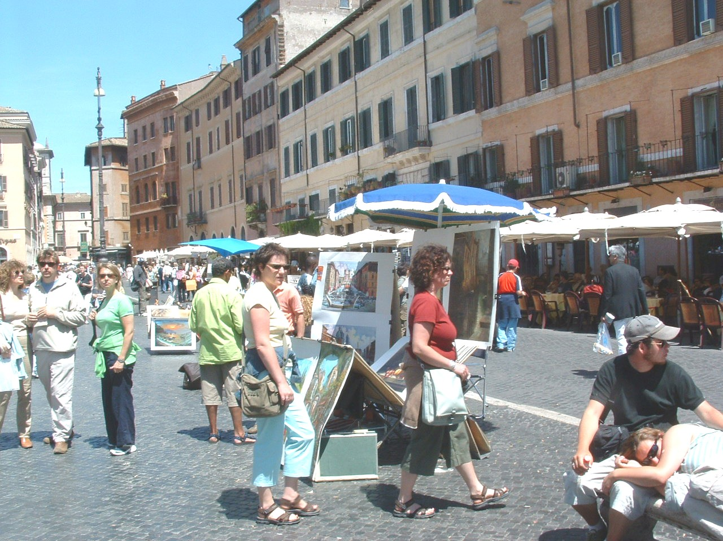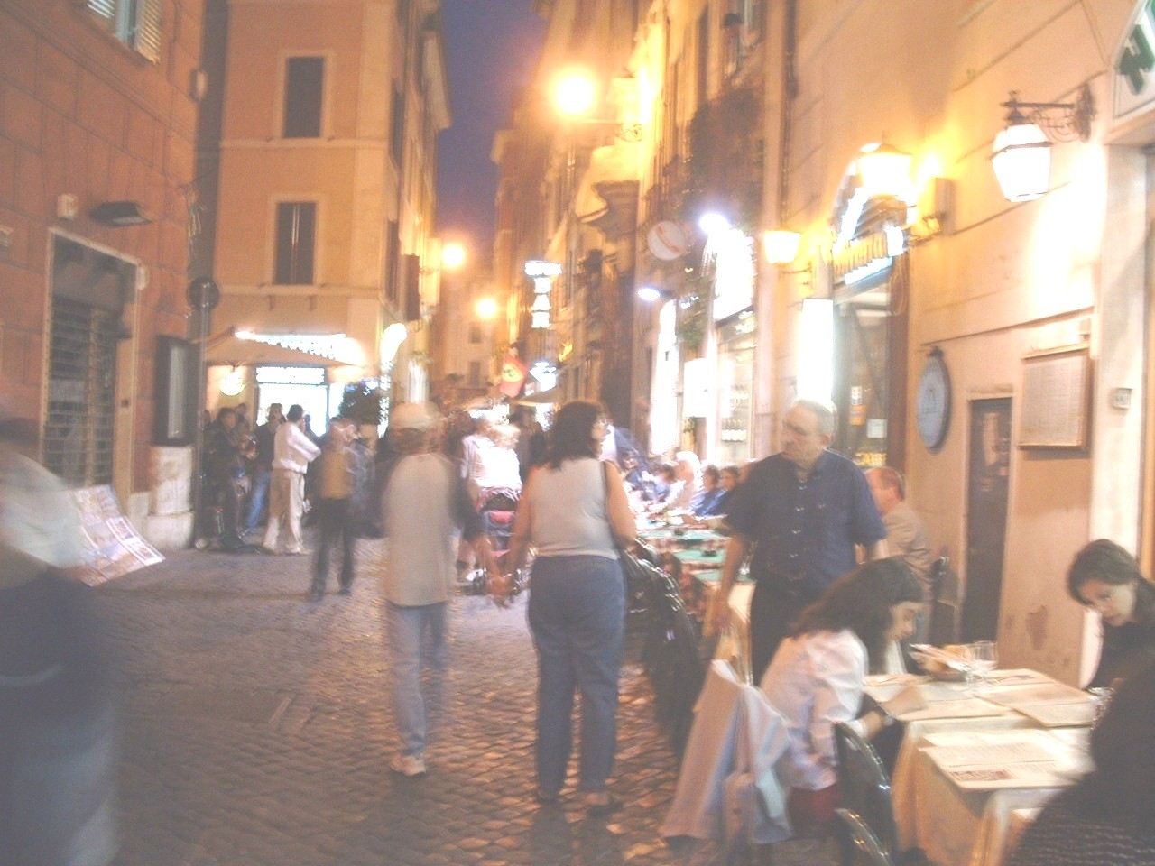
Piazza Navona

We split a pizza and a 3€ liter of water. I had a local beer. All the artists packed up by 8 PM so we did too and took a cab home.
Wednesday morning dawned overcast with a little ground fog. From the balcony, Rome was quiet. A landscape of tile roofs and a zillion antennas in the morning sun. A blackbird or European robin (Turdis merula) was singing. A hooded crow (Corvus corone) cruised by. House Sparrows (Passer domesticus) and spotless starlings (Sturnus unicolor) were twittering about. Temperature was 18°C (in the lower 60s).

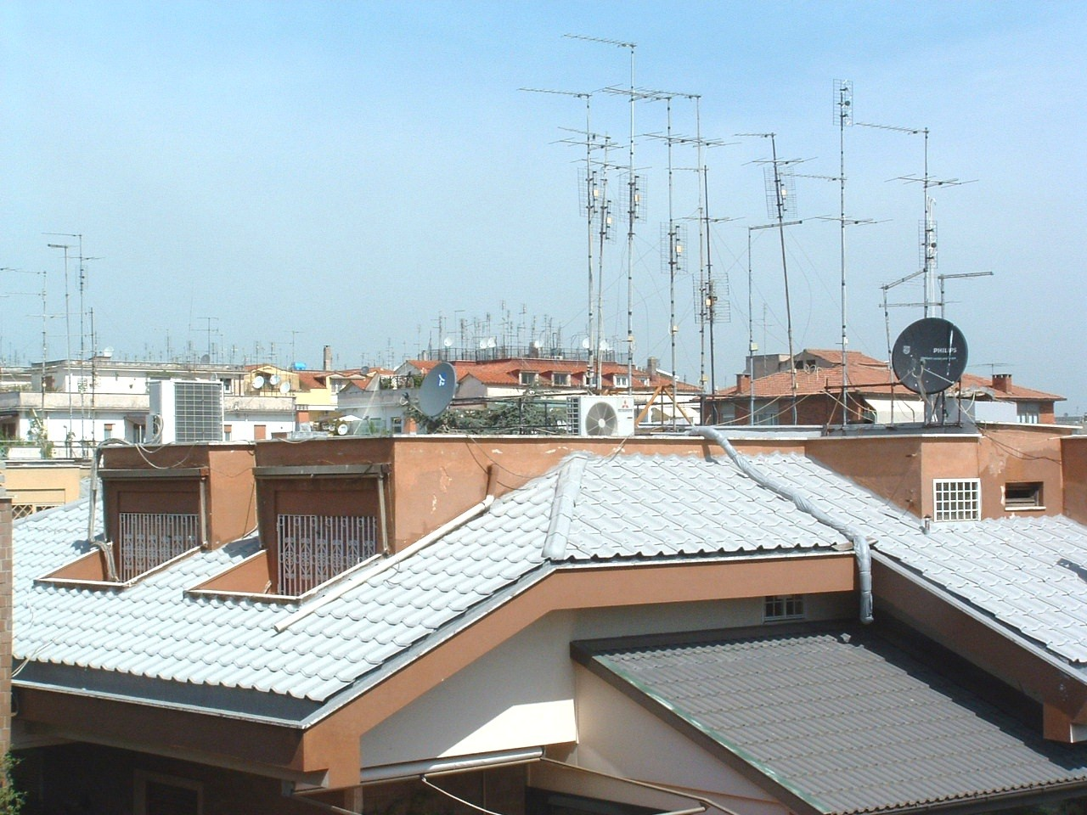
After breakfast, we waited to be picked up for our tour. They called the hotel to tell us to take a taxi to their office at their expense.
Our first tour took us to the Vatican museum, the Sistine Chapel, and then to Vatican square.
We arrived at the Vatican museum and joined a block-long line of tourists and school kids that only took about 20 minutes. When we passed through the gate we entered the Vatican, an independent country.
A metal detector checked everyone before entering the museum proper. Ticketing was followed by a ride up an escalator under the “world’s tallest dome”.
The museum was the former Vatican Palace, built in 1377, covering 13 acres. The first gallery was the Stanza di Rafaela or rooms of Raphael. Pope Julius hired Raphael to paint biblical and historical scenes beginning in 1503. In the Signature Room, hung the only picture with the signature of Raphael. The path led through the Chapels of Nicholas V and Urban VII, then to the hall of statues, the hall of maps, and several self-contained museums including the Vatican Library, the Museum of Pagan Antiques, the Ethnological Museum, and the Historical Museum. These were followed by a visit to the Sistine Chapel. Many of the works had been recently cleaned. The newly restored Sistine Chapel was outstanding with faux drapes on the lower wall and paintings of the life of Jesus and Moses on the upper walls. The ceiling was covered with scenes from the Old Testament. (Consider breaking up this paragraph.)
It is remarkable that Raphael (also known as Santi) and Michael Angelo both painted friends and enemies into their frescoes the way Dante had written his friends and enemies into the Devine Comedy.
Panic time. At the Vatican bookstore, I discovered my card case with two credit cards, my driver’s license, and military ID card were missing. I thought I had left it at the tour office. The tour people had handed me my credit card and the slip to sign for the trip and announced the bus. Since I am not into multitasking, I might have left the card case on the desk at the Vastour office. Vastour people claimed not to have seen it. Our guide suggested that it could have been pick-pocketed by one of the Capitol of Catholic Christianity’s less than honest customers. Later we visited a police station to report the loss and, after waiting an hour, the fat officer said he did not speak English and besides it was quitting time. Since the credit companies did not require a report we gave it up as a lost cause.
We left the museum and went to Vatican square. Looked just like it did on TV when the new Pope was chosen, with a few less people. Some of the Italians were unhappy with a non-Italian Pope, calling him Papa Boche the French slur for the Germans.
Lunch was included in the tour but was mediocre at best. Antipasto was limp grilled zucchini and fava beans. This was followed by pasta with white sauce. The meat course was veal. There was a carafe of wine and a liter of mineral water. Desert was a flake pastry.
We cancelled the afternoon tour to return to the hotel and try to cancel the credit cards and traded that tour for a night tour of Rome that was a flying tour of many sights from the bus. It was a tour in Italian, German, Spanish and English, the kind that if you quickly look over your shoulder you might see what we just passed. We made a stop at the Fontana di Trevi and tossed pennies to assure a return to Rome. We abandoned the tour at the Plaza Navona and got a cab home.
Thursday. Several 1-800 calls finally got the credit cards cancelled. The MasterCard representative was reluctant to replace the card but his supervisor agreed to FedEx (for $35) a replacement card to the hotel by Friday. Visa said that San Antonio Credit Union, where we have had a card since 1982, had refused to replace it. On returning home, we climbed the SACU chain of command chomping all the way. Finally, an officer said they did send emergency replacement cards, and the clerk had not been properly trained. He also said they required that anyone leaving town notify them and the credit card company that of the trip or they would block the card. He apologized for any inconvenience of stranding us in a foreign country but it was for our protection. He would see that his customers were notified of this requirement.
As Plan B, we called our son to send money through Western Union. Picking up the funds proved another goat rope and required another call home since the recipient name did not exactly match the name on the passport and we did not have the confirmation number.
The Western Union offices were at the central train station. This was functional and a nice looking structure. Inside, were three levels with lots of shopping. There were 30 covered platforms for tracks or “bins”. Outside were several outbuildings selling newspapers and souvenirs. Every corner and anywhere out of sight, smelled like an outhouse. Not a bad place to pass through but not a pleasant place for a walk or lunch.
We visited the US Embassy, and that was a waste of time. They said if I went to a police station and called them they would provide an interpreter. Since the passports were not involved they have no obligation to do anything. They could provide an affidavit to use to collect the money from Western Union for only $35 in a day or two because they were shorthanded with training. To top things off, the only toilet available to non-embassy employees was closed.
We had cancelled the morning tour and took the afternoon tour of the Roman Forum and the Coliseum. It began near the pyramid that Cleopatra wanted built for her burial and the old Roman wall. We drove past the Capitol with the Palatine hill behind it. We began near the monument to Victor Emanuel, passed Michael Angelo’s New Museum, the Piazza di Campodoglio and Capitol Hill, then into the Forum. The Arch of Settimio Severo. The Basilica Aemilia, and many other remains of buildings and temples. The Coliseum. The Arch of Constantine. Then a relatively long ride to St Paul’s.
I saw some Alexander’s along with other wildflowers and a blackbird in the Forum along with swifts darting through the cool damp air.
St. Paul’s was unique in having 80 one-piece granite columns. There was a lot of gold trim, a malachite altar and a copy of a Raphael painting in mosaic. The gift shop had mosaics and pictures. Large 20X30” were several thousand €. Smaller ones were a few hundred and 2 in squares were about 80€. The mosaics were neat art all made by the Vatican mosaic shops. We drove back to the area near the pyramid and were transported home.
The tour description did not mention all the steps in the Forum or the uneven slate slabs, cobblestones streets and few handholds. This was not a tour for the handicapped.
We tried a restorante across from the hotel. I had squid and a local wine. Pretty good.
Late that afternoon we took a cab back to Plaza Navona and shopped the artist stalls. We walked around the Benini statue of the four rivers with a tall column and a bronze dove on its top.
We walked a block to the Pantheon, the oldest church in Rome that had been a Pantheist temple to Gaea or Mother Earth. Roman Consul Marcus Agripa had built it in 27 B.C. Hadrian rebuilt it in 119 A.D. One chamber with five walls and the demon hole or oculus in the center of its 141-foot unsupported dome. In the sixth century the Venerable Bede commented that the hole had been made by demons escaping when Pope Boniface IV consecrated the Church. The tomb of Rafael Santi (1483-1520) was moved to the Pantheon in 1759. It was closed for restorative work.
Friday. Our ride for the trip to Naples was ready at the hotel by 0645. We were on the bus and off to Naples by 0730. The mountains began half-an-hour south of Rome. This was Highway 6 which was the road to Rome in WWII. This replacement highway was well designed and in good repair. Thick wildflowers lined the highway – red poppies, white Myrtle, yellow Gorse. There was a field of red clover. Vineyards and peach orchards in bloom were scattered across the hills.
Old houses were scattered through the hills with poodle pines and olive groves. Power lines and their right-of-ways blemished the hills.
We made a pit stop at a restaurant just off the turnpike that must have specialized in tours. There were ten busses there by the time we left. Landscaping was somewhat tropical with Canary Island palms, false bamboo, gardenias, pyracantha, pines, spruce, creeping juniper, and seasonal pansies. There was an adult locust eating pyracantha leaves. This was the site of San Angelo which had been destroyed in February of 1944 as the first battle in taking Montecassino.

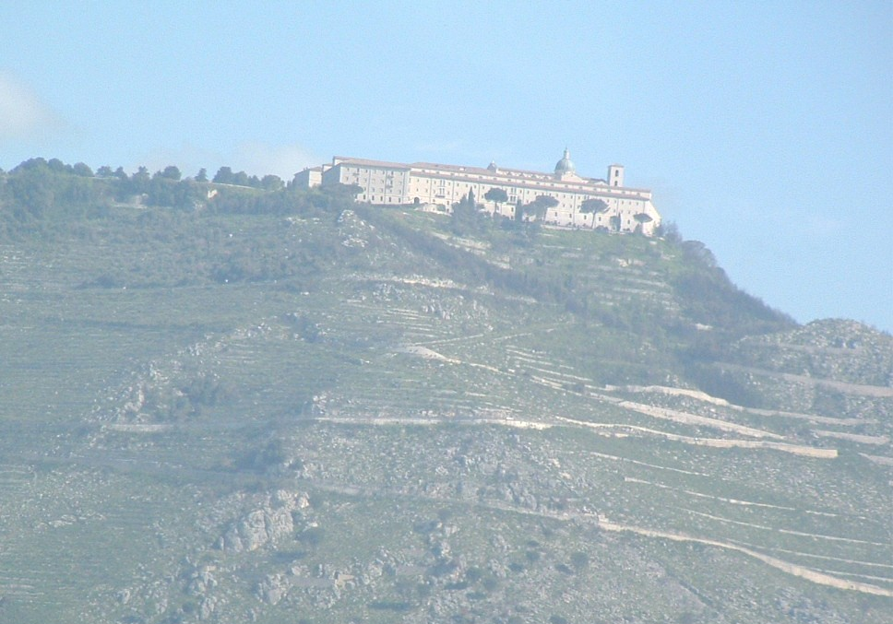
Montecassino

The road passes the town and below the monastery of Montecassino. The monastery sits high on a hill overlooking the village of the same name. This was the site of a four month battle, February to May 1944, to dislodge a strong German force in the monastery. The monastery was heavily bombed in February but the monastery was not taken until May when the 200 remaining German paratroopers retreated. This battle cost 180,000 casualties. It was rebuilt as its fourth incarnation in the 1960s.
The roads were lined with False Acacia trees and spiny Gorse. Grape arbors were of several kinds - concrete or wooden posts with wire strung between them; a V-shaped frame of two wooden stakes; or a single stake. Grapes also covered some of the fences. Gardens contained orange and lemon trees as well as assorted vegetables. Several fields were colored red or yellow with clover and Brassica. The sky had become overcast with possible showers.
Further down the road we passed through Caserta with its huge royal palace and the home of fine porcelain makers. Caserta, called Castle Hill in WWII, was the second objective after San Angelo in the Battle for Montecassino.
In the NE edge of Naples in the industrial district were numerous shade houses (similar to standard green house but open sided) that reduced the hot sun for growing vegetables and flowers for the market.
In Naples, we drove past the old French capitol, the Palace, the opera house, etc, then into new Naples with several big parks, lots of hotels, the old fleet landing, Castile de Ovo and the new harbor. There was a rest stop, and then the drive back the same way and on towards Pompeii.
My first time in Naples was in 1962 after a long military flight. We were told specifically not to bring anything along since the carrier USS Independence would be at anchor in the Bay of Naples by the time we landed. Never happened. We were shuttled from Capo do Chino airport to the Hotel Mediterraneo and lived in our scroungey orange flight suits for three days of flying, shopping, sightseeing, and lots of beer (with the exception of the flight commander who had civvies with him). One night we took a horse cab back to the hotel and I drove. We lived in the hotel for a month flying for NATO before going to Athens for a month. This was in the midst of the elections with sixteen political parties having rallies all over town so we shared in their salami and wine, hollered for their candidate, and then went to the next rally.
Naples was still had high crime and high unemployment. I asked if there were still “pistoreas” along the streets and urinals up the alleys. Pistoreas, like the name implies, were screened sidewalk urinals where men could do their business while talking to people on the street. Our old man guide said there were still a few but our young female guide said she had never heard of them.
We passed more shade houses raising vegetables and flowers. The volcanic soil around Naples is rich, but the weather gets cool in the winter.
There was a stop at a cameo factory that I had visited in 1962 where I had bought a cameo for my mother. Carol bought a pair of coral earrings. They had cameos and other items running from cheap up to the thousands of euros.
In 1962, I visited Pompeii and Vesuvius and went down into the crater. Herculaneum had not been excavated yet. I also took a trip down the Amalfi coast to Positano and Sorrento. Our current tour was to Pompeii only.
We passed into Pompeii and parked at a restaurant for lunch of five courses with antipasto, pasto, primero, secondo, and desert. I had fish, and Carol had veal. I split a bottle of Lacrema di Christo, the “Tears of Christ” wine with another couple. It was a little too dry for me.
We entered the west gate into Pompeii. The area excavated was at least twice the size I saw in 1962 and some of the displays were different. They rotate the display houses to allow for maintenance and efforts to stabilize the frescoes.
One change was the home of the bachelors where the frescoes and an erotic statue that were highly controversial in the prudish 1960s were on display without paying extra, and women were allowed to see them. (Men had been allowed to see them for an extra hundred lira.) Also, some of the casts of the victims were on display. These death casts had been made by filling the fused-ash molds of people and animals with plaster. Some new excavations were underway such as a dining room where spaces were found under the floor for cool storage wine, etc.
Details of Pompeii are available in books and History channel videos.
The overcast turned to rain, but it was a short warm shower. By the time we left, the weather had cleared.
We exited the site to catch the bus. There was about 20 minutes to shop and snack before we left. I tried one of the local oranges – very good Valencia.
One thing I noticed was the lack of kids hustling tourists with objects like “flying cock and balls” charms representing the sign of the bawdy houses of old Pompeii and begging cigarettes and money.
I don’t know if the infamous Naples wolf packs of kids were still around. They were the bane of safety to a solitary sailor
The bus charged back to the crowded rest stop then back to Rome. and were at the hotel about 2100.
The credit card arrived as promised.
Saturday. Early morning was quiet. Clouds were gone and the sky was black with stars. Italy is pretty far north and the bottom of the big dipper was directly overhead.
There was a problem with the GPS - no satellites. The walkie-talkies worked fine.
We visited a neighborhood supermarket. They had about the same as a 7-11. I was looking for an adaptor so I could plug in the computer, razor, hair dryer, and clippers. We tried a medium-size department store and a larger grocery supermarket and a retail electronics shop each of which sent me somewhere else. I passed an electrical supply house that had just what I wanted and cheap.
I passed a patch of Mallow-leaf Stork’s-bill (Erodium malacoides) and Hedge Bedstraw (Galium mollugo) in a vacant lot.
We went back to the Piazza Nuova for the afternoon. This piazza has been the social center of Rome forever. Artists and vendors of all kinds were out. We found another painting, had lunch at an outside pizzeria, and went back to the hotel to wait for the limo.
I walked around the local Plaza Fleming and photographed some anti–Bush graffiti. Italy was big on the siesta from 1300 to 1600. A grocery had just opened so I bought a bottle of water, a couple apples and half-dozen loquats that were as large as large eggs and weighed about 70 gm each. I saved the seeds. Maybe Mr. Moy can grow some.
There were a few English sparrows and pigeons. A white cabbage butterfly with black spots on the upper wing was flying around a potted flowering lemon tree. Kids used to get a lira each for the butterflies that produce a big agricultural pest.
Rome and Italy in general look like crazy driving. They drive aggressively but at speeds of only 20-30 KPH. Cars, busses, scooters, motorcycles all get along, and pedestrians still have the right-of-way.
I looked at Rome and Naples with a different perspective from the one I had in 1962. Italy has a historic conscience that is rare in the US. They have sacrificed a lot of comfort and efficiency to retain historical context. Although the various wars over the past 200 years and the massive amount of damage they’ve done, gave opportunities to tear down, rebuild, and upgrade the infrastructure, the old structures and streets were mostly retained and rebuilt partly because there was no captor or occupying force or money. Many other places under US or Russian domination were bulldozed, redefined and built from scratch like Berlin or Agana, Guam. It is difficult to build in an area where the soil cannot be touched without uncovering historical artifacts. Of course, progress is expensive and the tourists love the primitive, and historical and different are a major source of income.
At 1730 the limo driver picked us up for the 30 KM drive to Civitavecchia in a new Honda Maxima with leather seats. Land along the highway was scattered farms and wooded hilltops. Sheep and some cattle were grazing. We drove down the Viale Garibaldi passing a number of passenger ferries, tour boats and a respectable fleet of trawlers tied up along the dock.
Civitavecchia is the port on the Tyrrhenian Sea that services Rome, Sardinia Corsica, and several Italian cities. Civitavecchia and neighboring town of Corneto are part of an ancient fortified port facility (the ancient Centumcellae) dating back to the Emperor Trajan. It was built on the ruins of an important Etruscan outpost called Tatquinii with Etruscan tombs and archeological sites. Christian catacombs date to the third century AD. There is a large stone fort and customs house and several grain elevators along one of the docks. We were at the ferry terminal at Civitavecchia about 1830.
We checked in and Carol decided to try the local McDonalds instead of the terminal snack bar. Burgers had tomato and cheese but no lettuce and the fries were crisp.
I checked out the men’s toilet. There were no urinals and the crapper had no seat. Most remarkable was that the toilet was set on a grating. I guess this was efficient in keeping the place clean. I don’t remember but one public toilet in Italy that had a seat. The most unique toilet was in the train station in Pisa with a half-euro entrance fee. The stalls were lit with purplish UV light to help keep them sanitary.
I took a walk along the dock watching gulls and swallows. Besides McDonalds, there was a Chinese takeout and several shops including a tattoo parlor and surf/dive shop. There were seats and an elevated view of the harbor and a kiddie carnival for the kids. We were on board about 2000.
The cabin was two bunks and a bath. Since the tourist season had not begun yet, they had extra rooms, so we were allowed to put our five bags in the adjoining cabin for the trip to Sardinia.
The ferry had a dining room, a snack bar, and a bar/lounge. We left at 2100 into the setting sun for the 125-mile run to Golfo Aranci.
Sunday morning I was up and showered and on deck by 0530 to see the sunrise. Morning temperature was about 15°C and smelled of the sea. The hills were green as we passed Cape Figari and approached the harbor. Yellow-leg and Common Gulls (Larus michahellis and L. canus) were checking out our wake. White houses with red tile roofs speckled the hills. What looked like a jagged mountain range stood purple in the morning mist. Actually the mountains were no more the 400 M or 1300 feet.
At 0700 we docked in Golfo Aranci and disembarked onto a bare asphalt parking area a couple of acres square. Other than a couple cars, we were the only passengers. The tourist season would not start until mid June so museums would not be open, tours were unavailable, and tourist facilities were still being readied.
There was a bar and newsstand with a phone about half a mile away where I called a cab.
The ride to the airport gave the first view of the ecology. This is maquis country with myrtle, thorny gorse, and numerous wildflowers.
It was 20 KM to the Olbia airport where we were to pick up the rental car. The airport was modern and well managed with lots of commercial and private flights. Next time I will know better and fly or land in the port of Olbia.
Hertz did not say they had an office at Cannigione where we were staying. This would have saved a hundred euros in taxi fares and allowed for a smaller car. I had reserved a little Ford, but since I could not drive with my license stolen and the car was not available, and the luggage would not fit in a compact we wound up with a Mercedes diesel with six-on- the-floor for only three times the price for Carol to learn to drive.
We were on our way and arrived at our condo about 1030. The road was almost a continuous switchback two-lane blacktop with numerous steep cuts and steep grades. Much of the road had concrete curbs but no shoulders. Lots of wildflowers were in bloom but most were mowed by the end of the week.
No one had used the unit the previous week so they did not make us wait until 1500 to move in. The condo consisted of a living room, a kitchenette, one large and two small bedrooms, two baths and a front and rear patio.
We moved in and did the inventory then went out for lunch. The office recommended the Anchor. We ate there three times, and it was outstanding. This first time, I tried fried Dory and a local red wine. Apparently, Sardinians drank red wine with seafood. Carol got veal cutlet and Coke light. We got an order of fresh focaccio and ordered Seadas for desert with a local white desert wine. Seadas are cheese and lemon peel fried fritters served with local bitter honey. Bill was 48€.
Back at the ranch, I went to the beach, and walked a couple miles. The path to the beach was half a mile through maquis of Holm Oak (Quercus ilex) and Mastic (Pistacia lentiscus) shrubs. Several ponds with cattails (Typha latifolia) and giant reed (Arundo donax) supported a population of Painted Frog (Discoglossus pictus), Common Toad (Bufo bufo spinosus), and Green Toad (Bufo viridis). There was also a tidal marsh with Sea Rush (Juncus maritimus) and Sharp Rush (Juncus acutus) with Coots (Fulica atra) and Moorhens (Gallinula chloropus), a Little Egret (Egretta garzetta garzetta), and an occasional Yellow-legged Gull.
At the beach, the water was clear but cold, and the shells were mostly broken. A list of those shells is included with my other lists. The sand on this beach was granite with a few pebbles of white limestone. A pair of Dunlins (Calidris alpina alpina) was spooked and flew into the maquis. Sea rockets (Cakile maritma) and Sea Bindweed (Calystegia soldanella), a beach morning glory grew in the sand. Small black army ants had a roadway cleared to their mound. No mosquitoes but numerous midges and crane flies.
I walked home along the top of the beach with lots of wildflowers.
We went to the condo snack bar for supper. I had a seafood salad and sampled both the red and white wines. Carol had spaghetti and meatballs (a special order since this mixture was not a common Italian dish) and Coke light. Then we each had a dish of ice cream. Came to 28€.
It was dark and clear and the bottom of the Big Dipper was straight overhead. At least three species of frogs or toads were singing.
Monday morning we were up early to see the sunrise and went for a walk on the beach. The wildflowers opened as soon as they were brushed with sunlight. There was a white butterfly with black spots on the forewing and a small blue butterfly that just sat there instead of being jumpy like the Blues. The beach was cool and totally empty.
We stopped at the snack bar for breakfast then drove north along the water and past the lighthouse to Palau. On the way was another beach, so I stopped for a look. Schools of small fish crowed against the shore. I found several small delicate abalone shells (Haliotis terberculata – the Lemellose Omer) and some limpets. A tidal pond across the road had a Little Egret wading around, feeding.
We drove into town and, after several wrong turns and passing the ferry landing twice, found a waterfront with several restaurants. I had squid and a local Sardinian beer, Ichnusa. There are some advantages to not driving.
Once more around town and we found the right road to Santa Teresa Gallura and its lighthouse. There were several small communities that did not appear on the map.
We were back home about 1700 just as the grocery store was opening. We bought makings for a green salad and ham and cheese sandwiches, along with several liters of bottled water, cold cereal, milk and fruit. I stopped at the snack bar for beer and an ice cream cone.
Tuesday morning came up overcast. We got BBC on the TV, and they said a front was coming in over Corsica and northern Sardinia. Sure enough.
Looking over the condo, it was built at low cost for easy maintenance. Concrete block, paint, and tile. The only two plugs that would take my adaptor were in the bathrooms. I charged up the razor, but I was not enthused about sitting on the toilet to use the computer.
European blackbirds (Turdus merula) were hopping on the lawn. Cetti’s Warbler (Cettia cetti cetti) was calling and picking up stuff for a nest. The Common Swift (Apus apus apus) and the Barn Swallow (Hirundo rustica rustica) were feeding of flying insects. European Turtle Doves (Streptopelia decaocto decaocto) were calling in the maquis. Flowers (Centaurea pullata) were growing in the “green roof” dirt insulation on the roofs down hill from our unit.
We headed off to Sassari. Entering Olbia we, took the branch to the right that led to downtown and wandered around a half hour trying to find our way to the highway. It was about 100 KM of good, two-lane blacktop bypassing most of the little towns. We took a couple detours to look at the countryside. One stop was Berchidda at a Museum of Wine Making that was closed. Lots of vineyards and sheep. We tried to find a couple of the ancient nuraighi sites, but the directions were bad. We finally arrived in Sassari and made a big loop through town without seeing a parking place or a place to eat.
We went on down to the 12th century city of Alghero, built by the Doria family of Genoa. We found the walled old town sector and a parking place on the waterfront near all the yatchs. Entering through one of the old gates we stopped for lunch. I had prawns and red wine while carol had a green salad and a pizza with mozzarella. We wandered along most of the old narrow cobblestone streets passing the Duomo and many old buildings. Several shops sold coral jewelry. Two shops sold seashells from the Philippines for inflated prices. At siesta time, most shops closed. We headed back about 1600 and were home in about two hours.
We stopped at the condo office and visited the snack shop for pizza and then visited the craft shop with examples of cork ware, weaving, pottery, and other local arts. Carol dropped off two sets of clothing for laundry that would be ready Friday.
Wednesday morning we scheduled a trip to the islands off the north coast. I walked over to the office through wildflowers. I watched a Cetti’s Warbler flying a couple wing beats up a couple feet then glide dropping a couple feet. At the office was a dead locust that may have been blown in from Africa.
We drove about 2Km to the dock and boarded the tour boat. The boat made about a five minute run to the dock at Cannigione for more passengers then another a ten minute run to Baia Sardinia for more passengers. On every rock sat one or more Cormorants (Phalacrocorax carbo sinensis). There were also some Yellow-legged Gulls.
The weather was overcast and cool. We passed Caprera Island, where Garibaldi had lived and passed the waterfront at Palau and St Stefans Island before landing for 45 minutes at the port of la Maddalena on Maddalena Island. This was a nice little town of about 4000, mostly fishermen and merchants.
We were served a spaghetti lunch on the way to Santa Maria Island and stopped on the Island of Spargi. I walked the beach and found no new shells. There were several new plants, Greek Spiny Spurge (Euphorbia acanthothanos), two kinds of ants, the Common Wall Lizard (Podarcis muralis) and several piles of rabbit droppings. One person did some snorkeling. We chugged back home and were in the condo by 1700.
Thursday morning was partly cloudy and cool. We had been present for the peak of the flowers and now the edge was off. After breakfast, we went to see a travel agent to book a hotel room near the airport to await our return flight. He charge 25€ for his services. Every body tries to get in your pocket. Carol picked up her laundry for 28€ or almost $40.
We took a ride over to the Costa Smeralda. This included Baia Sardinia, Porto Cervo, Capriccioli, Portisco and Porto Rotondo. We drove into each village and through the civic center, then out around the harbor with the fancy yachts, then out to see the homes and condos. We were back home about 1600.
I looked at the vegetation in the lawn. The weeds were familiar cosmopolitan invasives like Dichondra and Creeping Charlie.
Friday we took a ride to Nuoro, which had four museums advertised. It was a nice 100 KM drive. We stopped for a flock of sheep being driven down the highway. One of the men was controlling traffic on one lane. Not many wildflowers but there were several Alexander’s, some large geraniums and purple as well as red poppies.
The town was much easier to find than Sassari but was just as crowded. None of the museums were open, which made little difference since there was no parking. Wonder how crowded it is during the actual tourist season? There was a real live parking lot where we stopped for a few minutes while looking for information on the museums. One of the local city employees said the museum was only three kilometers away and we could walk there in an hour. It was 1230, and siesta began at 1300. We got lost up on the edge of the hill with tight steep turns so I got to drive for a few minutes.
On the road back, there were no places to eat. We drove through several small towns but between the small and siesta time there was nothing. Even the gas stations were closed. Back at Olbia, we found a mall near the airport and had lunch. Mediocre fast food.
We went to Porto Cervo to return a shirt that was too small and arrived just as siesta was over. Nothing in the shop, including extra and extra extra large fit across my shoulders since I am neither young nor Italian.
We went to the Anchor for supper. I had fried squid, and Carol had veal. I tried another red wine. For desert, I had Sedas, and Carol had a hot chocolate pie. We ordered Porceddu (roast suckling pig) for the next evening.
We watched TV for a while. Both CNN and BBC repeat themselves every half hour. Watching these stations give a better picture of the world where the US is not the center of the universe. Politics and finance do happen on other parts of the planet. Most of the world was unhappy with Bush and the Bolton nomination. Most US tourists who travel outside the US bring back trinkets instead of new ideas or viewpoints.
Saturday morning came up overcast, and it had rained overnight.
We went over to the office and told them we would be leaving early Sunday morning. I walked back along the trail to the condo and met a British couple photographing wildflowers. They had seen a small Grass Snake (Natrix natrix) and a small turtle (Emys orbicularis) along the trail to the beach.
We cleaned up and packed, then took a ride back to Porto Cervo and returned in mid-afternoon. I went down to the beach and found several new plants and was back about time to go to supper.
The Porceddu was ready about 1930. The pig, as served, weighted maybe ten pounds which was really too much for two people. I had a couple beers, and we had the hot chocolate pies for desert. This was similar to the luncheon or barbequed whole pig in the Philippines and Hawaii that are buried and cooked over night. The piglet was roasted on a spit about 2-3 hours and served with roasted potatoes. It would have served four to six people.
Sunday morning we left about 0730, dropped the key off and headed for the airport. We stopped to fill the car, 28 liters (7 gallons) at 1.4€. We dropped the bags at the airport and Carol turned in the car while I took everything inside.
The terminal was large and modern, and the airport was busy with commercial and private traffic. Nice. Genoa. Zurich. Rome. Venice. I had been told there were no flights to Venice.
We read and walked around until about 1800 and took a taxi to Golfo Aranci for the ferry. As we crossed the bridge over the channel at Olbia, a celebration for the patron saint was taking place.
When we arrived at the ferry landing, the ferry from Genoa was unloading. It left for Cagliari and our ferry docked. Although we were the only passengers to embark, there were numerous students heading back to school that had embarked at Cagliari. We stuffed everything in the room and went to supper.
Monday morning I was up to see the sunrise and the docking. We had breakfast as we docked at Civitavecchia. The students got off first and we were the last.
In the terminal, one of the local policemen called a cab for us to take us five blocks to the train station. Trains to Pisa ran every hour so we only had a few minutes to wait.
Getting five bags on the train was good exercise – up and down two flights of steps and under the tracks to track or “bin” two and then getting the bags onto and off the train. There were no seats and baggage storage was not available so I had the pleasure of standing in the landing with the luggage. There were signs saying reserved seats, but I saw none. Reminds me of standing or squatting in the aisle all night getting to Switzerland 40 years ago with students – girls with unshaved legs and combat boots and long-haired guys that had not bathed since forever. I had bought tickets for a compartment that was not available.
The ride was through Tuscany with rolling hills with woodlands, grain fields, vineyards, olive groves, orchards, and fields for cattle grazing occasionally along the coast. There were many old houses and a lot of new homes. Cities were a mix of old brick and new glass. Lots of graffiti. Not what I had pictured.
Just outside of Livorno, several men were spraying herbicide on the roadbed and right-of-way. I saw a magpie in a grain field.
As a whole, a drive or train ride through Missouri would have been as exciting and a lot less expensive. Farmers were doing farm work. Major difference I saw was the brand of tractors and the architectural details. Towns looked like any town along a railroad track in midday. Allowing for stops at Grosseto and Livorno, we arrived at Pisa a little over two hours later.
We crossed the Arno River. The area between Livorno and Pisa was marshlands and a number of streams in the valley of the Arno.
We arrived about 1100 and got the bags off and into the terminal. The Hotel Touring was about two blocks away but Carol insisted on taking a cab for 8€. I think we got took since the drive was considerably more than two blocks.
We checked in and went to a restaurant the hotel recommended. There was an overtone that we were intruding on the Italian lunch hour. Of course, seating us in a back room by ourselves and giving real slow service may have been considered an honor.
After lunch, we walked four blocks along the Corso Italia to the Pont di Mezzi crossing the Arno and return. We stopped in many shops, looking at clothes, shoes, and jewelry noting and prices. Seemed like all the all the clothes and shoes were 100+€. (Reread the preceding two paragraphs. There are places where words are mixed up or seem to be missing.)
Tuesday morning we were up and hit the hotel breakfast - rolls, jam, and weak orange juice. We walked back along the same street to the Arno, crossed the river, then four blocks along a street that changed names every block to the Piazza dei Miracoli with the Duomo and the leaning tower. The front of the church San Michele in Borgo had a dozen Africans selling scarves, purses, and sunglasses.
We took a couple side trips for a flea market and to see the Piazza dei Cavalieri. The flea market contained a dozen large tables piled with cheap clothing and was surrounded by shops selling Indian jewelry and meat and vegetables.
Fuzz from sycamore trees was flying on the breeze but no trees were in sight. Looked like someone had shaken a huge rug.
The Piazza dei Cavalieri was the site of the Roman forum. It was designed by Giorgio Vasari for Cosimo dei Medici around 1560. The most striking building was the Scuola Naomale Superiore, Italy’s top university, with its facade of graffiti patterns and a statue of Cosimo I dei Medici. It was designed as the headquarters of the Order of the Knights of St. Stephan. Next-door, was the church of Santo Stefano dei Cavalieri. Across the plaza was Palazzo dell’Orologio, built around the Torre dei Gualandi and a large administrative building.
A couple blocks further, we came to the Campo dei Miracoli officially called the Piazza del Duomo. We entered the Museo del’Opera del Duomo where we bought tickets for the museum and the Composanto or cemetery. Although the Leaning Tower or Campanile was open, a ticket was 20€. There was a line since the number of people in the tower was limited and regulated.
The museum, built in the 11th centaury, was officially known as the Palace of the Cathedral Canons and the cathedral treasury. It housed a collection of models of the buildings, artifacts from previous construction projects, statues, paintings, frescoes, etc. It had several good vantage points for pictures.
We walked around the leaning tower and passed the cathedral to the cemetery and entered through a door that must have been 20 feet tall. This walled cloister forms the north wall if the Piazza. It was begun in 1277 to house a famous relic, soil from the Holy Land. There is a collection of Early Christian and Roman funerary art and sarcophagi art and is the burial place for church and local notables with mosaic portraits in the floor. There are a number of giant frescoes.
The walls surround a landscaped inner courtyard with the Dal Pozzo Chapel. We walked around the cathedral in a light drizzle. The cathedral was begun in 1064. The circular Baptistery was begun in the 12th century and passed the former hospital. It currently houses the Museo delle Sinopie with the artists outlines of frescoes under the frescoes and past the home of Galileo and the natural history museum.
We stopped at a sidewalk restaurant with a view of the leaning tower for lunch. I had pasta with clams and a red wine, and Carol had pasta and a Coke light. The clams were in the shells and small clams or broken shells made eating the clams difficult. It stopped raining, and we went window-shopping towards the botanical garden. Carol found a hairdresser while I went to the garden that turned out to be closed for the day. Pisa had very little urban greenery like trees, and even the planters by some of the shops contained dead or wilted plants. There were few birds, sparrows and pigeons, and I had heard a couple of blackbirds at dawn, singing in the rain.
I had about an hour to wait while Carol had her hair done, so I looked around the university area and admired the graffiti on the walls. “Stop Bush. Stop War.” “Mussolini Rules.” “Pisa for the Pisans.” Complaints about the mayor and governor in Italian and English.
I walked along looking at good-looking fashions for angular young skinny people. What ever happened to the rounded curves of a few years past? Many of the young females wore jeans low and had tattoos on their belly or lower back. Many were wearing new ragged jeans that cost 150€. In northern Italy, there was more blonde and brown hair and the people tended to be taller than those in southern Italy.
When the hair job was finished, we window-shopped some more on the way back to the river, then across the bridge and to the hotel. Supper was an experience. We found that most restaurants did not open until 1900 and good ones were crowded. We finally picked one. I had tripe Florentine and a white wine. Carol had a veal cutlet.
After supper, we walked to the train station to pick up tickets to Florence. The trains ran about every two hours, so we picked one at 1100.
Wednesday morning we packed up after breakfast and walked over to the train station toting our bags. Here began a half-day comedy of errors.
Shuffling five big bags was a nuisance if nothing else. I asked at the ticket counter if we could check the bags and was told where the checkroom was. (You might already get the hint that there could be a basic misunderstanding.) I told Carol it looked like baggage storage but we did it anyway at a cost of 10€. When we arrived in Florence we went to the checkroom and found I had been right - the bags were still in Pisa. We went to the hotel, checked in and had lunch and returned to Pisa for the bags.
The Tuscany countryside was largely farmed with wheat, vineyards and orchards. Infrastructure of railroads, power and water distribution, and mixed housing and light industry looked much like the NE US. Some of the small towns were in a building frenzy with new architecture. Some of the trip was along the Arno R. A small white egret and several yellow-legged gulls and a sparrow hawk cruised the river.
The train to Florence was cleaner and more modern than the one we had taken to Pisa. No compartments. Plastic seats.
The train station in Florence was better than the Pisa station. The tracks end in the terminal so no walking across tracks or up and down stairs.
Our hotel was a 17th century palace that had been renovated as a hotel, probably in the 1950s. It is the site where the Mona Lisa was discovered many years ago. There was no elevator so we told the clerk we needed a handicapped room since Carol had had both hips replaced. They gave us a room on the first floor, which in Europe is one floor up the stairs. Breakfast was just down the hall.
I took a walk while Carol rested. I was looking for a laundromat and barbershop. The man at the desk gave me directions. I passed the Chapel of San Lorenzo, walked about a block, and there they were. I got a haircut. I asked for a flat top and got a crew cut. I got the hours of operation of the laundry and returned to the hotel.
Supper was at a small place next to the hotel. Carol had pizza and I got lasagna.
Thursday morning it was barely light when the low roar of suitcase wheels began on the sidewalk as people hurried to or from the train station.
After a breakfast of rolls and tea, we left to see the city. We walked about three blocks to the Piazza San Giovanni with the Battistero (Baptistery) with the famous bronze doors by Pisano and Ghiberti and the Campanile (the Duomo bell tower) and the Piazza del Duomo then around the Duomo (Santa Maria del Fiore) to the Duomo museum.
We visited the bookstore while waiting fifteen minutes for the museum to open. The museum contained works from the Duomo and other facilities by masters including Michelangelo, Donatello, and della Robbia. Touring the museum took about an hour and a half. Then we walked about four blocks to the Piazza della Signora (city council).
We stopped for ice cream. I can’t believe 20Є for two sundaes. The streets back to the hotel were narrow and, as the sun dropped, dusky. Little shops with office supplies, wine, shoes, and you-name-it. Some had well decorated windows while, in others, the windows probably matched the quality of merchandise. I found one antique shop with mostly religious stuff and two art galleries.
We walked over to the train station and bought tickets for Rome and the airport for 1100 Sunday morning. Cost was 77Є.
For Friday, I had booked a bus tour of the town, but we found the busses were on strike for half the day. Come back tomorrow. Apparently these strikes were largely symbolic, well coordinated, and advertised in advance.
We took a taxi to the Ponte Vecchio and walked across, shopping on the way. The bridge has several stories of shops and no traffic. There were over a hundred shops of goldsmiths and jewelers. We crossed the bridge and it cost about a hundred euros each time.
We returned to the Piazza della Signora for lunch along narrow cobblestone streets with car and motorcycle traffic, parked vehicles, and little or no sidewalk. On the way there, was a pair of carbinari on horseback complete with swords escorting a small marching group with uniforms, flags, and feathered hats. These were veterans from various wars heading somewhere for a ceremony like Veterans Day.
We toured the Palazzo Vecchio. Four floors tall with rooms with 16 foot vaulted and decorated ceilings. The main hall was done in frescoes by Vasari and statues. It had a vaulted ceiling that must have been 30-40 feet high. There were rumors that Vasari had saved a Michelangelo behind one of the false walls that had been built for the huge Vasari paintings.
There was a brass band playing and as we were leaving, groups of veterans marched into a big room for a veteran’s memorial service. By the time we got outside, the Piazza was full of tourists attracted by the band. There were numerous police and military groups all in full dress uniforms.
We left and walked back to the Ponte Vecchio and a couple blocks to the Piazza Pita with its six museums that were closed for siesta. One museum, the Galleria Palatina, contained 11 Titians, 14 Raphaels, and works by Andrea del Sarto, Perugino, Caravaggio, Velasquez, Rubens, and Van Dyck.
Since everything was closed, we went to the formal Gardino di Boboli with numerous trails and formal steps leading to a formal rose garden and crystal museum. There were few flowers except the occasional weed.
We got back to the hotel and crashed for a couple hours then were out looking again and found a shop that sold Morano glass.
I looked at real estate listings. Rent ran around 1000Є/month. To buy a house, prices began about 80,000Є to 1.5 millionЄ ($2.2M)for a house 300 square meters depending on location, view, garage or not, etc. Don’t know that the wages are but this looks like an expensive place to live. I know unemployment in Naples was about 40%.
Saturday morning we packed up and put the luggage in storage for the day. We checked out and finally found the double-decker red bus like in London. We took both routes. One route went northeast through numerous plazas, past the stadium and up the hill to San Marco and back again. The morning air was crisp and cool on the open upper deck of the bus. The driver was not photography and sightseeing friendly, speeding along. The narration was provided by earphones on a multi-channel recorded program. The streets were two lane divided with trees down the middle. We went through Fiesole with lots of big villas. Plane trees. Poodle pines. Lime trees.
We changed to the other loop that went from the Piazza della Signora, through the residential section of town, across the river, through the high-end real estate to the Piazzale Michelangiolo and the Iris Garden, to the Piazza del Pitti, and back to the Piazza della Signora. We stopped at the Michelangelo statues. The site overlooks Florence and the Arno. We had a coke and found that the Iris garden was closed until 1500. We caught the next bus and got off at the Pitti Palace to walk across the Ponte Vecchio one more time to Piazza della Signora. Lunch was a couple pizzas in the plaza.
A city bus had a sign that said it ran on gas naturale. We had had a propane bottle under the kitchen stove in Sardinia.
We went back and checked in at the new hotel, an international chain. Central air. Good mattress. Just like an $80 motel at home but this ran 225Є ($340).
About 1600, we took the bus back to the Iris Garden. It covered about 20 acres on a hillside overlooking the Arno River Valley. Paths crisscross the hillside defining iris gardens that contain over 20 plants. (20 plants? Do you mean 20 varieties? Otherwise, it wasn’t a very big garden.) The garden is only open in May when the Irises are in bloom. This is the home of the Societa Italiana dell Iris that began in 1954. They maintain historic plant lines and do hybridizing and propagation of new varieties. Outstanding.
Dinner was a Tuscany feed at the hotel.
Sunday morning we went down for a really good breakfast with fruit and juice and fried eggs and sausage. This is going to look good on my frequent flyer account.
I got the bags down and checked out about 1000 when a parade began. Band and soldiers and canons and jeeps and a good crowd.
We got everything arranged and headed down the sidewalk and beat the train by a couple minutes. There was an hour train ride to Rome and a transfer to the airport train. Lots of construction was visible and numerous houses and apartments were being built. We got into the hills north of Rome and dove through a dozen tunnels. There were still a number of olive groves and vineyards. Grain fields were accompanied by grain elevators. Electrical transmission lines, roads, and rails carved up the countryside. There were a few picturesque small villages with old churches and new villas. We passed several tree farms with Plane trees and oaks. I guess these were for landscape specimen trees.
Near Rome, the land flattened into a wide valley with grain and hay fields and numerous greenhouse installations. Closer to Rome were rolling hills with villas on the hilltops and grain fields and vineyards and creeks with lots of trees.
At the Rome station, we must have walked a mile or more from the arrival point to the airport train.
We arrived at the airport about 1530 and caught a van to the hotel for 10Є. The Mach 2 hotel was a $30 beach motel for 150Є. Halls and lobby were under construction. There was a deposit on the TV remote. I looked out at the view of the parking lot and the kitchen dumpster. But it has AC and TV. No electrical plugs except in the bath.
It was Sunday and nothing was open so we took a taxi back to the airport for supper.
Supper was steamed sandwiches and Cokes. Italian style, you pick what you want and pay for it before it is prepared.
We decided to find another bag since a couple bags were probably over weight. We found a small duffle bag with wheels.
It rained for the evening and over night the temperature dropped to about 16°. This is a flat delta near the beach.
Monday morning we had an early flight and were scheduled on the 0730 shuttle. The hotel restaurant opened at 0700.
The enhanced business check in had two people ahead of us, but it took almost 30 minutes. Security check took about 10 minutes; then we went to the VIP lounge that went with out upgraded tickets.
We sat for 45 minutes with free drinks and newspapers and CNN on TV. Excellent toilets up to US standards. I remember one toilet in Rome with five sinks and one working commode with no seat. The only toilets with seats were in the Florence where they charged a half-euro and the stalls were sanitized with UV light. Strange what fluoresces in a toilet.
We boarded, and away we went. We were at 10,000 feet before it got down to freezing. A few minutes later we passed over Elba then north of Corsica with snow-covered peaks.
The stewardess took our lunch order. Antipasto of salami and artichokes, then a pasta course and a main course of shrimp with fruit for desert.
We hit land near Nice, France, at 30,000 ft. and –56°F. We passed over Grenoble then NE of Paris to Dunkirk. The route was north of Greenwich and London, north of Manchester and Liverpool and across the Irish Sea and Ireland. The North Atlantic was relatively calm with no clouds and no large ice flows visible. We came in over southern Labrador and the Gulf of St Lawrence. Newfoundland was visible to the south. We soon passed north of Prince Edward Isle and on in to Cleveland. After a short break, we were on the way to San Antonio and home.

I’m glad to be back home. Three weeks on the road gets long. The trip was more expensive than I planned for. It was interesting to see how Italy had changed in 43 years, but I am in no hurry to go again. Maybe China or Australia next time.

Bibliography
Travel books

Aedito, Fabizio (1998). Eyewitness Travel Guides Sardinia. DK Publishing, Inc.
Brown, Clare (1993). Karen Brown’s Italian Country Inns & Itineraries. The Globe Pequot Press.
Donati, Germano (1991). Tuscany Colored Guide-Book. Plurigraf.
Facaros, Dana and M. Pauls (1990). Cadogan Guide to Tuscany and Umbria. The Globe Pequot Press
Jepson, Tim (1996). Fodor’s Exploring Italy. Fodor’s Travel Publications, Inc.
Lombardi, Matthew (2003). Fodor’s Italy 2003. Fodor’s Travel Publications, Inc.
Porter, Darwin and Danforth Prince (2003). Fromer’s Italy 2003. Wiley.
Serra, Vittorio (1990). A Day in Florence New Practical Guide. Bonechi Edizioni il Turismo.

Natural History

Blamey, Marjorie and C. Grey-Wilson (1993). Mediterranean Wild Flowers. Harper Collins.
Heinzel, Hermann, R. Fitter, J. Parslow (1995). Collin’s Pocket Guide to Birds of Britain & Europe. Harper Collins.

Italy trip | Trans | Hotel | Telephone | Tours
2-May | Delta 708 at 1126A SAT to ATL 244P
 | Delta 70 at 520P ATL to Rome 520P-855A
3-May | arrv Rome 0855 | Grand Hotel Fleming
4-May |  | P. Monteleone di Spoleto 20 | Rome | city
5-May |  | Rome 00191
6-Jan
7-May | Ferry to G. Aranci (Olbia) Sardinia lv2100
8-May | Arr 0700 Rental car – Hertz | Portolaconia Residence
9-May | Rental car – Hertz | Villaggio Tanca Manna
10-May | Rental car – Hertz | Cannigione
11-May | Rental car – Hertz | 07021 Arzachena (SS)
12-May | Rental car – Hertz | IT 0789-8511
13-May | Rental car – Hertz
14-May | Rental car – Hertz
15-May | Ferry to Civitavecchia Lv 2100
16-May | Arr 0700 Train to Pisa | Hotel Touring Pisa | 1 (0) 39 (050) 46374 | city
17-May |  | Via Puccini 24, Pisa 56125 |  | city
18-May | Train to Florence | Hotel La Gioconda | 1 (0) 39 (055) 211023 | city
19-May |  | Via Panzani 2, Florence 50123
20-May
21-May
22-May | Train to Airport Hotel | Mach 2
23-May | Delta 33 at 1055A Rome to Cincinnati
 | Delta 430 at 430P Cincinnati to SAT 628P

Birds of Italy

Pelicanidae: Pelicans
Dalmation Pelican – Pelecanus philippensis Isla Magdalena

Phalacrocoracidae: Cormorants
Cormorant – Phalacrocorax carbo sinensis Sardinia and islands

Ardeidae: Herons, Egrets, and Bitterns
Great White Egret – Egretta alba Rome airport
Little Egret – E. garzetta Sardinia

Anatinae: Ducks
Pochard – Aythya ferina Sardinia

Rallidae: Rails and Crakes
Coot – Fulica atra Sardinia
Moorhen – Gallinula chloropus Sardinia

Scolopacidae: Waders
Dunlin – Calidris alpina Sardinia

Laridae: Gulls
Audouin’s Gull – Larus Audouinii Sardinia
Common Gull or Mew – L. canus canus Sardinia
Yellow-legged Gull – L. michahellis Rome, Sardinia

Sterninae: Terns
Caspian Tern – Sterna caspia Sardinia

Apodidae: Swifts
Swift – Apus apus Rome, Sardinia

Hirundiniae: Swallows
Barn Swallow – Hirundo rustica rustica Sardinia, Florence

Motacillidae: Pipits and Wagtails
Yellow Wagtail – Motacilla flava Florence

Corvidae: Crows
Hooded Crow - Corvus commix sardonius Rome, Sardinia
Jay – Garrulus glandarius Sardinia
Magpie – Pica pica Livorno

Hirundinidae: Swallows and Martins
Swallow – Hirundo rustica Sardinia

Turdidae: Thrushes, Chats and Allies
Blackbird – Turdus merula Naples,Rome, Sardinia

Sylviidae: Warblers
Cetti’s Warbler – Cettia cetti cetti Sardinia

Troglodytidae: Wrens
Winter Wren - Troglodytes troglodytes Sardinia

Sturnidae: Starlings
Starling - Sturnus vulgaris Rome

Passeridae: Sparrows
House Sparrow - Passer domesticus Rome, Sardinia
Herptiles

Common Wall Lizard (Podarcis muralis) - breviceps and nigriventris?
Grass Snake (Natrix natrix) - sicula and lanzai?
Emys orbicularis?

Heard
Painted Frog (Discoglossus pictus)
Common Toad (Bufo bufo spinosus)
Green Toad (Bufo viridis)

Invertebrates

Insects
Locust N, S
Blue Butterfly S
White Butterfly black upper wing spots R, S
Crane flies S

Sea Urchin S

Stone Crab S

Sponge S

Land Snail
Masularia niviensis – Nice Helix S

Marine shells
Haliotidae
Haliotis terberculata – Lemellose Omer S
Patellidae
Patella caerulea – Rayed Mediterranean Limpet S
Patella ferruginea – Ribbed Mediterranean Limpet S
Vermetidae
Vermicularia arenaria – Worm-shell S
Cerithidae
Cerithium vulgatum – European Cerith S
Naticidae
Euspira poliana – Poli’s Necklace Shell S
Neverita josephinia – Josephine’s Moon S
Payraudeautia intricata – European Gray Moon S
Muricidae
Hexaplex trunculus – Trunculus Murex S
Columbellidae
Columbella rustica – Rustic Dove-shell S
Nassariidae
Nassarius cuvierii – One-banded Nassa S
Nassarius mutabilis – mutable nassa S
Bullidae
Bulla striata – Atlantic Bubble S
Arcidae
Arca noae – Noah’s Ark S
Barbatia barbata – European Bearded Ark S
Mytilidae
Mytilis galloprovincialis – Mediterranean Blue Mussel S
Spondylidae
Spondylus gaederopus – European Thorny Oyster S
Limidae
Lima inflata – Inflated Lima S
Chamidae
Pseudochama gryphina – Graphin Jewel Box S
Cardiiae
Acanthocardia tuberculata – Tuberculate Cockle S
Veneridae
Dosinia exoleta – Mature Doscinia S
Venerupis aurea – European Aurora Venus S

Plants of Italy
(Numbers from Mediterranean Wildflowers)

32 Cytinus hypocistis Cytinus S
38 Ulmus canescens Mediterranean Elm S
74 Rumex angiocarpus Dock S
106 Amaranthus retroflexus Pigweed R, N, S
110 Bougainvillea glabra Bougainvilla R, S
121 Lampranthus roseus Lampranthus S
243 Ranunculus muricatus Buttercup S
283 Papaver rhoeas Common Poppy R, N, S
284 Papaver dubium Long-headed Poppy S
293 Glaucium flavum Yellow Horned-Poppy S
313 Malcolmia littorea Sand Stock S
336 Lobularia maritime Sweet Alison R
363 Cakile maritma Sea Rocket S
364 Crambe hispanica Spanish Seakale S
389 Sedum rubens Reddish Stonecrop S
400 Platanus orientalis Plane Tree R
402 Pittosporum tobira Pittisporum R, N
421 Prunus dulois Almond R, N, S
423 Prunus persica Peach R
438 Acacia retinoides Acacia S
440 Acacia pycnantha Golden Wattle S
428 Rubus sanctus Bramble S
452 Calycotome infesta Thorny Broom R, N, S
456 Cytisus scoparius S
475 Ulex europaeus Gorse R, S
488 Robinia pseudacacia False Acaia R, N, S
534 Vicia narbonensis Vicia S
602 Medicago intertexta S
652 Trifolium fragiferum Strawberry Clover R, S
656 Trifolium campestres Hop Trefoil S
752 Erodium malacoides Mallow-leaf Stork’s-bill R, S
794 Euphorbia acanthothanos Greek Spiny Spurge Spargi
798 Euphorbia pinea Spurge S
1052 Mytis communis Common Myrtle R, N, S
1060 Eucalyptus globules Blue Gum R, S
1087 Smymium olusatrum Alexanders R, S
1109 Peucedanum anisum Dill S
1176 Arbutus unedo Strawberry Tree S
1198 Anagallis arvensis Scarlet Pimpernel R, S
1240 Jasmine grandiflorum Jasmine S
1244 Ligustrum lucidum Chinese Privet R, S
1256 Nerium oleander Oleander R, S
1294 Galium mollugo Hedge Bedstraw S
1315 Calystegia soldanella Sea Bindweed S
1334 Convolvulus arvensis Bindweed S
1417 Lantana camara Lantana S
1418 Verbena officinalis Verain S
1425 Ajuga chamaepithys Ground Pine S
1528 Lavandula stoechas French Laverder S
1664 Orobanche minor Commom Broomrape Spargi
1696 Plantago coronopus commuta
Buck’s Horn Plantain S
1701 Plantago elaia Ribwort Plantain S
1760 Campanule trachelium Nettle-leaf Bellflower S
1887 Matricaria recutite Scented Mayweed S
1897 Coleostephes myconis S
1958 Cirsium vulgare Sperr Thistle S
2006 Centaurea pullata S
2091 Asphodellus albus White Asphodel S
2222 Smilax aspera Common Smilax S
2245 Allium nigrum S
2252 Phomium tenax New Zealand Lilly S
2265 Leucojum trichophyllum Three-leaved Snowflake S
2458 Cynosurus echinatus Rough Dog’s-tail S
2462 Melica ciliata Hairy Melick S
2504 Juncus acutus Sharp rush S

Dichondra sp. S
Myosaurus sp. S
Typha latifolia Cattail S, F

