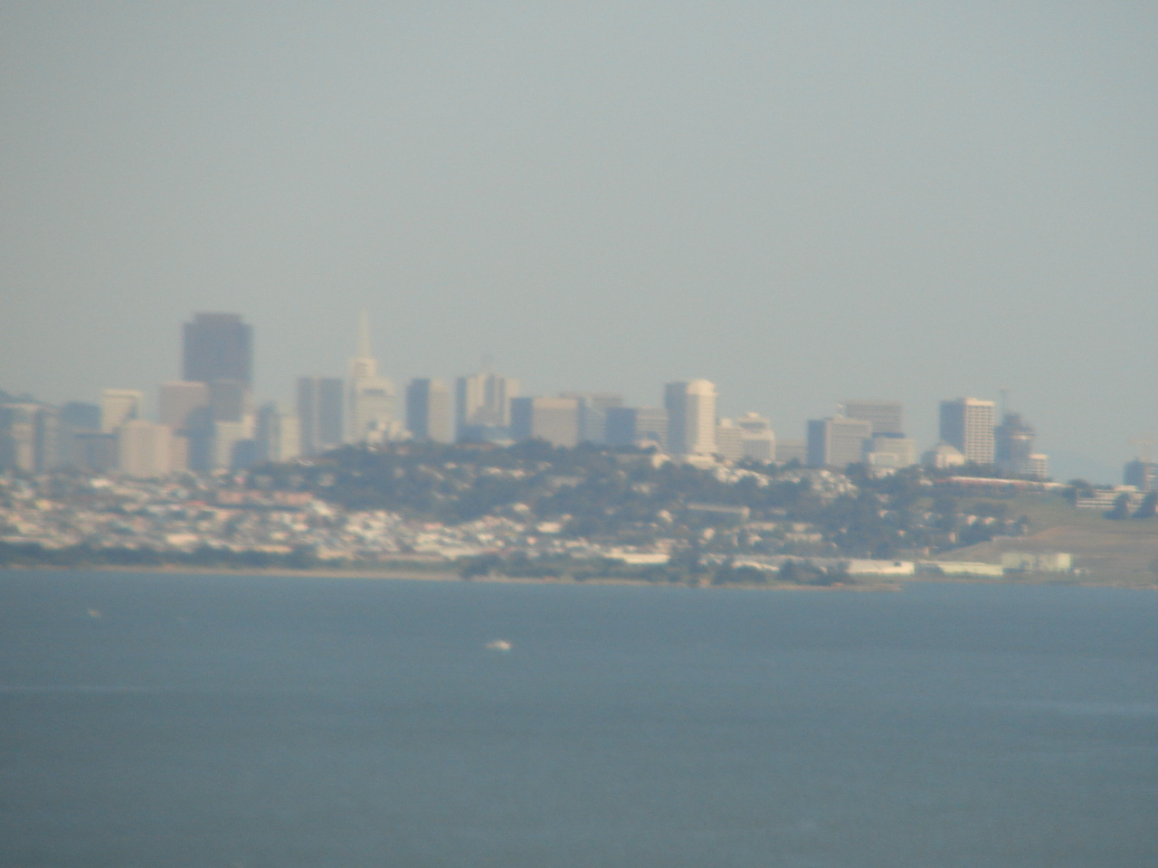

San Francisco Home Exchange

Carl Lahser

15 April 2007

San Francisco Home Exchange

Carl Lahser

15 April 2007

Introduction. We received an inquiry about a home exchange in San Francisco that my wife, Carol, immediately accepted. They wanted to come to San Antonio in the 24 March to 14 April 2007 timeframe. I was teaching a class every Monday. We settled on exchanging houses and cars for the week of 27 March to 4 April so I would miss only one class.
Background. I had been to SF a number of times over the past 40 years, and I thought it would be interesting to see another part of San Francisco. I had stayed across the bay in Alameda or in the downtown areas like Russian Hill, Knob Hill, Chinatown, North Beach and Fisherman’s Wharf. Over the years, I had seen these parts of town and spent a day seeing Golden Gate Park, another day at Muir Woods and had spent two weeks at the radar site on top of Mount Tamalpais. Never had I seen any of the area south of Market Street or any of the local neighborhoods.
I had spent most of 1959 stationed at NAS Los Alamitos near Long Beach. We had spent the year working and playing surfer, beach partier and would-be beatnik. I discovered surfing, coffeehouses, poets like Ferlinghetti, Ginsberg, and Kerouac, and heard tales of North Beach.
My first trip to SF was actually to Alameda Naval Air Station in 1960. I got to see Chinatown and the view from the Twin Peaks. This was followed by business trips to visit Naval and Air Force civil engineering offices. I also had a two-week AF Reserve assignment to the radar site above Mill Valley that sat atop Mt Tamalpias.
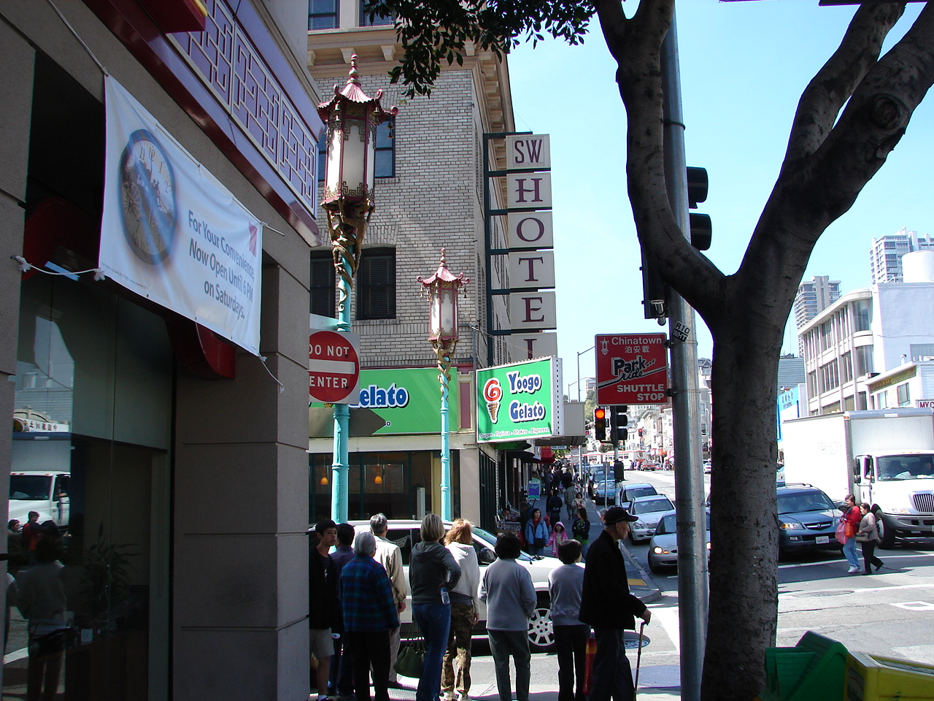
I preferred to stay in the Sam Wong Hotel at 615 Broadway. I liked it for price but mostly for location where the worlds of Chinatown and North Beach collide. What’s more romantic than going out the door into Chinatown for a breakfast of congee in a hole-in-the wall that had tea cups and chopsticks on the table and then catching the cable car to work. Old Sam’s grandson now runs the hotel. It was closed for a couple of years for remodeling in the late 90’s. It reopened as the SW Hotel. The rate is not $35 a night any more but it’s still reasonable. The rooms were small with wardrobe and a bath. There was no AC but AC was not needed. This was a family oriented hotel and along the hall you could hear several oriental languages and smell good cooking.
In 1978 my mother-in-law wanted to go to Hawaii and talked my wife into accompanying her. I arranged a couple of days of business in San Francisco and flew out to see them off. My mother-in-law had reserved a suite at the Francis Drake Hotel for a couple nights. She and Carol shopped and saw the sights while I took care of business. The last evening we had dinner at the Top of the Mark in the Mark Hopkins Hotel. Carol’s mother insisted on the place and insisted on paying a $120 bill for supper. They left the next morning. I finished my work and went back home to Colorado Springs. I doubt that we will be eating that high on the hog this trip, but the guidebooks showed even taqueria prices were double San Antonio prices.
Here we go. Our partners in this swap arrived the evening of 27 March. We picked them up at the airport. We showed them our house and then went out for Mexican food and a quick ride around downtown.
We reserved A Yellow cab for 0530 on 28 March. At 0540 I called and was told that we had no reservation, but they would have someone there by 0600. We got to the gate as the plane was finishing boarding. The flight departed late, so we arrived in Houston as our SF flight was finishing boarding. (I found that time between flight legs was 30 minutes for domestic flights instead of an hour.) The next leg of the flight took off 20 minutes late.
The sun came up golden behind rows of blue stratus clouds. Over West Texas we were in clouds until we were over the Sierras. All of the reservoirs were down with little thaw water expected. We flew south of Yosemite National Park and out over the wine country. It was reported to be 51 and clear in SF. We passed over the Coyote Hills Park, the Don Edwards San Francisco Bay National Wildlife Refuge, and the San Mateo Bridge on the way to touchdown near San Bruno. Alameda and San Francisco were visible in the haze in the distance.
Our 3 hour and 20 minute flight to San Francisco International Airport was on the ground just about 11:00 local time. We had our bags about 11:30, and a taxi with a GPS unit zipped us on a $30 ride to our temporary, new home with no missed turns (pretty neat gadget). We flew north on 101 past the ballpark and through Daly City and north on Mission Cortland. There was a large, empty farmer’s market with murals and graffiti. (There were numerous murals and a lot of graffiti scattered around town).
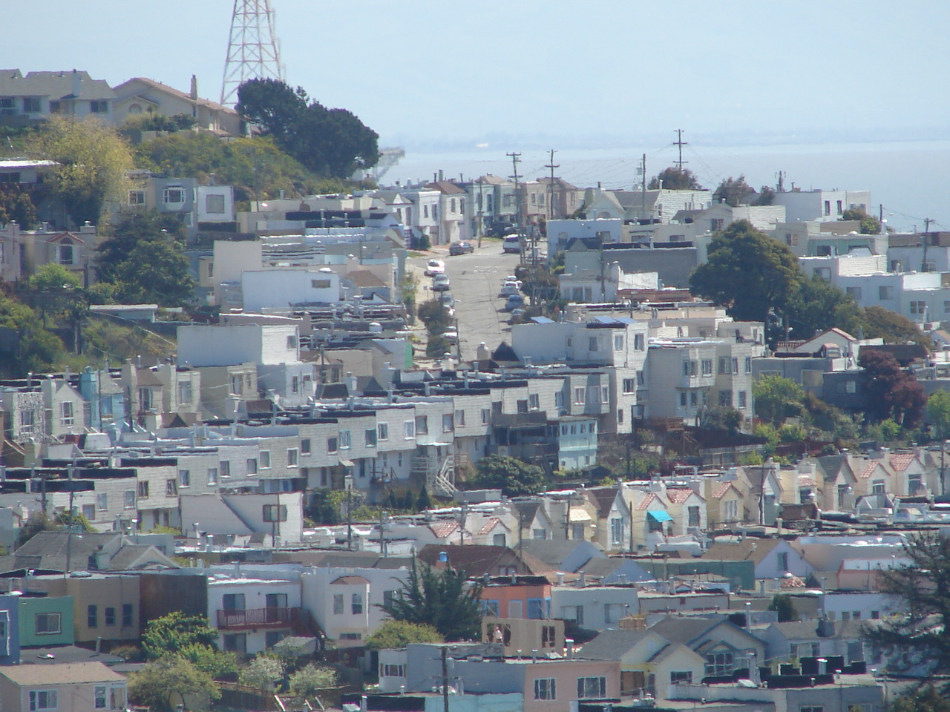
We put the bags in the house and walked down the hill to find lunch. There was a church to St Kevin on one corner, a coffee shop on another, a primarily beer and wine store on another and a deli/grocery on the fourth. West along the street were Mexican, Italian, American, and Chinese restaurants, a bookstore, an art gallery, several other shops, and a larger grocery. We ate Chinese and picked up a few groceries on the way back home.
We got settled and headed down town. As we waited for the bus there were four black young adults verbally harassing passersby and taking turns on a small bicycle. A longhaired white guy with a plaid shirt on popped into the corner store and emerged with a quart of beer.
The bus arrived to take us to the underground. It wandered down Cortland through Bernal Heights, Noe Valley and the Castro district to Castro and Market. Adult bus fare was $1.50 but we were seniors so it was only fifty cents including transfers. We got off at Market Street and crossed Castro to the Harvey Milk Plaza and Muni station.
We passed several gas stations. Regular was $3.41, mid range was $3.51, and high test was $3.61. When we left San Antonio this morning regular was $2.19.
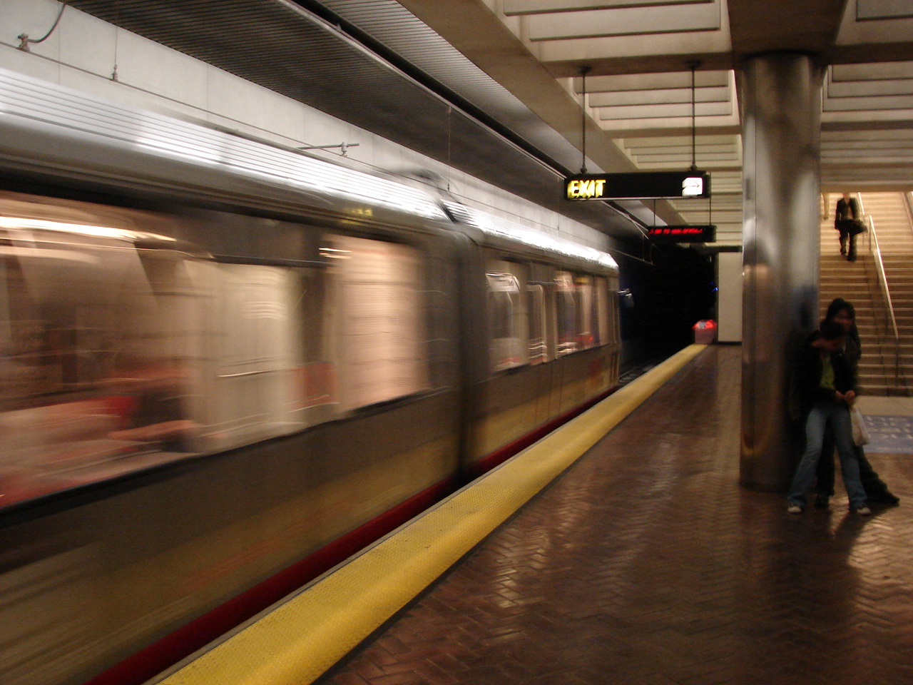
We rode the MUNI underground rail to the Montgomery Station near the financial district and walked through the almost empty streets to Chinatown. Carol found a Chinese restaurant that suited her for supper. I had salt and pepper shrimp with the shells still on like I like and Carol had a chicken dish. Prices were more than double hometown prices. We were home before dark.
The area around the Castro Street bus stop was interesting. The Castro Theatre showed gay movies. There were several small eateries, a cookie shop called Hot Cookies painted on red briefs, and a bead shop. .
When we returned home, I set out the trash. There was a large wheeled container for wet garbage and another for everything burnable that went to make electricity.
The house had three floors and a small backyard. We entered through the garage on the second or street level. The garage had a parked car and lots of bookshelves. We stayed in the apartment that had a kitchen, bath, and bedroom. The bottom floor was filled with bookshelves since our host sold books on-line. The top floor was a more formal living area up narrow stairs. There was a gas heater in the apartment that knocked the edge off the cold. It was in the 40’s over night with 50’s and 60’s during the day. This was a neighborhood of laborers and many of the homes had been owned for years.
Thursday morning we went down to the corner coffee shop for rolls and hot chocolate for $10. We took the MUNI to the Montgomery Station and walked up Sutter. Just past Kearney we stopped at the Asian Art Center. They had some outstanding embroidery pictures that we put a bid on.
Nearby was a modern gallery that was unimpressive. On the next floor was The Square Butte Gallery and John’s Western Gallery with some outstanding western art including paintings by Zhiwei Tu of the California Chinese heritage. They had a good collection of art books and a showing of sketches by Joe Brotherton. Brotherton was an artist and dancer. He became prominent later but these sketches were in the Caffe Trieste in the 1950’s. (I bought one. Later we visited the Trieste to see if things had changed.)
Down the street was the Sujaro African art gallery. They had masks like some of mine. They also had some outstanding antiques. Maybe I can sell some of my collection.
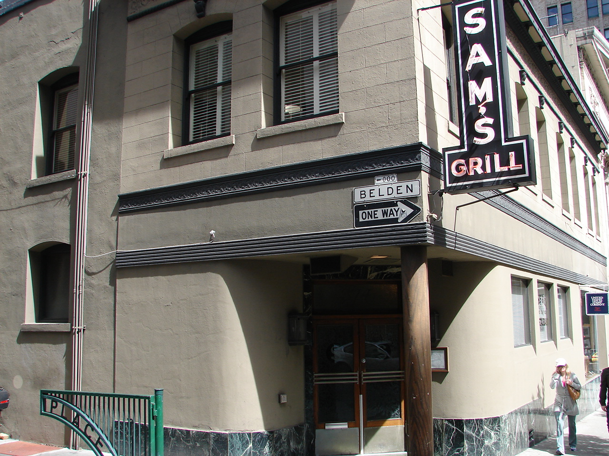
We stopped at Sam’s Grill for lunch. Outstanding. It was established in the 1850’s and specialized in seafood. The walls were dark paneling with wildlife prints and mounted fish. Lots of tables but plenty of room. They had some private dining rooms European style that probably dated to the 19 century. I tried their famous Hangtown Fry. This was a three egg and dozen oyster omelet. It was very good but there goes my cholesterol for the week. Carol ordered sautéed liver. The sourdough bread was very good. Creamed spinach was seasoned with nutmeg.
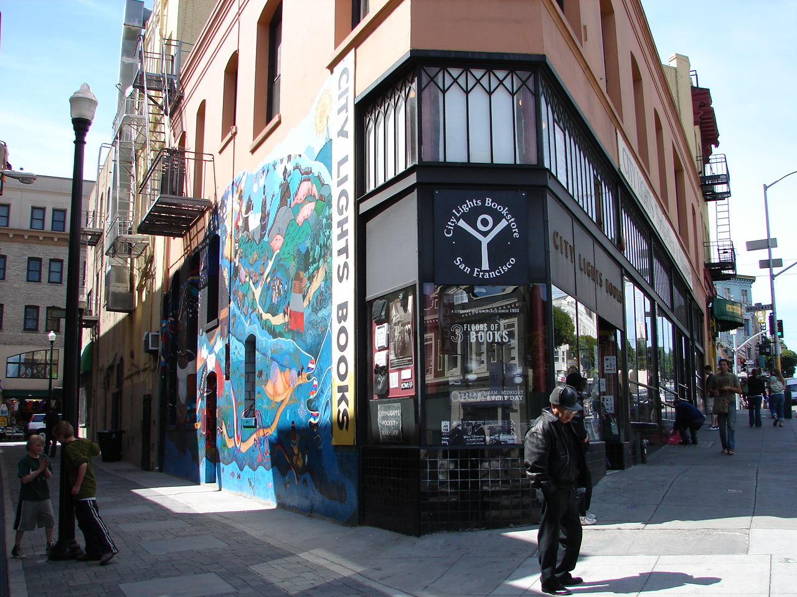
We walked up to the City Lights bookstore. It was still there. They had turned down my book of Southern California transit poetry. We stopped in at the Caffe Trieste and passed the Hungry I and Larry Flint’s Hustler Club. The Sam Wong Hotel was around the corner on Broadway. The Transamerica Building was prominent sitting on its four spring-loaded legs.
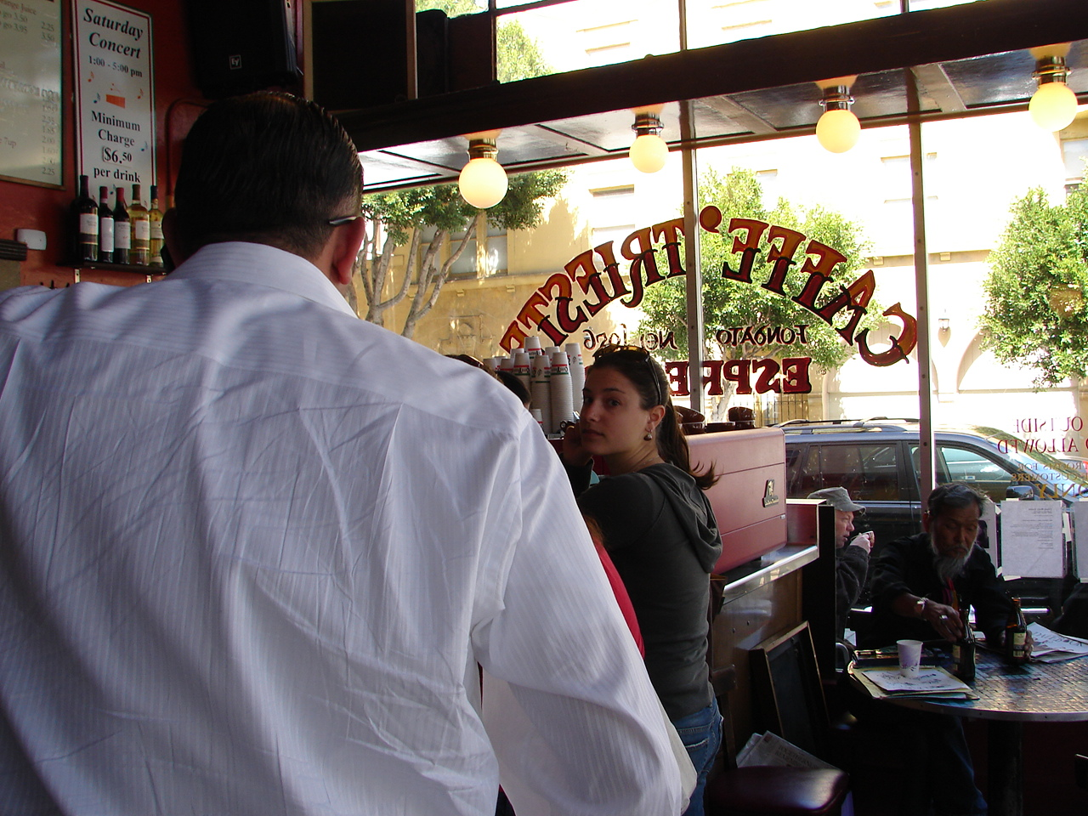
On Friday morning Carol insisted on driving out to Golden Gate Park and I got to navigate. Traffic was no problem after she got used to the hills. Once inside the park there was a parking problem. We finally found the parking garage under the museum of science that was closed for remodeling. We learned that the Asian Art Center had been moved downtown. That left lakes, athletic areas, the Japanese Tea Garden, the arboretum, and the de Young Memorial Museum to see.
The de Young Museum has a new facility for what I remembered. It’s a new modern structure with a strange looking tower on one end. First stop was the bookstore then the exhibit of 20th century art and aboriginal art. We had lunch in their cafe where I had one of the most artfully served hotdogs I have ever seen. Then we went to the second floor for New Guinea and Oceanic art. We went back down to the first level and took the elevator up to level 9 of the Harmon tower. It had a panoramic overview of the entire tip of the peninsula. Lincoln Park to the northwest contains long closed Fort Miley and Hamilton AFB. The top of the Golden Gate peaked over the top of the Presidio. The major buildings of downtown stood out in the greening spring vegetation.
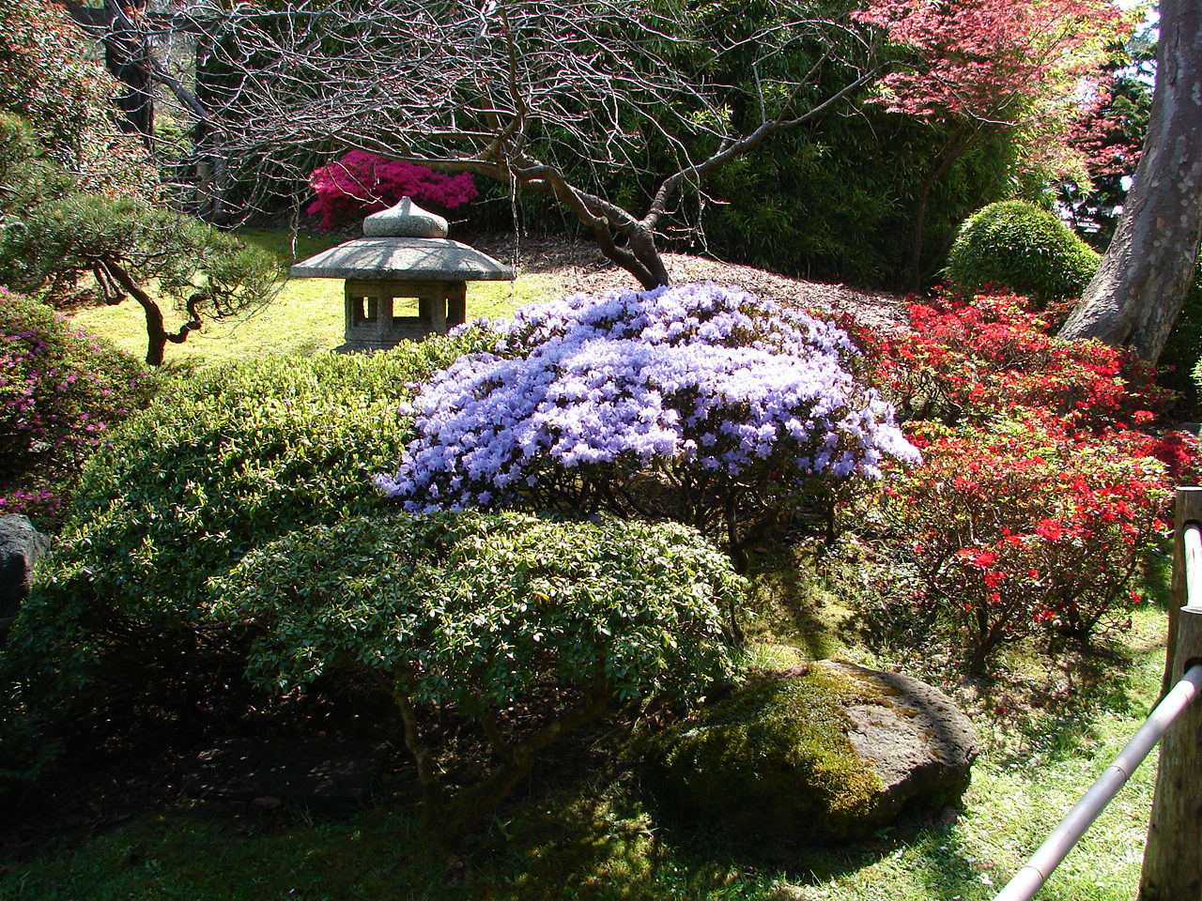
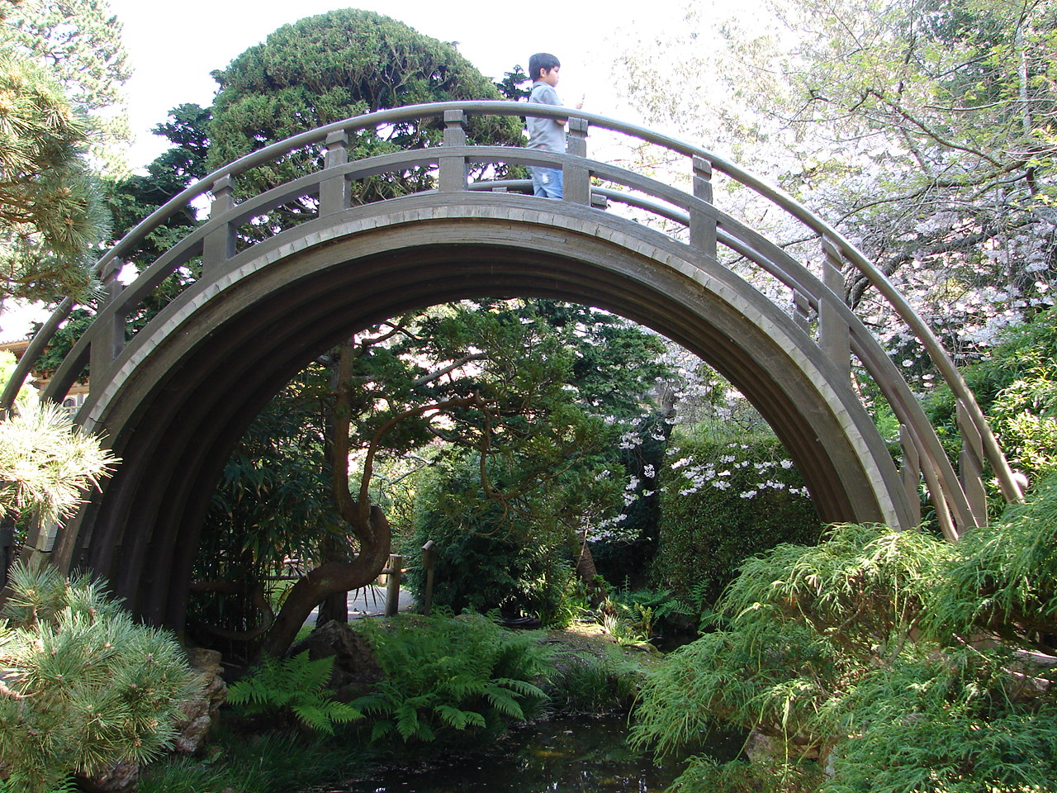
We left the de Young Museum and went to the Japanese Tea Garden. Azaleas and cherry trees were in bloom. The pagoda and other artifacts of Japanese landscaping were in the Garden. The dragon bridge still crossed the steam so dragons could not cross. A tall Japanese bridge crossed the narrow stream so boats could pass under the bridge.
On the way home we drove home through the Upper and Lower Haights neighborhoods and looked at many of the restored homes. Many of the old Victorian homes had a rounded turret of sorts. There was a legend that the rounded corners on homes deflected bad luck.
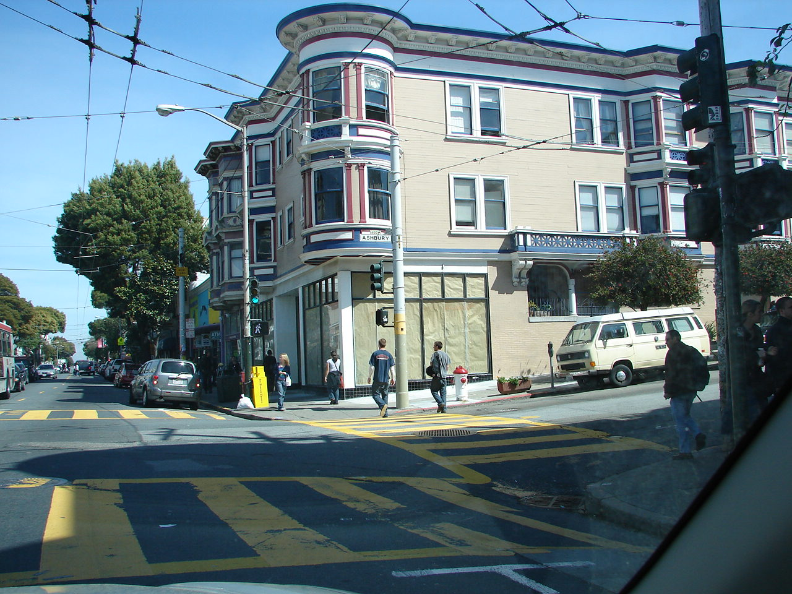
Back at the ranch we went out for Italian in Bernal Hgts neighborhood. I had polenta and sausage.
Saturday, we got off the MUNI at the Civic Center Station to go to Union Square. We walked down Market Street through the Tenderloin. There were the older inhabitants sitting along the street smoking and talking and enjoying the sun in front of resident hotels. I remember hearing someone in the Tenderloin district years ago call parking meters homeless outhouses because they held on to the post and crapped in the gutter. Tattoo shops and tattooed people were still there along with young blacks with lots of gold and young blacks that looked half starved. I walked through this area one evening years back coming from a meeting on the Embarcadero.
A group of about twenty young folks were occupying most of the sidewalk in one place. There were only a of couple strip clubs. and the porn shops were at least not visible. National hotel chains had opened hotels along the end of Market and were crowding out the former low rent inhabitants.
We turned up Powell to Union Square. The James Flood Building still sits old and gray. This is where the GAP is now located. It survived the 1906 earthquake and was the home of Pinkerton National Detective Agency where the writer, Dashell Hammett, once worked.
A several men wanted to be our guide and direct or lead us wherever we wanted to go for a price. There were a few homeless sitting in corners and at least one stack of bundles where someone had staked his territory.
Union Square is a public park sitting on top of a parking garage. An art show occupied the center. Most interesting exhibits were by a young woman who did oriental themes and incorporating coins and other oriental artifacts into the works (about $400 each) and a young Latino who had some metal sculptures and some things he called shadow figures. They were like wire sculptures but were mounted on a background so that a shadow of the figure could be projected.
From there we went to Gumps. Gumps began as general merchandise store dealing in Chinese imports. It has turned into a high-class department store and was nothing like I remember.
I asked if one of the clerks could recommend a place to eat. His recommendation was Moka about a block away. It was on Maiden Lane next to the Xanadu that was in the only Frank Lloyd Wright building in SF. I had a $9 tuna sandwich and Carol’s chicken breast sandwich was even more. I guess I’m still a cheapskate.
We passed a large lady in Maiden Lane who was singing opera for donations. It seemed too cool to me to endanger an operatic voice.
We walked back to the Muni and headed home. We waited for over an hour in a cooling breeze on Castro Street before a full bus arrived followed by another empty bus. The busses apparently have no tight schedule but show up at 20-30 minute intervals.
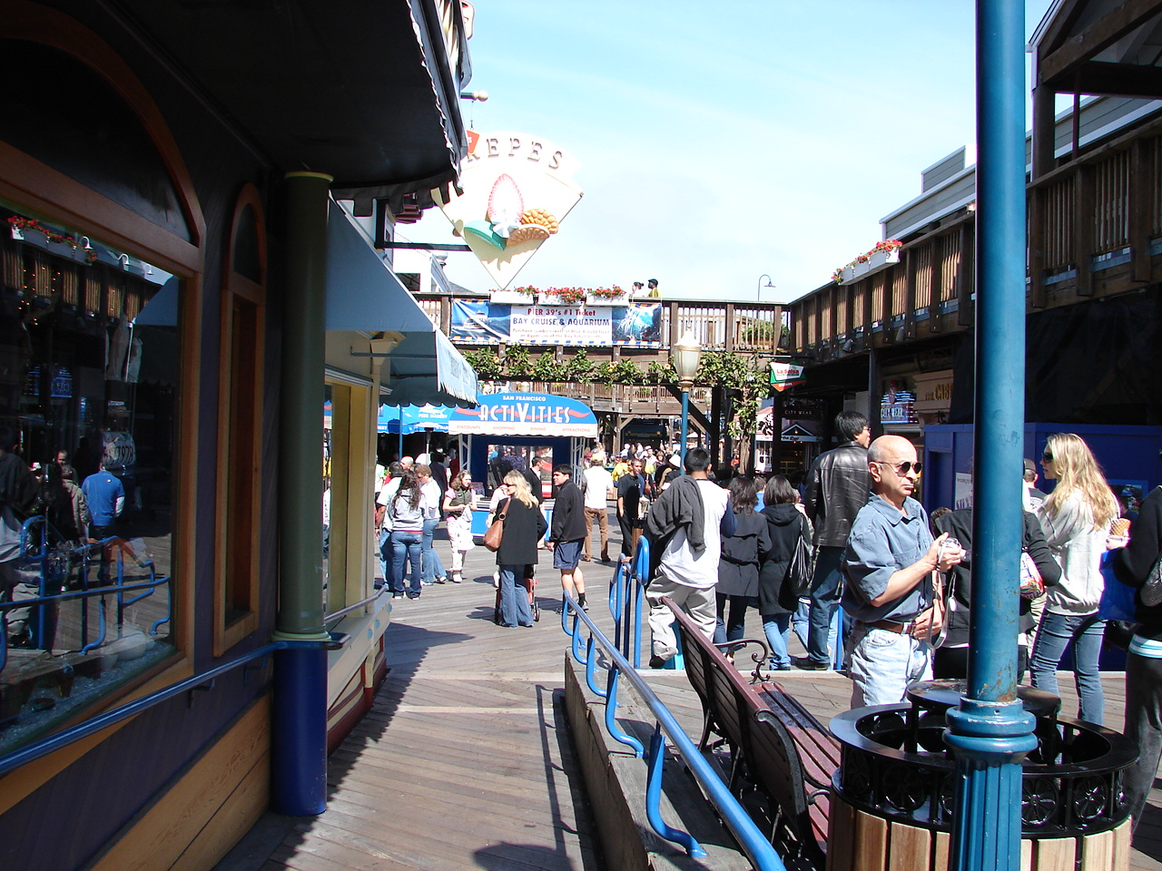
Sunday morning Carol drove us to the Embarcadero. Nothing was open along Market Street. We drove the length of the Embarcadero and finally arrived at Pier 39. We parked and crossed over to the fisherman’s side. This was new since I was in SF last. This area was once full of fishing boats moored to the piers. Big pleasure boats in a modern marina have replaced this. Sightseeing boats and the tours of Alcatraz leave from this area. Boutiques, restaurants and an aquarium have replaced the fish houses.
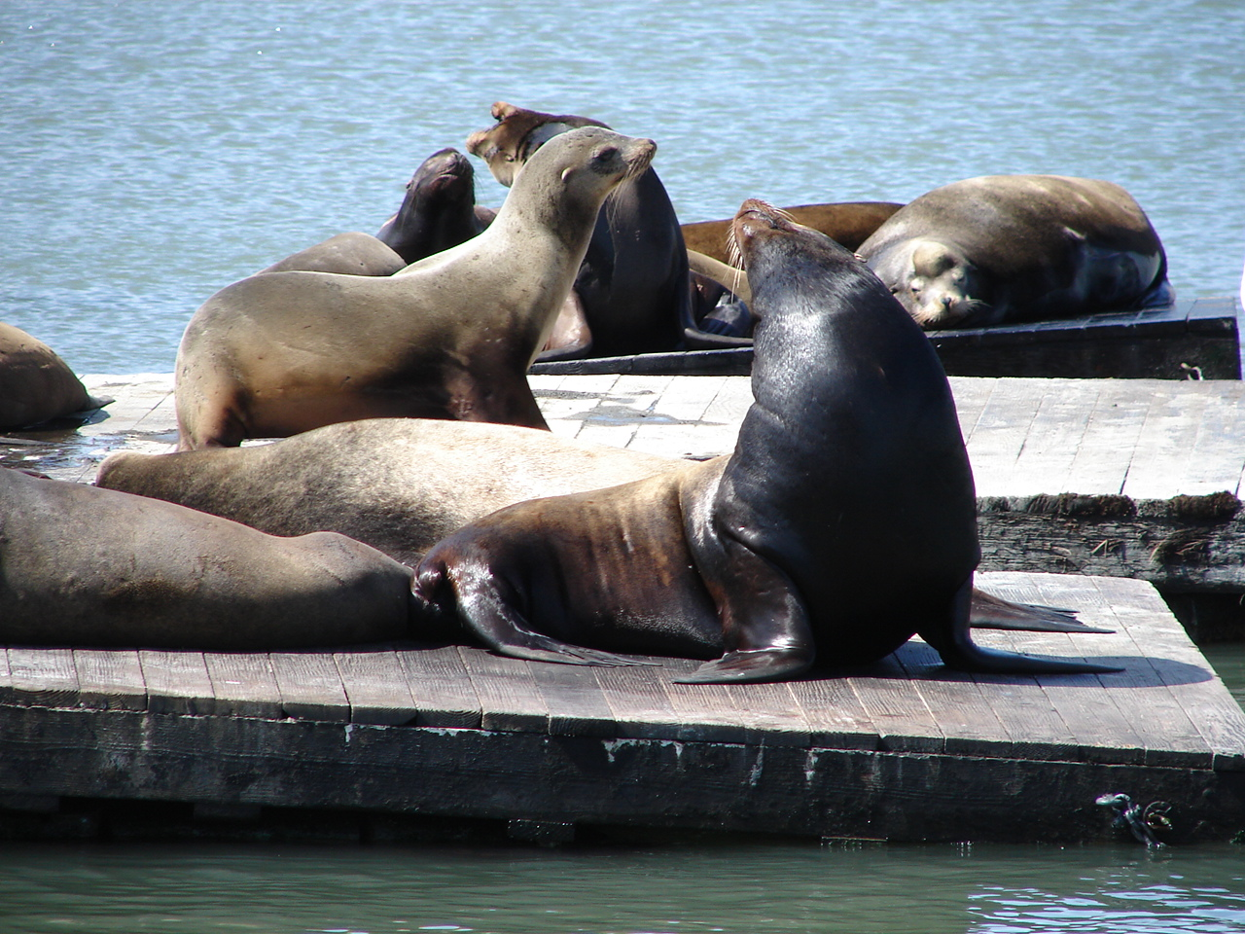
First stop was the Alcatraz shop where Carol bought a jacket since it was pretty cool. We had breakfast at a place decorated for surfing. Signs were displayed like “the only good suit is a wetsuit” and “dogs and boards must be on a leash at all times”. I had a BBQ shrimp omelet.
I heard sea lions barking from the street but did not see them until after breakfast. I remember seeing occasional harbor seals around Alliotos restaurant. Large male California sea lions began to come into the area in the early 1990s. They climbed up on the moored boats and did considerable damage. Tourists were attracted to see the basking animals so the marina was constructed and large floats were constructed and moored to attract the sea lions away from the boats. The sea lions are now one of the biggest attractions in the harbor.
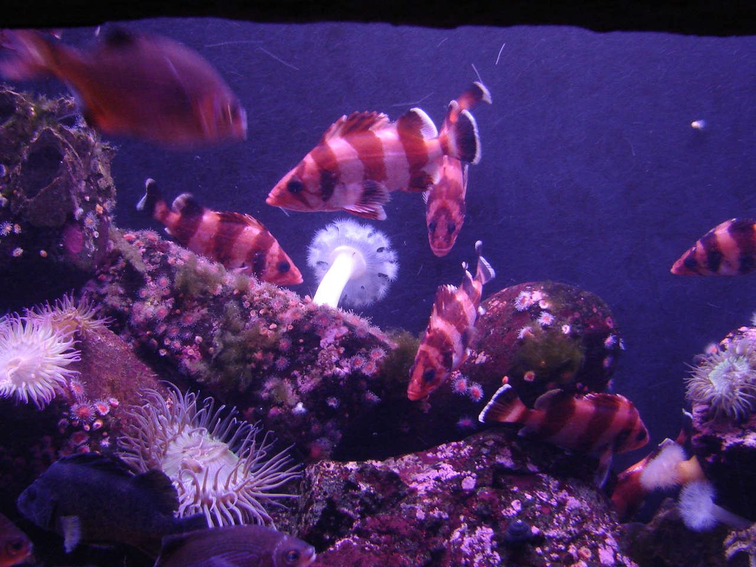
We walked the length of the pier and went to the Aquarium on the Bay. The main attraction is the glass tunnels where the fish swim around the viewers. A tunnel was first successfully used at the lake front aquarium in Chicago in the 1960s.
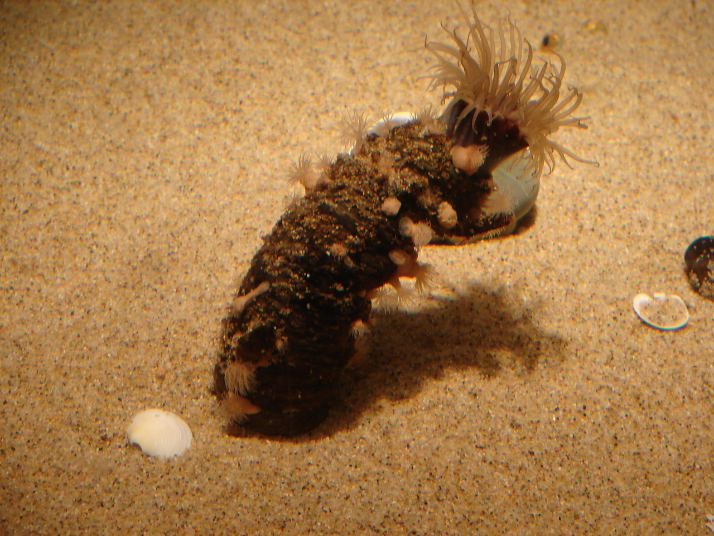
In the aquarium entrance were displays on specific ecological topics, a discovery room where you got to touch the critters, and a well-stocked bookstore. The aquarium trip began with the fauna under the inner bay piers. The tour proceeds to kelp beds then to fast water ecosystem under the Golden Gate. Local fish were on view close up along with sponges and other invertebrates of the area. I got some pictures better than any I saw or photographed while diving (So I cheated a little).
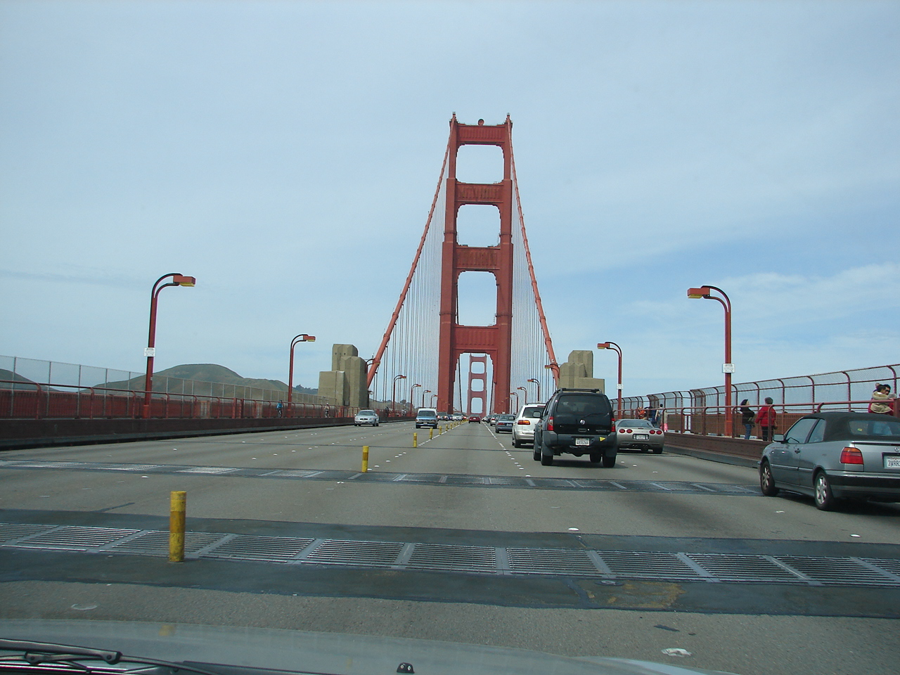
We ransomed the car from the garage for $25 and drove across the Golden Gate Bridge to Sausalito. We drove passed Fort Mason and the Marina Green Park and then along Doyle Drive to US 101. The Golden Gate Bridge is a toll bridge south bound but you get out of town for free. There were a lot of people walking across the bridge.
Sausalito was crowded and finding a parking spot difficult. We finally found a city lot. There were several art galleries including one selling Dr. Seuss prints. We had a pizza then drove back home across the bridge.
Diversadero Street took us south to home. We passed through a variety of neighborhoods. Restored Victorian. Modern. Mixed styles. Art deco. A little landscaping in front like in old Mexico. (Most landscaping was reserved for their backyards). Some were highly restored with six colors and gold leaf. Others were more modestly restored but there was nothing in terrible shape. Median price was over a half million.
Monday morning we walked up hill to Bernal Hill. The hill has a view of much of the Bay area and has a transmitter relay station on its top. Carol stayed at the bottom while I went to the top. I met maybe thirty people running or walking the trails and several exercising their dogs.
There are supposed to be some owls on top of the hill in a grove of pines. It was cool with lows in the 40s and highs in the 60s. Giant Coreopsis was in bloom. Most of flowering vegetation was introduces. The grass was speckled with Seaside Daisies. The only birds I saw were sparrows, starlings and a few gulls in the distance.
Back downtown we got off on Montgomery Station and walked up Sutter to the Asian Art Center. The picture of the Chinese Opera star had sold but they had a similar one for the same price that we bought. We had a good discussion with the sales people. Mr. Sun was from near Chungking and the young lady was from Taiwan.
We stopped at Sam’s again for lunch. I had sweetbreads since I seldom saw them on a menu. Definitely had enough cholesterol for the week.
We went to the Asian Art Museum. We began with the bookstore where Carol bought a Chinese style jacket. The elevator took us to the third floor where there were exhibits from China and from south, southeast and west Asia. The second floor had more modern China, Korea, and Japan. Back on the first floor we saw a collection of Japanese baskets.
We walked up Columbus Avenue to see the Caffe Trieste. It changed considerably from the 1950s.
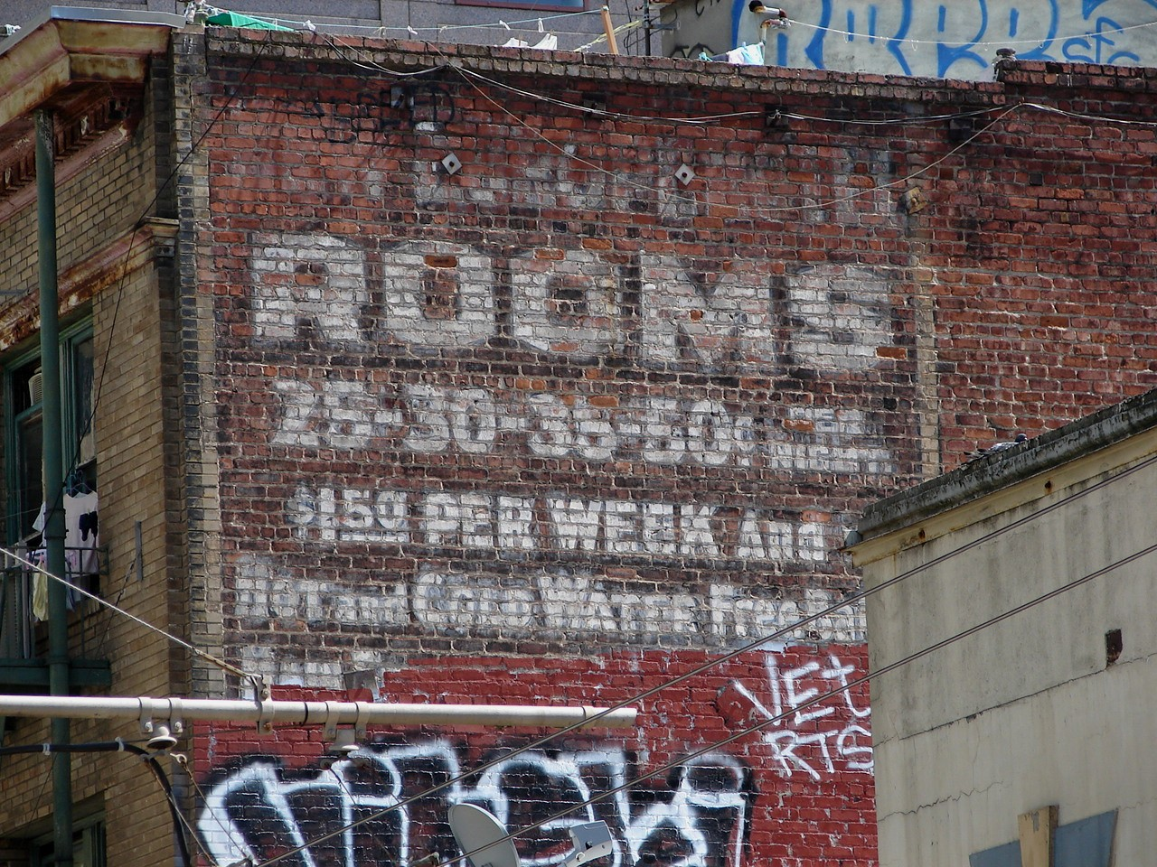
Tuesday morning we went back down town to see more galleries. We first visited the SF Art Academy gallery and the Museum of Modern art. Then we visited about twenty of the galleries located on Geary Street none of which had anything of particular interest. The main store of the Asian Arts Center was on Geary so we stopped there.
Back at the ranch we packed up ready to leave about 0500 Wednesday morning. The taxi arrived on time and we were back at our front door about six in the evening.
carl

