Taiwan
or is it
Formosa
By
Carl Lahser

Copyright © 2012 by Carl Lahser. All rights reserved. If you must copy any part of this work please give the author appropriate credit.

Published by: Pretense Press
6102 Royal Breeze
San Antonio, TX 78239
(210) 657-5139
clahser@satx.rr.com
Publications by the author:

USA Bigfooting Around – Washington state
Blue Ridge, GA
City of Angels
Galveston
New York Christmas – Hudosn Valley and NYC
Niagra Falls and Toronto
October was a Busy Month Minneapolis and the Shennadoah Valley
Portland in the Summer
San Francisco Home Exchange
Santa Fe Getaway
Shelling Trip
Summers End
Canada Backdoor to the Yukon
Do Bears do it in the Woods - Winnipeg
Enterprise II – Calgary, Edmonton, Athabasca
Enterprise North
Vancouver – Vancouver, Victoria, Inland Passage
Where Have All the Pretty Colored Houses Gone - Newfoundland
Mexico Cabo San Lucas
Copper Canyon
Flowers of the Air
Hey Momma, When we Goin Again
Mata Ortiz
Mr. Cuul in Yucatan
San Miguel
Searching for the Phantom Crown
Todo Santos Ecoadventure
Europe A Quick Little Christmas Trip Christmas on the Rhine
Dickens Christmas - Three Weeks in London
Cross-section through a Rainbow – Corfu, Athens, and Rhodes
Greek Poems
Return to Assinara Bay – Italy
Three Weeks in Berlin
China China Tour / China Sings
Hong Kong 1979
Taiwan or is it Formosa
Other Travel Panama Cruise
Under the Southern Cross (Under Clouds) – Machu Pichu and the Amazon
Poems Cryptic Romance
Ecoview 1 - Not Your Usual Neighborhood
Ecoview 2 - Texas
Ecoview 3 - D.C.
Ecoview 4 - St Louis to Minneapolis
Ecoview 5 – Southwest
Ecoview 6 - Green Things
First Hours of Fall
Rincon de Carl
Snapshots of the North
Snapshots of Mexico
Summers End
Texas to Alaska
Traffic Games
Tyndall Beach
Walk on a Different Beach
Weather watching

Other Alamo Road – Mom’s Story
BASH – Bird/Aircraft Strike Hazard
Bessies Pictures 1930
Butterflies and Birdwatching - PIF Bird Meeting
Forty Years of Fishing – Professional History
Green Stuff Articles from the SCION
San Antonio Wildflowers by the Month
Teacher, Leafs Don’t Change Color – Growing up in the Valley
Thinking of Flying – Military history

Plays Cryptic Romance
A Body in the Trunk
A Blow for JFK
A Beard like Mine
The Black Birds – A BASH Play

Essays Broken Shoulder
Dinosaur Diving
Haiti
Hip 3 – Hip Replacement
Impossibility of Time Travel
Knee Repair

Fiction HiJaak
HiJill
Stories Grampus Told
All titles are available from Pretense Press. Booksellers
are encouraged to write for seller’s information.
Printed in USA.

Dedication
Yeh Chi Fu, an old friend from Taiwan (Formosa?), insisted that he was from the independent island of Formosa. He remembered the Americans bombing his village during WWII when the island was occupied by the Japanese. He spoke Japanese well as well as the Cantonese dialect of Chinese and some Haka. He and his friends in the Formosan Student Association had no use for Chang Kai-shek.

Taiwan or is it Formosa
July 1981
While stationed on Guam we decided to visit Taiwan. We had access to space available military transportation and found a flight headed for Japan. We drove to Andersen AFB and left the car with a friend in family housing who took us to base operation. A C-130 cargo plane took us to Tokyo where we could see Mt Fuji in the distance. A couple hours later we got a hop to NS Kadena on Okinawa on the south end of Japan.
The “we” included my wife, Carol, our eleven year old son, Charles, and myself. I was a civilian environmental engineer working for the Navy Public Works Center on Guam.
We were lucky enough to get transit quarters for the night and a reservation on the ferry to Keelung, Taiwan, the next evening. Since we had military ID cards we went off base for some tourist shopping - China Pete and a couple others.
We had supper at a local Japanese restaurant before heading back to the base. I had sushi served on the scrupulously clean counter top. Charles and Carol shared a steak and bowls of rice. I noticed several vending machines that sold hot tea and coffee and noodle soup or cold sodas and even wine and hot saki,
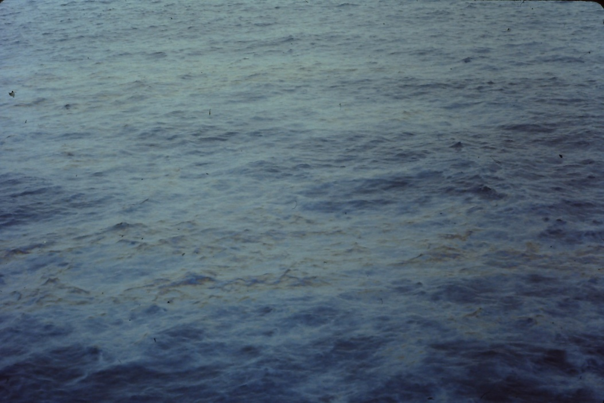
Next afternoon we took a taxi to the port of Naha to board the ferry. It was an overnight trip. We had an outside cabin with a little veranda. The trip was one of those “magic” nights with a near full moon shining over the South China Sea.
Polution
Supper and breakfast were purchased in the ship’s cafeteria. Our son was not impressed. He was bored with watching the sea and reading stories and annoyed that some of the Chinese wanted to pat a little blond-headed boy on the head for good luck.
Late in the afternoon about three hours from Keelung trash and oil slicks began to appear. This flotsam got thicker as we approached land. We docked about sundown, went through customs and caught a cab to the Imperial Hotel about 15 miles towards Taipei.
I had heard that the Imperial Hotel, No. 600 Lin Shen North Road, Taipei City, was an old hotel. It was built in the 1960s by Madame Chang as a 5-star hotel. Our room had teak floors and furniture with a breeze through the curtained windows.
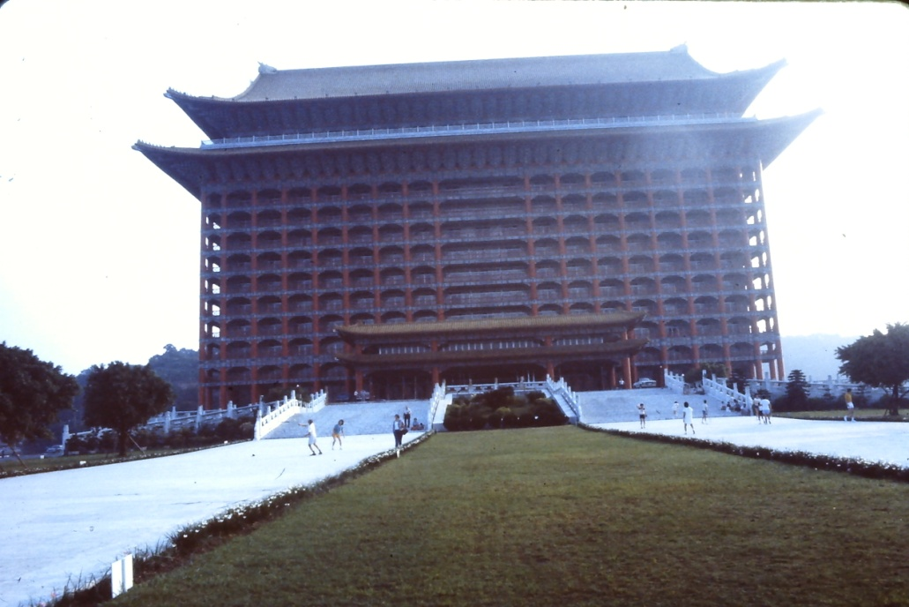
It was dark by the time we checked in. After checking out the room we headed for one of the hotel restaurants. We ordered dinner. It was slow in coming and Charles was asleep with his head on the table before we were served.
Imperial Hotel
Next morning we took a taxi to the airport to catch a mid morning plane for a 25 minute flight to Hualein on the east coast about half way down the island. We had booked a two day tour of Taroko Gorge, Taichung, Sun Moon Lake, and a bus back to Taipei.
After a 25 km ride to the bus station we boarded the bus with several Chinese and Japanese tourists. The road followed the Liwu River and along the edge of Toroko (marble) Gorge. There had been efforts made to mine the marble or dam the gorge for power generation but the government had made it into a national park.
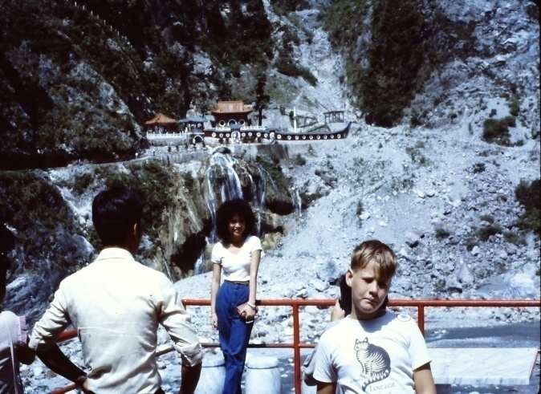
This road was two lanes wide in places and much less in most. We passed truck traffic with part of our tires over thin air a couple hundred feet above the river. The passengers were encouraged to sing so we got a variety of Chinese and Japanese. Even Charles sang one for the crowd.
Taroko Gorge
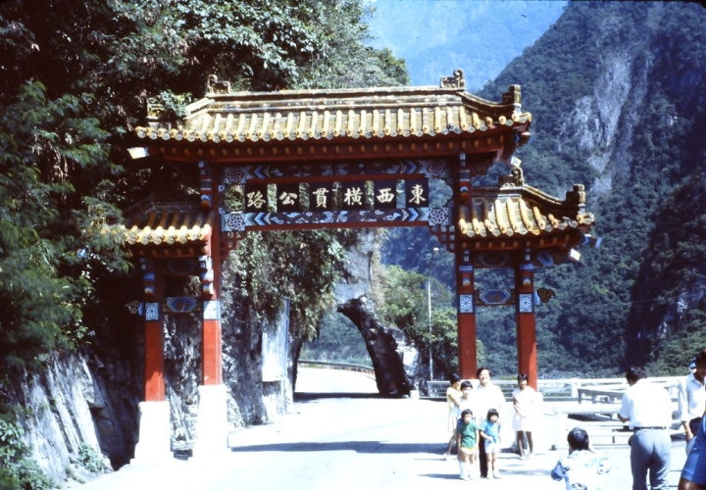
Taroko Gate
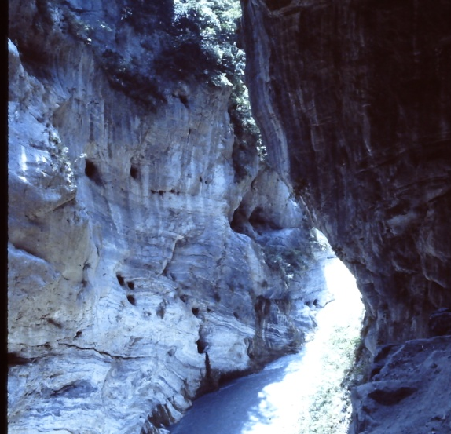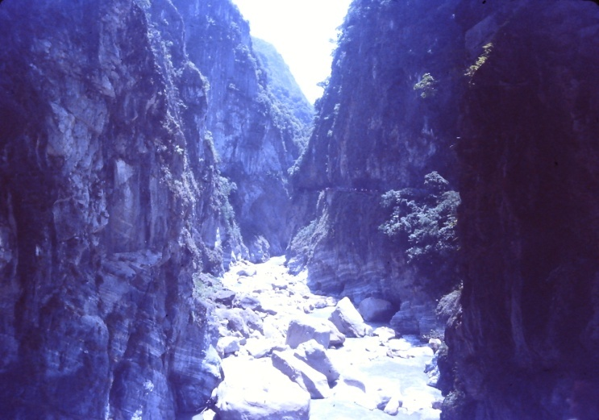
Liwu River

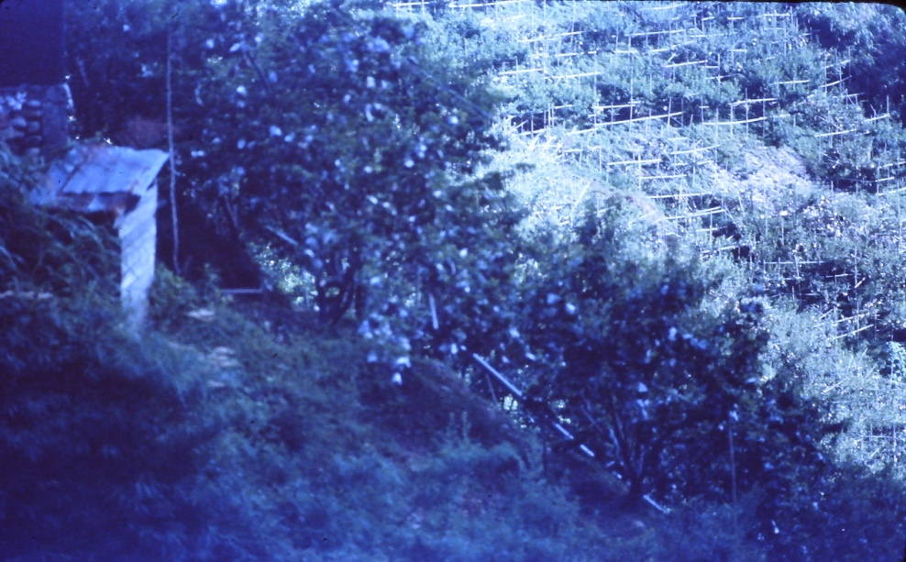
Orchards

The trip began at the Taroko Gate and passed Park Police Hostel and several small tunnels. After about an hour we left the gorge behind. We passed through several tunnels on the way to the top of the mountain range. There was a hour stop for lunch near Lishan.
We began cruising down the switchbacks with narrow terraced orchards of apple and pear trees espaliered against the against the mountain side.
There was a stop at the PaoCueh Temple near Taichung where we took a break and toured the facility. I bought several water color pictures done by the monks. There was a fruit stand where I bought a kilo of leeches’. I ate leeches’ for a couple days and there were still fruit left.

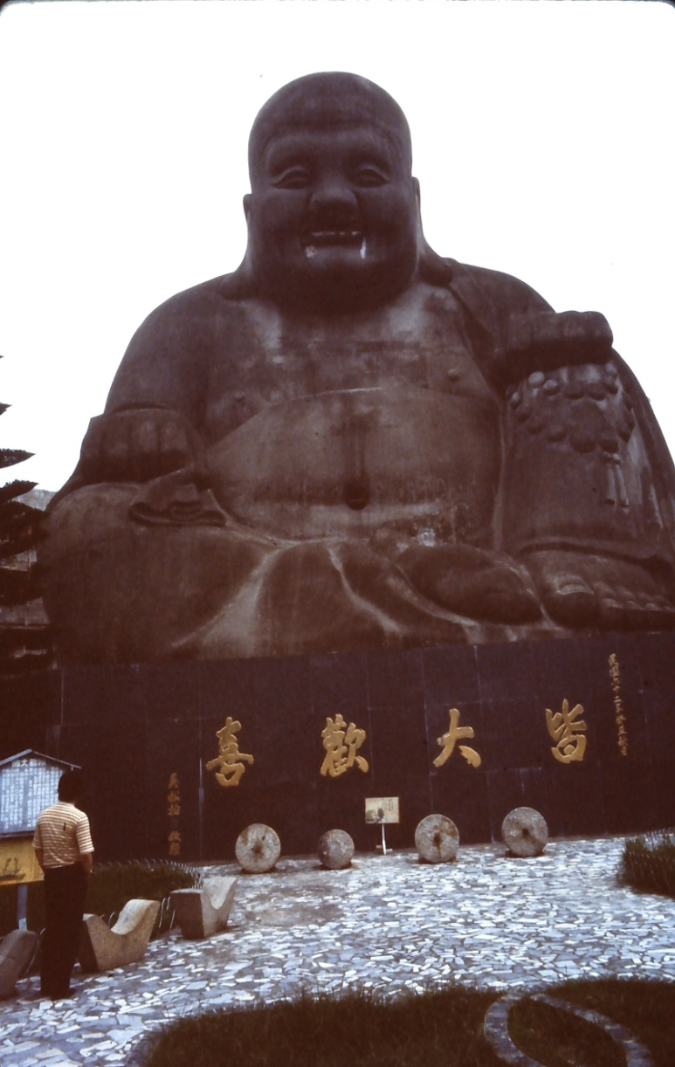
We arrived at Sun Moon Lake and checked in at a hotel for the night. Sun Moon Lake is the largest natural lake (7.7 sq Km) in Taiwan. It is a figure eight with Guanghua Island between the north and south portions. The lake with a average depth of 40 meters is nestled between Mt. Shuiset and Mt. Dajiae. It is famous as a honeymoon destination.
The Road to Sun Moon Lake passed the Wen Wu Taoist Temple near Puli with a collection of life-sized statues of the Immortals and the Monkey King. We stopped to see the temple and get a first good look at the lake.
Next stop was the Sun Moon Hotel. We checked in and walked along the beach to a Formosan Ami village where the Taroko First Nation aboriginals put on demonstrations of song and dance and sold crafts much like some of the US and Canadian First Nation Indian tribes. They came to Formosa about 8000 years ago and first encountered outsiders when the Han dynasty Chinese began to settle the island in the 17th century. The total population of these Austronesian natives is about a half a million. These aborigines are subject to social and economic discrimination.
Budha at PaoChuehTemple

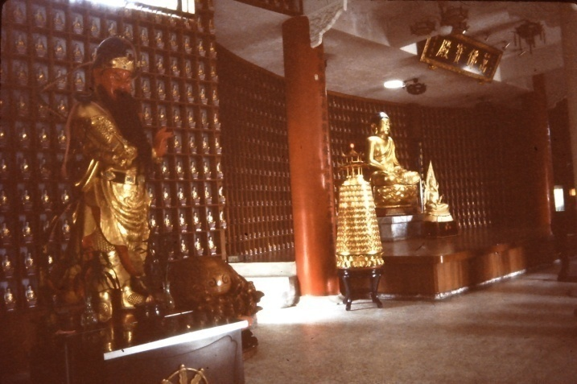
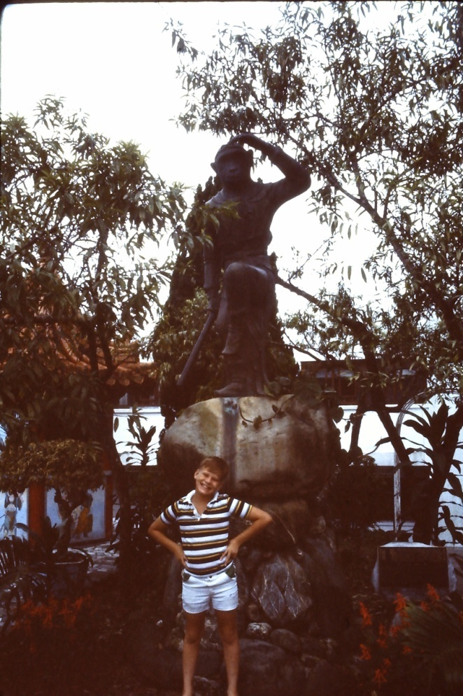
Charles and the Monkey King
Immortals at Wen Wu Temple

At supper Charles did not like anything on the menu except rice and upset the waiter when he put soy sauce on his rice. That was not the way Taiwanese ate their rice!
Next morning we continued down innumerable switchbacks through forests of camphor and pine trees to Shuli and Changhua. An outstanding feature was the bicycles outnumbered all other types of transportation with motorcycles and scooters coming in second. Another surprise was the use of every square inch of land for agriculture. There were gardens between buildings and in vacant lots and in pots in the windows.

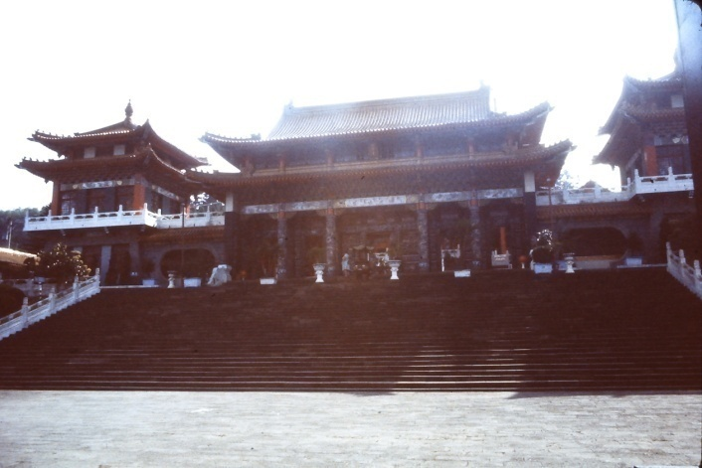
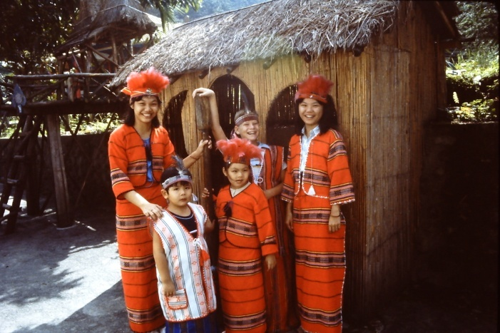
Wen Wu Temple
Charles and the Ami

We left the Sun Moon Lake area on a relatively modern road heading back to Taipei a little after lunch and arrived in mid afternoon.
We found a newer and less expensive hotel in downtown Taipei. We took a tour of the city and spent a afternoon at Elephant Mountain Park.
When we returned to the room we found that Carol’s jade ring had been stolen. The local cops said it would probably not be recovered. Next morning the person who had cleaned our room did not show up for work. .
Our last day was spent visiting a couple museums showing Chinese art and antiques that Chiang Kai-Shek had liberated from mainland China.
We were out to the airport at sunup for a flight back to Okinawa. It seemed strange to ride through the blacked out city and airport. The government was paranoid about being attacked and used the black out to get the population involved. We sat in the empty terminal as the sun came up and other passengers began to arrive. The flight left about 0900.
Back at Kadena we checked with flight operations for a flight back to Guam. They said there was one scheduled the next day and that we would have to get a Philippine visa in case we would have to stop in the Philippines on the way home. This would entail a taxi ride into Naha the next day to see the honorary Philippine consulate, a local businessman.
We checked in at the transient quarters and went to the beach for the afternoon Next morning we found the consulate. He took the information for the visas, charged us $30 each, and told us to be back after lunch.
We shopped in downtown and had lunch. About 1400 we went back to the consulate to pick up our visas and took a taxi back to the main gate area where we did some more shopping.
I left Carol and Charles at the room and went to see operations about a hop. A C-130 was leaving early next morning. We left at 0700 next morning and after a 6 hour flight were back on Guam.

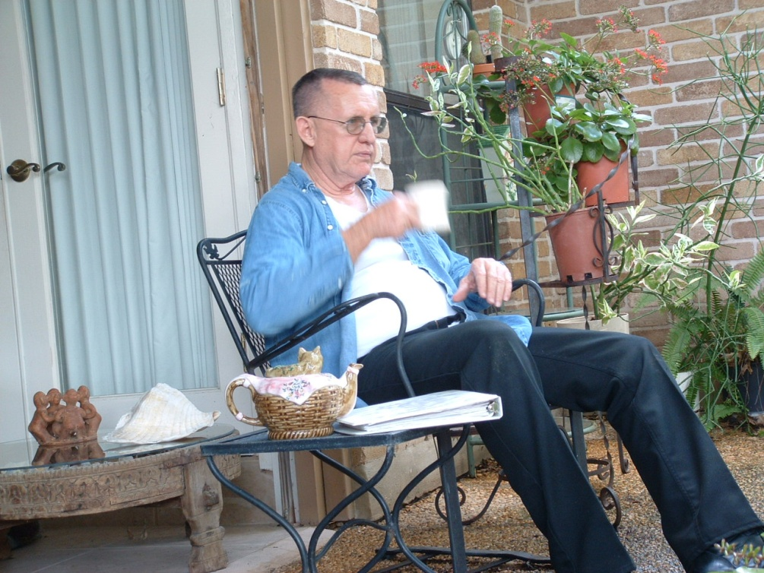

Home from traveling its time to write up my notes before I forget.
Was it Taiwan or Formosa?

