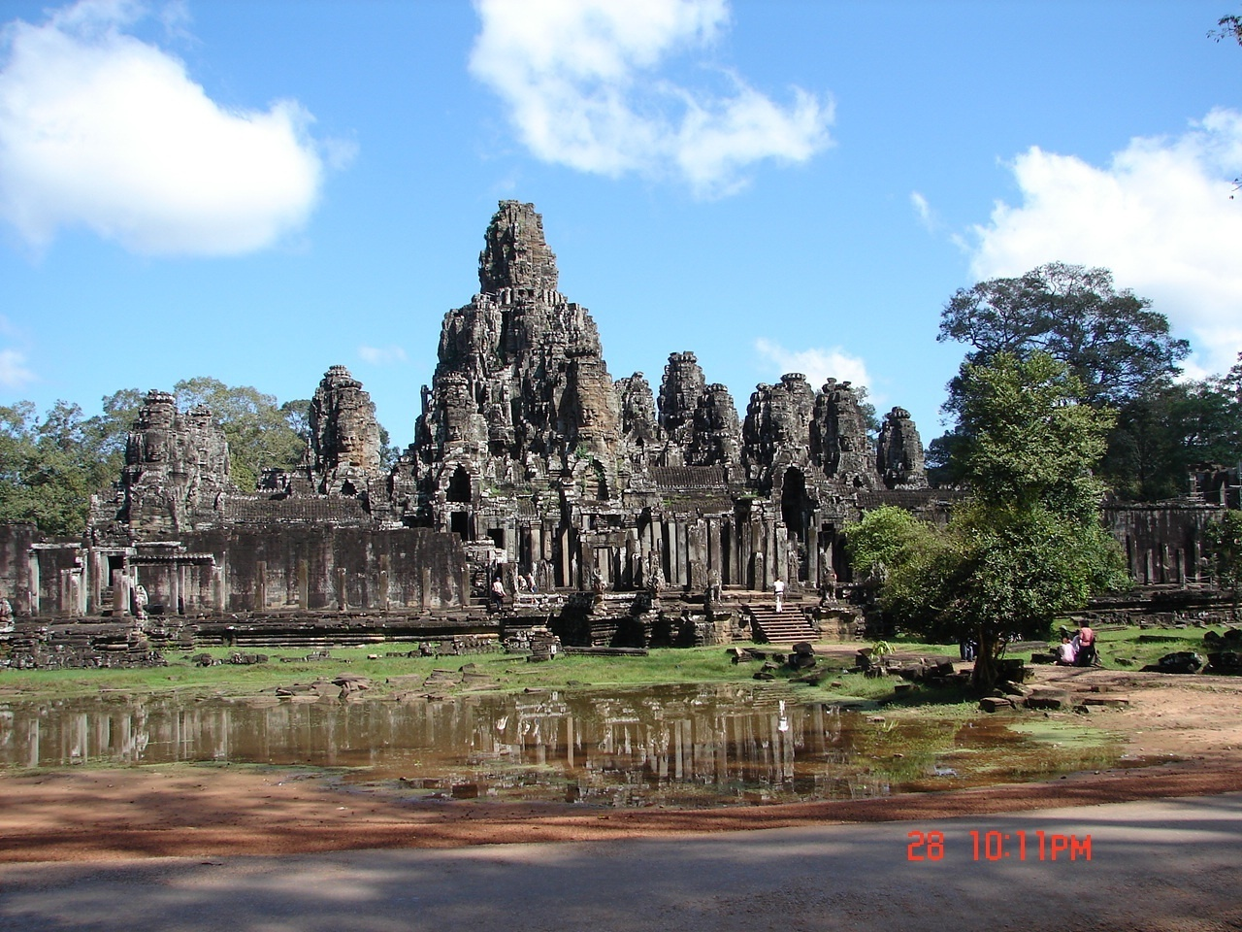Vietnam and Cambodia
Carl Lahser
24 Oct to 10 Nov 2011

Copyright © 2012 by Carl Lahser. All rights reserved. If you must copy any part of this work please give the author appropriate credit.

Published by: Pretense Press
6102 Royal Breeze
San Antonio, TX 78239
(210) 657-5139
clahser@satx.rr.com
Publications by the author:

USA Bigfooting Around – Washington state
Blue Ridge, GA
City of Angels
Galveston
New York Christmas – Hudosn Valley and NYC
Niagra Falls and Toronto
October was a Busy Month Minneapolis and the Shennadoah Valley
Portland in the Summer
San Francisco Home Exchange
Santa Fe Getaway
Shelling Trip
Summers End

Canada Backdoor to the Yukon
Do Bears do it in the Woods - Winnipeg
Enterprise II – Calgary, Edmonton, Athabasca
Enterprise North
Vancouver – Vancouver, Victoria, Inland Passage
Where Have All the Pretty Colored Houses Gone - Newfoundland
Mexico Cabo San Lucas
Copper Canyon
Flowers of the Air
Hey Momma, When we Goin Again
Mata Ortiz
Mr. Cuul in Yucatan
San Miguel
Searching for the Phantom Crown
Todo Santos Ecoadventure
Europe A Quick Little Christmas Trip Christmas on the Rhine
Dickens Christmas - Three Weeks in London
Cross-section through a Rainbow – Corfu, Athens, and Rhodes
Greek Poems
Return to Assinara Bay – Italy
Three Weeks in Berlin
China
China Tour /China Sings
Hong Kong 1979
Taiwan
Other Travel
Panama Cruise
Under the Southern Cross (Under Clouds) – Machu Pichu and the Amazon
Poems Cryptic Romance
Ecoview 1 - Not Your Usual Neighborhood
Ecoview 2 - Texas
Ecoview 3 - D.C.
Ecoview 4 - St Louis to Minneapolis
Ecoview 5 – Southwest
Ecoview 6 - Green Things
Rincon de Carl
Snapshots of the North
Snapshots of Mexico
Summers End
Texas to Alaska
Traffic Games
Tyndall Beach
Walk on a Different Beach
Weather watching
Other
Alamo Road – Mom’s Story
BASH – Bird/Aircraft Strike Hazard
Bessies Pictures 1930
Butterflies and Birdwatching - PIF Bird Meeting
Forty Years of Fishing – Professional History
Green Stuff Articles from the SCION
San Antonio Wildflowers by the Month
Teacher, Leafs Don’t Change Color – Growing up in the Valley
Thinking of Flying – Military history
Plays
Cryptic Romance
A Body in the Trunk
A Blow for JFK
A Beard like Mine
The Black Birds – A BASH Play
Essays
Broken Shoulder
Dinosaur Diving
Haiti
Hip 3 – Hip Replacement
Impossibility of Time Travel
Knee Repair
Fiction
HiJaak
Stories Grampus Told
All titles are available from Pretense Press. Booksellers are encouraged to write for seller’s information.
Printed in USA.

Vietnam and Cambodia

The Dream.
In Sep 2010, my wife, Carol, and I discussed taking a trip in late 2011. Maybe Africa? Maybe Australia and/or New Zealand? We looked at the programs of several tour companies and finally settled on a 16 day tour on AMA Waterways including a flight to Hanoi, a junk cruise on Ha Long Bay, a flight to Siem Reap, visits to Angkor archeological sites, by ship across Tonle Sap Lake and down the Tonle Sap River to Kampong Chhang wetlands, Kampong Tralach, Oudong, Phnom Penh, into the Mekong River Delta to Ho Chi Minh City. We picked October 2011, as it is the end of the wet season and not quite so hot.
*****
Itemized upfront cost:
Land tour $4,198 ea
Travel insurance $ 295 ea
Continental to Houston and Tokyo
Japan Airline to Hanoi
return from Ho Chi Minh City $1,678 ea
Transfers and local air fare $1,398 ea

Total $7,569 ea
Then there will be tips, taxes, and purchases
*****

Background.
Back in ancient times (1940’s), I learned of Indo China from reading Terry and the Pirates in the Sunday comics. Somewhere in the back of my mind has lived a desire to see Hanoi, Saigon, and the Angkor temples. I was in the Air Force Reserves and did not get sent to Vietnam during the “police action”. Since then, I have been to Hong Kong, China, Macao, Japan, Taiwan, Korea, and Guam but not to the Philippines or Vietnam.

Homework.
Reference books include:
The Vietnam Guidebook. Barbara Cohen (1971).
Treasures and Pleasures of Vietnam and Cambodia. Impact
Guide (2002)
Vietnam, Laos, & Cambodia Handbook. Passport Books
(1996)
Guide to Angkor, Asia Books, Dawn Rooney (1994).
Angkor – Splendors of the Khmer Civilization, Asia Books
Marilla Albanese (2006)
Plant Life of the Pacific World. The Infantry Journal. Elmer D.
Merrill (1945)
Handy Pocket Guide to Tropical Plants by E. Chan
A Field Guide to Tropical Plants of Asia by David Engel
Tropical Plants of Asia. Timber. David Engel and S. Phummai
(2000)
Birds of Southeast Asia. Princeton. Morten Strange (2000).
Hong Kong Birds by Viney and Phillipps.

There were also a number of Internet sites on plants, seashells, and butterflies of China, Manchuria, Korea, Vietnam, Singapore, Malaysia, and the Philippines. Several titles are out of print or cost $100 or more.
*****

Getting Ready.
We began preparations a year early. Tour tickets and plane reservations. Passports. Check inoculations and get whatever is required. Apply for visas 90 days before we leave. Trip insurance. The tour company has the tour well planned.
For me, the planning and preparation for a trip is fun and a learning experience in itself. It should be an important part of any trip. Of course, like an old English traveler said, if you do your research well there is really no reason to visit exotic places. This is probably true but I’ll go if I get the opportunity.
I may be obsessive but my procedure for any trip is as follows: make a chronological picture record and chronological tape recordings to create a trip report; lists of birds and plants seen and identified - many would be identified on site while others would be identified later from pictures. Most of the plants I will see are assumed to be ornamentals, agricultural crops, and invasives and only a few natives. Birds and other cretures will be recorded where seen. Hopefully, there will be some trips out of towns.
I checked with the Air Force Office of Special Investigations (AFOSI). I got their latest anti-terrorism briefing and found the terrorist threat for Vietnam and Cambodia to be moderate. Several travel security sites recommended only standard situational awareness with no special precautions.
I checked the medical area intelligence reports for Vietnam, Laos and Cambodia in the Monthly Disease Occurrence (World- wide), reviewed the Disease Vector Ecology Profiles (DVEP) prepared by the Defense Pest Management Information Center, and called the Communicable Disease Center (CDC) [(800) 232-4636] and CDC Malaria Hotline [(707) 488-7100]. They listed TB, dengue, malaria, and chloera as endemic and measles, chickenpox, hepatitis A and B, polio, HIV/AIDS, and bird flu plus a few others in rural or agricultural or other unique situations. Basic sanitation and mosquito and fly control have greatly reduced diseases in the cities.
In late August, a typhoon rolled over Vietnam and Cambodia. Saigon and Hanoi were hit with 80 km winds, Laos was flooded and 200 tourists were evacuated from the Angor area. There were about 3000 deaths along the Mekong. Two weeks later Typhoon Nesat ran over the Phillipines and Hainan Island then into southern China. Two weeks later, 3 Oct, Typhoon Nalgae hit a little further north in China and sucked the monsoon northeast into Thailand and Laos causing widespread flooding.
Ten days before we were to leave, the tour company notified us that we would take a bus from Siem Reap around Tongle Sap Lake and board the ship at Kampong Cham. The lake and the Mekong were up about 20 feet. I was hoping to see the floating rice and marsh birds along the lake.
Cambodia‘s recovery from the US bombing during the Vietnam War, the Khmer Rouge, civil war and a long history of poverty and corruption has been largely due to clothing manufacturing. There are 300 registered garment factories with 70% of exports coming to the US. At the beginning of 2011, Cambodia increased the minimum wage to $61 per month but still less than the $93 average living cost. Twenty percent of the wages go to support the family farm. Many of the workers put in overtime to earn an extra $50 a month to cover $15-25 for rent, $5-10 for utilities plus food, drinking water and transportation. Food costs average $1.25 a day but workers often only have $4 a month available.
Working conditions are poor inspite of what we saw. About 3,000 workers were reported to have lost consciousness in 17 separate mass-fainting incidents at 12 garment factories. Poor ventilation. Hazardous chemicals. Long hours. Malnutrition. Corrupt unions fighting amongst themselves. Large international companies taking advantage and pressuring the workers, businesses, and the government. All this not readily visible to the casual visitor.

*****

Physical Setting.

Vietnam is a long narrow S-shaped country lying between the Tropic of Cancer and the equator. China and the Gulf of Tonkin is to the north, the Pacific Ocean to the east, and the Gulf of Thailand is on the south. It is less than half the size of California. Cambodia (Kampuchea) and Laos border it on the west.
The Truong Son mountains stretch over 700 miles along the western border. Northern Vietnam is mounainous except for the Red River valley. Southern Vietnam is relatively flat, drained by the Mekong River and its tributaries.
There are two major rivers in Vietnam. The Mekong begins in eastern Tibet and flows 2800 miles to the South China Sea. Several tributaries join the Mekong before the river splits into many branches (called the Cuu Long or nine dragons) in the Mekong delta. The river flows continuously thanks in part to the Ton Le Sap Lake, a natural reservoir in Cambodia. This reservoir receives a tidal backflow from the Mekong which reverses as the Mekong level and flow decreases.
The other major river is the 250 mile long Hong (Red) River. It begins in China’s Yunnan province and discharges into the Gulf of Tonkin. Its major tributaries are the Lo (Clear) River, the Black River, and the Thai Binh River.
The climate is tropical monsoon with only a single wet and dry season. Humidity stays about 70-80% with about 140 inches of rain. Temperature ranges from 62°F to 100°F in Hanoi and 78°F to 84°F in the south. The wet season is normally mid-May to mid-September with the cooler dry season the remainder of the year. This was an la Ninã year with above average rainfall.
Cambodia is a somewhat circular country bounded on the east by Vietman, the north by Laos and by Thailand on the west and northwest. The central lowlands border Vietnam and three mountain ranges. Temperature ranges fro 24 to 32 C.
*****

History.
Vietnam’s history stretches forward from the Lower Paleolithic (stone age) about 300,000 years back. Modern history embraces a succession of kings and invasions by the Chinese, Portugese, French, Japanese, and Americans. Details can be found in several books and on the internet.
Mesolithic sites near Hanoi date to between 5,000 and 3,000 BC. A bronze-age society was developed by the Lac Viet on the Ma River called Dong Son. About 22 BC, the capitol was moved to Co Loa, 10 miles north of downtown Hanoi. This was captured by the Chinese who built a new provincial capitol at Luy Lau east of present day Hanoi.
Hanoi came into being as the capitol of the Ly Dynasty in 1010 AD at the end of the Chinese occupation. King Ly Thi To moved the capitol from Co Loa to where the To Lich River ran into the Hong (Red) River. It was called Thang Long or Dong Kinh. In the 19th centuary, the French corrupted Dong Kinh to Tong Kinh to Tonkin. The land was swampy delta land with numerous lakes and streams. A system of dikes surrounded the city marking the boundary. A fort overlooked the port of Dong Bo Dau. In 1902, the French consolidated their Asian colonies into the French Indochinese Union and chose Hanoi as its capitol.
The Japanese invaded in 1940 and set up a Vichy government to run the country. After WWII, Ho Chi Minh siezed power in the 1945 August Revolution and proclaimed the independence of the Democratic Republic of Vietnam. After WWII, the French wanted to move back into the south while the Nationalist Chinese took the north. The French convinced China to leave and recognized North Vietnam independence. During the following eight years, Ho Chi Minh’s troops killed about 36,000 French troops culminating in the two month battle for Dien Bein Phu. Vietminh General Vo Nguyen Giap forced the surrender of 10,000 French soldiers. The Vietminh took the rest of North Vietnam and Laos. The dividing line was set near the 17th parallel along the Ben Hai River.
South Vietnam, under Ngo Dinh Diem, was supposed to have an election on reunification. The US backed Diem who declared himself President of the Republic of South Vietnam. The Vietminh (also called Vietcong) formed the National Liberation Front and began guerilla warfare in 1960. The modern history of the Vietnam war is readily available elsewhere.
The other major area we will visit in Vietnam is Ho Chi Minh City (formerly Saigon). Traders from India and China searched the coasts to find settllements and trading partners. Goods to and from India crossed the Bay of Bengal and were carried across the Isthmus of Kra, then across the Gulf of Thailand to Saigon. From about 100 to 600 AD, this area was part of the Kingdom of Funan. From the last half of the 6th century it became part of the Khmer Kingdom of Chenla (Zhenla). Beginning about 1,000 AD, Saigon (called Gia Dinh Thanh), was a seaport controlled by the Angkor kingdom for about 200 years. In the 1500s, the Lac Viets invaded Cham and Khmer territory taking control of southern Vietnam until the French moved in.
Archeology and anthropology of Cambodia begins about 4,000 BC concluding about 800 AD. These were emerging stoneage people who began making contact with traders and missionaires from India and China. As the power of the Kingdom of Funan declined, the Kingdom of Khmer/Zhenla expanded until 802 AD and the beginning of the Angkor or Kambuja Empire. The Angkor period ended in 1432 when the Thais sacked Angkor Thom. The capitol was moved to Phnom Penh.
*****

ANGKOR.
Since we will be flying to Siem Reap to visit the Angkor temple complex, a short introduction seems appropriate. Siem Reap is about 200 miles northwest of Phnom Penh near the current Thai border. The complex covers about 120 square miles and contains over 1000 temples. Many are collapsed or only a trace remains. The most famous structure is Angkor Wat. Another archeological site, Mahendraparvata, is located about 40km north of Angkor.
The Angkor period covers the years between 802 to 1432. The area was occupied by the Chinese and Zhenla. The Angkor period extends from when the Zhenla emperor, Jayavarman II, established the Khmer empire until the Thais sacked the capitol of Angkor Thom in 1432.
The area was visited by traders and missionaries but Angkor was relatively unknown until a French naturalist, Henri Mauhot, visited in 1860. He died in 1861. His diaries were published in 1864 describing the “lost city in the jungle” that were the work of ancient giant gods. In 1873 the French archeologist Louis Delaporte removed many of the best artifacts “for the cultural enrichment of France”. In 1898 the French began clearing the jungle and mapping and restoring the site. This continued until 1930. In1953 the French and Cambodian joined in the Angkor Conservancy until 1970. In the mid-1980’s Indian archeologists were contracted to clean and restore Angkor Wat causing more harm than good. UNESCO Commissioned the Japanese to develop a plan of action in 1989 with followup restoration contracts in 1991 when UNESCO commissioned Angkor as a World Heritage site. About a dozen sites are open for visitors.
Construction was out of wood, brick, latterite, and limestone. Kapok and fig tree roots have damaged many of the structures along with lichens and other vegetation. Lateritte is a soft stone that was easily carved when wet. It is sound when it dries but due to the humidity and clogging of the extensive system of ponds and canals the latterite has rehydrated and deteriorated.
There are books on the site, the art and the history of Angkor if you want more information.

The kingdom of Cambodia was a rural country, a former French colony (1863-1940). During WWII Thailand took control ofwestern Cambodia and Japan siezed the remainder. The French regained control in 1945. The independent Kingdom of Cambodia was recognized in 1954. Cambodia tried to remain neutral but there were Vietnamese troops stationed in eastern Cambodia.
In 1970, General Lon Nol overthrew the prince and Cambodia was declared a republic. Nol attacked the Vietnamese and was defeated. The Cambodian communist (Khmer Rouge) antagonized the US who heavily bombed Cambodia. In 1975 the Khmer Rouge entered Phnom Penh under the leadership of Saloth Sar (better known as Pol Pot (political potential)).
Pol Pot tried to copy Mao by establishing a totally collecrive state where the entire population worked the land and the educated middle class was eliminated. Vietnam invaded and eliminated the Khmer Rouge in 1979. During the four years 1.5 to 2 ( 1.7) million people died – a third of the population – from execution, torture, forced labor, disease, and starvation. Vietnam withdrew in 1989 and the monarchy was restored.
The killing fields monument and park was set up in Choeung Ek where 9,000 people were killed and buried. Pol Pot died of old age in 1997. Four other leaders, Nuon Chea , 85, chief ideologue of the Khmer movement; Khieu Samphan, 80, head of state; Ieng Sary, foreign minister; and Ieng Thirith, 79, minister of social affairs, were tried for genocide and other charges in 2011.
*****

Off and Running

Sunday, 23 Oct 2011. An e-mail arrived that we could check in and get boarding passes for tomorrows flight. This could not be done because this was an international flight.

Day 1. Monday, 24 Oct 2011. We left the house at 0545 by taxi to the airport. We checked in at the Continental Airline counter. Check in with e-tickets was easy. We got boarding passes for the flights to Houston and Narita with bags checked to Hanoi. We would change to Japan Airline for the Narita to Hanoi leg.
We arrived in Houston about 0900 and found the international terminal about 1000. We boarded a 777 for the 16 hour flight to Narita near Tokyo, Japan. They provided two meals and a snack plus drinks about every hour. There were movies and music but I slept most of the way. There was a flight tracking map on TV that showed our track ran from south of the planned route. Houston to El Paso to Las Vegas to San Francisco across the Pacific to Japan arriving at 1420 Tuesday afternoon.
Carol left some stuff on the plane. This was retrived before we went through immigration and customs.
We had arrived in terminal one and finally found our way to terminal two for check in and departure from Narita about 1800. The terminal was new and shiny. It had been built about 30 miles NE of Tokyo in a historic agricultural area after a lot of local resistance from famers and environmentalists.
We finally found Japan Airlines (JAL) and found that our bags were checked only to Japan. Our bags were found and rechecked to Hanoi.
The route to Hanoi was SW over Tokyo to Nagoya to Fukuoka to Hangzhou to Guangzhou to Naning to Hanoi. Supper was oriental style food and included chopsticks. Nice looking efficient stewardesses. This was the first time flying JAL and I was favorably impressed compared with the Continental flight.
We arrived at Noi Bai International Airport serving Hanoi about 2100 on 25 Oct. This was a modern airport. Customs and immigration were painless. It was about 20°C (70°F), high humidity and no rain.
Our AMA tour guide met us and drove us through the dark about 28 km (30 minutes) to our hotel, the Metropole, in downtown Hanoi. Traffic was heavy with cycles of all kinds, small cars, large Korean trucks, and tourist packed busses. Traffic passed on both sides and the wrong side of the road. Traffic flowed well at 20-30 mph.
After we checked in, I bought $200 US in Vietman Dong at a rate of 21,000 per dollar. For the first time ever I became an instant millionaire.
While Carol was getting settled and ready for bed, I went down for supper. Only thing open was the hotel bar. I ordered a prawn pizza and a Bai Ha Noi beer. The beer was good but the prawns on the thin crust pizza still had the shells on. The bar played the same music video repeatedly for the twenty minutes I was there.
Its always amazing that it takes about three days heading west and one day returning east crossing the International Date Line. It is still twenty-one clockhours on an airplane. I’m getting too old for this temporal abuse.

Day 2. Wednesday, 26 Oct 2011. We went down looking for breakfast and found it in an “orangerie” in the courtyard near the pool. Congee with all the fixings. Eggs to order. White Dragon fruit, watermellon, pineapple, and papaya. Bread pudding with choclate chips. Sweet rolls that were not sweet by US standards.
Vegetation near pool included Alamandas, wood rose, Ixoria, Pothos on sugar palms, Blue Morning Glory, Hibiscus, Camelia, and Travelers Trees. Birds were Mynas and Eurasian Tree Sparrows.
The tour gathered about 0800 and was divided into three groups. One thing I noticed was that there was no group introduction.

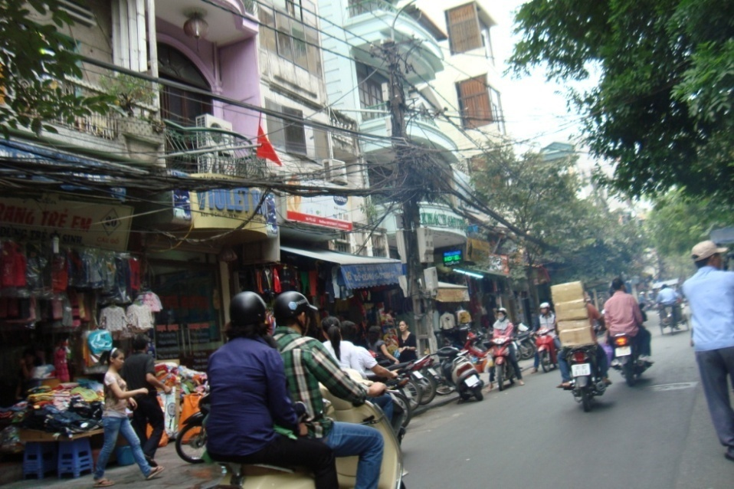
Hanoi Street Scene

About 0830, we loaded onto pedicabs for a city tour. Glad I was not driving. Rome or New York at rush hour was nothing like this traffic. Scooters and other small cycles were the majority mixed with push carts, pedestrians, taxis, and occasional busses and trucks. Sometimes the driver pedaled. Other times he pushed. The tour took about half an hour. The recommended tip was one dollar US (The basic fee was contracted by the tour company). The vendor shot a picture of each occupant in his pericab with a print for “one dolla, GI”.
Sites along the way included French colonial architecture, a couple ATMs, a sidewalk barbershop, a kid cutting meat on the sidewalk, coffee shops where people sat on short plastic stools, vendors selling almost anything you could want, and a one-hour laundry for a dollar a kilo. There were numerous parks and memorials and several small lakes.
I saw Streak-Eared Bulbuls, Eurasian Tree Sparrows, and Spotted Doves near the Presidential Palace and a Black Drongo near the One-Pillar Pagoda.
Next tour was Ba Dinh Square, the Ho Chi Minh Mausoleum, the Presidential Palace and park, Ho Chi Minh’s house, the One-Pillar Pagoda, the Temple of Literature, and the water puppet show. Interesting day.
There is a large parade ground across from the Citadel. Located on the west side the Mausoleum was opened in 1975. It was copied after Lenin’s tomb. Ho was embalmed bythe Russian, Dr. Debor, taking a year to complete.
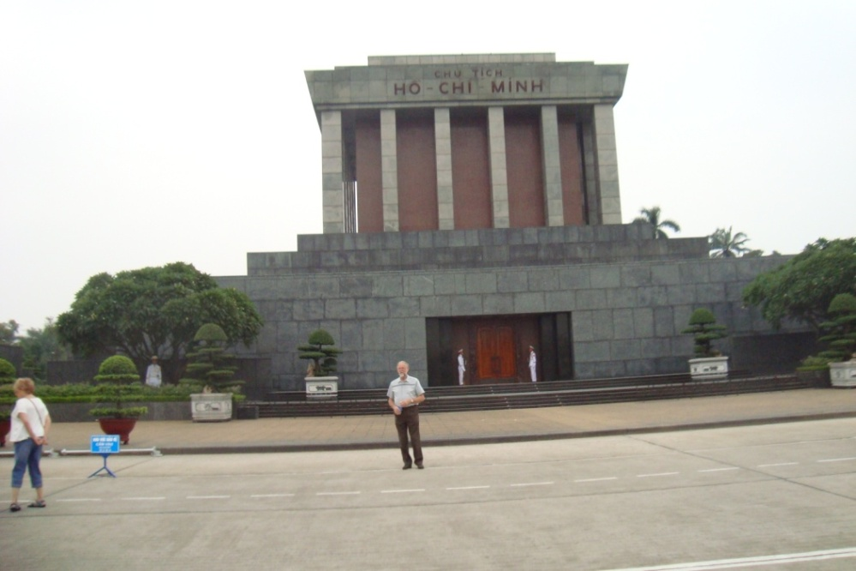
To the north, the Palace is the former French gouvenor’s residence and currently used as the official visitor quarters. There is a large pond called Ho’s fish pond. The House of Ho Chi Min is a former servants quarters where he lived instead of in the Palace. The lake and grounds were well landscaped. Ornamentials
included Ixoria, Oleander, Ho Chi Minh Tomb
Bonhinia, Kapok, Teak,
Fish-tail palm, and a new tree with aerial roots like Cypress knees.
The One Pillar Pagoda (Chua Mot Cot) was built in 1094. It has been rebuilt several times on the same foundation. Its form represents the pure lotus blosum. There were several souvenier shops in the plaza selling water puppets, musical instruments, plus all the normal tourist items.

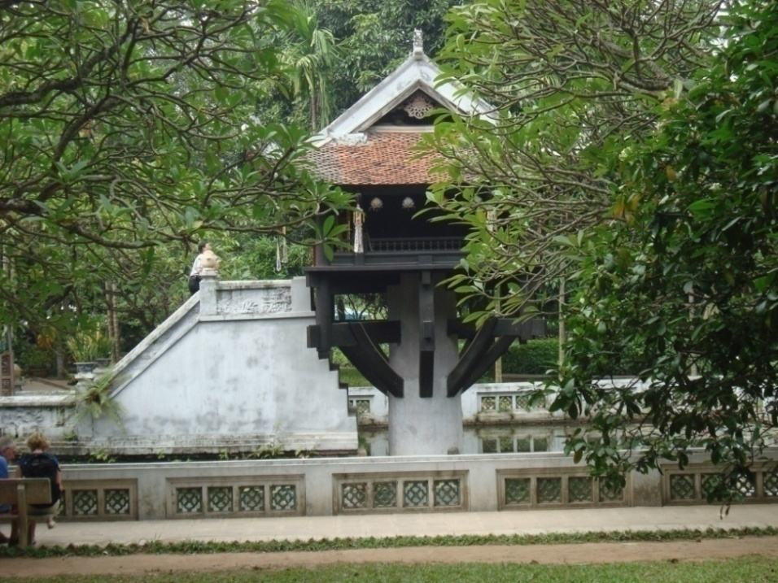
One-Pillar Pagoda

We passed but did not visit the Ho Chi Minh Museum.
The Temple of Literature (Van Mieu Pagoda) was dedicated to Confusius. It was built in 1070 modeled after a temple in Shantung where Confusius was born. It is the largest temple in Hanoi. This was the hostproc site where the 35-day doctorial examinations to become Mandarins were administred. We entered the first gate. The grounds covered a couple acres with giant Banyan and other trees. There were a lot of bonsai trees in pots and topiary animals with a variety of invasive weeds like Ruellia. The grass looked like Bermudagrass. Through the next gate was a pond and a line of 53 stelae naming the 1306 successful candidates for mandarin between 1442 and 1779. Each stelae is mounted on a tortoise, the symbol of strength and longevity.
On the way out we met a group of school girls in traditional dresses.
Back at the hotel we had lunch. Carol ordered borchetta and a Coke. I order a local beer and a panini and got a beer and some tall, fizzy drink. They took back the fizzy drink and I cancelled the panini and ate half Carol’s borchetta.
The afernoon tour included the water puppet theatre. According to Wikipedia, “Water puppetry (Múa rối nước, literally "puppets that dance on water") is a tradition that dates back as far as the 11th century when it originated in the villages of the Red River Delta area of northern Vietnam. Today's Vietnamese water puppetry is a unique variation on the ancient Asian puppet tradition. The puppets are from wood and then lacquered. The shows are performed in a waist-deep pool. A large rod supports the puppet under the water and is used by the puppeteers, who are normally hidden behind a screen, to control them. Thus, the puppets appear to be moving over the water. When the rice fields would flood, the villagers would entertain each other using this form of puppet play.”
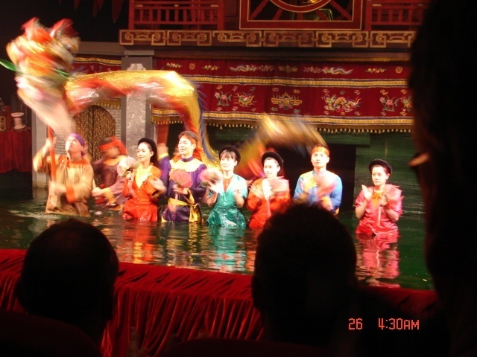
Water Puppet Theatre

The water puppet show played to a sell-out crowd. Entertaining half-hour show.
After the puppet show, we went to a market. Interesting. Live fish, snakes, and ducks, clothing, watches, etc.
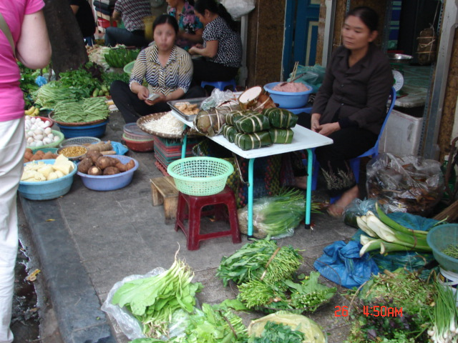
Street Market

Back at the room the temperature had been turned down to 16°C (about 60°F). These hotels seem to think a duvet alone is a bed cover. At least, this one was wider than the mattress. I prefer a sheet and a blanket if necessary.
I turned the heat up and we went for a walk. We hit a several art galleries and had dinner at the Opera House. Really good French cuisine.
Back at the hotel we repacked for the trip to Ha Long Bay.

Day 3. Thursday, 27 Oct 2011. We checked out and set the bags out to be loaded on the bus. After breakfast, we boarded the bus for the four hour trip to Ha Long Bay in the Gulf of Tonkin. This is a UNESCO World Heritage Site and nominated as a modern wonder of the world.
We crossed the Red River. There were rice fields. duck farms, and ponds of lotus and water morning glory.
Most of the houses had a lotus symbol in the ridgeline center and the Buddist cobras (Naga) on the house corners. Many of the houses were about 20 feet wide 40 feet long and four stories tall. They say land, at $2,000 a square meter, is expensive, but up is free. An average 65 m² lot runs about $150,000 so up is definitely cheaper. There is often a business in the ground floor. It looked like zero lot line zoning.
About two hours down the road, we made a pit stop at a craft center. They made and sold laquer items, paintings, stone works, silk, etc. High
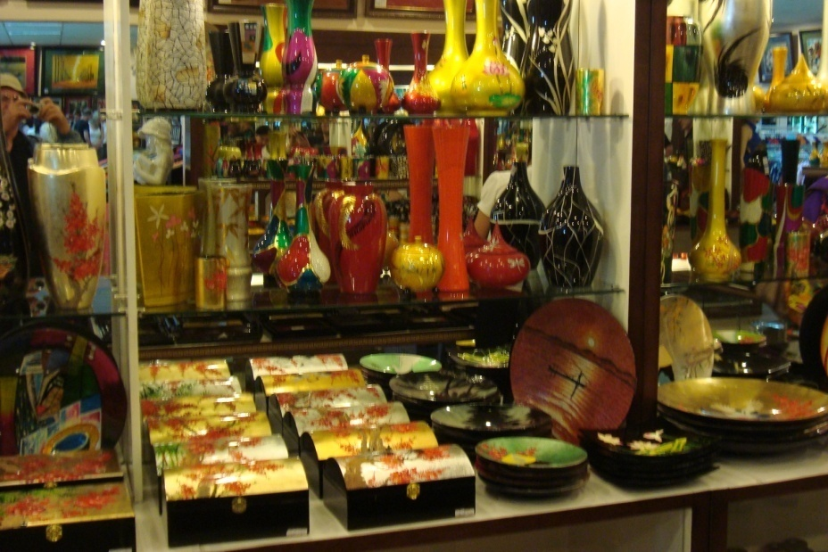
quality and relatively low prices. Surface shipping was recommended and took about three weeks.
Highway 5 running from Saigon to the China border lead through rice fields that had been bombed during the war leaving craters everywhere.
The yellowing heads of rice were being harvested by hand.
Barn Swallows flitted through the humid air. A Great Egret waded in a Craft Center canal. Depressions left over from craters were common..
Traffic was heavy. It seemed that our bus spent half the trip on the wrong side of the road tooting to pass cycles and other busses. Speed limit was 40 mph.
Cycles carried pigs, chickens, bags of rice, bundles of hay, and up to three or four people. Cyclists were required to wear helmets but many of the cheap plastic helmets were worthless and for looks only. There were few big cars or large mororcycles. Gas was about $4 a gallon. The little cycles got about 30-40 miles a gallon while cars and big motorcycles got about 20 and the trucks and busses much less.
We passed many tombs scattered in the fields. The tombs were sited using feng shui. Rice was planted around them and harvested like normal. Our guide discussed this. The dead were buried for abount 2.5 years. Then, one of the children or grandchildren would then clean the bones. These would then be dressed up in finery and placed in the tombs. We passed several areas where the tombs had been relocated in small areas to allow for factories and other public facilities.
We passed through a range of hills that were being mined and the turn off to Haiphong. It had been heavily bombed during the war.
We arrived at Bai Chay for lunch and then boarded a motorized wooden junk for an overnight tour of the bay. A fancy bridge Was visible in the distance. It had been built by China connecting Bai Chay to Hon Gai and continued on into China.
The bay had a low chop and no wind. Water had a tan cast due to the recent storm runoff. We sailed for a couple hours past colorful sea stack islands with sparse vegetation.

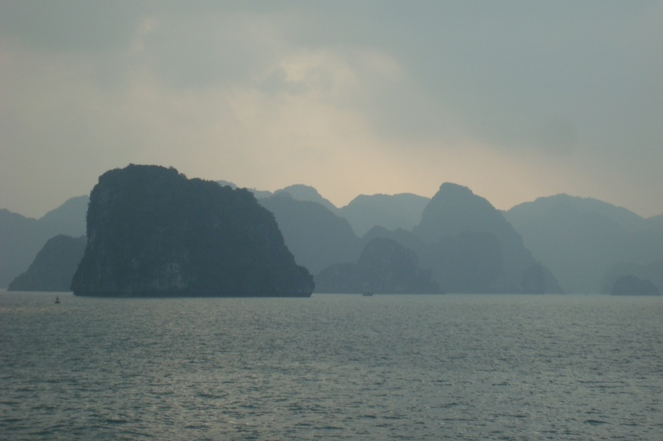
Our first stop was at Tiptop Island. This was a high island where a set of stairs had been installed to get to the top of the 300 foot peak for the spectacular view. I made the first hundred steps and decided, with the overcast, the rest of the climb was not be worth the effort.
Back on the beach I
Ha Long Bay walked along the waterline
and found a few oyster spat, some juvenile hard clams and a few small pieces of broken coral (Porites porites). This was a narrow beach of tan calcareous sand.
Several individual Ospreys cruised the sky. What appeared to be a few white gulls or terns were also seen but too far to identify.
With a low sun, the junk dropped anchor near the Cua Van floating village ( one of four villages). This congregation of about 300 house boats and 600 people was anchored or moored around a small cove. The village could be moved to safety in case of a typhoon. Generations had lived on these boats fishing and pearl farming. Facilities included a government school and a doctor. There was a bar and several shops all located on boats. A couple boats had a generator and TV. There were numerous small boats for aquatic business.
We took a boat to the village where we changed to a skiff rowed by a woman standing and using two oars. Kids in boats dropped by selling stuff. Kids had their own boats and one kid was showing off rowing with his feet. By the time we returned to the dock it was dark.

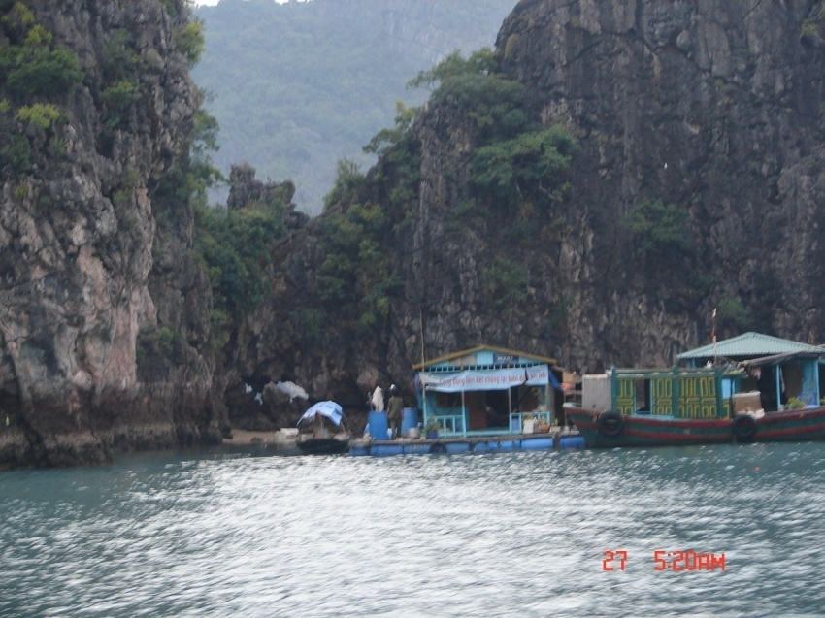
Cua Van Flating Village
We returned to the ship for supper. There was food carving demonstration before dinner and folk songs and dance after supper.
We arrived at the Luon Bo anchorage for the night and dropped anchor. About 2200 I crashed.

Day 4. Friday, 28 Oct 2011. Good old jet lag. I was awake about 0200 and went up on deck to watch the clouds drift by. The constellation Scorpio was rising overhead. I sat in the breeze listening to the creaks of the ship’s planks, the halyards beating on the masts and the rustle of the Vietnamese flag.
About sun rise, the Junk hoisted anchor and and probably woke everone. She headed to another floating community for a tour of the Cave of Surprises (Sung Sot Cave).
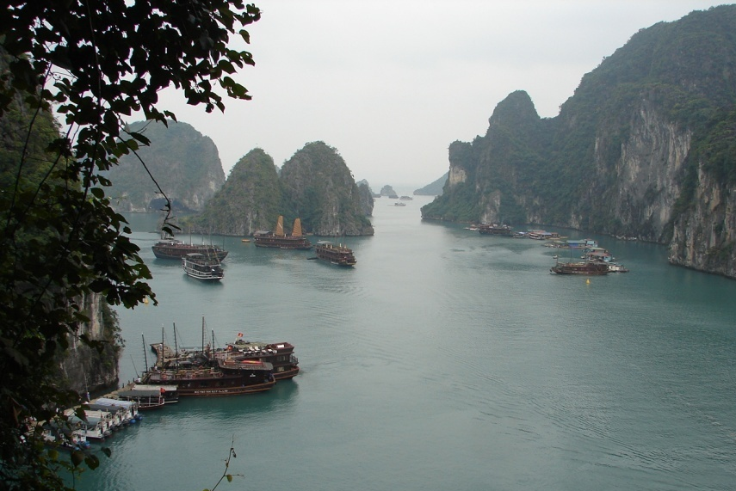
It was overcast and it just got light with no particular sunrise. Several Ospreys cruised the peaks of the islands. After tai chi and breakfast we boarded lighters for the trip to the dock. There was no beach and a catwalk met the rock about 20 feet above the water. There was big sign promoting the selection of Ha Long Bay as a modern Ha Long Bay Seven Wonders.
We climbed about a hundred steps to the cave entrance. The cave was a dead cave. It had been dry for many years and the human impact had been considerable. A trail had been laid out around empty pools and dead stalactite formations with exotic names. Colored lights lit the way. The looping tour took about 45 minutes.
There were gift shops in the cave entrance and exit and on the dock. A few shells were on sale like a Tiger Cowry for $2 and $8 for a small Murex.
Back aboard the junk we repacked and set out the bags before going to brunch.
We were back ashore near noon and had time for a Coke while our bags were loaded on the bus for the trip to the airport and the flight to Siem Reap. A light rain began.
Most of the houses had some blue on them – trim, cornice, roof, walls. Both new and faded. I asked the significance and was told this had no significance except it was cheap and longlasting. Blue is a lucky color in the Middle East.
We stopped for lunch at a large golf resort. Nothing to brag about.
The golf course was well designed and looked challenging. Landscape trees included tropical almond, papaya, alamanda, ixoria, and Jackfruit. Golfers were rich locals, Chinese, Japanese, and other orientals. There were several groups playing in the rain and more waiting to tee up.
The flight on a Vietnam Airlines 737 was smooth. Our route crossed northern Vietnam, central Laos, and the eastern tip of Thailand before landing at Siem Reap in western Cambodia.
We landed after dark and were taken to our five-star hotel/golf resort. After we found our rooms, we hit the buffet for supper. Very good selection of local food and fruits. An Aspara show of native dance and music finished the evening.
Songs of two species of frogs seranaded us as we crossed the bridge over the pond leading back to our room.

Day 5. Saturday 29 Oct 2011. I woke as the sun was rising through the palm trees to the calls of Crested Mynah birds.
Breakfast was out standing. A fruit new to me was red Dragon fruit. The red Dragon Fruit was more tart then the white. Strange. Dragon Fruit is a cactus from Mexico but I never saw it in Mexico.
About 0830, we gathered in the lobby to board busses to the Angkor World Heritage site.
I saw a purple heron in a rice field ditch and a kingfisher flitting in brush along a major canal.
I noticed that most of the buildings had one or more lightning rods installed. I asked about the lightning rods and was told lightning was common during the monsoon season.
We stopped at the South Gate for our three-day passes. There were hibiscus, Ixoria and various palms. Weeds included Bidens, Oxalis and others invasive weeds. There were tiny purple or blue flowers like Houstonia and some thorny legume shrubs that looked like Neptunia and a
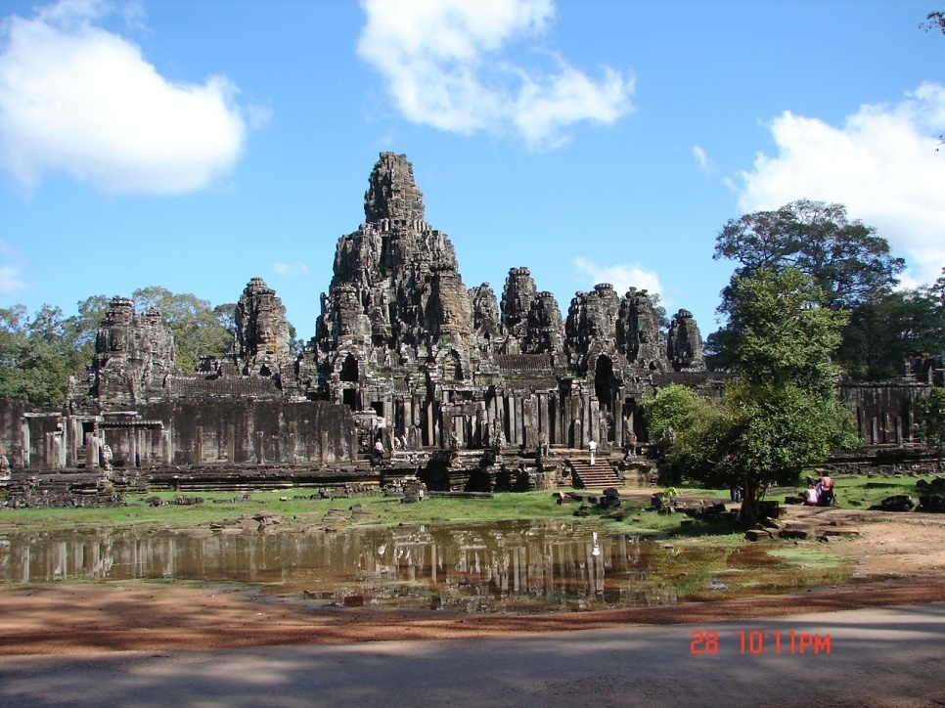
Anghor Thom
purle flowered Dayflower. Large white and large yellow butterflies flitted in the distance. The road led through forest that included the big kapok and teak trees to Bayon then up the road by the terrace of the Leper King and the elephant terrace. A vendor was providing elephant rides. We visited Angkor Thom and then Bayon and the Ta Prohm temple. Details are available in numerous references,
Banyan trees were tearing up some of the sites and being constantly trimmed or eliminated. Long-tailed Parakeets were calling and were visible in the trees.
Like many other sites world-wide, there were numerous tours from many countries conducted in many languages. There were a few monks in orangish safron robes.
We returned to the hotel. Carol and I took a motorcycle cab, called a tuk tuk, to downtown for lunch. Lots of shops and tourists. Carol picked a resturant called “Viva” that specialzed in Mexican and Khmer foods. Carol had a burger and I had one of the fish local specialties.
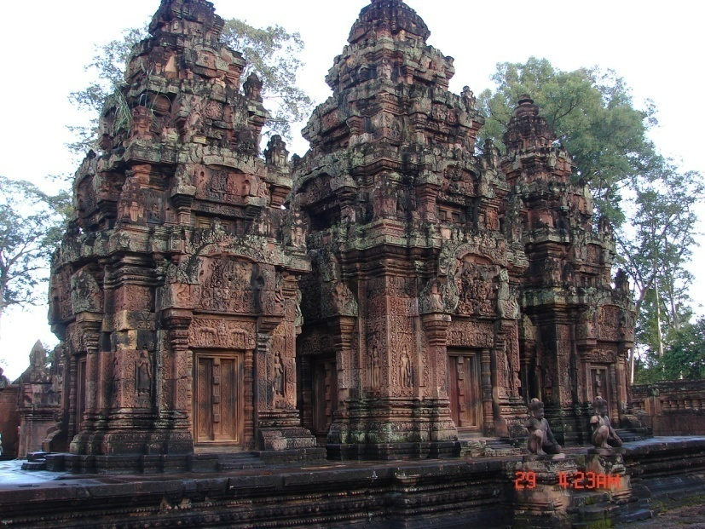
While we were eating, a young man with both arms amputated asked if we would like to buy a book on Angkor. I looked at it and decided to suppliment my other Angkor guide. He told us he lost his arms to land mines. Thousands of mines had been planted by French, American, Khmer Rouge, Thai and Vietnamese over the past 50 years, several for every person in the country. I also bought a tee shirt to support the group that was sponsoring amputees education to work and not to beg, I asked if he had some post cards. He left and returned in a few minutes and I bought several packs of cards showing the Angkor sites. Another tuk tuk took us back to the hotel.
About 1430, we left to visit the Bantey Srei temple and were caught in a shower. This was a small temple had some unique features.
Returning towards the hotel, we stopped at a village to see palm sugar being made. They used sugar palms not coconut palms. The necter was boiled a couple hours then poured

Temple Bantey Srei
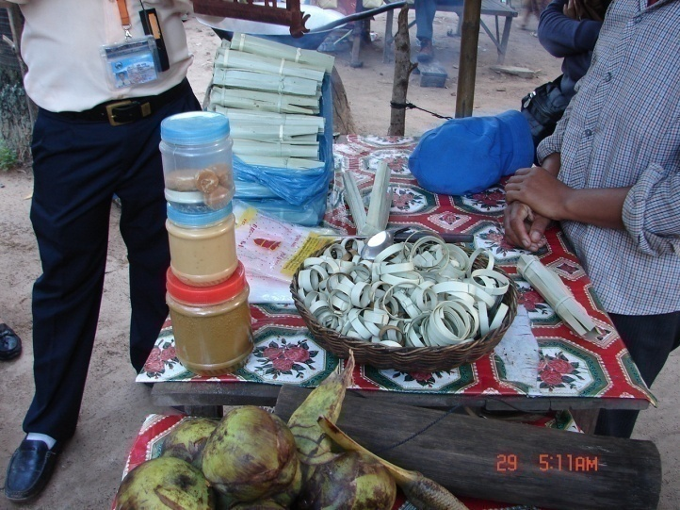
into molds to set. The sugar drops were wrapped in palm leaf ready for sale. There were other things for sale including scarfs and coconut crafts and woven palm leaf items. They had a large coconut tea pot, the first I had seen in years (I have a small one about 50 years old).
Palm Sugar making
About sunset, we stopped at the AMA school. The company sponsored an orphanage where dance, music and art was taught. The kids sang and danced for us and we shopped their crafts. I bought a watercolor. It was rolled and slipped into a woven palm leaf tube.
So far it looks like the kids of Vietnam and Cambodia are different. Cambodiam kids are friendly while the Vietnamese kids were more withdrawn. Many Cambodians act like we are entertaing them.
Back at the hotel, it was time for a shower and another good supper. We went to the night market where I tried amok. This is a fish-based khmer dish, a coconut curry served in a banana leaf packet. This is called the national dish and was very good.
We sat on a bench along the bridge in the middle of the lake and listened to the frogs and night sounds as the crescent moon rose. No mosquitoes but there were lots of leafhoppers around the security lights.

Day 6. Sunday, 30 Oct 2011. I was up for the sunrise. There were calls of the mynah birds and several doves or pigeons in the distance. One tree frog was still chirping. Two men in a boat were trimming the floating vegetation along the edge of the lake.
After breakfast, we loaded onto the busses for the visit to Angkor Wat. Along the railing of the causeways across the two moats were many Nagas (multihead cobras). Inside the walls were banyan tree seedlings on the roof and ledges that are removed every year.
I went to the top (third level) of the major temple. On the way I saw a skink that disappeared into the rubble. Back on the ground were some Plantago growing in the cracks.
Carol thought the walk would be too long and did not want to climb so she took a tuk tuk tour of the site.
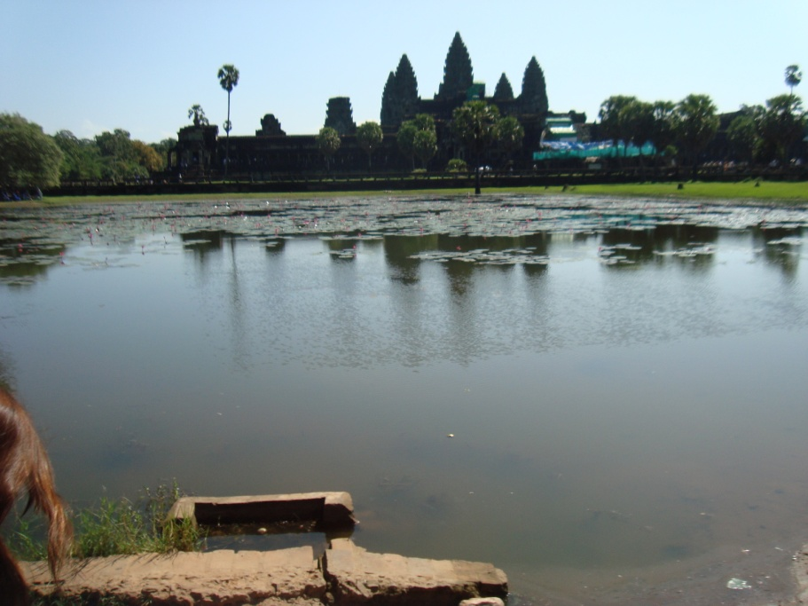
Angkor Wat

We were back at the hotel for lunch and free time. Siem Reap was much smaller, guieter, and less hurried than Hanoi. There was traffic but not the jams of Hanoi. Since this was a tourist area and had only been developed over the past ten years, the shops and resturants were much more modern and much cleaner.
We went shopping in the afternoon. One of the shops sold carved stone. I had been told of the “instant antiques” in Thailand and Vietnam. These were replicas sold as antiques. I peeked through a curtain and saw a carver sitting on the floor with a stone between his feet using mostly hand tools. He had a dust mask but no eye protection.

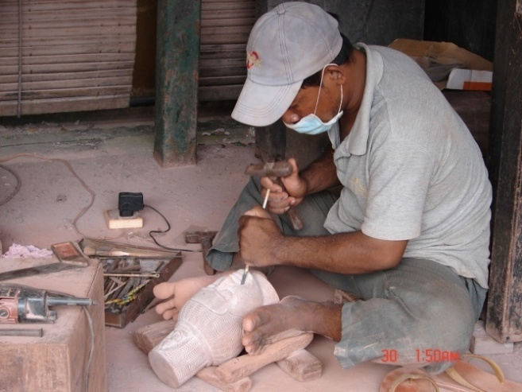
Stone carver

We repacked the bags and I crashed for a couple hours. About sundown we went downtown for supper and to visit the night market. The market was about two blocks long with jewelry shops instead of stalls, massage parlors that gave massages, large aquariums for a fish pedicure, art galleries and several resturants. We bought two oil paintings that were demounted, rolled and put into a woven palm leaf tube. There were two foot massage places where you let fish do the work. Probably not too sanitary.
Supper was pretty good. I had banana blossum salad and another Khmer fish specialty. Carol had beef and peppers. Not very spicy. We were the only ones in the resturant except the owner and his family. The little kids came up to the table several times to say hello and grin.
.
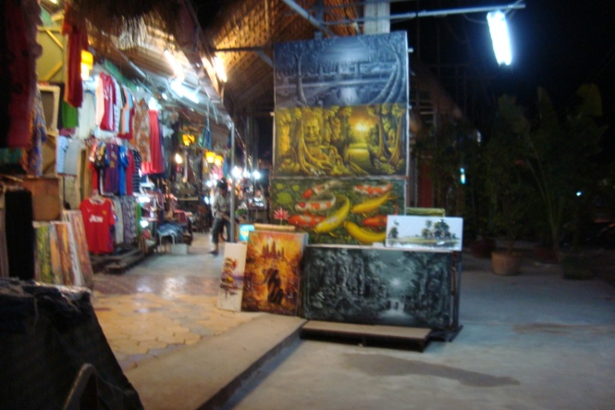
Night Market

At night the flashing lights of a KTV (Karoke bar). Our guide explained that these bars were often fronts for brothels and that many of the girls were under age. I later found that an NGO called Agape International Mission was trying to save these young girls that had often been sold to reduce family debt. Virgins were worth maybe $1500 to a brothel owner who sold them to foreign pedifiles for $5,000 and up. Without a certificate of virginity young girls were worth about $500 to the family.

Day 7. Monday, 31 Oct 2011. I was up abour 0530, finished packing and set my bag out. While Carol finished packing, I went down to check out.
After breakfast we boarded the busses and headed to meet the ship at Kampong Cham. I was disappointed to find we would not traverse Tongle Sap Lake with its birds and vegetation.
One of the Crested Mynahs was sounding like a Mocking bird with a variety of songs.
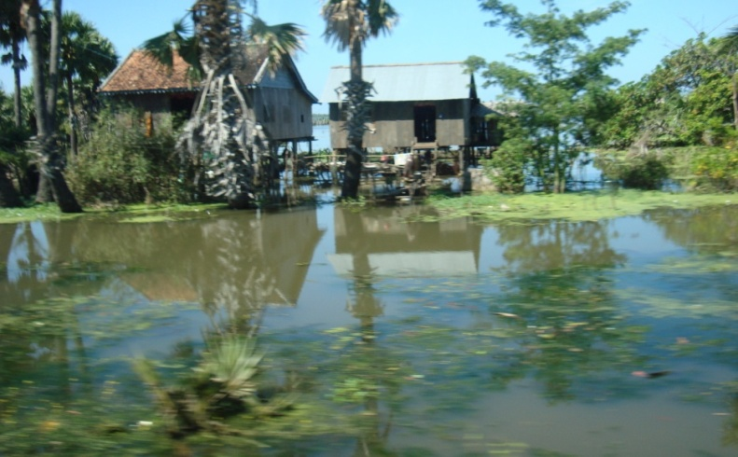
The Tongle Sap Lake was still 10-15 feet high from the flood and monsoon water so we had to drive around the lake. The lake was several time larger than usual and the water was still draining from the countryside flowing at maybe 4 kts.
The highway bypassed Tongle Sap Lake on the north and east, This was mostly rice farms.
There was still standing water on both sides of the road but water had covered the
High water road a couple weeks previous.
About half way, we passed through some hills with rubber plantations. There were crops of casava and sugarcane, coconuts and bananas, and a tall grass grown for hay. There were also plots of corn and sweet potato.
The International Wildlife Federation was concerned about the loss of wildlife habitat due to the purchase of the open areas for agriculture.
After travelling about 200 km and three hours, we came to the Mekong River at Kampong Cham about 1300. Our home for the next week, the RV La Marguerite, was moored to a muddy bank where the water had receded about 15 feet. The path to the ship was covered in sandbags to keep everyone out of the soft gray mud. We boarded and had lunch.
The rooms were soon ready and we were scheduled for a safety briefing at 1700 (bring your lifevest). The welcome dinner was at 1900 followed by a piano bar.

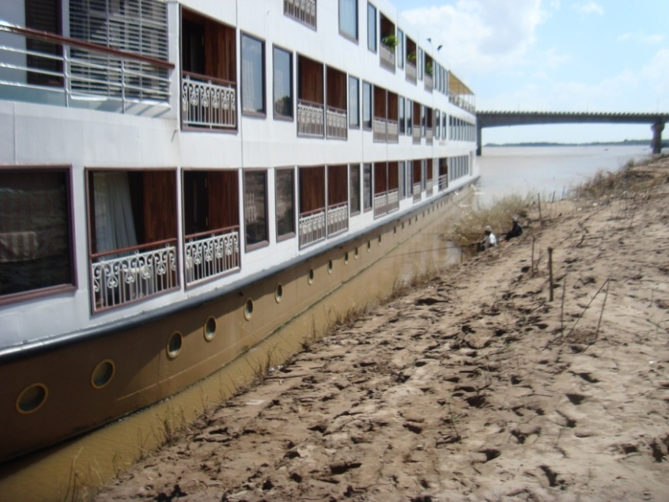
Day 8. Tuesday, 1 Nov 2011. I was up 0530 before light and went topside to hang the sun up a little after 0600.
After breakfast we met about 0800 for a walking tour of Kampong Cham and the Dei Dos Pagoda.
The water was a thick coffee latte color too thick to drink but too thin to plow. The river was still dropping from the recent typhoon.
RV La Marguerite I watched various ships pass by – cargo types,
ferries and fishing boats. I noticed some kids fishing and catching small catfish (Clarius batrachus?). The floodplain was almost totally scoured of vegetation and covered in silt. Further along the river, men were setting out gardens of morningglory, casava, long bean, bitter melon, etc.
The first tour was to a pagoda. We walked about a half mile along the bund. Long thin fishing boats with long shafted outboard motors were beached. Fish traps were on the beach or emerging from the water. People were gathered talking, doing tai chi, sitting in outdoor coffee shops. We passed a small market with food and quart jars of scooter fuel. A fortune teller sat under a tree doing a fair business. There were several portable presses for making sugarcane or other juices. The asphalt street had quite a bit of traffic for the time of day.
Yellow Cassia shrubs (“yellow flower?”) grew along the street. Other trees included Mango, African Tulip Trees, Jack fruit, and tropical almond.
There were a few tall Mast Trees with long crenate leaves.
On the beach people were fishing with poles, dip nets, and cast nets. This was the fishing season with many fish having been swept down stream in the flood waters. The most popular were small catfish locally called Trey Dang Dau.
Along the inland side of the street were numerous small shops, several furniture factories, a coffin factory, a Catholic school, and numerous small coffee shops.
We entered the pagoda grounds and were greeted with a number of bell-shaped structures and a row of family tombs. The grounds were landscaped but not well maintained. I saw patches of Neptunia, morningglory, Bidens, Nightshade, Ruellia, Purslane, and knotweed. Poinciana trees, roses and camelias were in bloom.

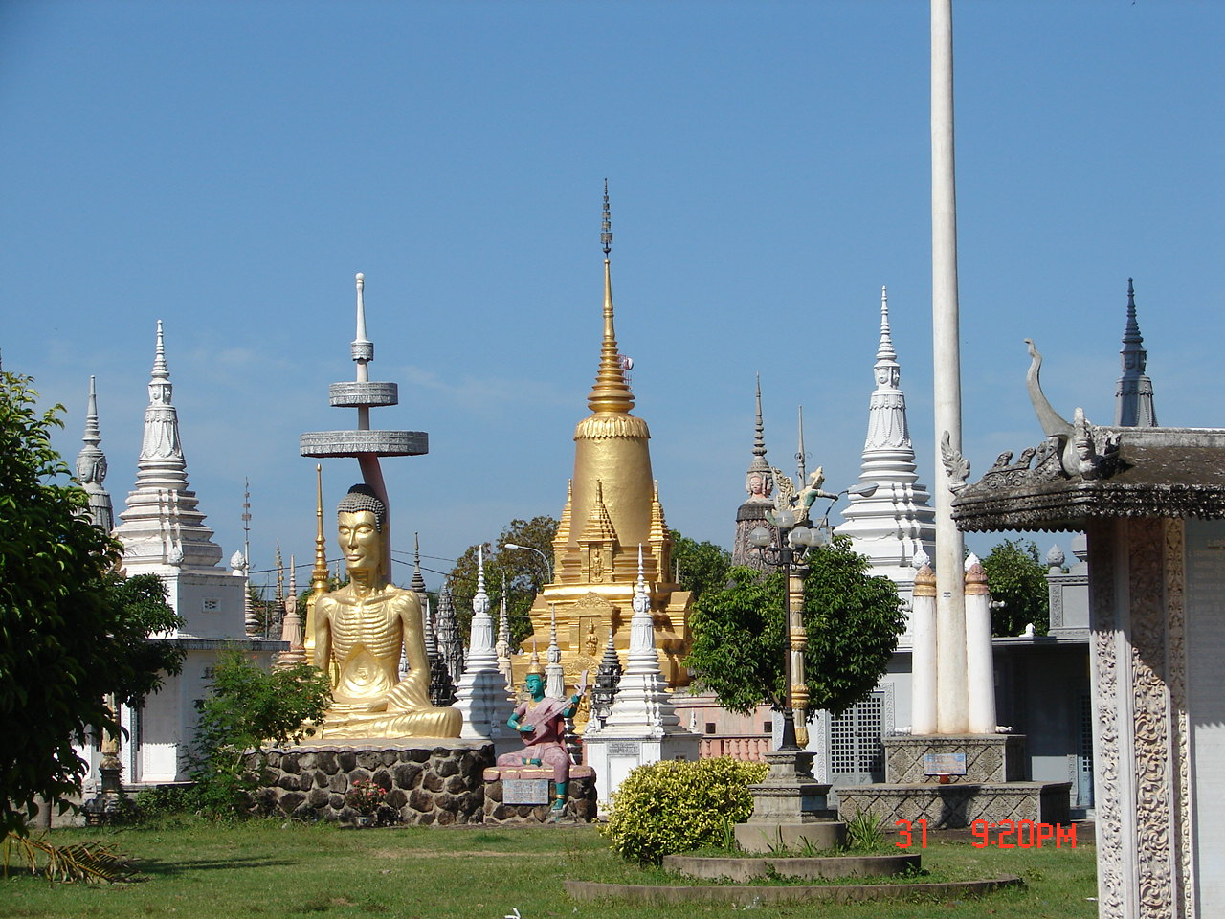
Pagoda
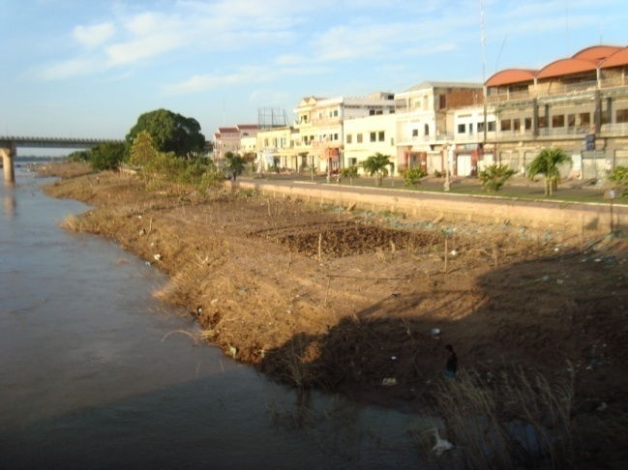
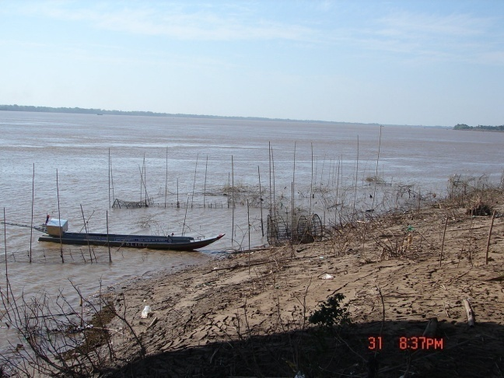
Fishing Boat Garden Plots
One of the large statues was a skinny golden budda. The temples were gold color with red tile roofs. There were a lot of gold colored life-size statues of Khmer figures like the elephant god and large Nagas on the stair hand rails.
Headed back to the ship we met several kids trying to fly home-made newspaper kites.
About 0915 the ship cast off and steamed under the Mekong bridge. We arrived at Chong Koh a little after 1500.
We passed the town’s large gold pagoda and warped its way to dock at a small concrete pier. All of the kids in town and most of the adults met the boat with a friendly “Hello”. Mats were laid out with silk goods for sale. Most of the group wanted to wait until we returned to make purchases. We picked up an escort of kids.

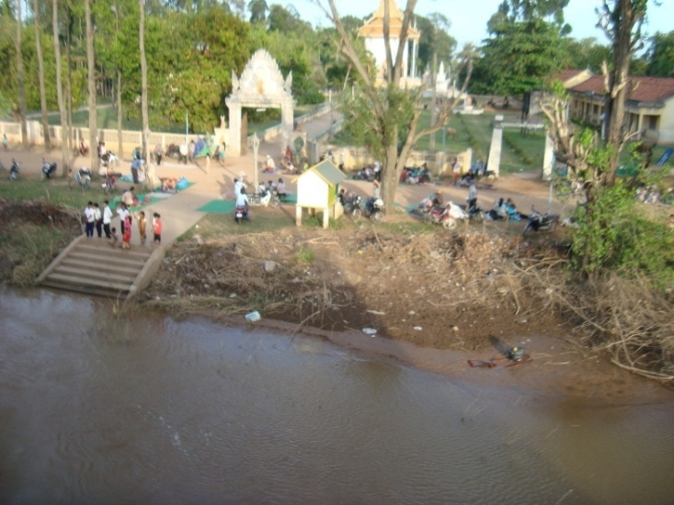
Chong Koh

The houses were all raised on piles with living areas under the houses. Smudge fires are often built under the houses to run the mosquitoes out. The yards were full of cycles, cows, and gardens and all the houses had a family shrine near the road. Several of the houses had looms set up under the houses producing silk fabric for scarves, table cloths and table runners.
One of the crops was black pepper. It grows on a vine. The leaf can be used with betel nut off the local palm trees and slaked lime to form a mild narcotic that stains teeth black and produces a red saliva. The lime is one source of calcium. Anyway, the pepper berries are picked green for immediate use or sun dried to make black pepper or the husk of the dry pepper is removed to make white pepper. I did not see any stained teeth although betel nut is sometimes given to the kids to keep them quiet.
We looked at looms under a couple houses then went to visit a pagoda. If you judge the prosperity of the surrounding area by the looks and condition of the pagoda, then Chong Koh was pretty well off. Well maintained and lots of gold leaf.
Back at the landing, wheeling and dealing was underway. I bought several scarves and Carol bought a tablecloth and table runner.
This was a two hour stop. The ship cast off about 1730 heading for Phnom Penh.
So far the population looked healthy. Other than the amputees in Seim Reap I had seen no invalids and no obvious skin or eye problems.
Discussion of local history with our guides showed that the general population was largely uninformed about recent history and the Khmer Rouge in particular. Cambodia and Vietnam both require schooling through grade 8 but many, particularly girls, don’t get this far. School is in morning and afternoon with a siesta break. Many of the students get two years English. Many of the little kids say “Hello”, “How are you”, “How old are you” (since there is a respect for elders), and similar phrases. They giggled when I tried Khmer or Vietnamese phrases.
Post-Khmer Rouge society has reasserted teachings of the Chbap Srei (The New Girl Book). This 17th centuary Khmer guide is a long narrative poem outlining the desired behavior of young women. It was taught in pre-revolution public schools. It is repressive and a factor in slowing the recovery of the country. As a result, in this relatively poor society education of males is common and preferable although women operate many small businesses. No equality for women.

Day 9. Wednesday, 2 Nov 2011. We had anchored mid-channel at Phnom Penh. About sunrise we warped up to dock at the Sosowath Quay.
Phnom Penh was founded in 1434. It was occupied by the Japanese in WWII and the entire town was evacuated by the Khmer Rouge in 1975. Since 1979, there has been a lot of modernization and development.
After breakfast, we had a bus tour of downtown Phnom Penh including the Royal Palace, the Silver Pagoda, the Wat Phnom, and the National Museum. Much of the city was of French Colonial architecture.
The palace was a 15,000 sf structure painted saffron and trimmed in gold. No pictures were allowed and you had to remove your shoes.
The Silver Pagoda and the National Museum had religious and historical artifacts many of which were gold or silver.
Just before returning to the ship we visited the Central Market. The market was busy but not crowded. It was somewhat divided as to type of merchandise, i.e. clothing, jewelry, etc. Everyone laughed when I bought a suitcase the haul all our loot.
At 1430 we left to visit the Killing Fields and Tuol Sleng (S21). The Killing Fields is located 15 km south of downtown at Choeung Ek. The road was lined with small shops and houses with flooded rice fields behind them.
The Killing Fields was a mass burial site where 8985 people had been mostly bludgeoned to death. A glass memorial stupa filled with skulls found nearby is the centerpiece. We walked through the park avoiding the excavated burial pits. There are interpretive signs throughout in English and Khmer theroughout the park.

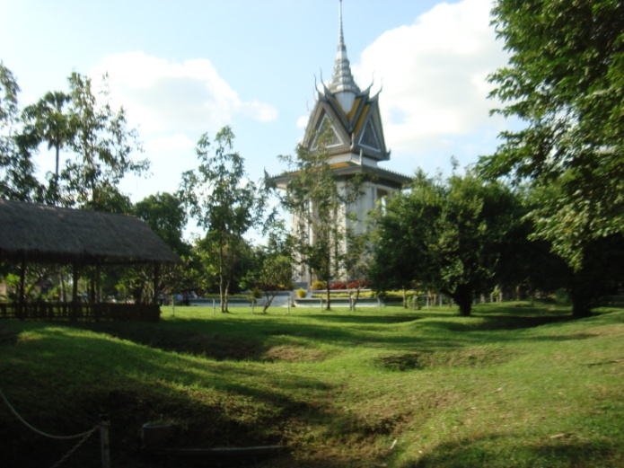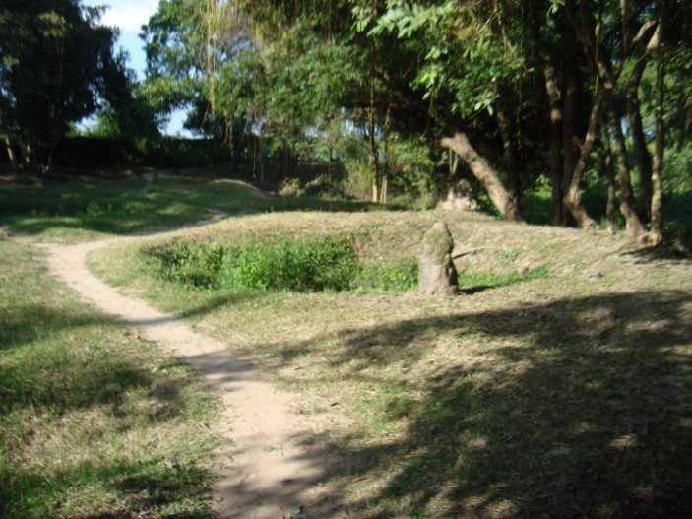
Memorial Stupa Killing Fields excavations

Returning to south Phnom Penh, we stopped to visit the Tuol Sleng (S-21) Museum. This was the site of the former Tuol Svay Prey High School. It was modified to serve as a Khmer Rouge interrogation and torture center. At least 14,000 men, women, and children were “processed” and the majority were executed. Here were the offices of the secret department S-21.

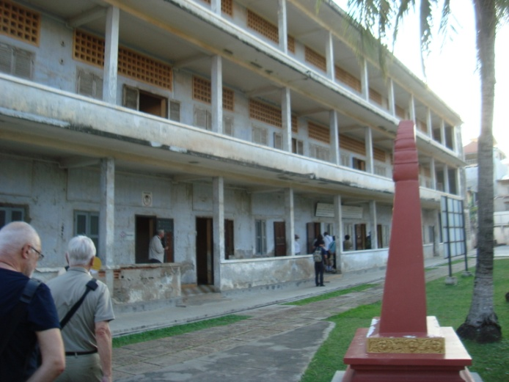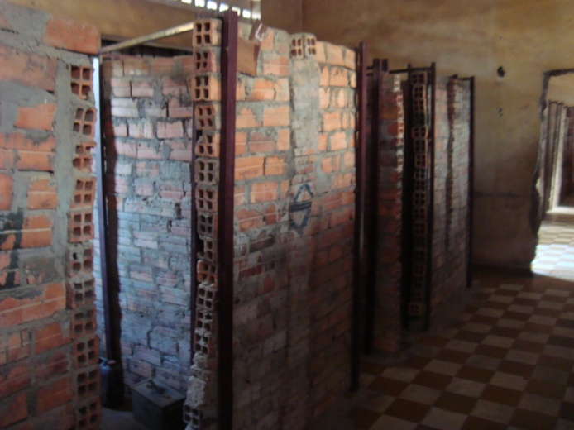
S-21 Torture Cells

A Khmer childrens dance group performed after supper.
The ship spent the night tied up at the Quay. Some of the group went out for the evening to see the new Phnom Penh night life.
To the south, about 150 miles on the Gulf of Thailand, is the port of Kampot where weapons and war material were imported and sent up the Ho Chi Minh trail for use in the war. This port is on the Cambodia/Vietnam border.

Day 10. Thursday, 3 Nov 2011. It was a colorful sunrise. My stomach was a little tender probably do to acidosis from eating too much fresh fruit. An Imodium tablet solved the problem.
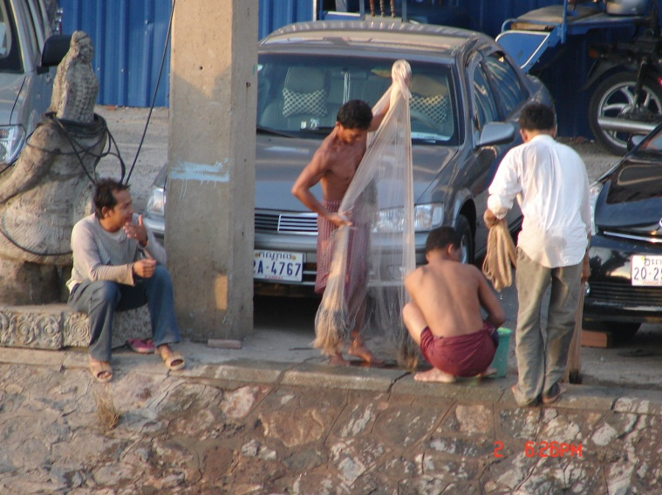
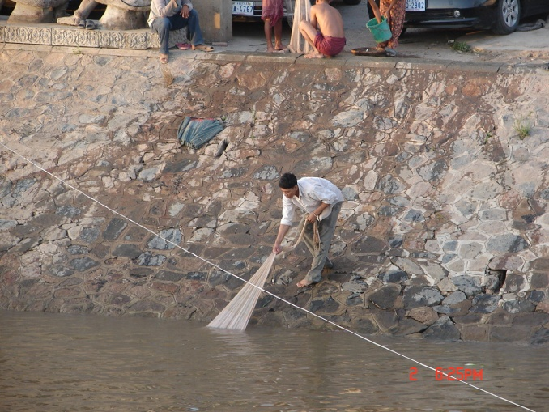
Fishermen

There were a couple fishermen using cast nets. They were catching fish and taking a swim if they slipped on the steep concrete wall.
After breakfast, we boarded busses for a 20 mile ride to Oudong. There were rice fields and several small villages along the road. A flock of white egrets occupied one rice field. There were several fish farms along the road.

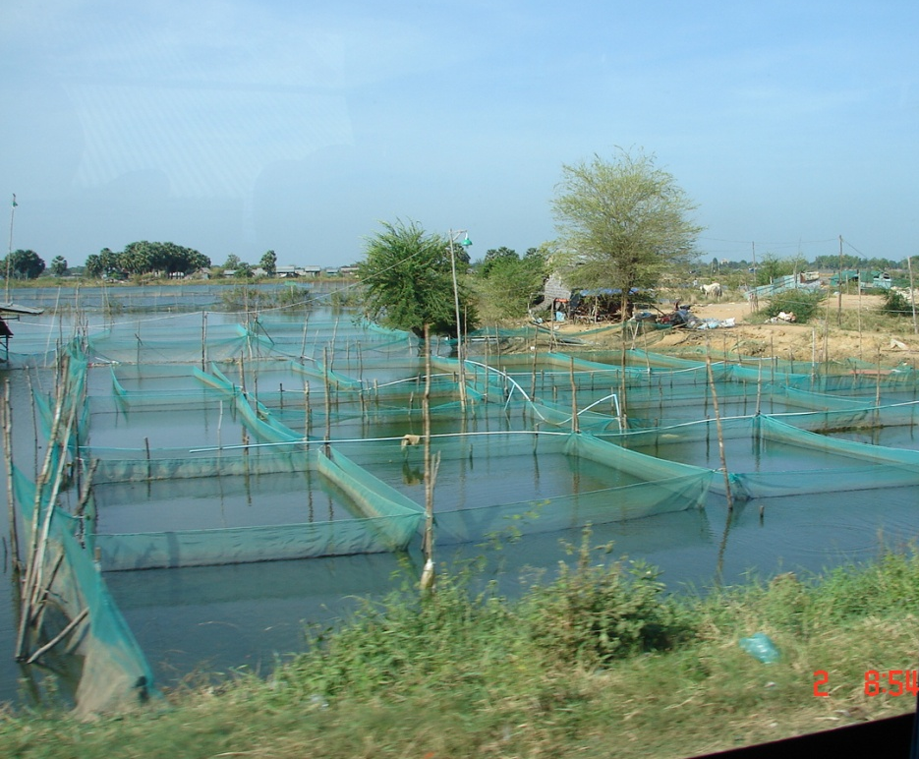
Fish Farm
Oudong became capitol of the Khmer Empire in 1618. King Norodom moved the capitol back to Phnom Penh in 1865. Much of the city was destroyed by air strikes on the Khmer Rouge that occupied the city in the 1970s.
Entering Oudong, I saw a cell phone shop and a pharmacy, then resturant then another phone shop and pharmacy. There were half a dozen phone shops and seveal pharmacies along about a mile of street.
Come to think of it along the river we were seldom out if sight of a cell tower.
The road lead to the Buddhist Monastery of Vipassana Dhura the largest monastery in Cambodia. There were about 50 monks in residence. We walked around the grounds and went to the main building for the monks blessing. After this, we visited a large building with many Bhuddist style paintings.
I looked at the grounds and pond. They were landscaped with ornamental shrubs and flowers and statues of Khmer mythology and well maintained.

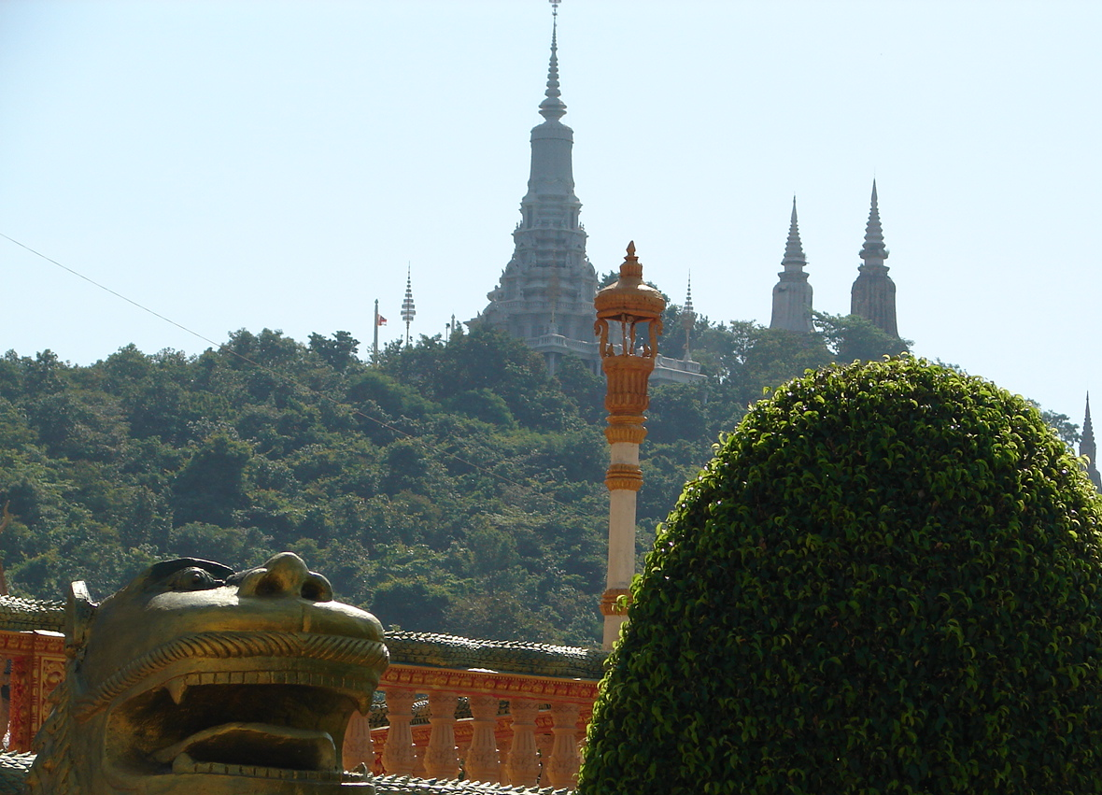
Buddhist Monastery of Vipassana Dhura

There was some construction going on. I saw a welder welding without eye protection and watched a man about three stories up installing roofing materials without shoes or a safety line. I guess only the materials and technology had changed in the past thousand years. Like the stone cutter in Siem Reap that held the stone between his feet while he hammered a chisel with a dust mask but no eye protedtion. OSHA would have a fit.
Forty-five minutes down the road was Kampong Tralach. This was a small farming community where we had a short ride in an ox cart. The ride was through the village where all the kids turned out to wave and shout “Hello”. Some of the kids were selling wild flowers (begging was forbidden).
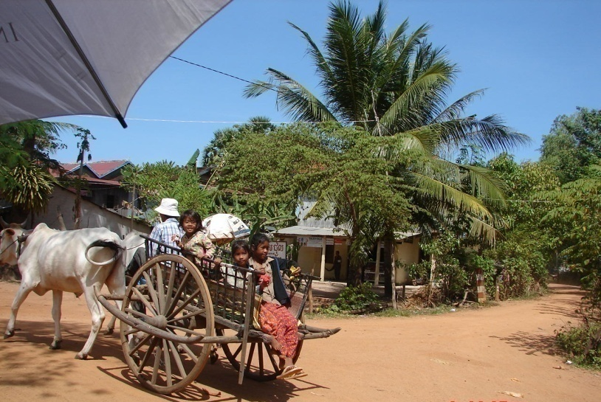
Ox carts are important in some rural areas used similar to a truck to haul food, feed, and materials. The ox is used in dry area and the water buffalo in used where it is much wetter.
Ox Cart Ride

We returned to the ship for a free afternoon. Carol wanted to go shopping so we found a tuk tuk that took us to a shop that sold good jewelry and antiques. She spent a half hour looking and bought a scarf while our tuk tuk waited. Then he took us to another shop for jewelry and then to the Russian Market and finally to the Central Market. I bought three pairs of Levi’s 560 cargo pants for $10 each and a couple five dollar T-shirts. (I later found they had flaws but they are good work pants.) They do not match anything currently shown on the Levi’s website. About two hours in our tuktuk cost ten bucks. I am sure the driver also received a percentage of everything we bought. If this is like Thailand and many other countries, the stores each own a fleet of tuktuks and drivers.
There was a Khmer music and dance show by local musicians on board after supper. The folk songs and music mostly represented rural life.
Out on the deck gekos hiding in the potted plants were calling. A low pressure front had rolled in from the west and the evening sky was filled with heat lightning. Lightning flashes appeared behind the clouds but there was no thunder. Heat lightning lit up the eastern sky backlighting tall sugar palms and cell phone towers.
.
Day 11. Friday, 4 Nov 2011 . After midnight it rained for about an hour. The morning came up breezy and cooler.
I was on deck with a pot of tea about 0600 waiting for the sunrise and watching the river traffic and the city come alive. The guys with castnets were at work. Big clumps of water hyacinth were floating down stream in the tan flood water.
We left the quay and headed east 120 km for the border crossing into Vietnam near Tan Chau. The river banks were punctuated with houses, small villages and factories. The horizon was scalloped with tall teak or kapok trees and sugar palms. A few barge trains were carrying sand from river dredging sites.
The sky was a white overcast like the monsoon was back. Lightning was back for the evening.
We anchored midstream for the customs check. Skiffs with officials arrived at both sides and left after about two hours. During this time the crew held classes on folding napkins and towels and fruit sculpting and the chef demonstrated how to make fresh spring rolls.

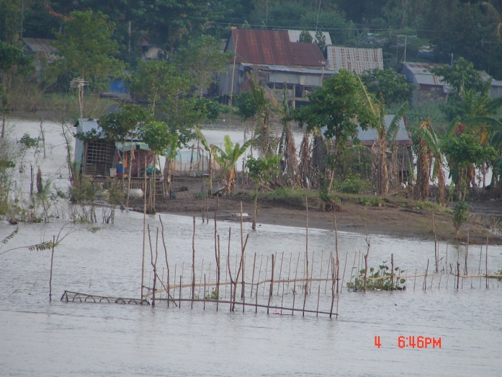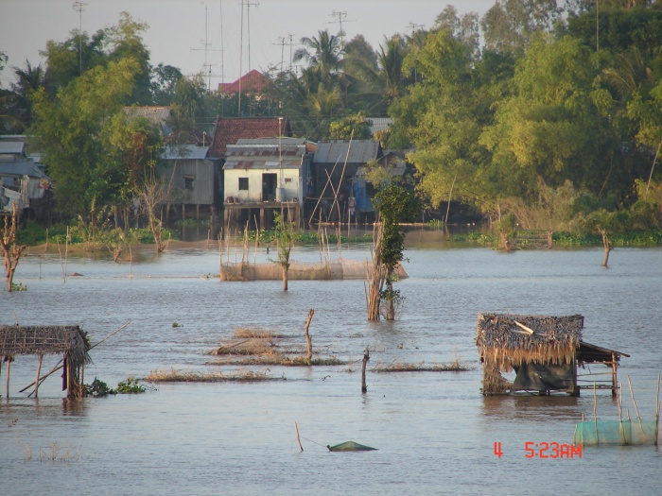
Villages and Fish Traps

Several of us watched fishermen setting hoop nets and using castnets from boats in the shallow water. There were also large permanent traps.
The ship pulled the hook and we continued about 25 km to our Tan Chau anchorage. During this period there was an ice cream party.
There was a briefing for tomorrow’s tours followed by supper. This was my birthday and I was surprised when the cookstaff brought out a birthday cake and sang “Happy Birthday”. We consumed about a third at our table and I walked around to each of the other tables offering birthday cake. Supper was followed by a crew talent show of songs and folk dances and then by karyoki music for dancing. I went up on deck to watch the lightning show for a few minutes before crashing.

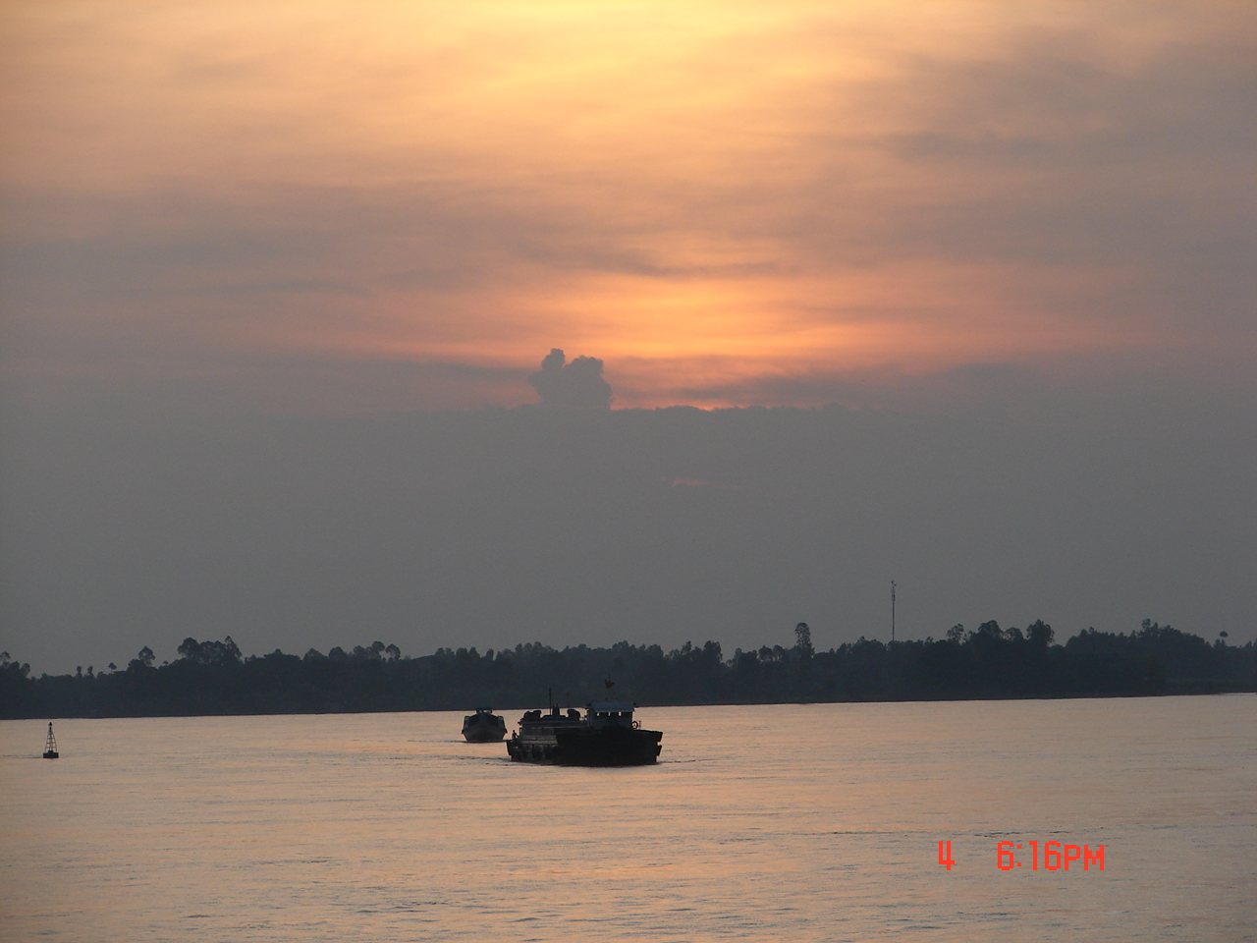
Monsoon sunset on the Mekong

Day 12. Saturday, 5 Nov 2011. About 0600, the sun crawled out of a cloud bank. The low pressure front had passed.
The excursion process is pretty orderly. The group is split into three groups if about 20 and each group is designated by a color. We were in the yellow/orange group. Each person had a boarding card that you picked up on leaving the ship and turned in when you returned so they could keep track of people. Pretty efficient.
We left the ship and were picked up by bicycle rickshaws (tuktuks). One person per tuktuk much like we had in Hanoi. They pedaled and pushed until we reached a silk factory where they made many silk items. A single weaver on a loom could produce about 5 meters of silk a day. The new machinery can do about 25 meters a day and a single person can maintain 5 to 6 machines. I bought Carol a colorful silk dress after asking several tour women if they thought it would fit.
Next was to the boat landing. We loaded aboard a small passenger boat and headed out to see a floating fish farm and a small island village. “Put on your life preservers”.

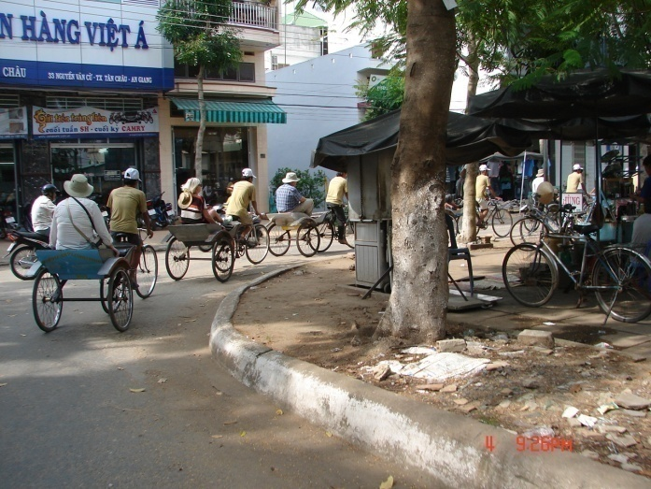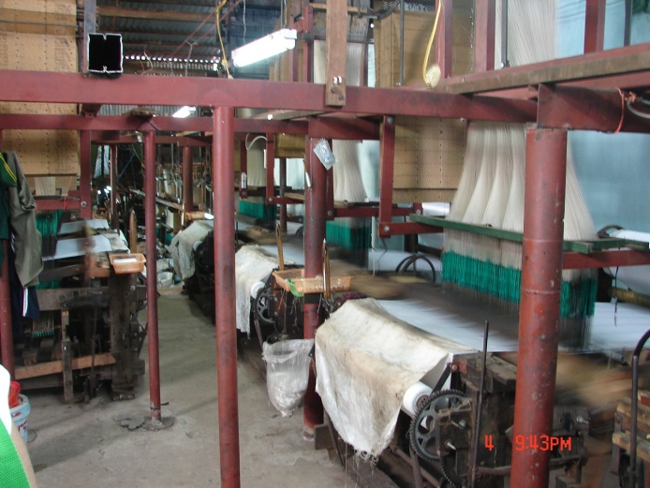
Pedirickshaws (tuk tuk) Silk factory

The floating fish farms were metal barges with wire mesh cages hung from the deck. The cages were 7X15X2 m (25 by 50 feet and six feet deep) wire mesh covered with chain link. The fish were fed commercial fishfood of 1.5% protein. Fingerlings are purchased and fed out. The catfish sold for about a buck a kilo. The choice fish was the Red Tilapia that brought $1.50-$2.00 per kilo. Construction cost per unit was about $50,000. It would have been interesting to see more than ten minutes of the process. Much of the world has problems with cage culture because the local river current is not enough to remove the waste away from the cages. If the Mekong flows like this all the time they are lucky to keep the cages from floating away. The Mekong is 50 to 120 feet deep and is running 2-3 knot current.

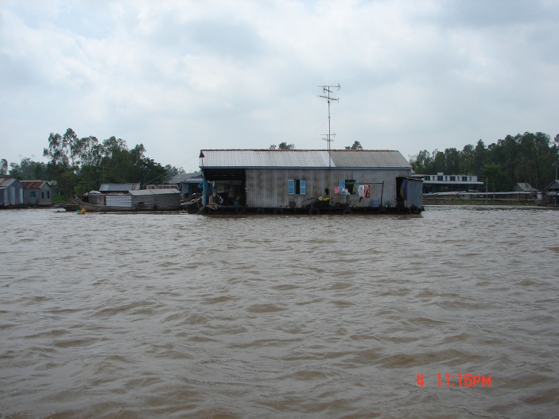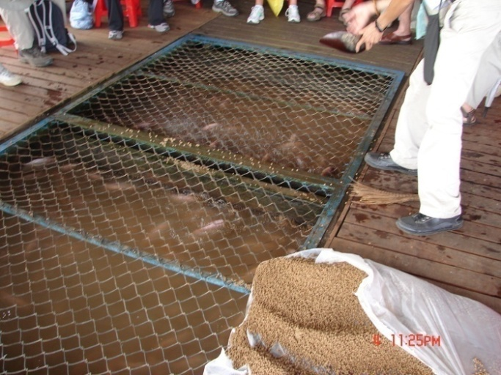
Floating Fish Farm Fish Cage
Tree sparrows were living in the eves and feeding on the fish food. On he way back I saw several gulls and a couple white terns.
Next stop was a village on the island. Crops included millet, melons, corn, and rice. Kids all over. The village had about 600 people. They also harvested pepper and pepper leaf, Jackfruit, mangoes, taro, and long beans. They also produced tea seedlings. There was a couple trays of fish drying in the sun.

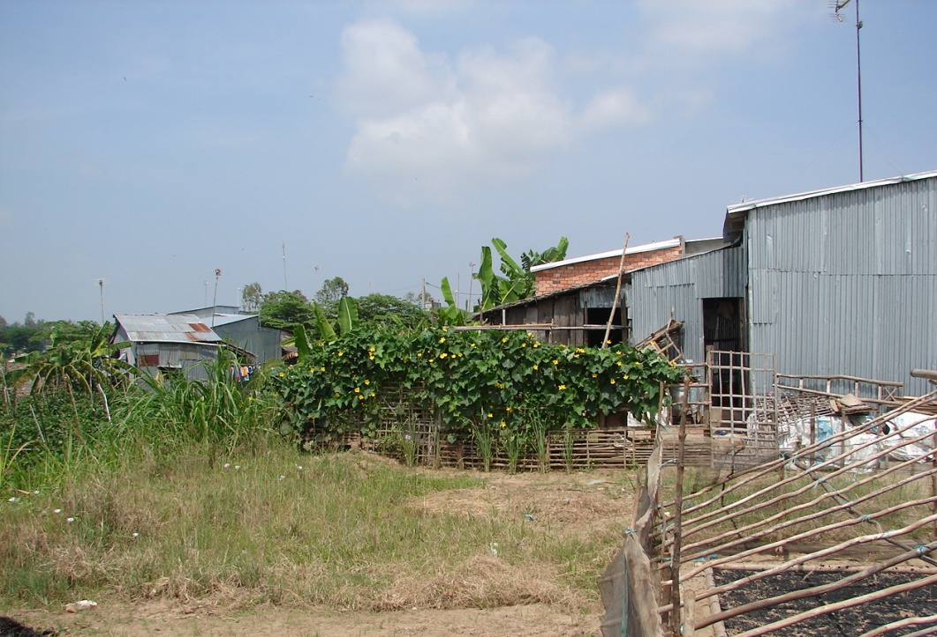
Small Farm
Birds included egrets, a crow, and small birds.
We returned in time for lunch. After lunch, our guides held a question and answer session about Cambodia and Vietnam. Interesting to hear their ideas and impressions.
About 1830, there was a briefing on tomorrow’s tour followed by supper. We pulled the hook and headed down stream for Sa Dec. Nice evening to sit on deck in the dark and watch the lightning. It rained for a couple hours in the middle of the night.

Day 13. Sunday, 6 Nov 2011. We were anchored midstream on a cool, breezy morning. The sun did not come up, but the swallows were busy over the river.
The day’s tour was to Sa Dec, a busy port and industrial center. During the Vietnam war this was the headquarters for some US Swift boats and later some of the A boats.
This was the home of Marguerite Duras between 1928 and 1932. Her mother ran a school. Duras had an affair with Huynh Thuy Le that became the basis for Duras’ 1984 prize winning novel, “The Lover”. She was the namesake of our ship.
After breakfast, we boarded a local boat for a ride across the river and up one of the small tributaries. We passed boat yards, houses and numerous shops overlooking the water.
We stopped to visit a brick factory. They import the clay and sand and mix it at the factory. Much of this material comes from dredging the river channel. The bricks are formed up and allowed to sun dry for a day. Then 10,000 bricks are loaded in a kiln and cooked for 30 days using rice husk for fuel. After the bricks are loaded and the fire lit, the wall of the kiln is bricked shut. The sale price was 30 bricks for a dollar. Since there are 525 bricks to a bundle or pallet this would be about $17.50. Local price for similar bricks in San Antonio, Texas, ran about $425.

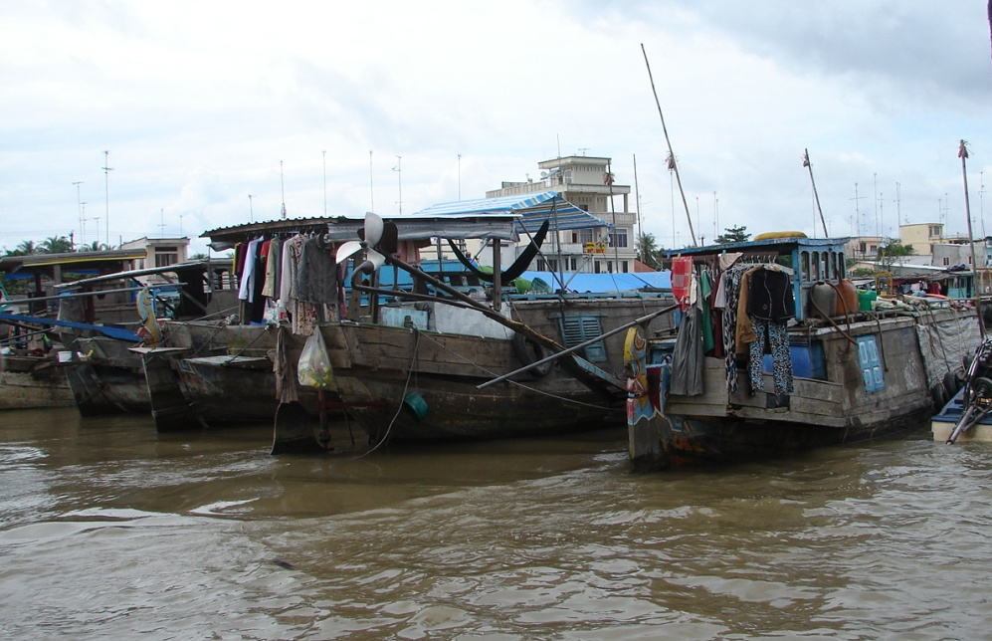
Living on the Mekong
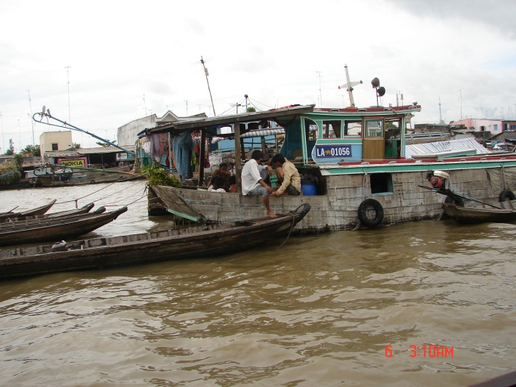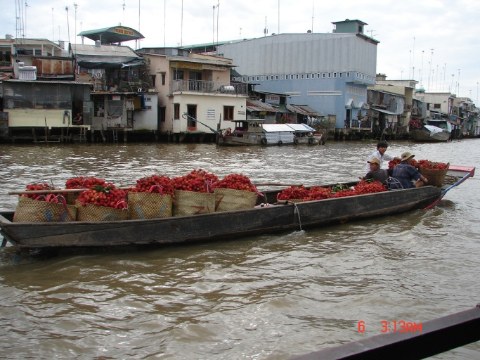
Floating Market

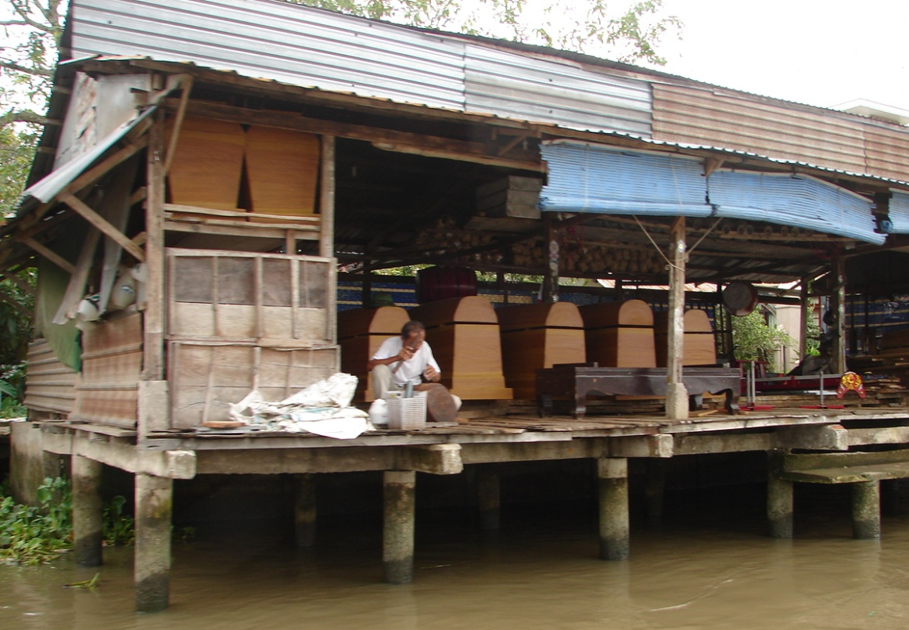
Coffin Maker

Next stop was downtown. We disembarked at a quay along the main street. The inland side of the street had all kinds of shops. The the Lover’s Museum was the house that had been the home of her lover and where Duras’s book was sited. Green tea and cookies. Her mother’s home and school are still in use as a school. There were pictures of the writer and the stars who acted in the movie adaptation.
We visited the Fujian Temple next door . This had been donated
to the city by the Le family.

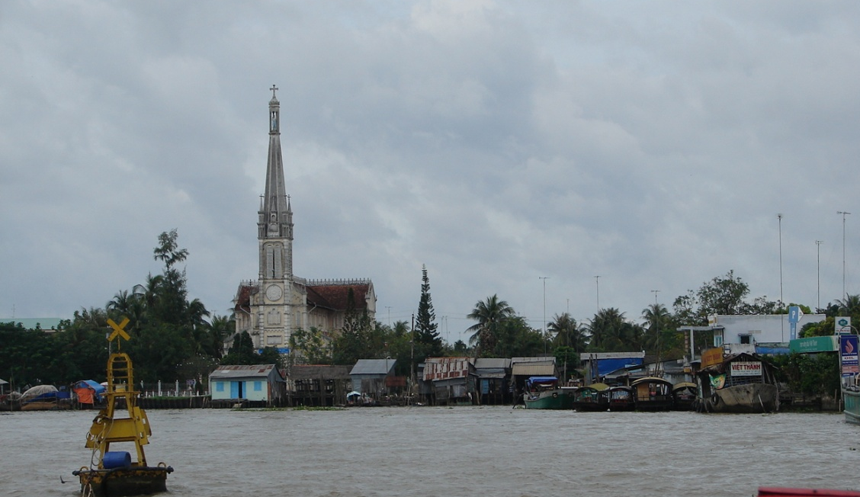
Cai Be Waterfront and Catholic Church

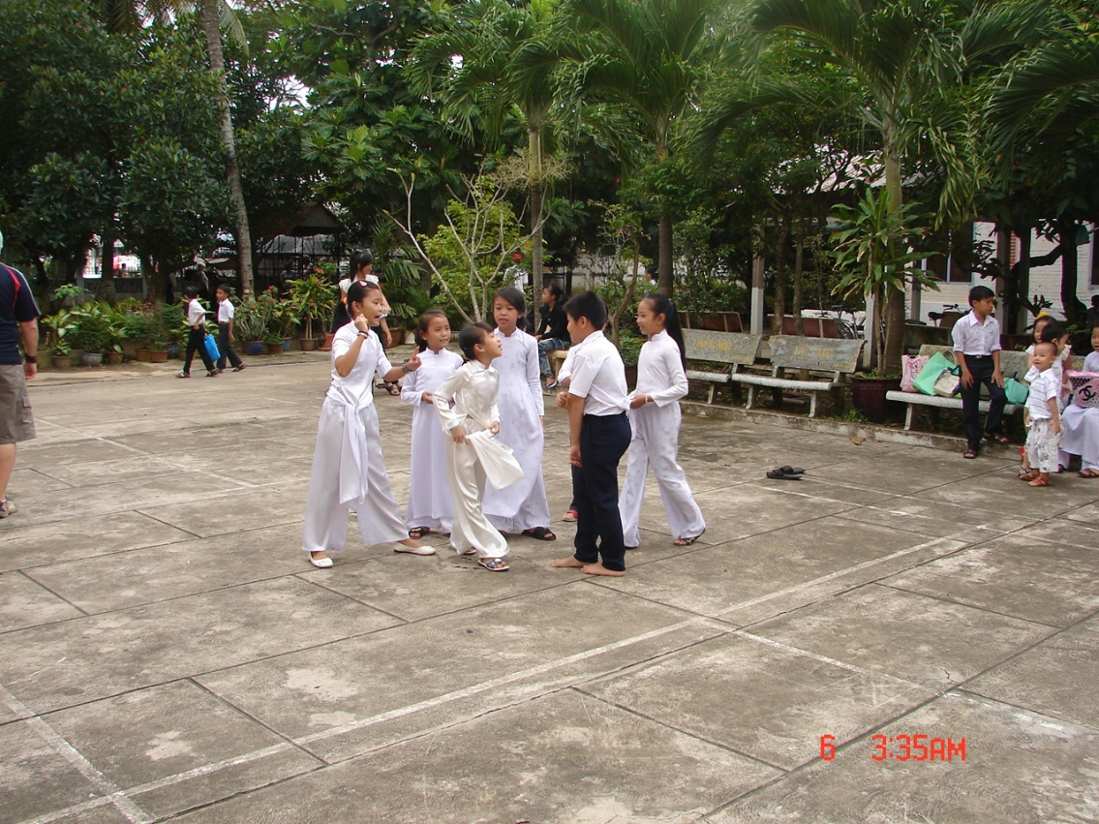
After Church
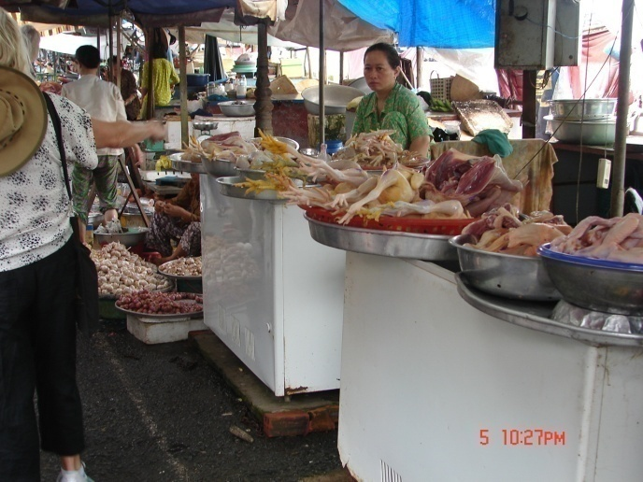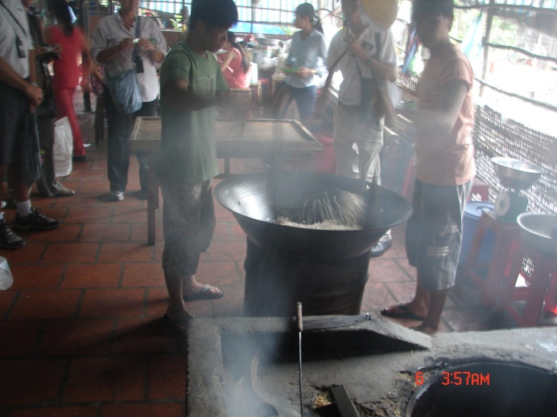
Market Candy Factory

After lunch we took a boat to Cai Be. It has a large floating market where boat loads of produce is sold wholesale. Boats loaded with lechees and other items anchored and opened for business. The were also shops along both banks.
We stopped down town to visit the street market. Back at the quay
we crossed the street to visit a Franciscan Catholic church with two large grotoes lining the side yards. A group of students was taking a break after services, the girls in long white dresses and the boys in black pants and white shirts. There were also a cages with a howler monkey, a macaque, and a couple parrots.
The market had vegetables, fruit, meat, and live fish, eels, frogs, turtles, and ducks. All this on both sides of the street with cycle traffic running down the middle.
We took a walk to a shop where sleeping mats and slippers were made. The straw was dyed and then woven by machine. Next, we visited a candy factory where they made coconut candy, edible rice paper, sweet puffed rice, and other Asian candies. They also brewed local wines – rice, banana, sugar cane and one with a snake in it. We got to sample everything but I don’t think anyone tried the snake. They also had a big selection of local crafts.
We headed towards the landing to catch our boat. One of the vendors was selling “‘water coconut”. I’m not sure but this looked and tasted like immature or green coconut.
Back on the ship, we paid our bill and handed out the tips and prepared for the farewell dinner and a musical show. I sat out on the deck after supper watching the lightning. I heard a geko calling. Looking around, I saw several gekos near the light fixtures catching bugs.
Day 14. Monday, 7 Nov 2011. We pulled the hook about 0700 and sailed about 70 km to the port of My Tho. About 0830, we offloaded to busses for a sight seeing tour of Thanh Pho and Ho Chi Minh (Ho Chi Minh City or old Saigon) on the way to the hotel.
The scattered farmland and small villages gradually became more complex. Finally, a wide street with business buildings. We stopped tp view a Chinese Buddist temple. Next stop was for a quick walking tour of the Notre Dame cathedral and the post office designed by Dr. Eiffel. The former US Embassy and CIA headquarters were pointed out.
Next was a quick trip through the central market.

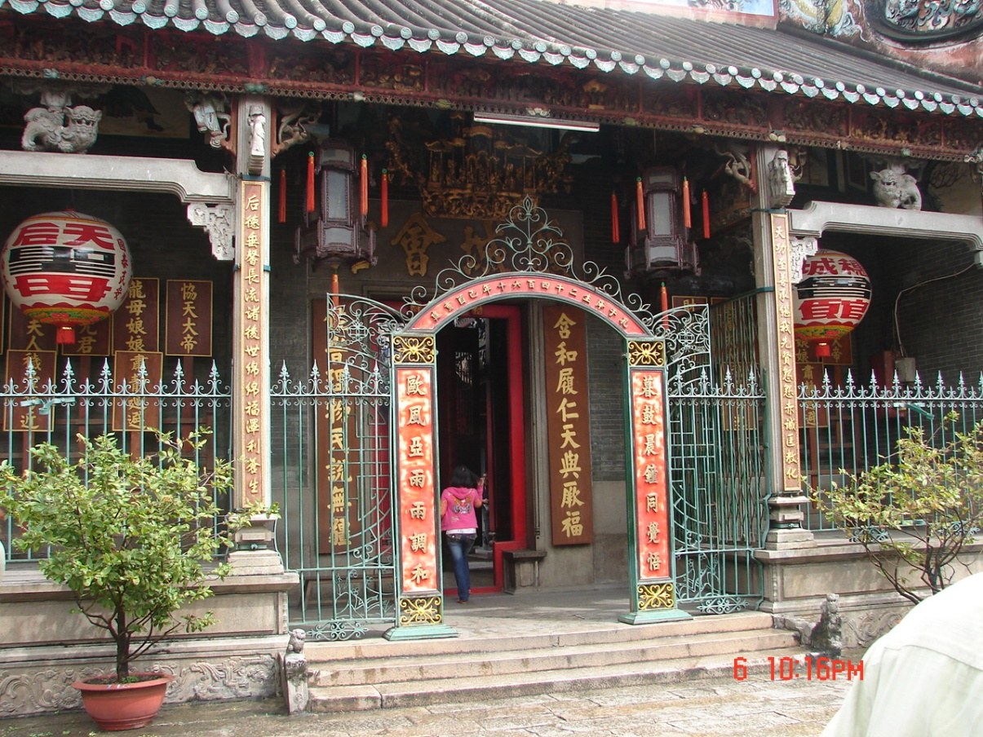
Chinese Temple

We stopped for lunch at the five star Indochin Resturant. This took over an hour. We left the resturant for the hotel about 1400, check-in time.
Of all the places we hit on this trip, all had modern Japanese Toto toilet fixtures except for one French bombsight. Even the smaller towns had running water. I’m sure this does not apply everywhere but our tour guides have really taken care of us. There are few public facilities so I never pass up one.
This was a five star hotel. We moved in and went out to look at a few art galleries and shops.

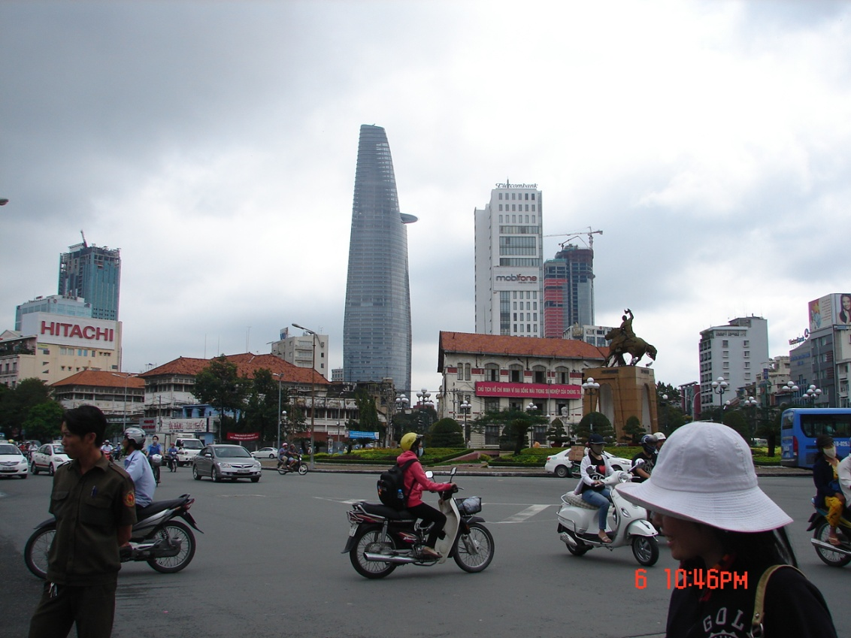
Central Saigon

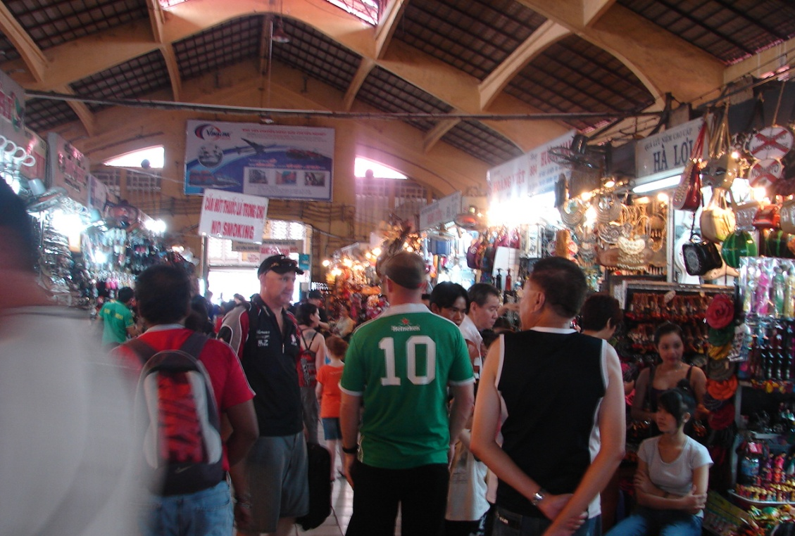
Central Market

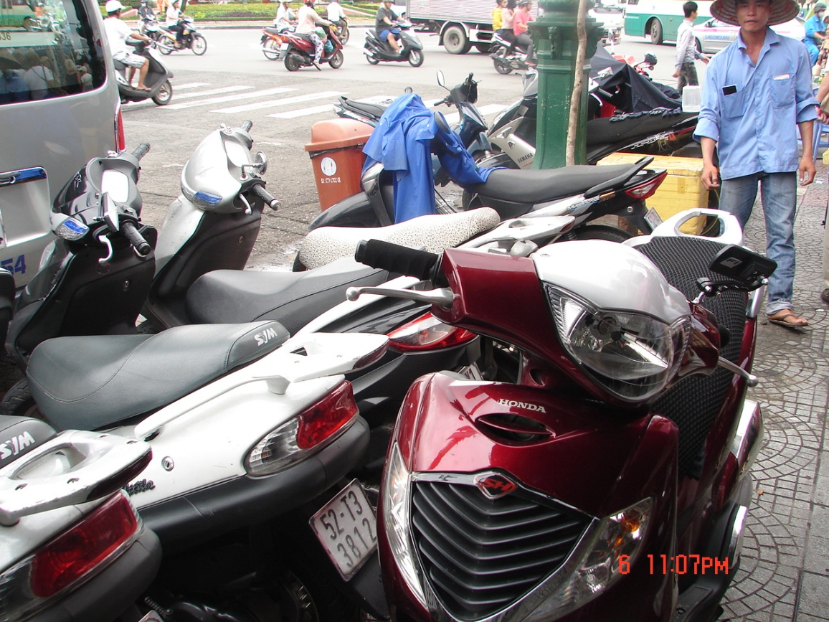
Sidewalk?

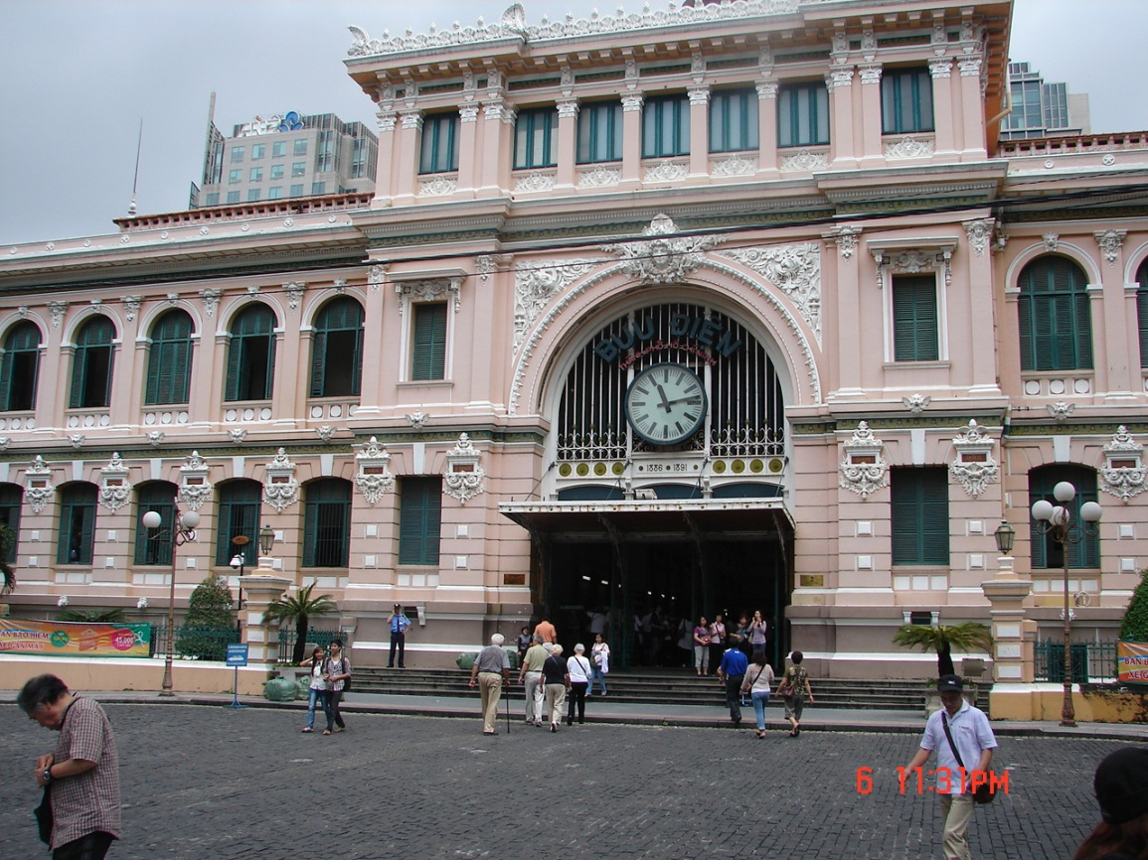
Central Post Office

About sundown we went to the hotel dining room. Carol got a decent burger and fries. I wanted to get a Mexican food fix and ordered quesadas. No bueno. The tortilla was replaced by flat bread; it had ground meat and no cheese; a really mild pepper sauce; and yogurt in place of sour cream. Even their breakfasts dishes were hybridized Asian and European dishes. I guess the menu was for the upscale international visitors since they did not have much local food and everythig I saw had a chef’s touch.

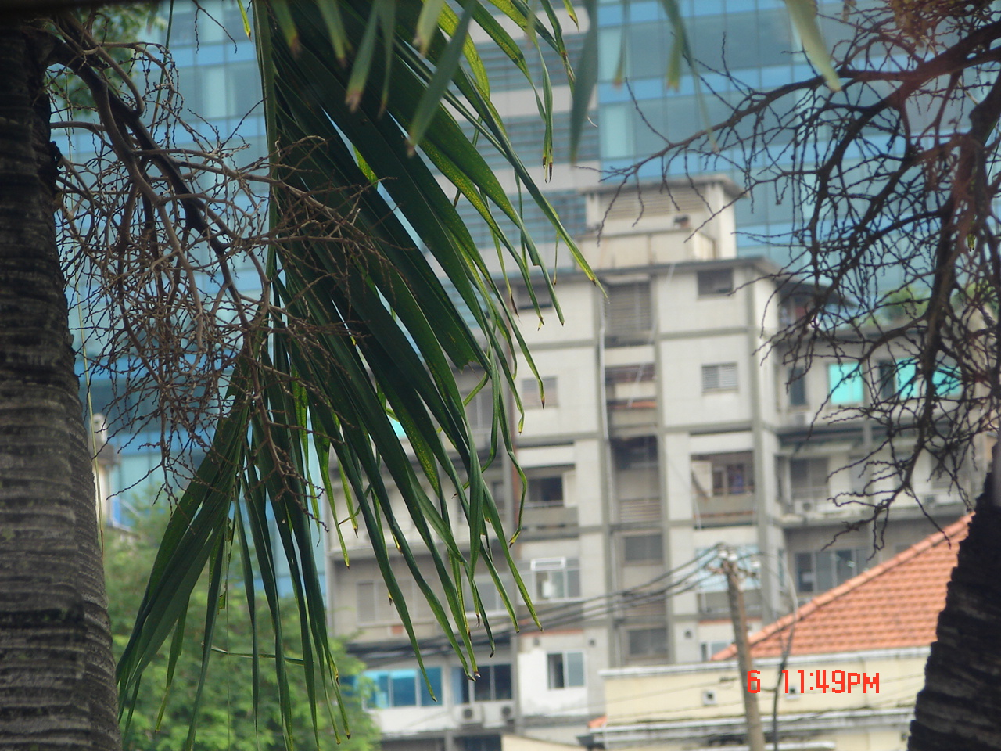
Old CIA Headquarters

Day 15. Tuesday, 8 Nov 2011. After breakfast we toured downtown including the Presidential Palace where we saw the ceremonial rooms and the private apartments with its heliport, then down to the basement and through the command post with the old teletype machines. A pair of Russian tanks that had invaded the Palace grounds were on display.
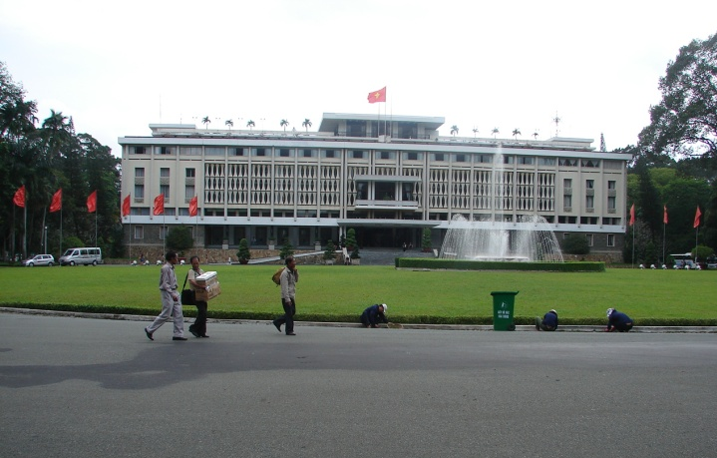
Presidential Palace

Seeing the various weapons on display reminded me of an engineer I knew who worked as a civilian in Saigon. Civilians were not permitted to have weapons of any kind but he always carried a postol stuck in his waistband. I asked if he ever shot anyone and he just grinned. I don’t know what he actually did.
Another civilian worker said he was ashamed of the way Americans treated Vietnamese help. When he moved into government quarters, the maid was expected to clean the toilets with a rag but no gloves, brushes, or chemicals. He procured a pair af rubber gloves for her.

Near the hotel we stopped at a laquer factory where laquerware was crafted. Pictures. Screens. Furniture. Containers. Really well done. Prices were very reasonable but the cost of shipping was prohibitive

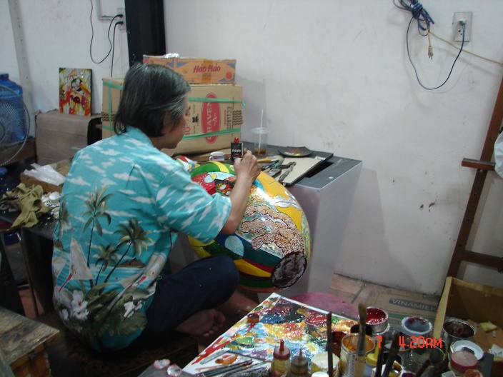
Artist
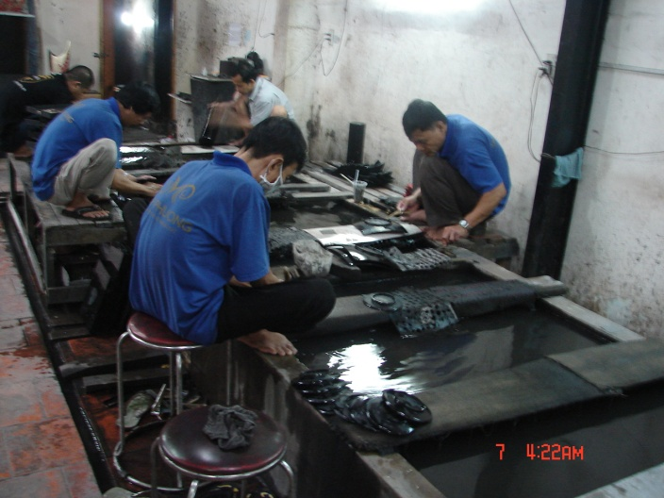
Setting the pattern

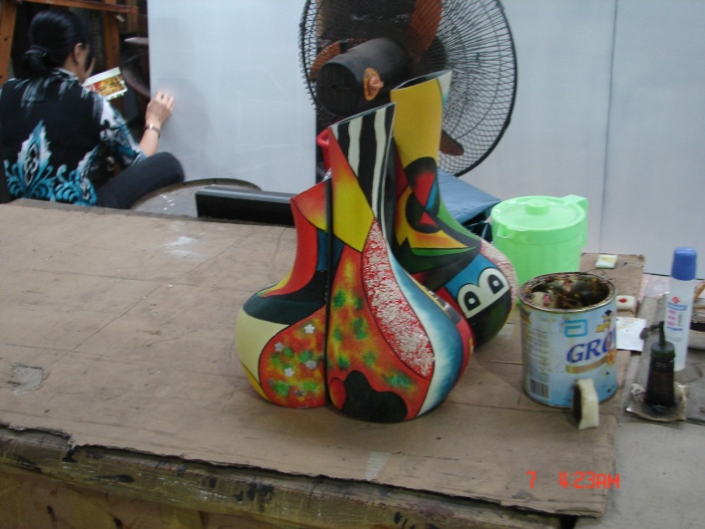
Art

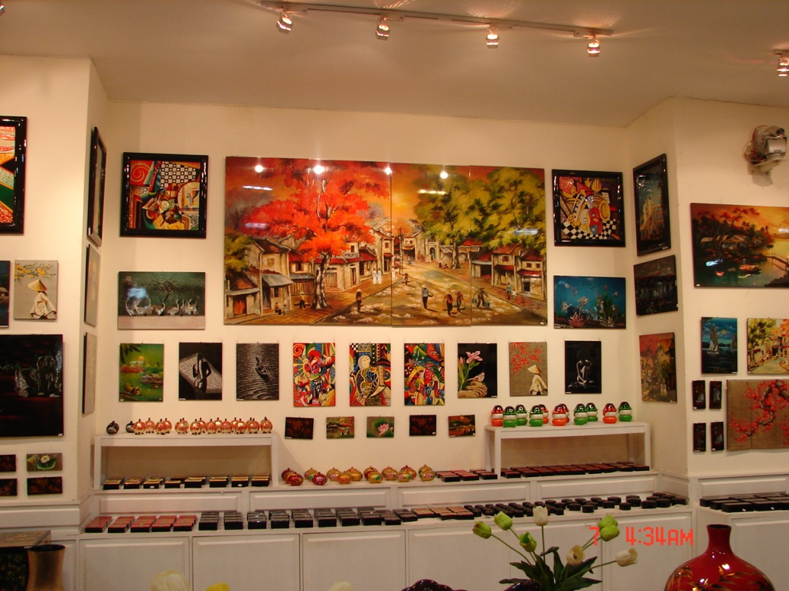
Display

After lunch our tour drove past Tan Son Nhat airport about twenty miles NW of HCMC under grey skies to see the 162 sq miles Cu Chi Tunnels park, aka by GIs as Hobo Woods.
We stopped to visit the Cu Chi National Cemetary containing about 10,000 graves. Lots of bodys were never found.
This whole situation came about in part from our brilliant strategy of pacification called Strategic Hamlets. A number of small farming villages were left alone. Instead of pacification, this allowed the Viet Minh (VC) and the North Vietnamese Army between 1948 and 1973 to construct 217 miles of tunnels up to three levels deep as much as 50 feet deep containing bunkers, command posts, hospitals, etc, all underground. These were not discovered for over ten years. The area was not totally pacified since this was where hung rockets and bombs were dropped. The area was full of booby traps and contained hundreds of troops. As a result of taming this area, it has been described as “the most devastated, bombarded, defoliated and gassed in the whole history of warfare.”

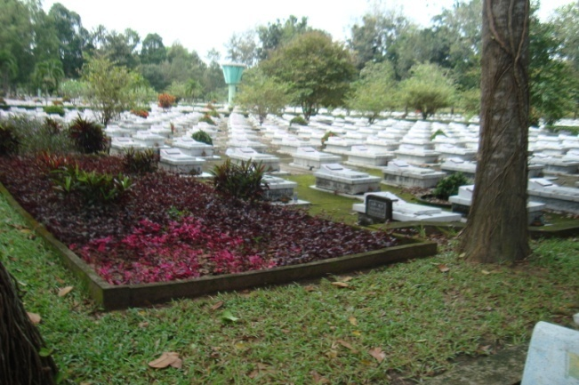

Cu Chi Cemetary

We had a briefing on Cu Chi including one of the old VC propagada movies and were taken around the the area. One display was a tip-up trap with pungy sticks. There were US and Vietnames weapons and several of the facilities that had been opened up for view. Several bomb craters still evident. The guide pointed out an air vent hidden in one of the numerous termite mounds.
We were shown one of the bunkers and its hidden entrance holes where tourists were allowed to enter. There was another 20 foot tunnel connecting two opened bunkers that we were allowed to crawl through. The guide said the tunnel had been enlarged for American tourists and we could duckwalk through it. I’m afraid my days of duckwalking are over so I went through on my hands and knees.

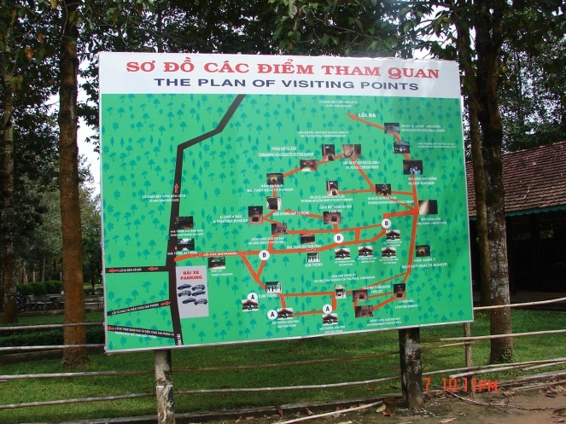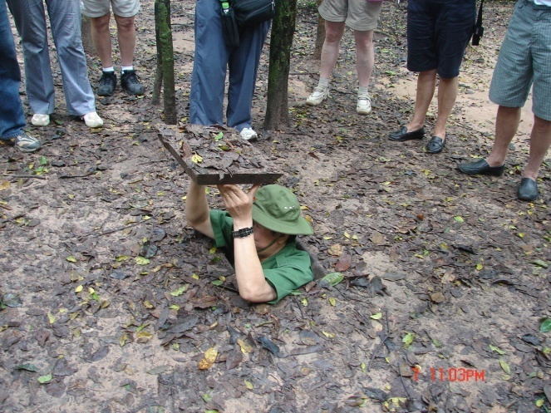
Cu Chi Map Bunker Entrance

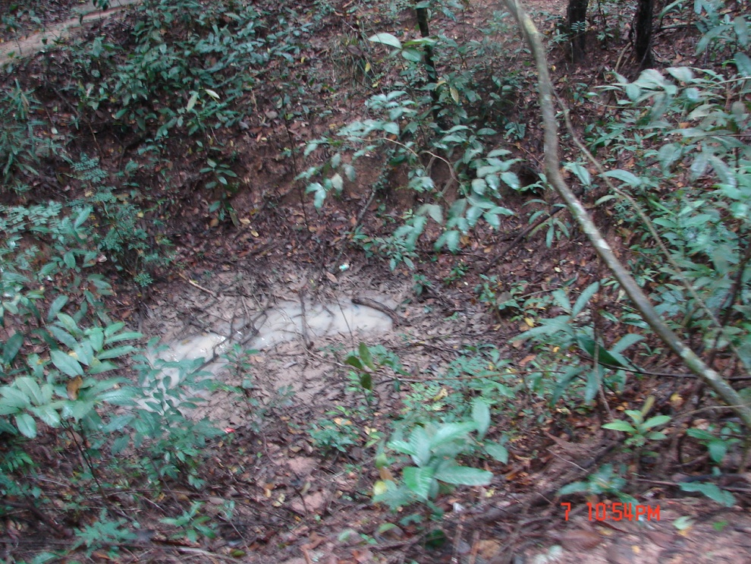
Old Bomb Crater

During the war, some of the tunnels were cleared by a group of soldiers called “Tunnel Rats”. I knew one of the Tunnel Rats. He had been weird before he spent a year crawling through these dangerous tunnels in the dark.
Although the area had been bombed on purpose it was also used as a dumping place for hung ordnance since planes could not land with bombs and rockets attached.
There were two gift shops with T-shirts, etc. Nearby was a firing
range where you could fire vintage weapons. There was also a museum of planes, etc, from the war era. We did not have enough time to visit these activities.
Next stop was at a rubber plantation with taps collecting latex. Each
tree had tap and a plastic collar to keep rain from diluting the latex. Latex is boiled or roasted to remove the water. It was then shipped for further processing. Ford Motors had large plantations and, according to a speech by President Eisenhower, we fought the war to protect rubber and our other strategic materials coming from Vietnam. I guess all wars have their corporate sponsors. Shades of the Gulf Wars
!
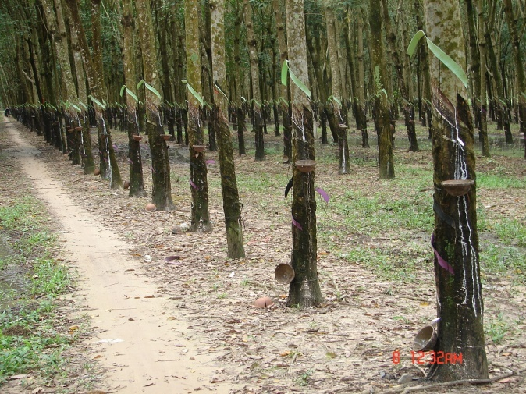
Rubber Tree Plantation
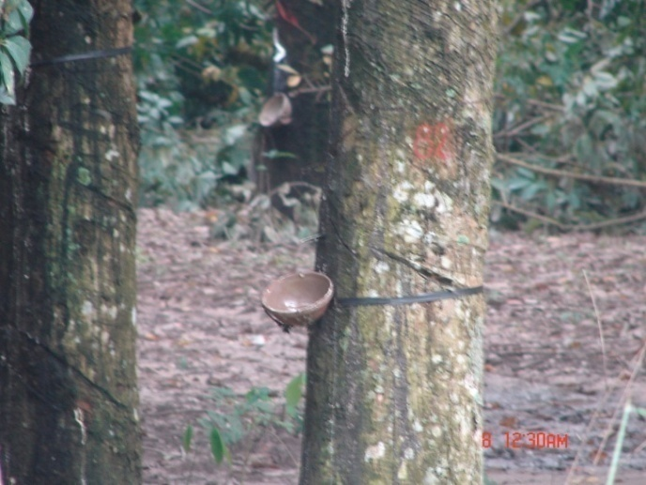
Rubber Collection

Many of the fields contained bomb craters that were slowly being filled. Many of the fields had tombs like we saw near Hanoi.
There were nurseries for ornamental plants used around Saigon and for thousands of young rubber trees.
Back at the hotel we decided to go out for supper. We took a taxi to the Hoi An (recommended by our tour director). Very good. I had the set 8 course menu. Carol had egg rolls and lemon chicken. There was a three piece group playing local music on local instruments –a flute, a concave guitar and a strange one string instrument that sounded like a moog.

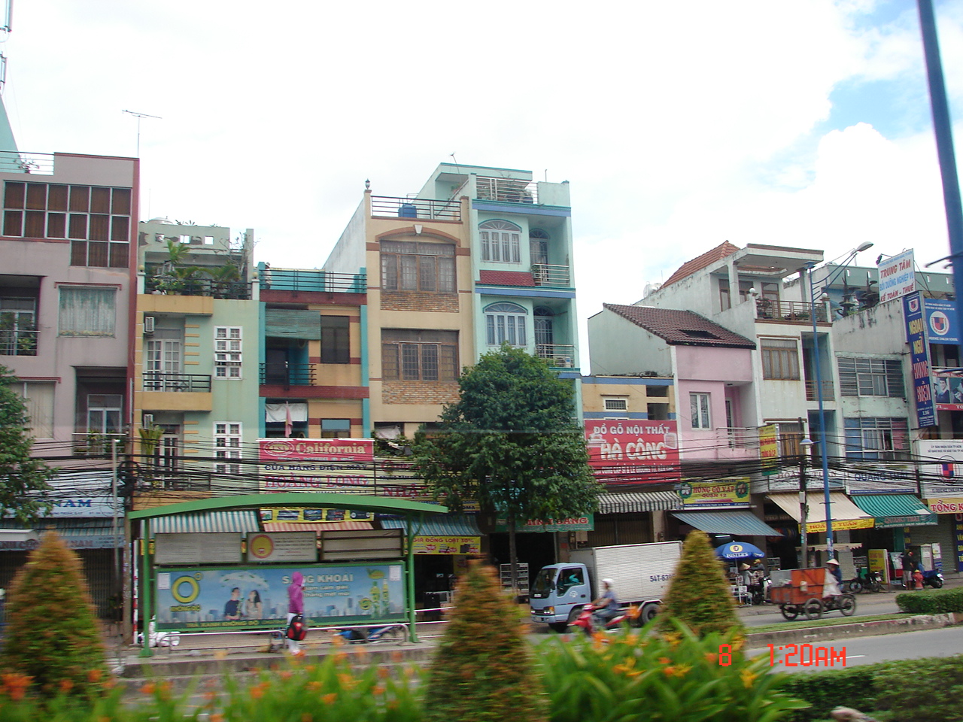
Old Saigon

Day 16. Wednesday, 9 Nov 2011. Ths was the last day. Our flight did not leave until 2355. We paid for a late checkout so we could stay in the room and do some shopping.
After breakfast, I went by myself to see the botanical garden and zoo. It was not bad for a small park with cages for common zoo animals. There were several small specialized gardens for palms, cactus, etc., and a small greenhouse. There was no bookstore and I found no books any where on plants and birds of Vietnam.
We hit a few more shops and a couple more galleries, returned to the hotel, and checked out about 1800. After checkong the bags, we went out for supper at the hotel recommended Xu resturant. It was pretty good but not nearly as good as last night.
A cab took us out to Tan Son Nhat about 2100. We had to wait an hour until the ticket counter opened. Our bags were checked to San Antonio and we headed for the gate. Through one passport check and body scanner then another passport check and body scanner and we were at the gate. Another half hour and we were on the plane for a four hour flight to Narita in Tokyo.

Day 17. Thursday, 10 Nov 2011. We arrived at Narita about 0630 local. Good thing there was a 10 hour layover because navigating to our next gate was not intuitively obvious unless you were born there. Catch a train then go down three floors and catch a bus then try to find the right gate. Several people indicated, “that way”. One young lady in a uniform said she had no idea. Finally, I asked a policeman who actually put us on the right path.
W got lunch at the terminal’s McDonald’s. High cost low quality Japanese copy of a burger and fries and a drink. Fifteen bucks apiece.
Carol checked into a $15 dollar an hour roomette for a couple hours sleep. These are handy for long layovers.
We stopped at the Hermes retail outlet. Carol checked on the price of a small purse similar to the knockoff she bought in Saigon and found they were asking $2,700. I saw ties for $175 each with $750 white dress shirts. Wow! I save almost a thousand dollars a day by being retired and not having to dress up. There were other outlets but one round of sticker shock was enough for me.
1700 Thursday finally arrived and we were on our way to Houston, 16 hours flying time across 9 time zones. We landed in Houston about 1700 for the second time that day. After immigration and customs and rechecking the bags we were off to San Antonio about 1900. A taxi delivered us home about 2100 the same day.
After thought and Comments
Altogether, it was a good trip. AMA Waterways tour was a success. I did not get to see the Hanoi Hilton or the Ho Chi Minh trail but I did see the Angkor complex and the Killing Fields in Cambodia and the Tunnels at Cu Chi near Saigon.
Extras included Hanoi/Saigon traffic, seventeen new birds seen, many new plants such as the Mast Tree, fog and rain along the Mekong, heat lightning, fish farms, canals and jungle, agricultural practices, the recovery from Agent Orange, fields still pockmarked with bomb craters, and lots of other details.
It surprised me to see many of the signs in Vietnamese or Khmer with English subtitles and the preferred use of dollars. Even the ATMs spit out dollars. I prefer to use dollars so I can compare the asking price with the price at home without Olumpic mental gymnastics or a calculator.
I was somewhat surprised to see rebuilt modern cities, industrialization and the development of the tourist trade. Hanoi, Saigon, and Phnom Penh, with a mix of old and new, were fascinating.
Vietnam belongs to the Trans-Pacific Partnership (TPP), the Pacific version of the NAFTA free trade agreement, along with the US and Australia. Imports and exports are duty free. This was news to me.
It was interesting to see “factories” at work. These were a few hundred to a couple thousand square feet of open covered space with people or machines turning out a variety of products from candy to clothing to furniture.
I suppose the war had some benefits. It removed over a million people from an overcrowded area. It also forced modernization of the cities, infrastructure and government.
I was in the US Naval Reserve during the Vietnam conflict and did not get drafted. My unit did participate in the Da Nang airlift twice but I was bumped from the crew in Hawaii both times.
After my pretrip research on the Vietnam, Cambodia and the Vietnam war, hearing comments from the Vietnamese and Cambodian side, being on site and seeing the areas of conflict were enlightening.
I have changed my mind about the leadership and conduct of the war. During US military indoctrination the Southeast Asian people were dehumanised, their God-given right to self-defence was delegitimised. Their resistance was reframed as terrorism and US soldiers were sent to kill. This was nothing new. From an historical perspective Vietnam was a continuation of the WWII and Korean mindset.
Actually Vietnam was lucky. In 1954/5 under President Eisenhower, an “A-Day” was proposed to make a premptive nuclear strike on the Communist world including Russia, China, and Korea. Thankfully this day never came. Eisenhower even offered to help France’s plight by bombing Dien Bien Phu where France eventually lost possession of North Vietnam. France declined. In 1962, there was a proposal to nuke Laos to prevent Communist takeover.
I tend to agree with at least some of the war protestors that there was poor upper level leadership. The war was highly political and underwritten by big business. Basic training for both enlisted and officers stressed a subhuman enemy and the need to kill anything that moved. This was much like the war with Japan where Japanese were seen with no civilians. Munitions and other war fighting equiptment was big business on all sides. Weapons were redesigned to maim and mutilate rather than outright killing. McNamera had dehumanized war during WWII while programming mas bombings.
I did not agree with the poor treatment of the veterans by the US public. Our military were mostly professional and fought well considering their foggy orders and the political constraints.
The proposed domino theory of Communist states was wrong. By Vietnam, Communism was already a failed system. Our leaders did not choose to have basic faith in democracy particularly when there was a economic potential. Our leaders alienated civilians and military alike to a point where you could have soon had a revolution brewing as Johnson and Nixon learned and events in Russia, Egypt, and Libya demonstrated. The Washington bureaucrats overrode the field commanders and demoralized the troops on the ground as well as the general population in the US. Targets were handpicked in Washington to avoid possible involvment by China or Russia.
The war in Vietnam killed many soldiers on both sides and numerous Vietmanese civilians. It psychologically damaged many on both sides. Barbarism allowed the worst human traits to be demonstrated. New cases of PTSD are still being uncovered. Atrocities and barbarism during this war is documented in a new book by Nick Tergel titled, Kill Anything that Moves. At the height of the war our troops operated on the MGR (Mere Gook Rule) principle to dehumanize the enemy and calling them gooks, slopes, rice eaters, etc. Many US veterans brought back personal items scavaged frim the ruins or taken off the dead, i.e, pictures, letters, etc. A few brought back trophies like ears.
Recently released recordings made in the Johnson Whitehouse indicate that the Johnson’s presidential race was sabotaged by Nixon. Nixon had approached the Vietnamese suggesting they not attend the Paris peace talks until after the election which they did. He also told his billionaire’s club friends that he would see to it the war would continue as long as possible. President Johnson threatened Nixon with treason but Nixon outsmarted Johnson by getting on the Sunday morning talk shows and saying he was going to do all he could to stop the war thereby getting himself elected. Without Nixon the war might have ended earlier but then there would have been no Nixon visit to China. Can’t win them all.

Birds
Pandionidae / Osprey
Pandion haliaetus Osprey Hanlon Bay
Ardeidae / Egrets
Ardea purpurea Purple Heron Siem Reap rice field
Egretta alba Great Egret Rice fields near Hanoai
Egretta garzetta Little Egret Small flocks in rice fields
along Mekong
Laridae / Gulls and Terns
Aterna albifrons Little Tern Mekong Delta
Larus argentatus Herring Gull Mekong Delta
Alcedinidae/ Kingfishers
Alcedo atthis Common kingfisher Siem Reap
Psittacidae/Parrots
Psittacula longicauda Long-tailed Parakeets Anglor Thom
Columbidae/Doves
Streptopelia chinensis Spotted Dove Siem Reap and Phnom Penh
Hirundinidae/Swallows
Hirundo rustica Barn swallow Hanloh Bay, Mekong River
Pycnonotidae
Pycnonotus blanfordi Streak-Eared Bulbul Hanoi
Dicruridae
Dicrurus macrocercus Black Drongo Hanoi
Sturnidae
Acriditheres tristis Common Myna Hanoi
Acriditheres javanicus White-vented Myna Mekong Delta
Acriditheres cristatellus Crested Myna Siem Reap
Passeridae
Passer mintanus Eurasian Tree Sparrow All major towns
Corvidae
Crypsieina temia Racket-Tailed Treepie Mekong Delta

Fish
Catfish Clarius batrachus ? Mekong River
Cichlids Tilapia sp Mekong fish farms

There were few insects pests or butterflies and only a few gekos.

Plants

Acanthaceae
Ruellia Ruellia sp
Anacarsiaceae
Mango Mangifera indica
Annonaceae
Mast tree, sorrowless tree Polyathia longifolia pendula
Apocyanaceae
Olrander Nerium oleander
Frangipani Plumeria obtusa
Golden Trumpet Allamanda cathartica
Vinca Vinca sp
Araceae
Taro Colocasia esculenta
Bignoniaceae
African Tulip Tree Spatheodea campanulata
Bombacaceae
Kapok Tree Bombax ceiba
Bromeliaceae
Pineapple Ananas comosus
Cactaceae
Yellow Dragon Fruit Hyalocereus megalanthus
Red Dragon Fruit Hyalocereus undatus
Commelinaceae
Day flower Commelina sp
Compositae
Wedelia Wedelia trilobata
Centurea sp.
Cruciferae
Rockets Hesperis mattronalis
Cucurbidae
Bitter melon, Balsam Pear Momordica charantia
Watermelon Citrullus vulgaris
Euphorbiaceae
Copperleaf Acalypha sp
Crown of Thorns Euphorbia milii
Cassava Manihot esculenta
Graminae
Corn Zia Maise
Sugar cane Sorgham vulgare var saccharatum
Rice Oryza sativa

Ipomea
Water Morning Glory Ipomea aquaticus
Leguminosae
Bauhinia Bauhinia purpurea
Royal Poinciana Delonix regia
Yellow Flower Cassia sp
Sensitive Briar Neptunia sp
Long bean Vigna susquipedalis
Soy Bean Glycine max
Leucocassia
Tsro Colocasia esculenta
Liliaceae
Corn Plant Dracaena fragrans
Musacaea
Banana Musa sp
Traveler’s Tree Ravenala madagasgarensis
Moraceae
Banyan Tree Ficus benghalensis
Rubber tree Ficus elastica
Jackfruit Artocarpus heterophyllus
Nyctaginaceae
Bougainvillea Bougainvillea glabra
Oxalidaceae
Oxalis Oxalis sp
Palmaceae
Fishtail Palm Caryota mitis
Sugar Palm Arenga engleri
Piperaceae
Knotweed Polygonum sp
Plantaginaceae
Plantain Plantago Psyllum
Ponrederiaceae
Water Hyacinth Echhornia sp
Portulaceae
Purslane Portulaca sp
Polyginaceae
Black Pepper Piper nigrum
Rubiaceae
Ixora Ixora stricta
Houstonia sp ?
Sapindaceae
Leechee, Lyche, Litchi Nephelium Litchi
Solanaceae ??
Teaceae
Tea Thea sinensis
Urticaceae
Artillery Plant Pilea microphylla
Verbenaceae
Teak Tectona grandis
Frog-bit Phyla sp.

Many of the plants seen were commercial, lornamental or invasives. We had neither the guides nor opportunuty to get out in the boonies.

Notes
See Wikipedia on Ha Long Bay. References for plants and animals. Geologic history.
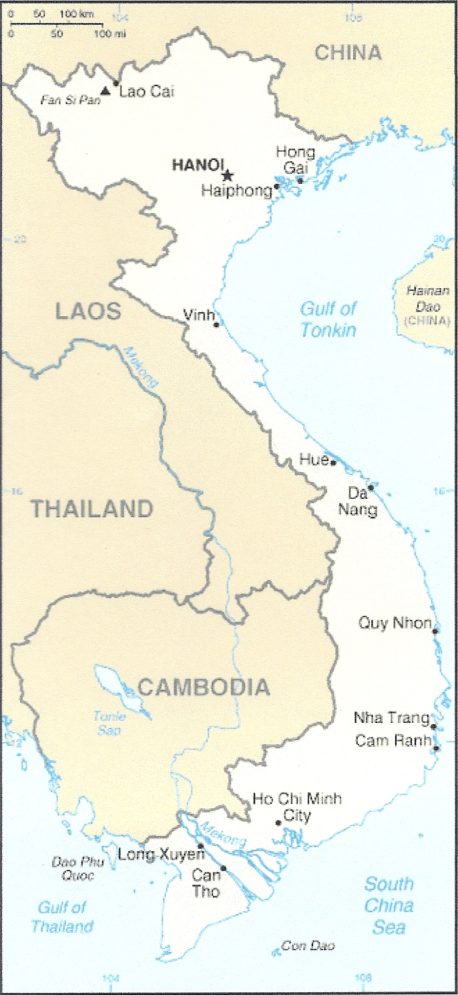
Phnom Pehn
Ankor complex

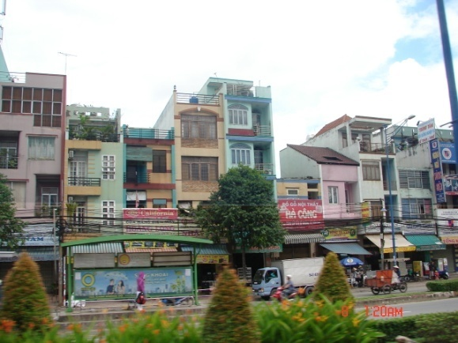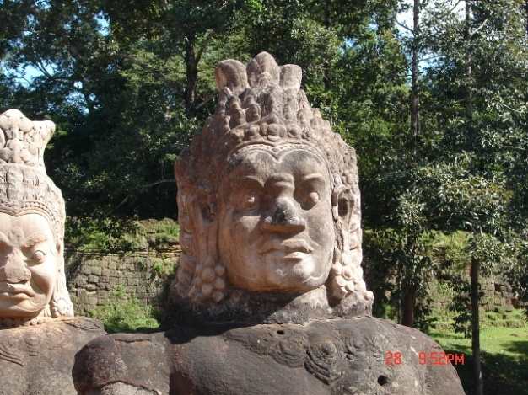
Hanoi Angkor Wat
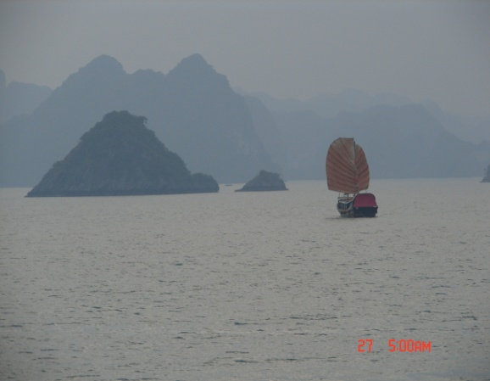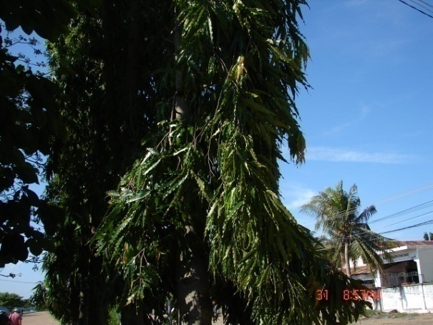
Ha Long Bay Mast or Sorrowless Tree
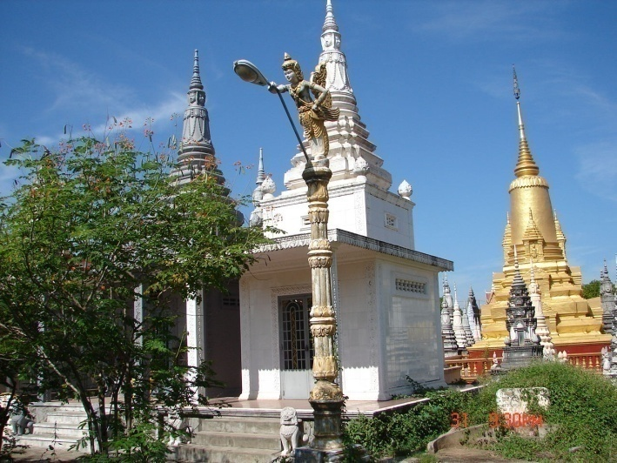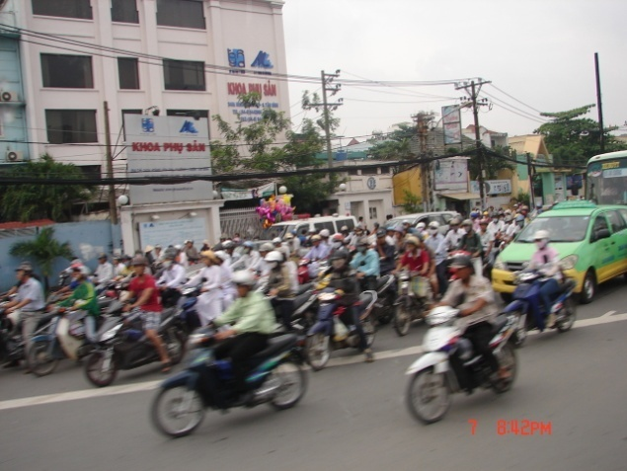
Buddhist Monastery Rush Hour in Saigon
Vietnam and Cambodia are growing into modern countries and probably no longer classed as third world. Their public health and tourist industry is thriving. We enjoyed the trip.
Carl

