Nancy’s Birthday Poems
Carl Lahser

Another Fine Birthday
Forty-five steps
Life has been a Song
Wishes for Another year
Year 48
Garden Comments
49: Old Enough

Another Fine Birthday
The painter Constable said,
“Nothing is ugly in this old world. “

Shouting girls from one side of the street
exude sexual defiance
in the way they challenge boys across the way
with their tinkling laughter.

Two mustached nuns dressed like penguins
walking side-by-side
in a flat-footed way
wave shyly as a passing Lowrider horn toots.

A homeless woman sitting on a bus bench
eating potato chips out of her purse
mumbles to anyone and
holds up a finger to a passing police car.

A snotty infant paddles rapidly along the sidewalk
in a T-shirt and screaming.
His sister runs after him waving a diaper
shouting for him to come back this very minute.

Time races and creeps and crawls
Minute by minute
Until another year has passed.
carl
++++

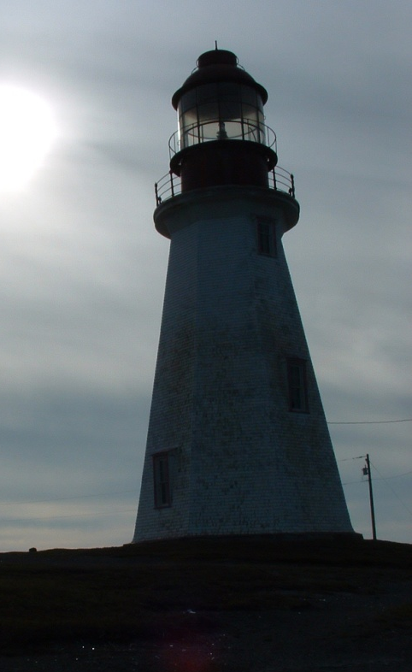

Forty-five steps

Forty-five steps
Up the spiral stairs
Each passing near its origin
But always charging upwards
To the widow’s walk
To view the future
Amongst the clouds
And changing fortune
Carl
++++

Life has been a Song
Happy 46

Born to the tunes of:

Simon and Garfunkel
The Beatles
The Jackson 5
Elvis
Glen Campbell
BB King

humming your way through life:

“Like a Bridge over troubled waters”
“Everything is Beautiful”
“Come and Get It”

Like Aretha Franklin sang, “Call Me”
Carl
++++

Wishes for Another year

47 Birthday wishes
A evening walk in your neighborhood
With your dogs
and a sweet boy

A morning walk along a beach
with a rising sun and scattered shells
hand in hand

A volume of verses
And a hot chocolate
When the cool winds blow

Happy Birthday
Carl
+++++

Year 48
Rincon de Mirada
What an old man sees

1
Jogger
Dark pony tail
Whipping left
then whipping right
in counterpoint to her hips
She looks like the Big Bopper song
“That’s what I like”.

2
Donde
It’s cool man
a Sarah Vaughn LP
with clicks and scratching
lit by candlelight.
Donde?
Where are you?

A sparkling spring day
Walking through azaleas and dogwood blooms
Under a wild blue sky
Across a wooden bridge over a roiling creek.
Donde?
Where are you?

Tropical sunsets paint the sky
Pina Coladas
Lobsters sizzling on the grill
Tropicbirds circling homeward.
Donde?
Where are you?

Mannnnnn bummer….
++++

3
I WONDER

black, black hair.
shoulder length.
cascading.
undulating.
reflecting sunny highlights.
would I still be attracted
if I saw her face?

4
Glimpses

I saw her in a Christmas crowd
but she vanished in a sea of bobbing heads
I called to her in the Plaka in Athens
She turned and spoke to me in Bulgarian

I bought her favorite drink from across a bar in St Louis
but she was gone before the waiter arrived

Countless glimpses of her over fifty years
in airports, on busy city streets, passing on busses.

She must be gone by now
Consumed by time
Absorbed in space
Existing only in a tiny corner of memory
Unchanged in a lifetime
+++++

Garden Comments
Nancy with the French braid
Carefully snipping wilted flowers and leaves
Watering everything
Plating specimen plants in the Conservatory

A lady with two young daughters
Said, “See what I have told you,
Working in the garden makes you pretty.”
“Oh Mom. Reaaaly!”, replied one of the girls.
Carl31Jul16

49: Old Enough

Old enough to kiss a boy
Old enough to take a drink
Old enough to save or spend
Old enough to choose your life
Old enough to see the world
Old enough to stop counting
¡feliz cumpleaños¡
Happy Birthday

Happy Birthday

Happy Birthday

HAPPY BIRTHDAY

