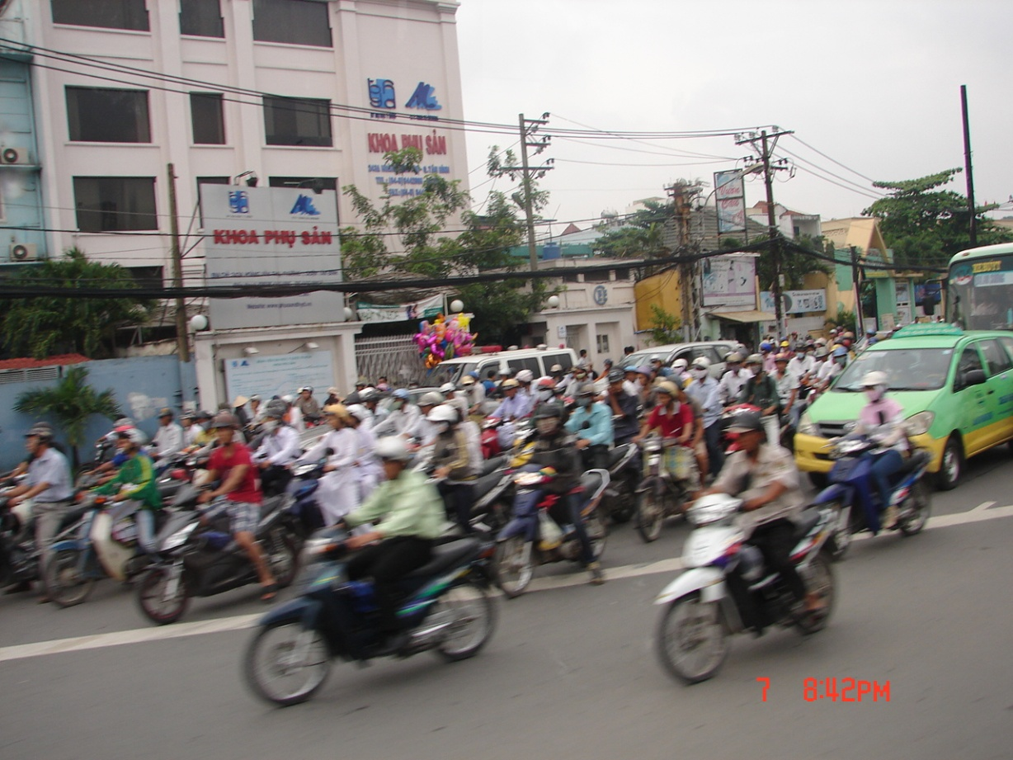

Poems
of
Cambodia and Vietnam
2011

Carl Lahser

Contents
Hą Long Bay
Water Puppets
Typhoons
Scooter Heaven
Snack Time
Sidewalk Market
Fish Market
Farm house
Mekong River
The River is Dropping
Killing Field
Tuol Sleng (S 21)
Ox Carts
Rubber Trees
Instant Antiques
Stroll Through the Night Market
Mekong River Morning
Candy Factory
Cu Chi Cemetery
Cu Chi Tunnels
Saigon Aint No More

Hą Long Bay
Hą Long Bay, Vietnam
Vįnh Ha Long
Bay of the Descending Dragons
The 2,000 emerald karst islets
Were spit out by protective dragons
And jewels and jade
Sprang up in front of enemy ships

Hą Long – the place where mother dragon lived
Bάi Tú Long – where lived her children
Islets swathed in a hundred kinds of trees
Protecting Haiphong
Protecting Vietnam

A quiet night on the Bay
Watching Scorpio overhead
Hearing halyards slapping the mast
Listening to the creaking wooden hull
Quiet and a pot of tea.
Carl 28Oct11

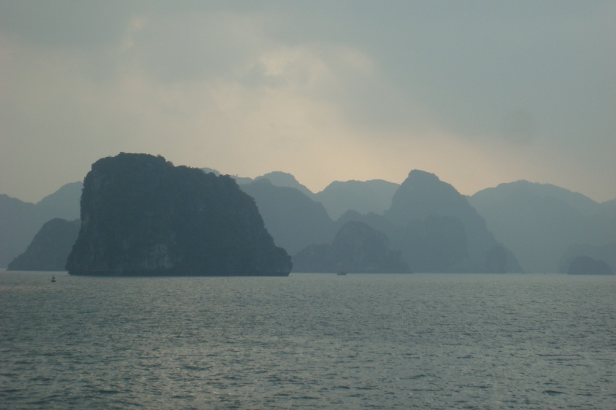

Water Puppets
In Hanoi live the water puppets
In a pool telling farmer’s stories
Mounted on rods beneath the surface
Operated by puppeteers waist deep
Hidden artists and three foot actors
Carl26Oct11

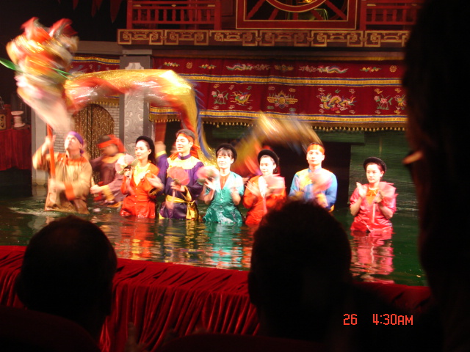

Typhoons

Typhoons, teeth of the Southeast Asian gods
A storm one hundred thirty years ago
Hit the Gulf of Tonkin
Decimated Haiphong
Killing 300,000 in the Red River Valley

In April 2011 a storm hit Saigon
On 24 September Typhoon Haitang hit Hanoi
On 30 September Typhoon Nesat hit Haiphong
On 9 Oct Typhoon Banyan hit Hong Kong
The Mekong rose 30 feet
And 3000 people were killed
Most of Thailand was flooded

Water was still be standing for months
Tong le Sap Lake was 70 miles wide

Quiet and humid
And a falling barometer
Need to listen to the weather man
It’s coming.
Carl 10Oct11

Scooter Heaven
Southeast Asian streets
Hanoi, Saigon, Phnom Pehn
A writhing sea of
Motor scooters,
Motorbikes,
Rickshaws,
Pushcarts
Cars,
Busses
Ox carts
Old women with a loaded yokes

Crossing a street
Walking into traffic with your hand raised
Walking at a steady pace
While demons fly past
Emerging on the other side unscathed.
Wheee!
Carl 26Oct11

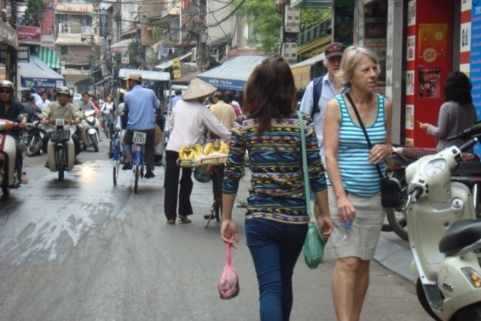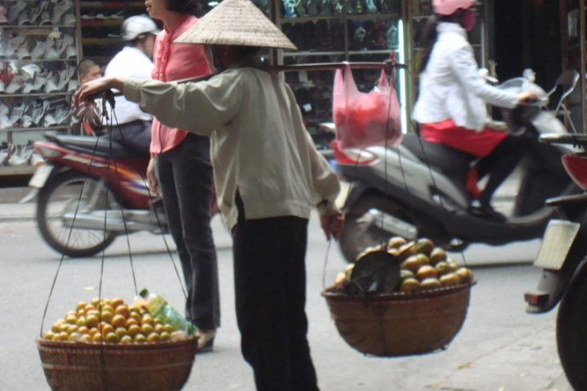

Snack Time

Sidewalk cafes
With red or blue plastic chairs
And knee-high plastic tables

Serving tea and pho
Talking news
Telling jokes
Oblivious as the world flows past
Carl26Oct11

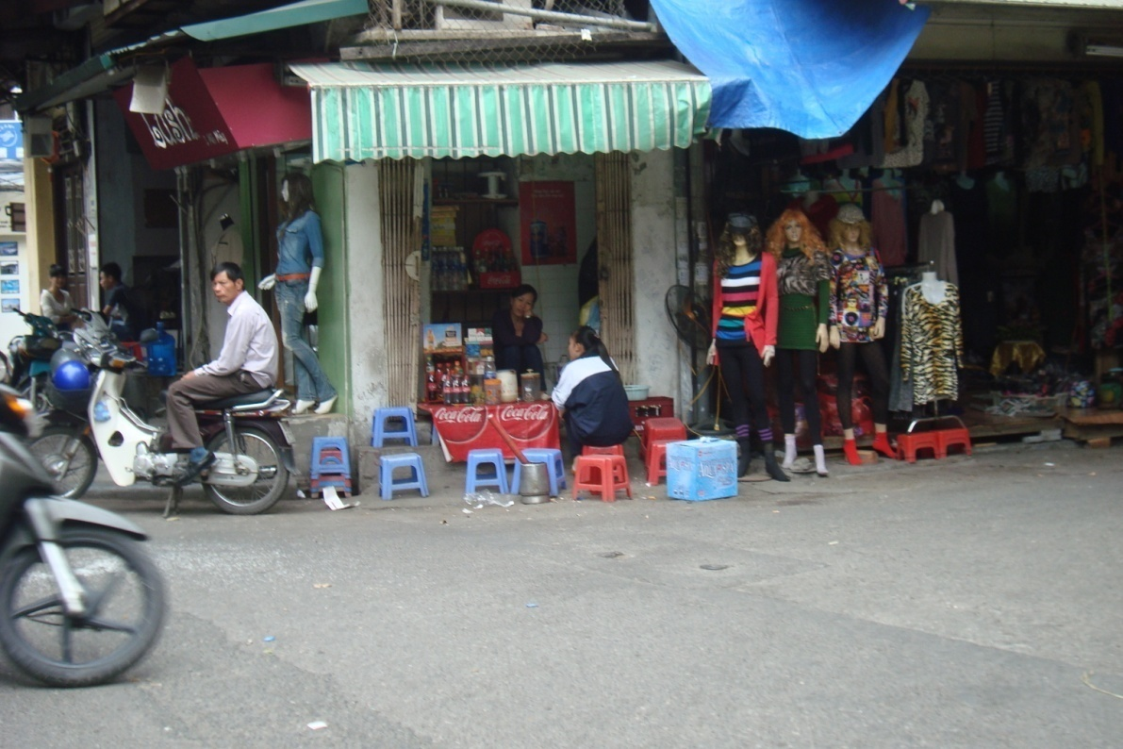

Sidewalk Market
Bok Choy
Dichon
Water morning glory
Taro roots
Peeled pineapples
Leeches
Rice
Sitting on the sidewalk
Resting on low tables
While the old women sit
Talking or dreaming of better days
Carl27Oct11

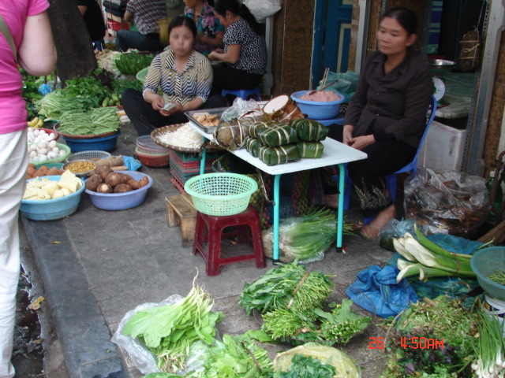

Fish Market
Crabs and eels
Catfish
Snails and turtles and frogs
It’s all good, Joe
I clean it for you, Joe
Right here on the sidewalk
30Oct11

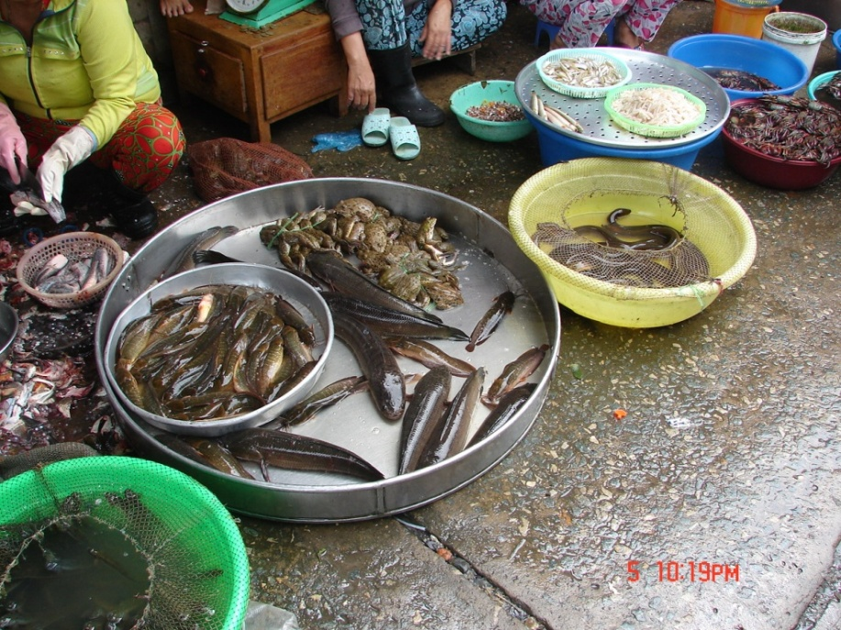

Farm House
In a clearing off the road
Beyond the family shrine
Past the tethered water buffalo
And jackfruit trees
A house on stilts
With hammocks strung between the posts
A loom on one side
Lightning rods for the monsoon
A lotus and Nagas on the roof ridge
Thatched roof
Blue shutters
Waiting for the monsoon
Waiting for the Mekong to recede
Carl 31 Oct 11

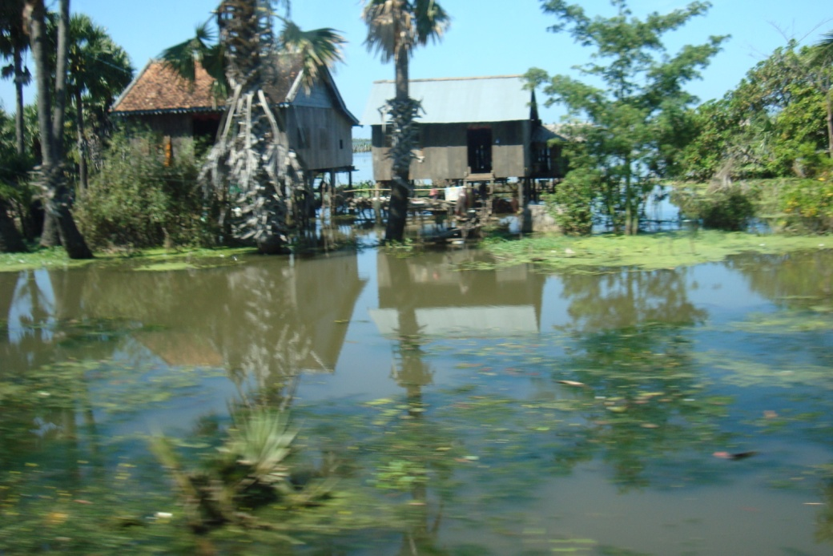

Mekong River
A mile wide and fifty feet deep
The Mekong flows from China
Then between Laos, Vietnam, and Cambodia
Essential highway

Suddenly the halyards beat against the mast
Evening monsoon clouds slide in
Cool and loaded with rain
Sheet lightning highlights tall clouds
Humidity and rain fill the night

Overcast daylight drips humidity
It is light but the sun forgot to rise
Don’t breathe too deeply
Or you will drown
Carl 26Oct11
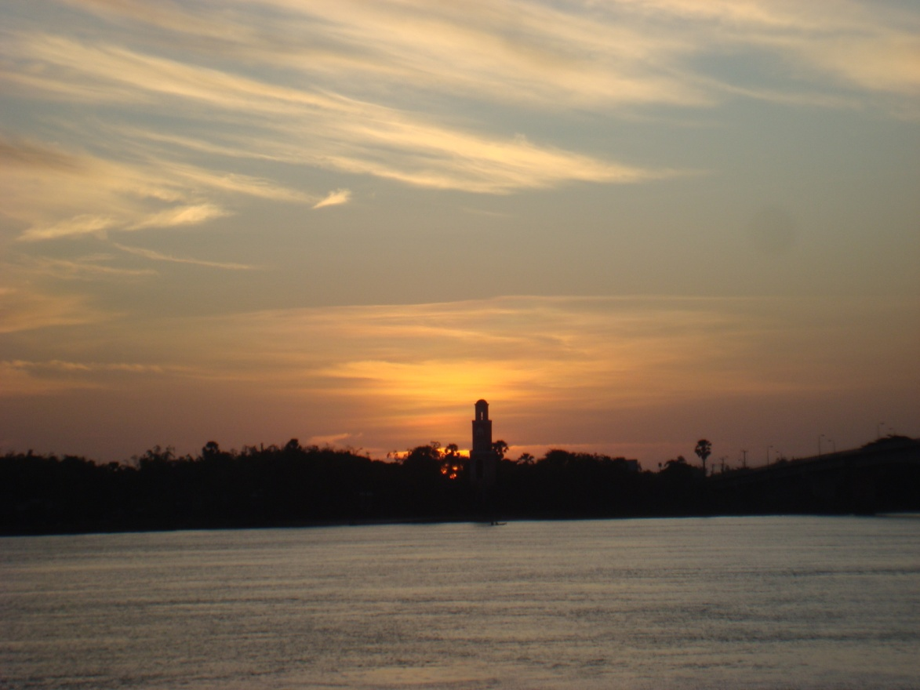

The River is Dropping
Typhoon rain and wind
Rushed up the Mekong valley
Raising the water level thirty feet
Backing up into Tong le Sap
Tripling its size

Six weeks later the river was falling
The farmers were following the river’s fall
Fishing in the water
Planting the silt covered banks
With pole beans, bananas,and taro

Time flows onwards.
carl30Oct11

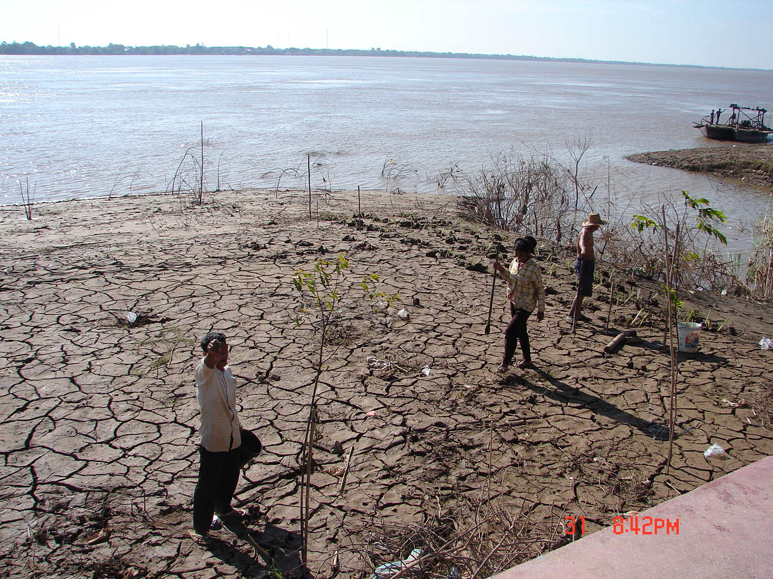

The Killing Field
An overcast morning
At the end of the monsoon season.
I visited the reborn Phnom Penh,
City of Ghosts.
I stopped at the Russian market
For a wide-brimmed hat
Anticipating a short trip to Choeung Ek
the Killing Field.

15km south
Through thinning businesses and homes
Behind houses where ran the river
Where rice and morningglory were raised

Passing through Choeung Ek
We found the glass-faced memorial stupa
Filled with unidentified skulls
0f 8000 victims executed
And buried in the Killing Fields

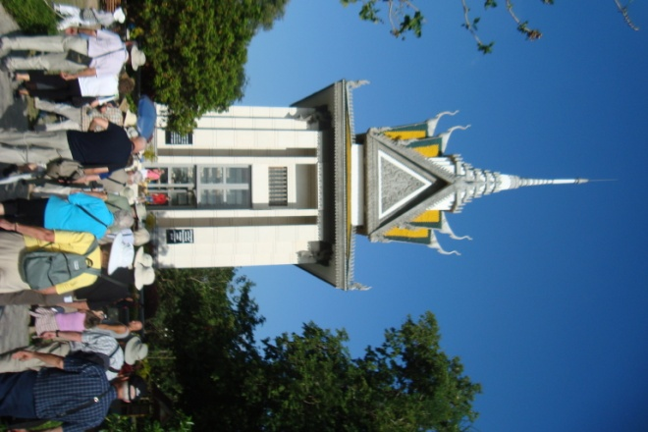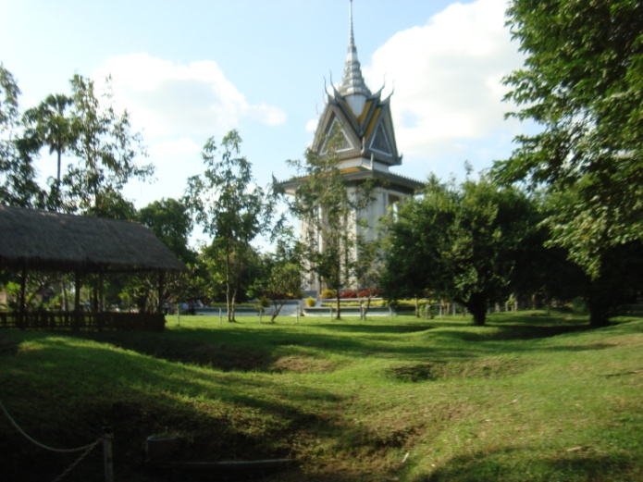

Under a gloomy sky we walked among the burial pits
Grown over with green turf and trees
Looking like a tough golf course
Pits contained remains
Men bludgeoned to death to save bullets
Women unclothed
Children smashed against the killing trees
Pits containing rags and bones and teeth of the victims

Remains of 8985 people have been exhumed
They were brought alive from Tuol Sleng,
The secret service headquarters,
Up to 300 a day for killing

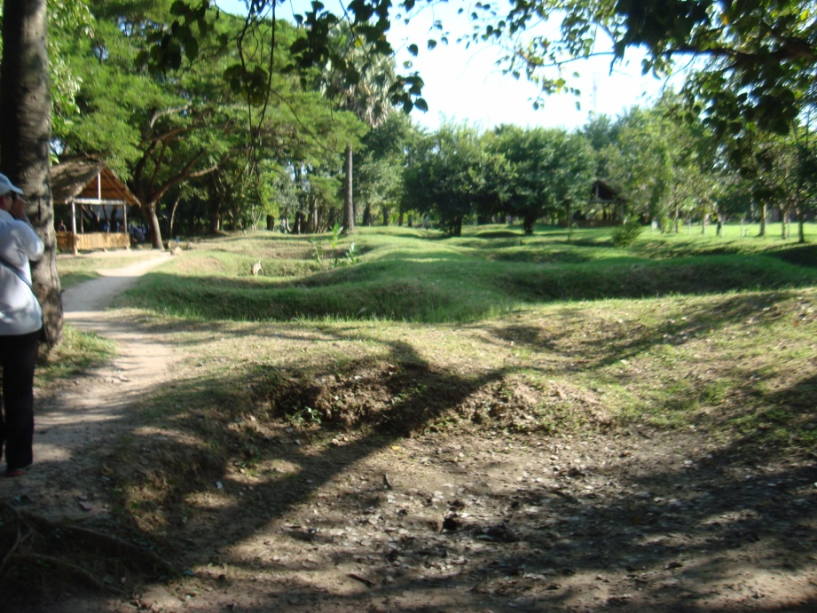

Under grey sky and a weak sun
This is a monument to cruelty and insanity
And the indifference of the outside world
A memorial to gentle poor people who did not resist

A lesson to future generations
Who think selfishly only of themselves
Who ignore corruption, tyranny and repression
Who do not participate in government
Carl2Nov11

Tuol Sleng (S-21)
In the outskirts of the City of Ghosts
Sat the Tuol Svay Prey High School

When Phnom Pehn’s people
Were ordered to leave town
Sent to the countryside
To meet Pol Pot’s dream
“Return to the old agrarian ways”
The school was desecrated,
Degraded, and modified
To serve as a Khmer Rouge interrogation and torture center.

Tuol Sleng, secret department S-21
1975 to 1979
Run by Comrade Duch
14,000 men, women and children
were “processed”-
Tortured and the majority killed
Grisley place.
Carl2Nov11
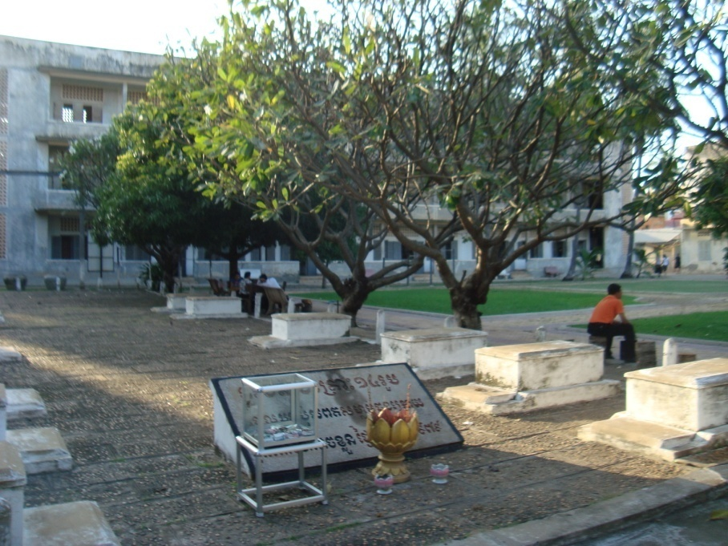

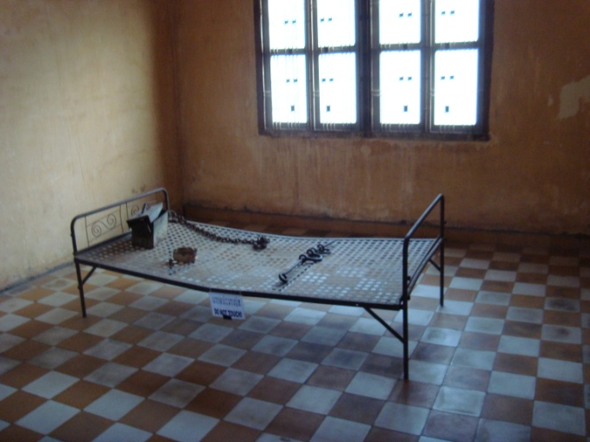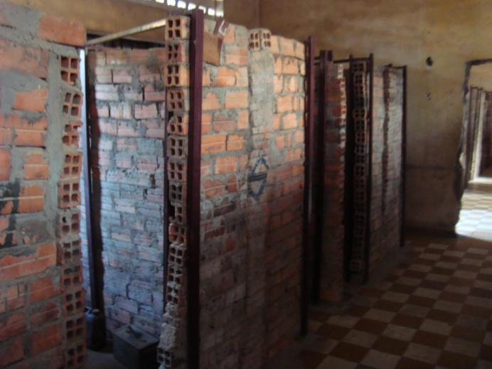

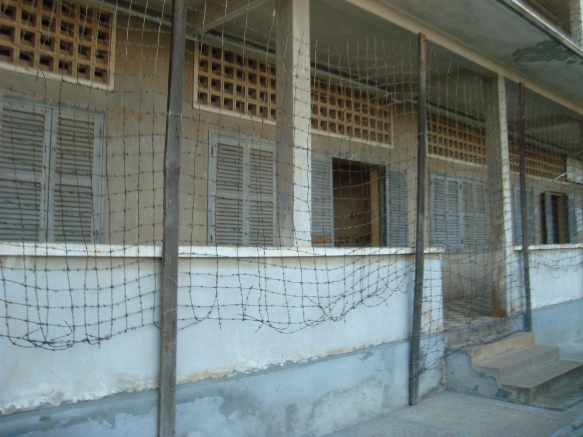
Tuol Sleng (S-21)

Ox Carts
In rural Cambodia and Vietnam
The Ford F-150 and Toyota Tundra
Are replaced by the ox cart
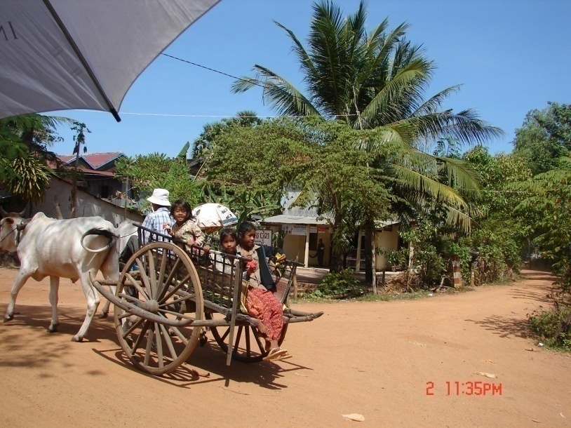

Off to the market
Out in the fields
Decked out for holidays
Jouncing along trails
And unimproved roads
Carl2Nov11

Rubber Trees

A rubber tree produces latex sap
The water is removed leaving
Raw rubber.

Ford and Edison had rubber plantations
In Brazil, Malaysia, and Vietnam.
Japan’s coveting Malaysian rubber
Starting WWII.
The US wanting Vietnamese rubber
Caused another war.

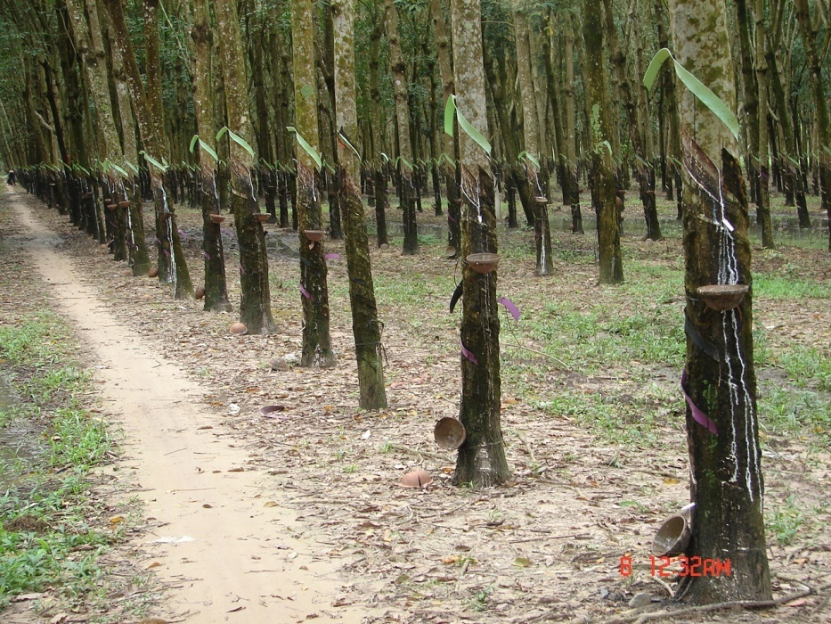

Most rubber is plantation raised
Young plants produced from cuttings or seeds
Planted in rows and tended

At seven years the trees are slashed for 30 years
A spout leads the latex to a collection bowl
A plastic ribbon is tied above the slash
To divert water from the bowl
The latex is boiled or roasted
To remove the water
Then shipped out for further processing
Wild rubber came from Mexico to Brazil
Where natives were enslaved
To collect and smoke raw rubber
They were mutilated or killed
For missing their quota

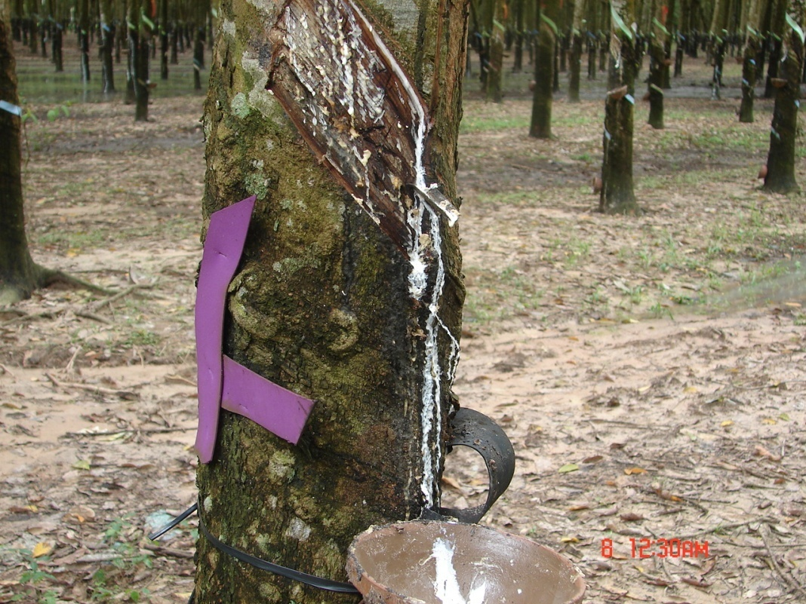

Carl8Nov11

Instant Antiques

Military friends from WWII, Korea, and Vietnam wars
And other Southeast Asian assignments
Talked of food, women, and instant antiques
They ate the food and brought the cooking home
They loved but mostly left the women
They decorated their homes with instant antiques
Like native homes and Indochinese Temples.

In Siem Reap near Angkor
We were shopping in local shops
One shop had antique treasures-
Carved stone, wooden artifacts, and furniture
From Burma, Thailand, and Cambodia.

Peeking through a curtain
I saw a work room
With carvers of wood and stone
Sitting on the floor
Like their fathers and grandfathers
Creating antiques between their feet.
Carl30Oct11
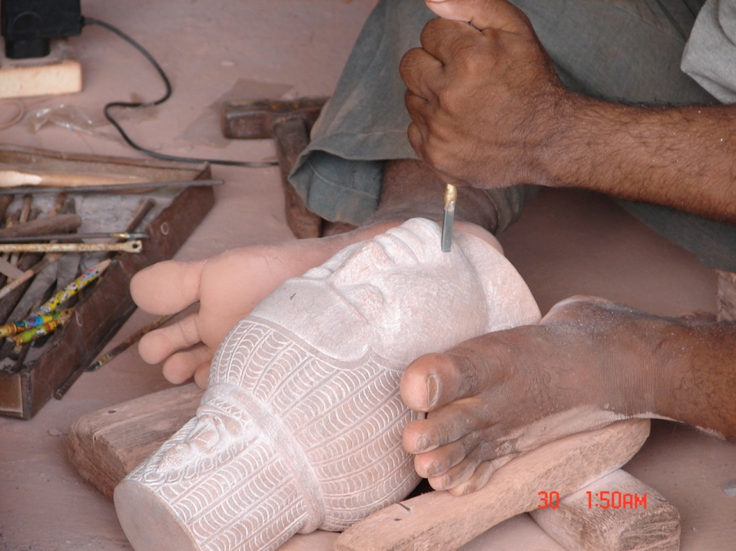
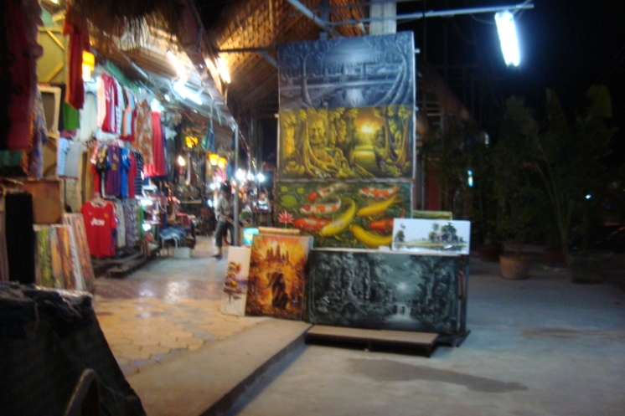
A Stroll through the Night Market
Siem Reap
In western Cambodia
Near the Temples of the Angkor complex
The monsoon has passed and the nights are pleasant

A night out under a rising moon
Supper of amok and local tea
A walk through the night market
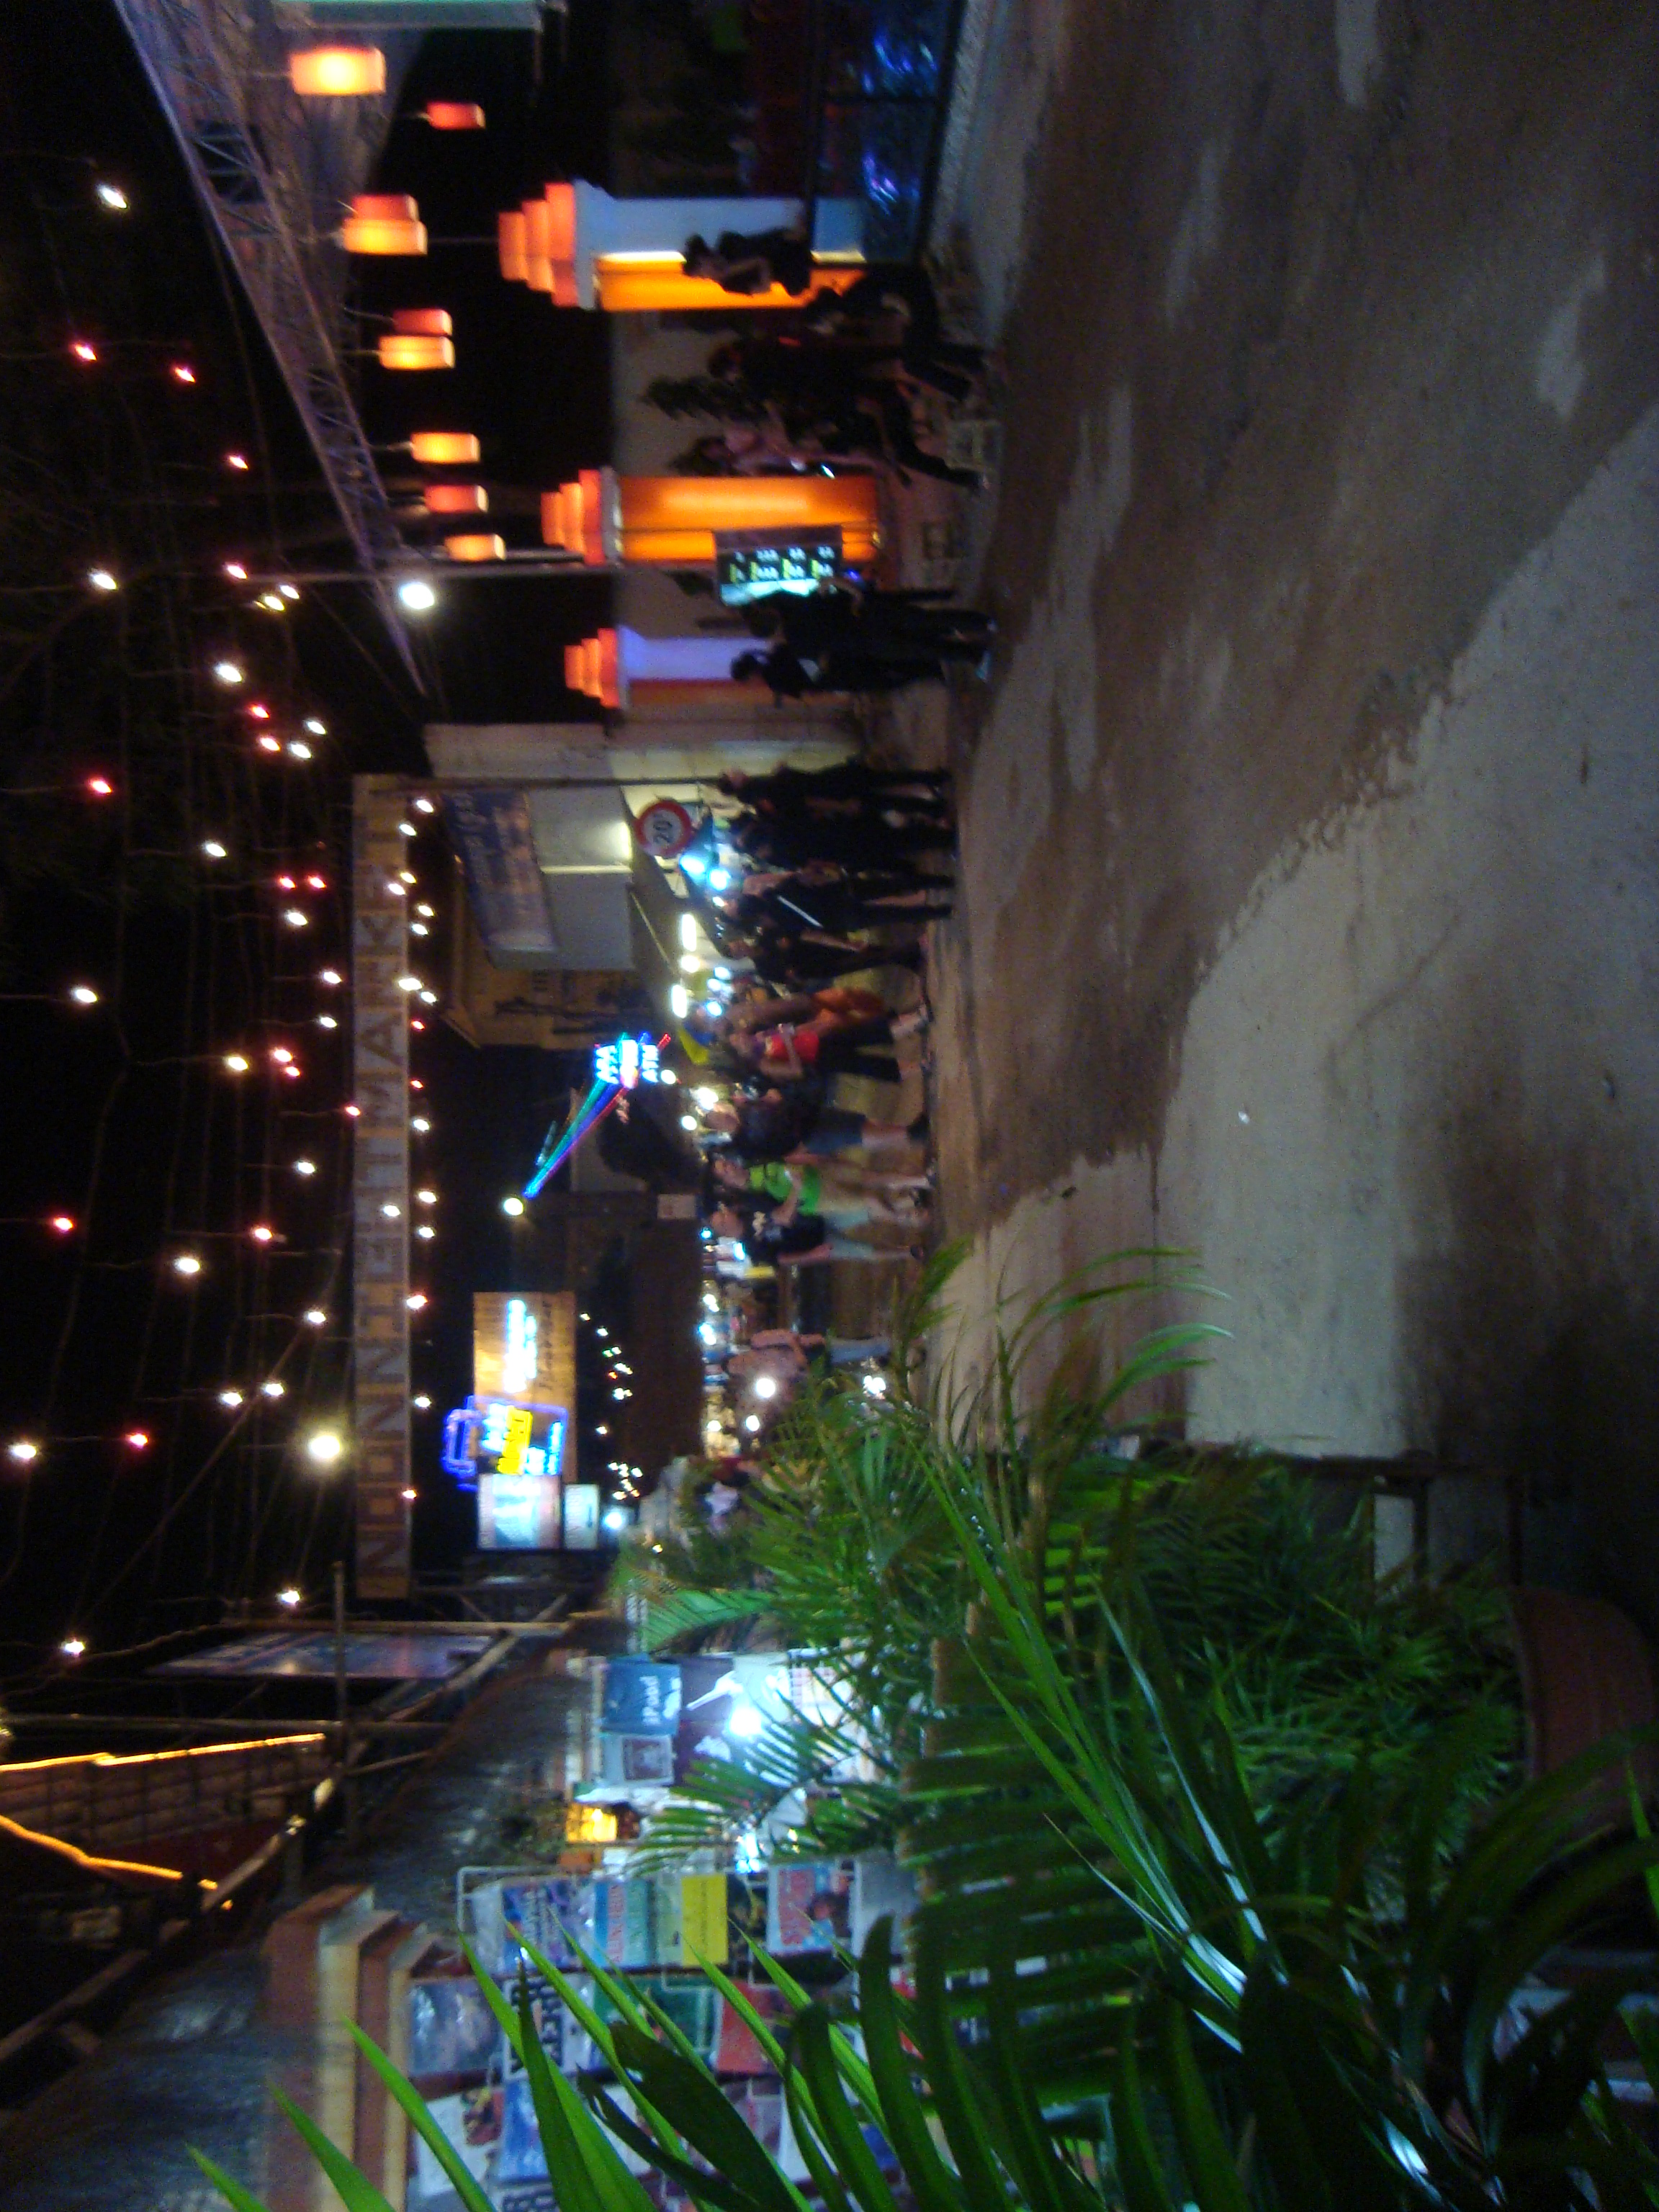
Color, a light breeze, and 1950’s rock and roll.

Art for sale
Large paintings of Anghor Wat
Bright orange pictures of sunrise on the Mekong
A few abstracts in obscene colors

Massage parlors that give massages
Jewelry shops and instant antiques
A giggling tourist her feet in a large aquarium
Where fish are nibbling - a fish pedicure.

A ride home in a motor tuk tuk
The old Honda 90 put-putting along the canals
A moon overhead as we crossed the bridge
To our room with a tree frog serenade.
Carl29Oct11

Mekong River Morning
On deck with a pot of tea
Waiting for sunrise
Clumps of water hyacinth streaming by
In the tan water.

White sky
Dark silhouettes of teak and sugar palms
Shallow water with permanent fish traps
Fishermen setting new fish traps
Houses hanging over the river.

Near Tan Chau were
Floating fish farms
A floating market
A casket factory
A silk factory where girls hand-made silk
Five yards a day in open factories.

Sa Dec
Where Swift Boats once docked
Cai Be
With its Franciscan Church
And floating market

A street market with fruits and vegetables
Both sides of the lane with traffic down the middle
Live fish, snakes, turtles, and frogs
Live or butchered on the street

Small farms with
Black pepper and pepper leaf
Taro, jackfruit, mangoes
Fish drying on rooftops in the sun
Tea plants

Highway, homestead, outhouse
To millions.
Carl 7 Nov 2011

Candy Factory

Along a muddy dike near the Mekong
Dodging cycles and playing kids
Past houses weaving silk
To the candy factory.

A large tin roof with no walls
Vats of boiling sugar
Tables for making Asian favorites
Coconut candy
Edible rice paper
Puffed rice
A sweet aroma of sugar making

They also made local wines
Banana, rice, sugarcane
Even one with a cobra in it.

One corner sold local crafts
Wove sleeping mats and sandals
Painted pictures in their spare time

All for $3 a day and no benefits.
Carl 14 Nov 11

Cu Chi Cemetery

Vietnam has its own National Cemetery and War memorial
Over ten thousand graves all neatly marked
And a half mile wall with names
Just for Cu Chi
Carl 8 Nov 2011

Cu Chi Tunnels

Near Tan Son Nhut Airfield
20 miles NW of old Saigon
The Air Force designated
Cu Chi as a Strategic Hamlet
To be left alone
Except for dropping hung ordnance.

The Viet Minh and North Vietnam Army
Constructed 217 miles of tunnels
Numerous bunkers, command posts
Even hospitals
Three levels and deep as 50 feet.

With such dedication
Little wonder the French lost the country
and the US abandoned its police action
Carl 8 Nov 11

It Aint Saigon Anymore
Today Saigon is called Ho Chi Minh City
High-rises, five-star hotels
Stand next to old structures
Eiffel’s post office still functions
Notre Dame Cathedral still stands
Solar powered traffic lights control traffic
The Palace and CIA buildings are there
Several million people occupy this space
A million scooters crowd the streets
Saigon aint no more.
Carl 9 Nov 11

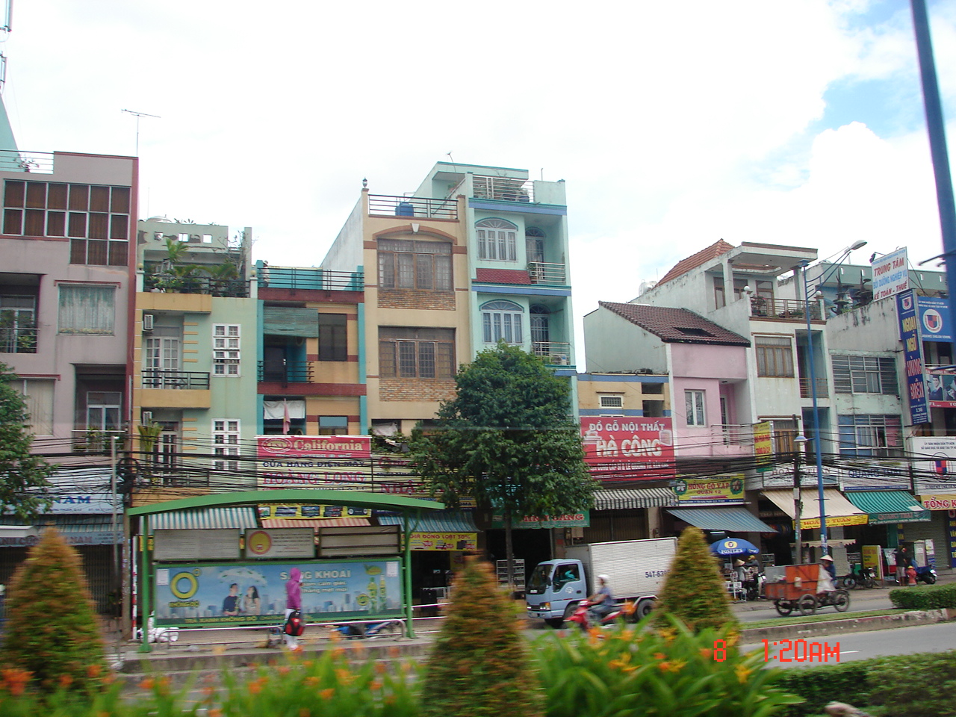

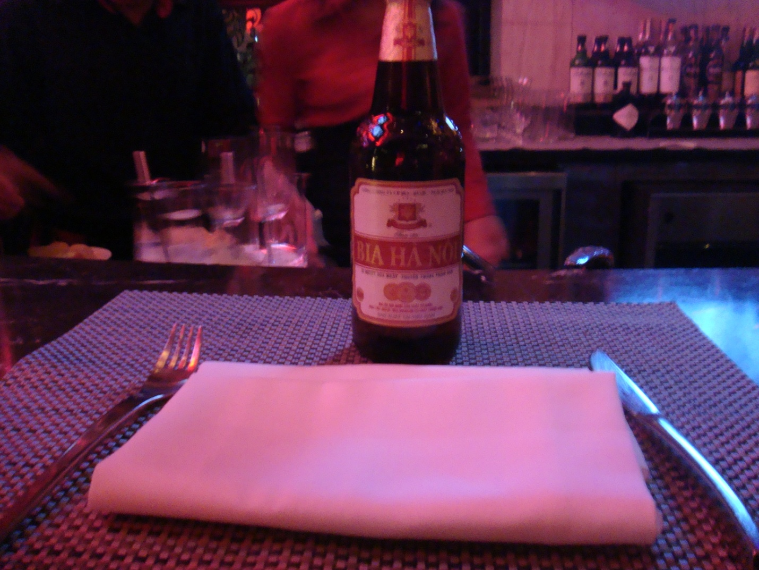

Vietnam and Cambodia – A Visual Fiest

